DIRECTOR’S NOTES for EP 117B Enormo Henry

Notes in grey - original director’s notes, please read them as well:

Overall notes: It is a good opportunity to use extreme up/down shots playing with the size relationships.

Notes by line numbers:

2 – Henry sits very low, no way he can eat, sitting in that chair – sketch below.

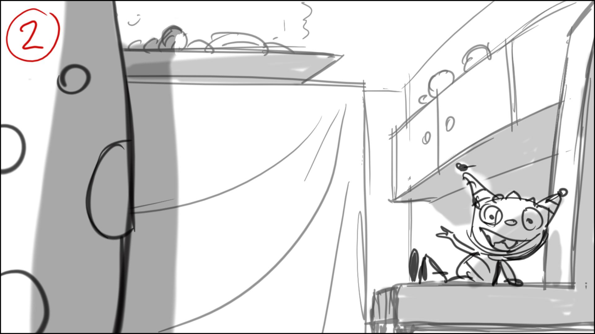

5 – make cool angles…

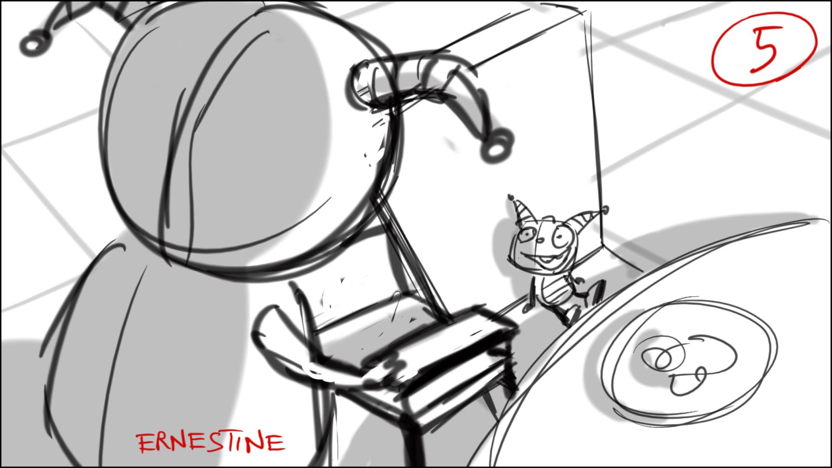

6 – 14 - Henry stays on his chair, and sits/stands on it until he gets the new (baby) chair, till line 14. Play with the size relationships’ of Henry and the plate/ table utensils, (down shots) – some of possible angles – below

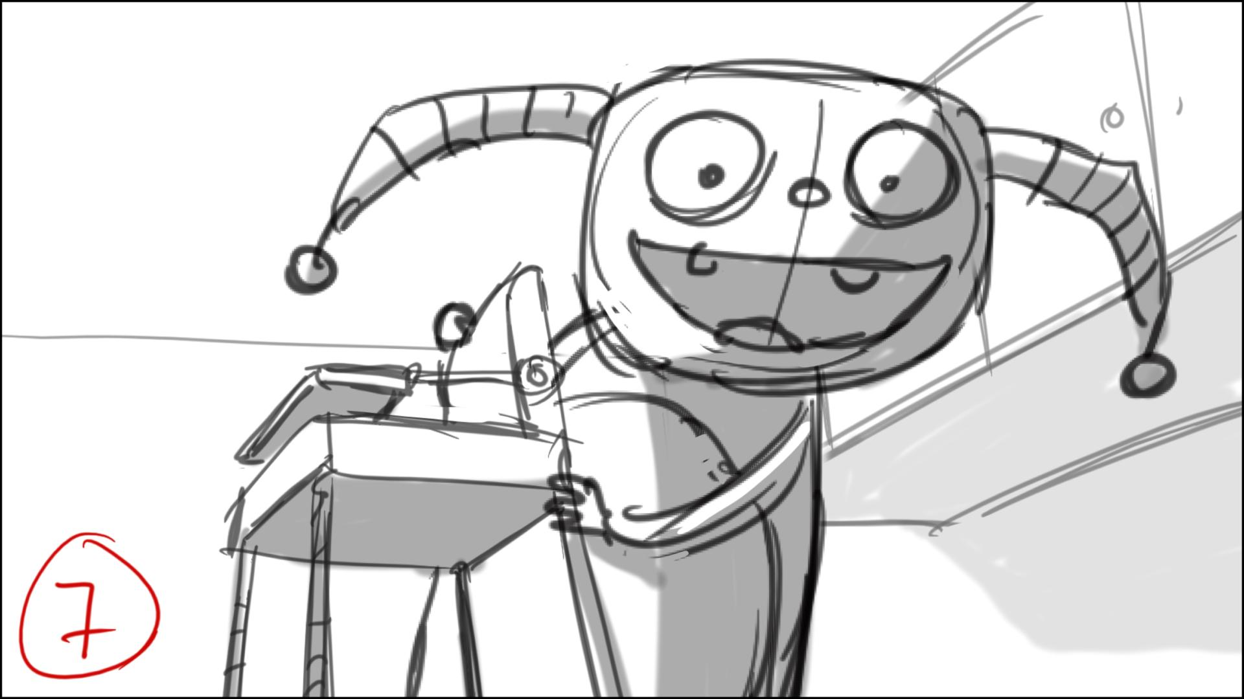

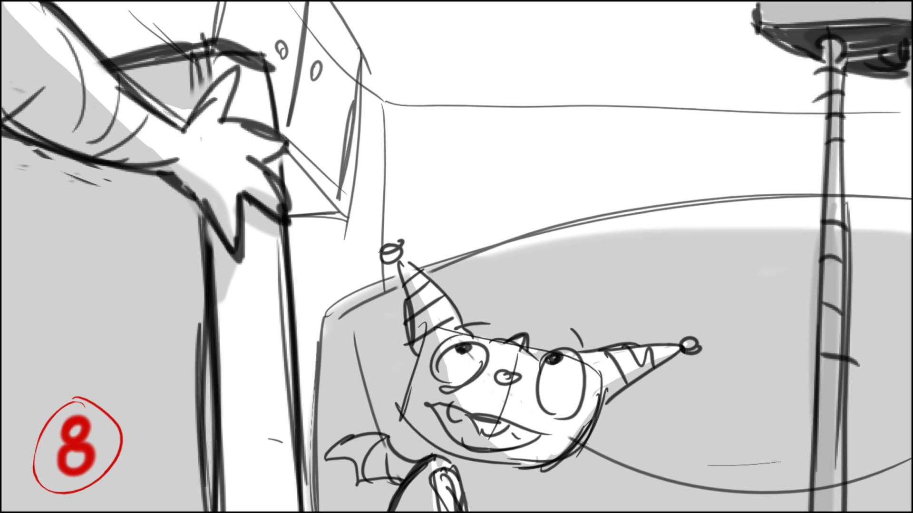

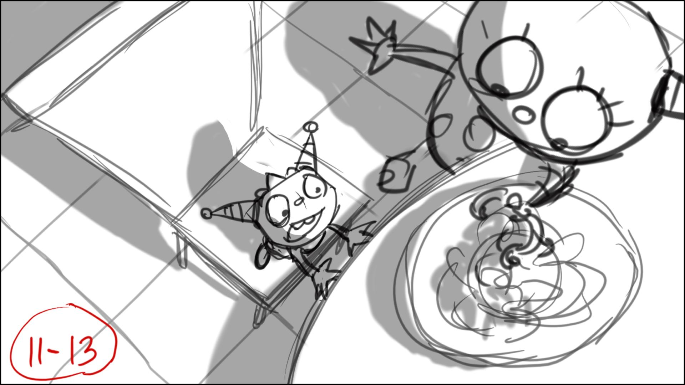

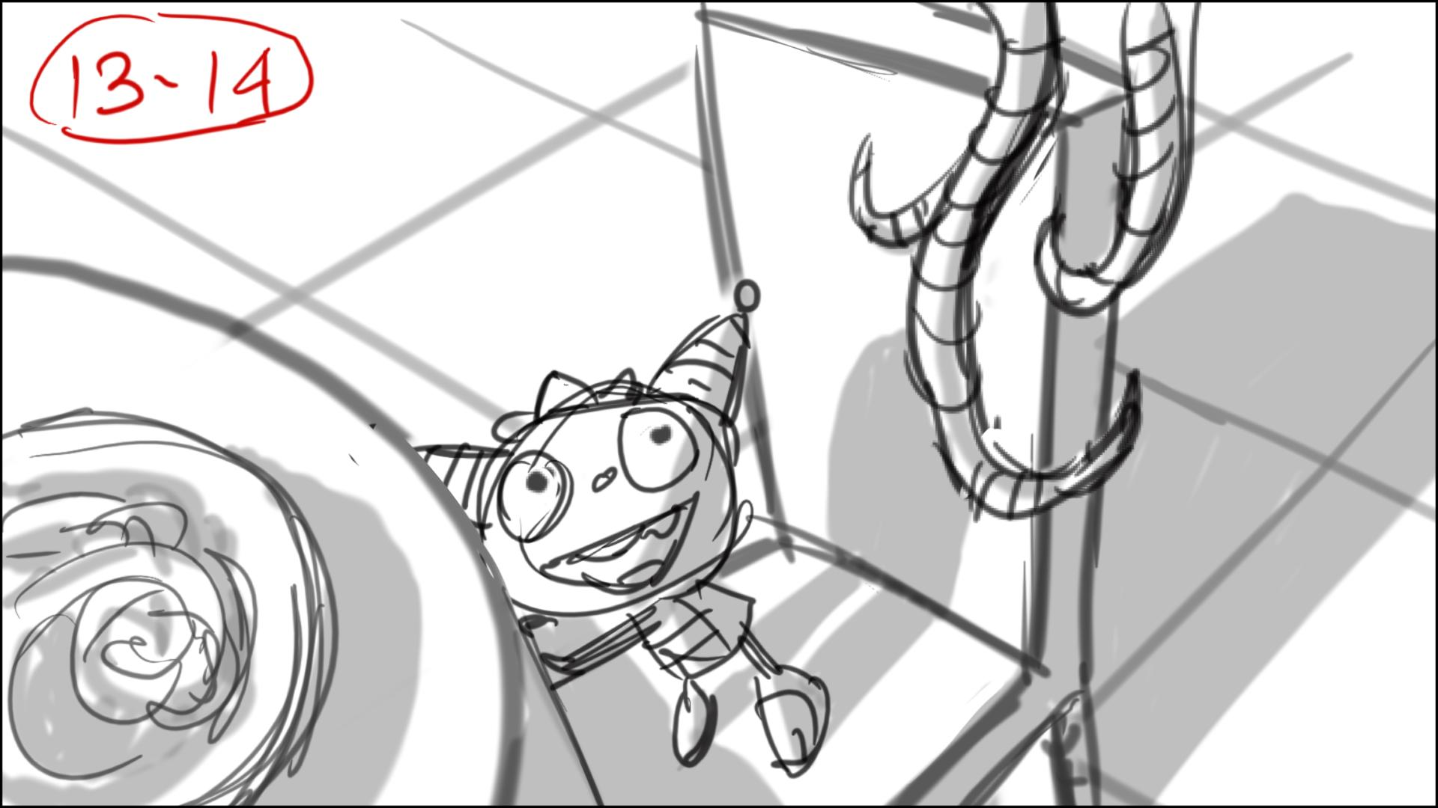

15 – Henry is in baby chair here. There may be a problem for him to reach the tray/plate from behind the baby chair’s tray – you can cheat by smart cuts. Estelle is also in her chair at this point. She stood by the table before next to henry.

22-26 – they stand in a circle, we can see their shoulders in frame as we cut from one to another. When they talk to each other, use up shots on parents and down shots on Henry, and use normal angles when Henry talks to camera.

26 – I understand this is a song, let’s wait for the audio…

34 – song again? Let’s wait for the audio.

26-35 – Henry is not playing, only watching, very excited. Make down shots on him like below.

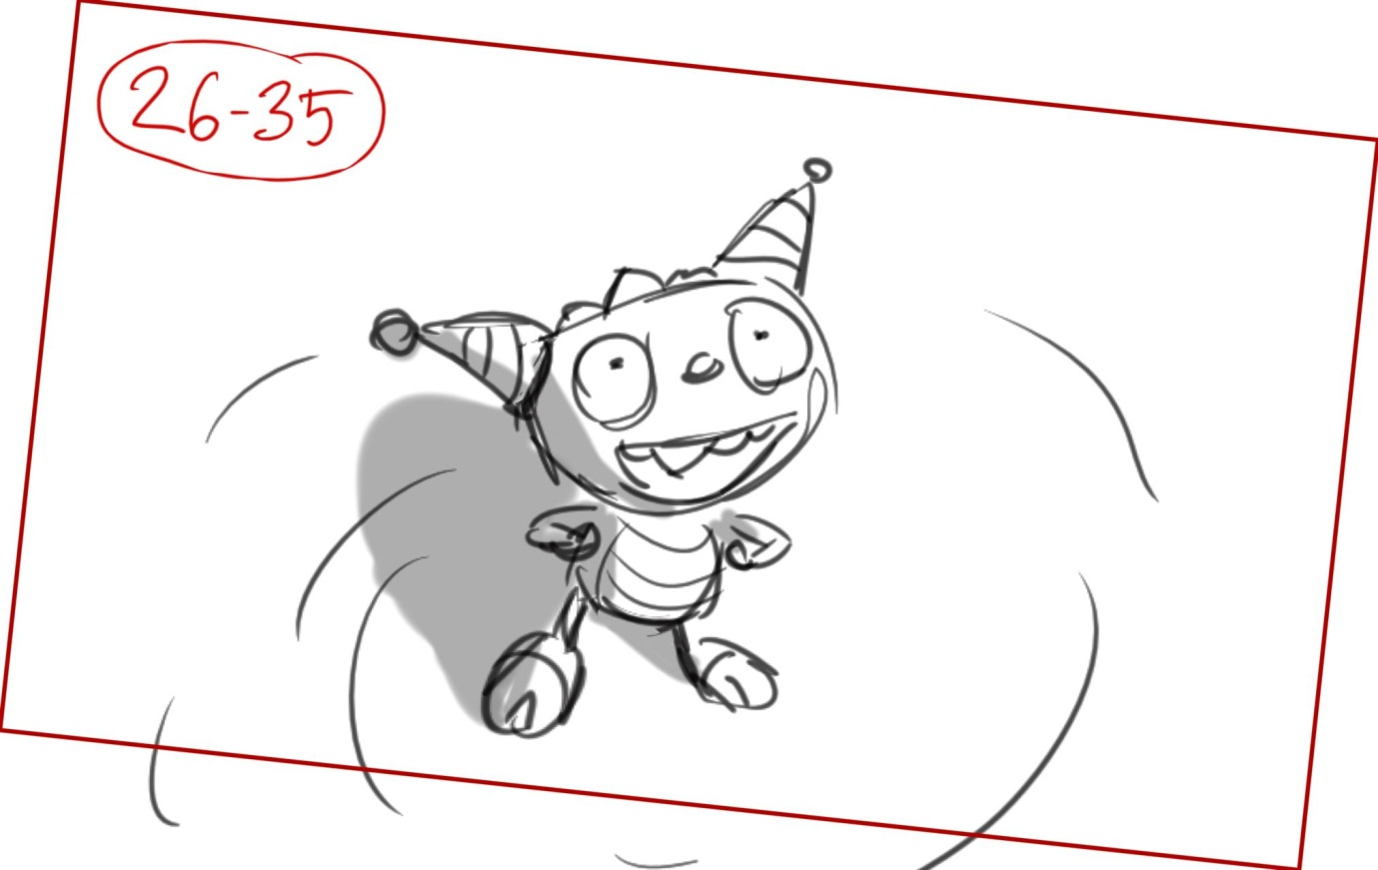

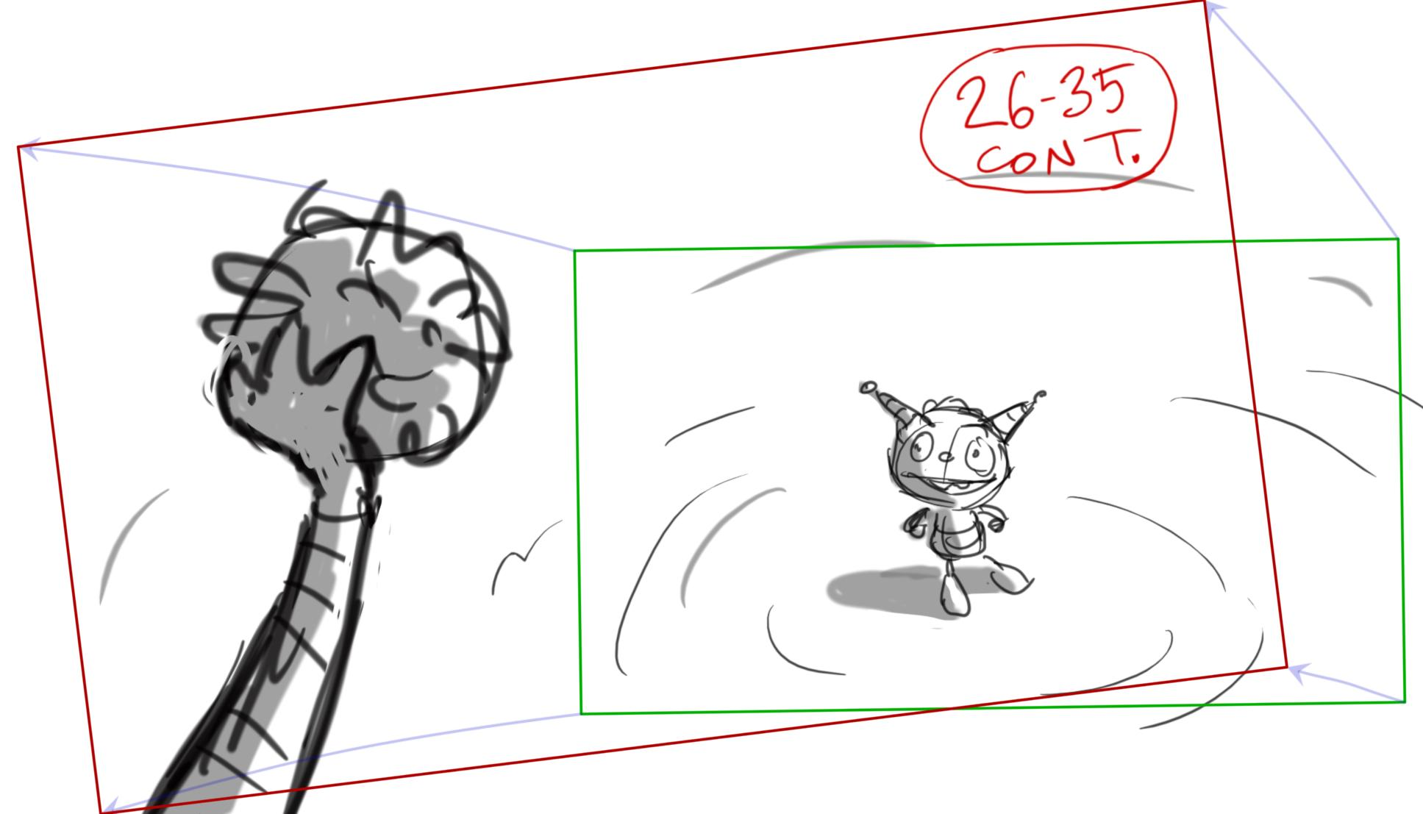

36 – Henry is in defeated position here, and stays like this up to line 38, then he crawls out of the ball – sketch below

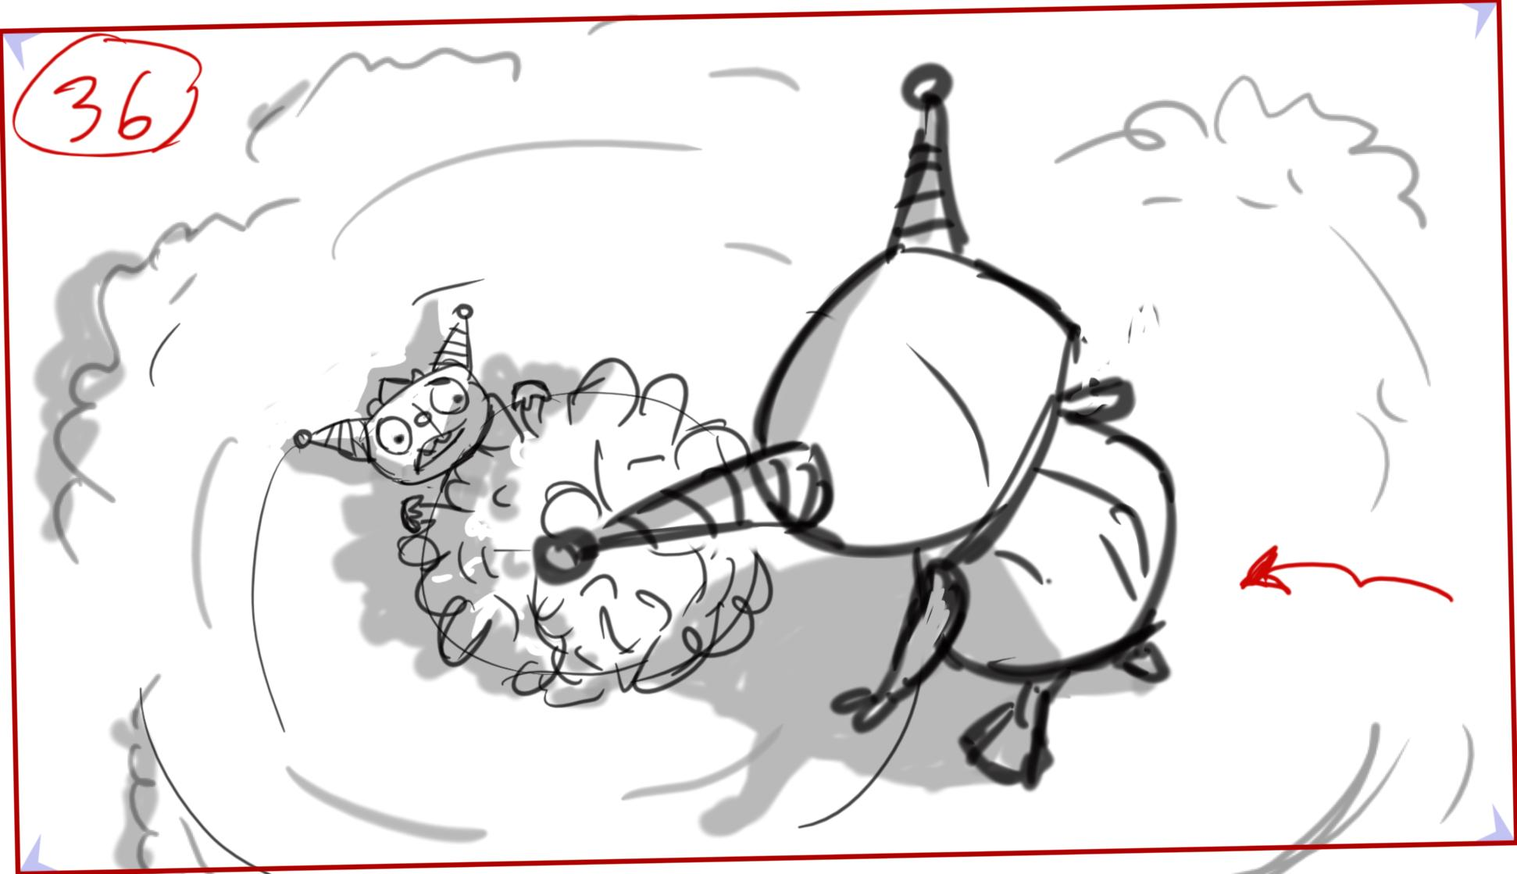

39 – Flopster’s ball is really small for E. – we should see it – below.

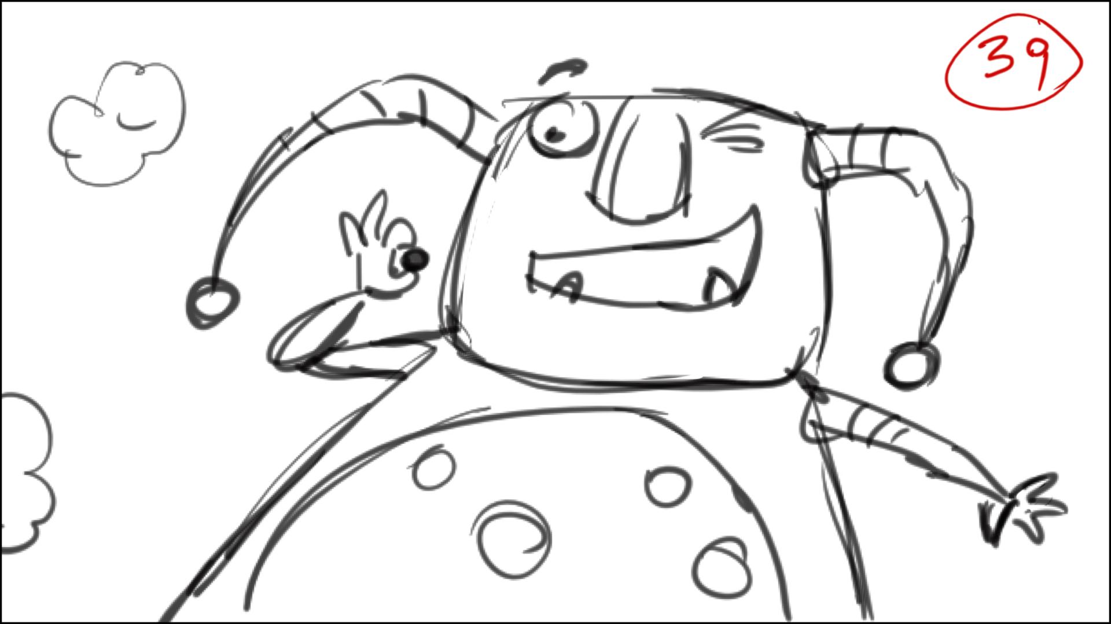

40 – cut to Estelle, she is sad, looking at Henry leaving, and holding the E.ball – size matters they all realise….

42 – this is the backyard.

51 – meaningful close up on Henry – he gets an idea.

55 – you can rough this out without the soundtrack as there is no lyrics here. Make cool angles, cut to extreme close ups.

57 – Cobby is proud here. He is out of frame on “Okay, maybe it is” – we truck in on Henry, leaving Cobby out. I think it will be easier and more readable if Henry just flies up to the top of the head instead of using a hatch.

58 – to the end – The hands of EnormoHenry are too short to reach his top of the head, so please cheat the scale by smart staging.

67-68 – Make Estelle not seeing real Henry at first – she talks to the toy. Show EnormoHenry from Estells’s POV – up shot that is, without Henry on the top.

76-86 – song. Make them dance-run in a particular direction, throwing the ball to each other. Use similar angles to those before, when Henry was small, and couldn’t play the huge ball, but now he can. Quick cuts to real Henry’s face to show how happy he is to be big.

85 – EnormoHenry can’t hop on his hands (they are too short) but he can make a pirouette in the air, during which he nearly falls out. He is not scared, but excited, like he is on a rollercoaster – below.

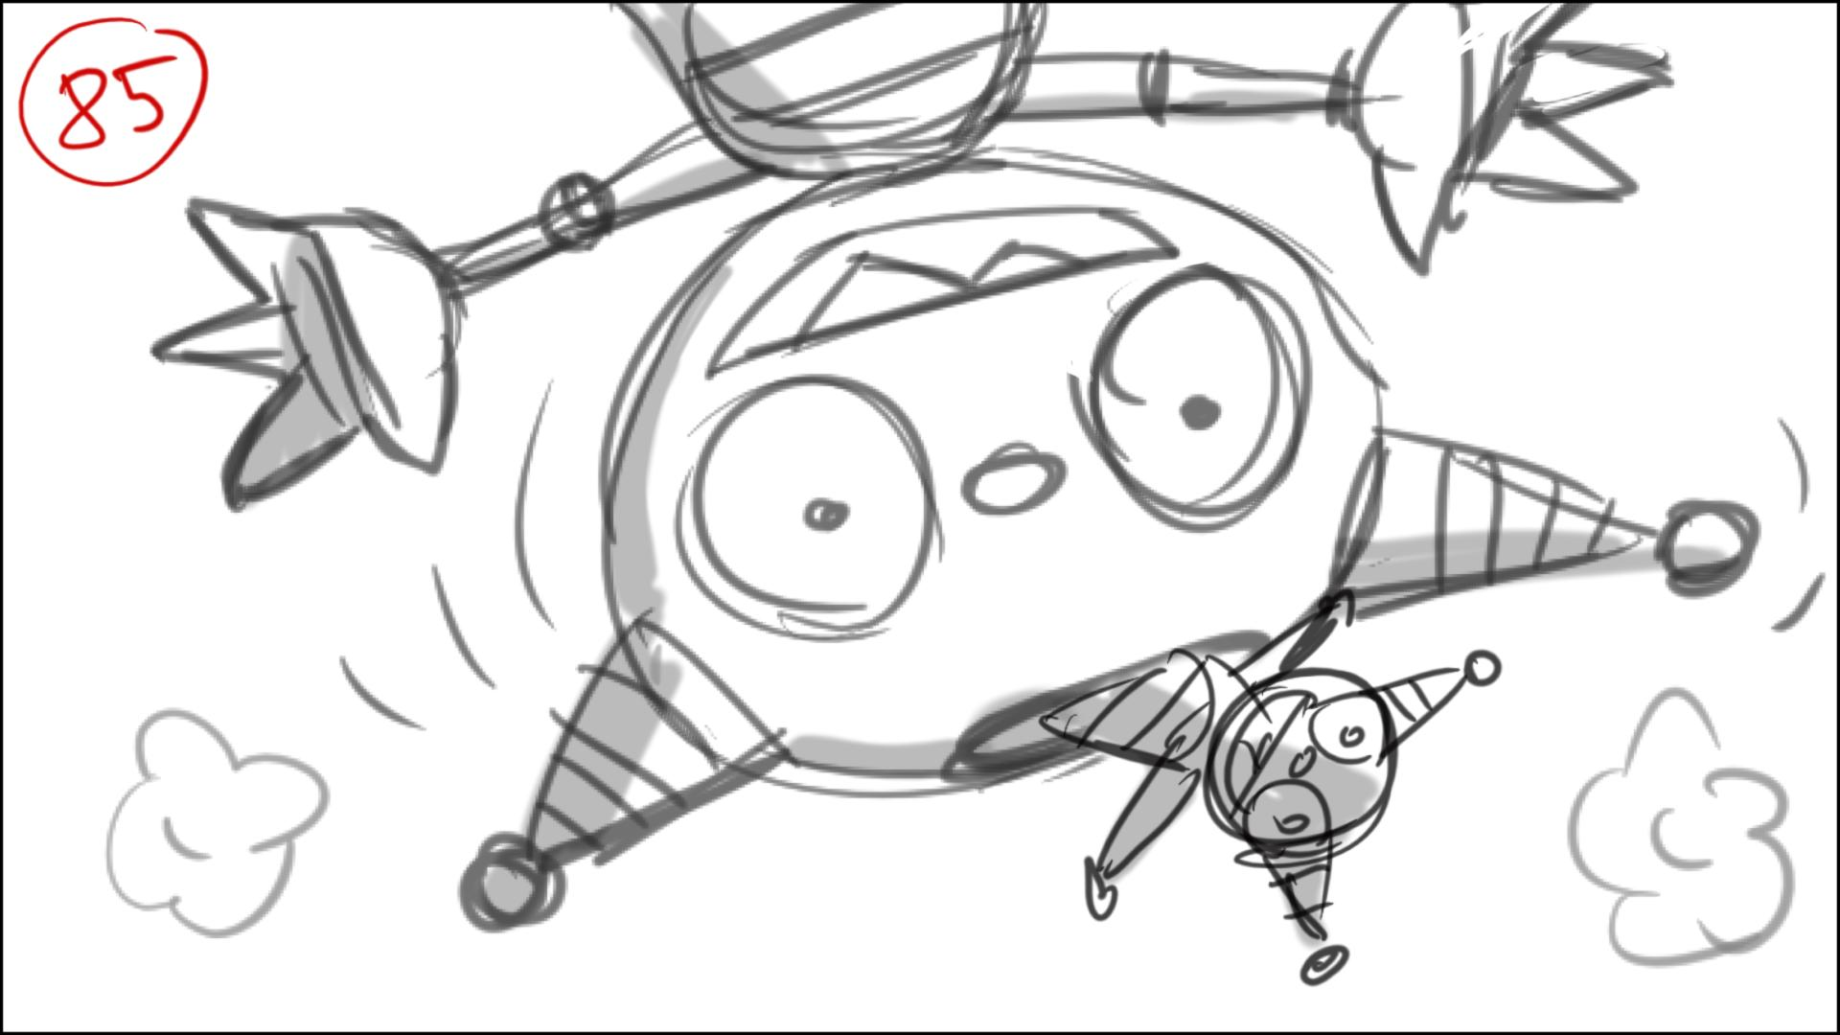

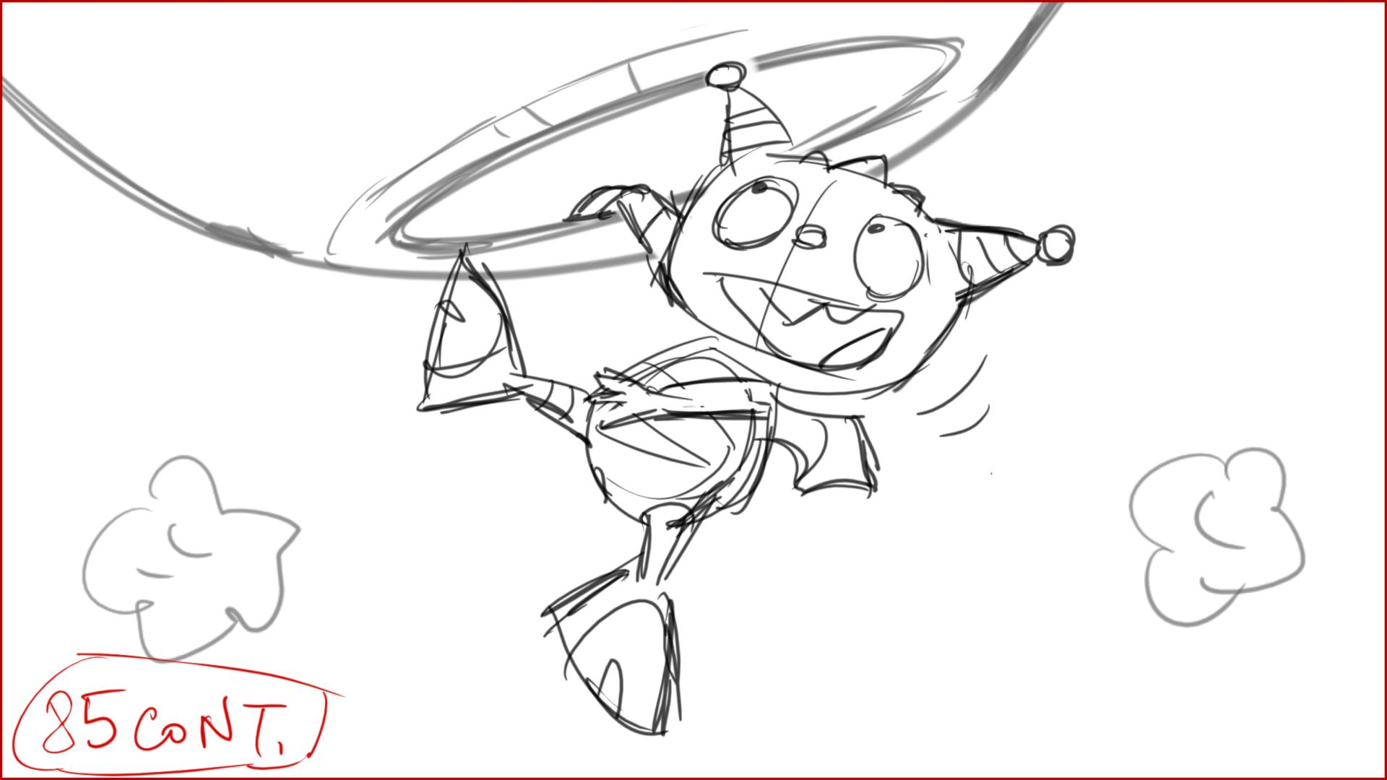

90 – Henry shoves the baby chair away with a sideway glance. In this scene as in some others don’t forget to cut to Henry’s face for his facial acting, otherwise he is too small now. He eventually tries to grab the muffin using both hands – below.

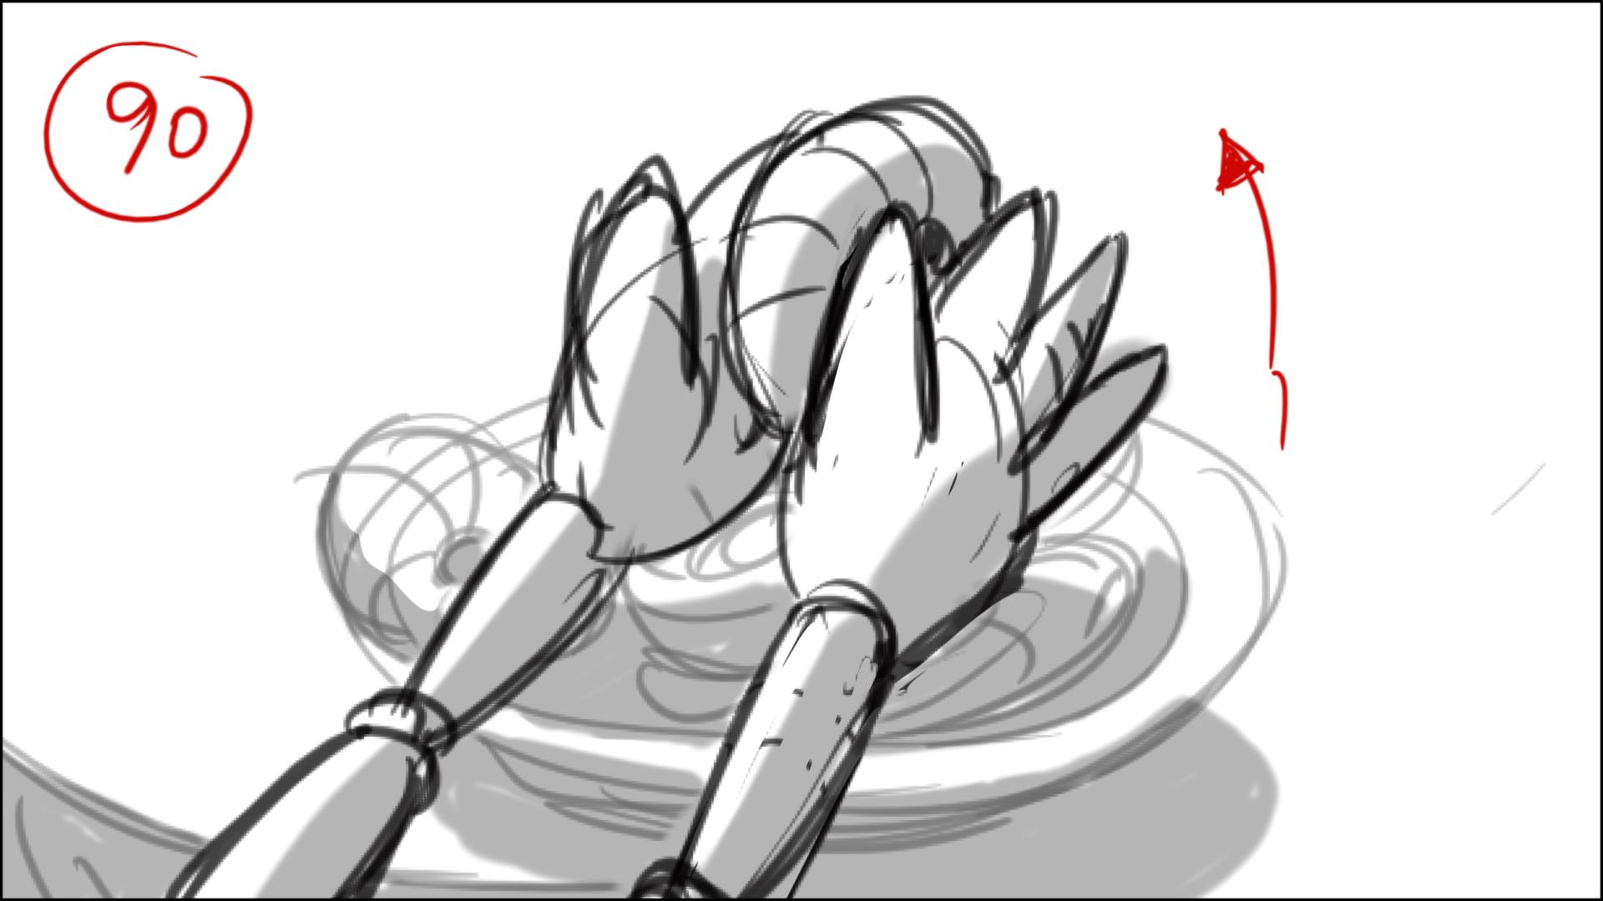

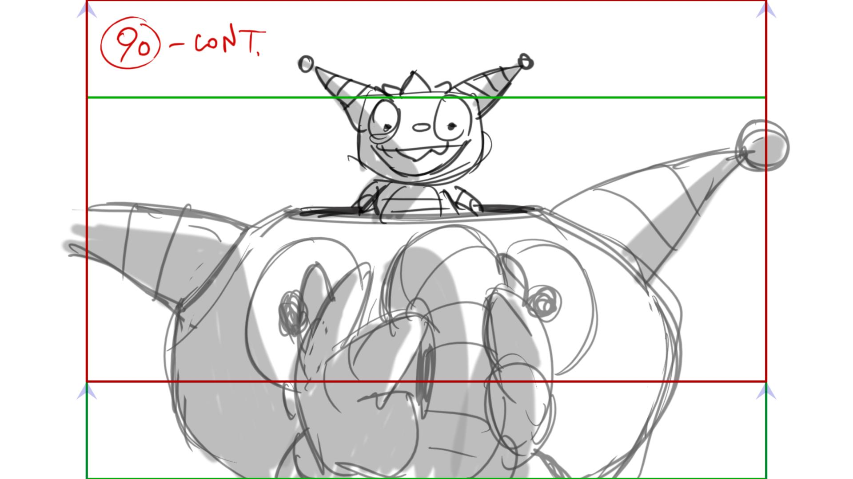

Eventually the muffin slips out of EH hands, flies up, but luckily Henry catches it.

95 – on “anything” Henry spreads his hands and hits the baby chair, Eduardo catches it with a smile.

99 – Henry tips the cereal box over his head in an attempt to eat, but gets showered with the flakes - below

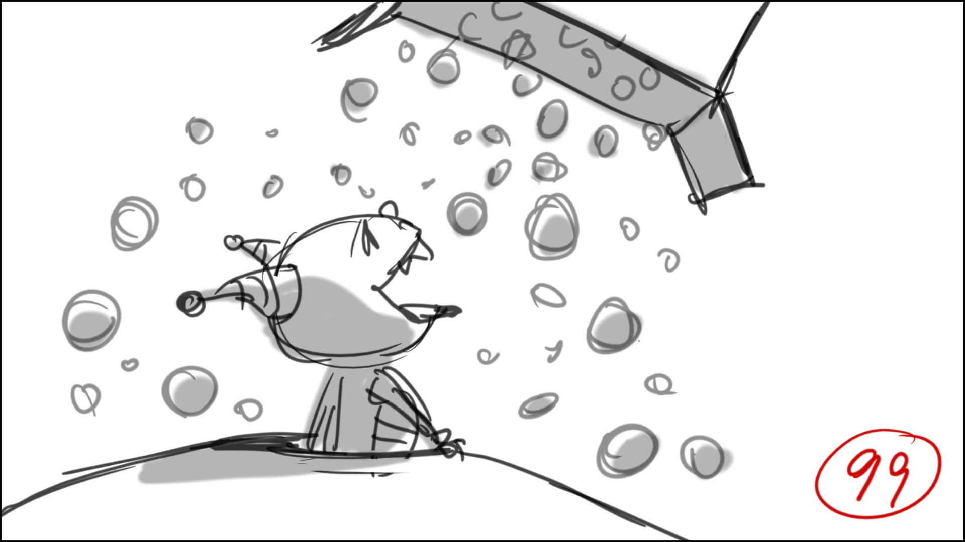

118 – For clear reading make the rope (starting from wheels) tie both of his roller skates – below….

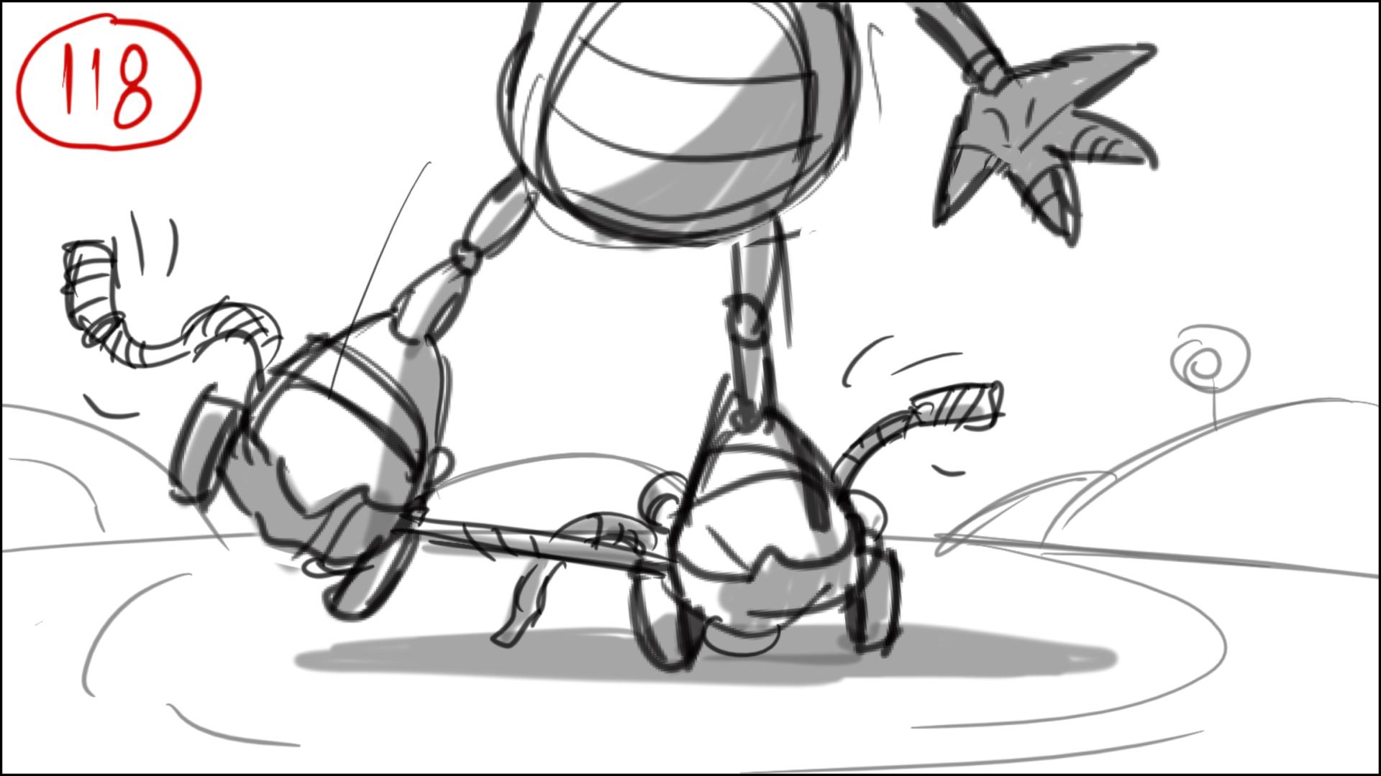

… and eventually like this – below.

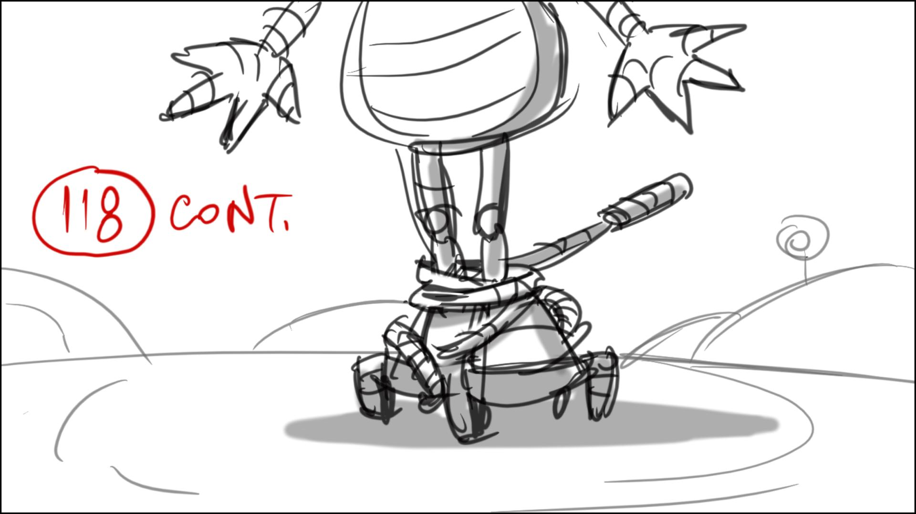

122 – Lots of frontal camera moves in the park, cuts to Henry’s POVs, but keep Henry’s shoulder in frame.

123 – Henry can’t lift his leg, so he just bends and spreads his arms (out of control) ….

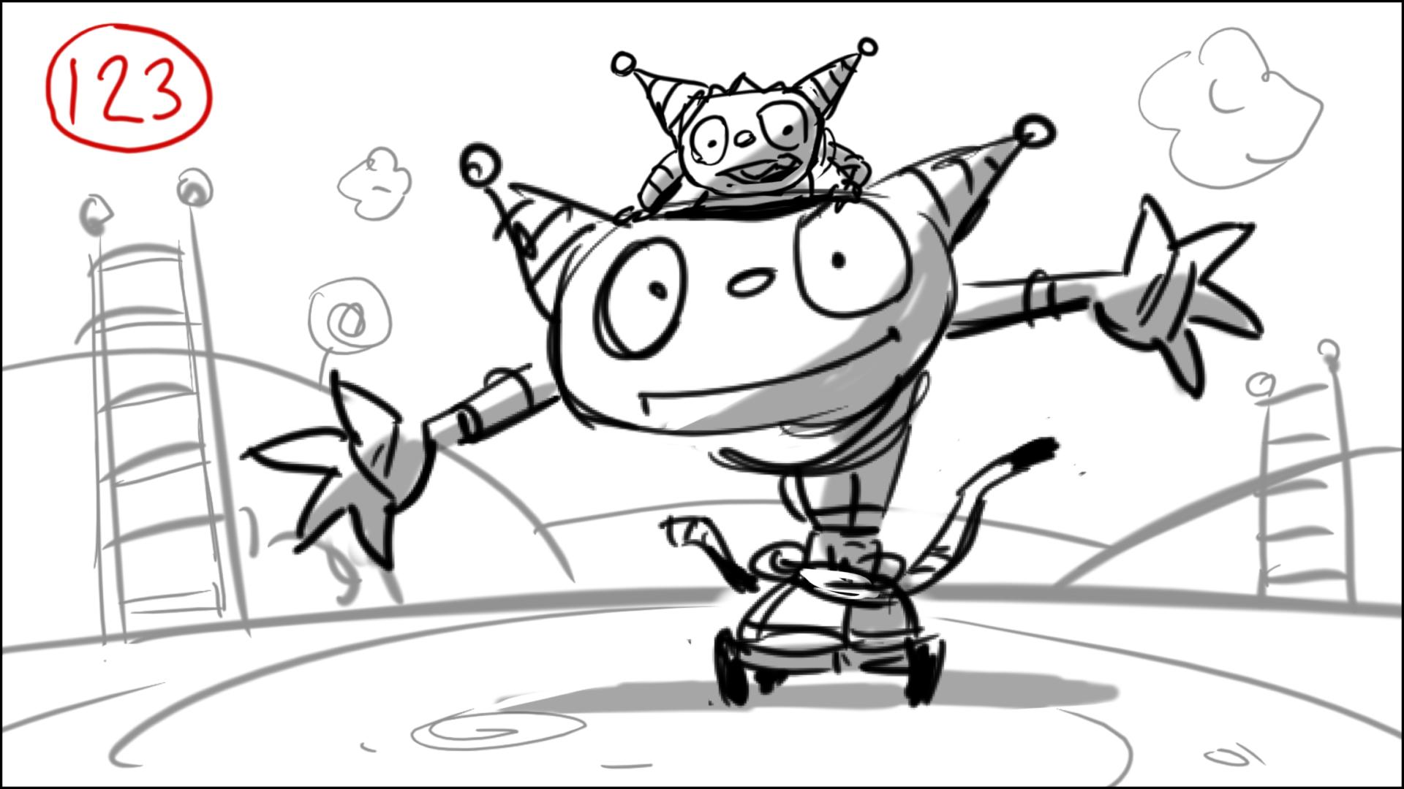

…threatening to hit Milo…

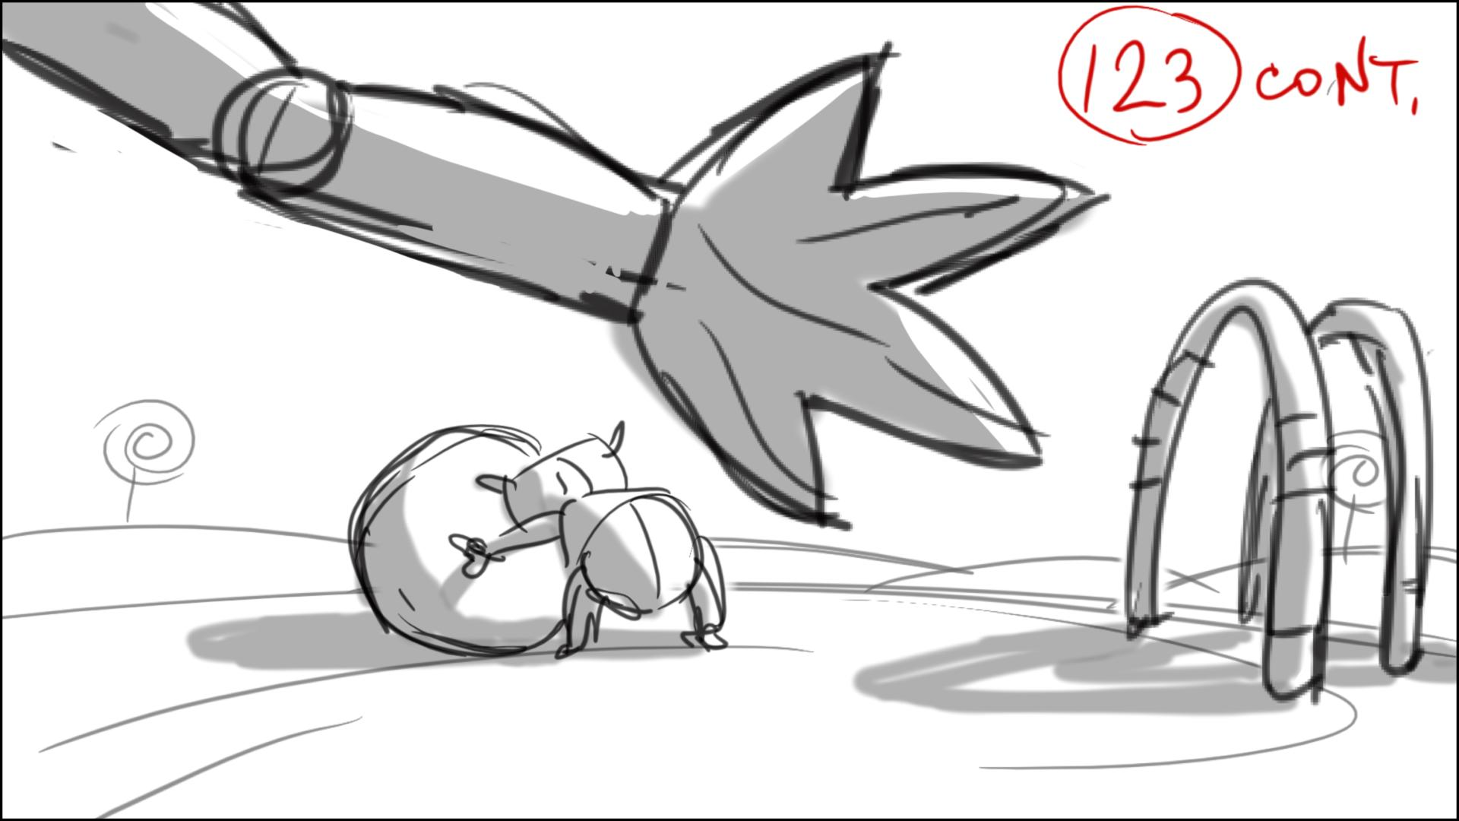

… but then it misses Milo.

124 – on “ PHEW” Henry wipes sweat from his forehead, and so does the EHenry.

128 – Use some clear profile wide shots here.

151-165 – Play with size differences using down and up shots, as it will be hard to use wide or medium flat shots. But you’re welcome to use them too…

ENORMO - Henry Board revision notes (by Norton 2.07.12)

Please use Estelle’s updated size (for this episode), below:

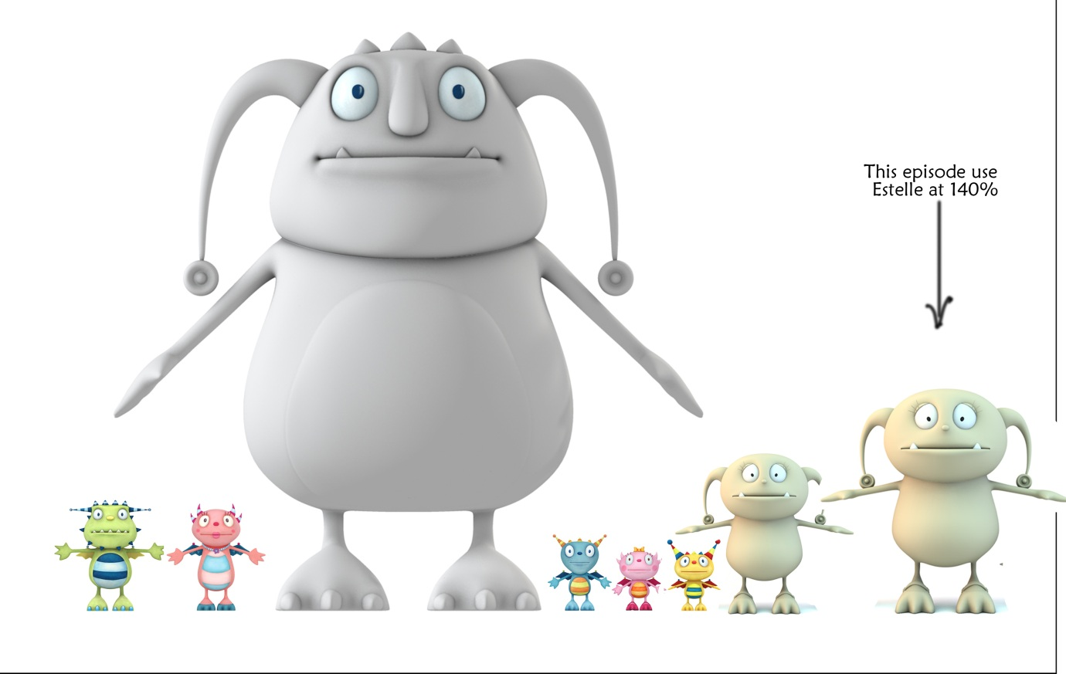

Yellow highlights are scenes needing extra attention – Edit things, production concerns.

Blue highlights refer to dialogue issues or re-writes needed.

General - There's no way I can see to make some of the story points as written without our creating an extra, scaled up model for Estelle. Also helpful would be to lose the second sized door in the Enormo House, maybe for all episodes.

Sc 1 – 14 – The notes below are in reference to the existing board…but this section can be altogether new, it might be easier. Vitaly’s original sketches are helpful for showing the idea of extreme angles etc too – but it’s also important to have clear shots showing the various sizes of characters and chairs involved in the situation.

1- Instead of zooming into the Enormo House, let's stay wide, drifting slightly in. Let’s start with Enormo-dad walking to the mailbox – the ground shakes with every step - then he bends to take the mail…

2- Let's add dialogue "hey hey, I said 'hey hey!'" over a shot that shows Estelle at the table and Enormo-mom doing some prep in the kitchen. Keep the camera flat at Estelle's eye level, but please create a POV style shot, as we are hearing Henry's voice but not seeing him. Then we reveal him, with the camera coming around the table and past Estelle to see the really small looking Henry standing, facing camera, on a big stool, way too low to reach the table.

3. Let's keep Estelle sitting. Note that she has to be on the same size stool as Henry but still has to be able to reach the table. So this is key to our determining her size for this episode.

Scene, like below will help to read their size difference in in one shot.

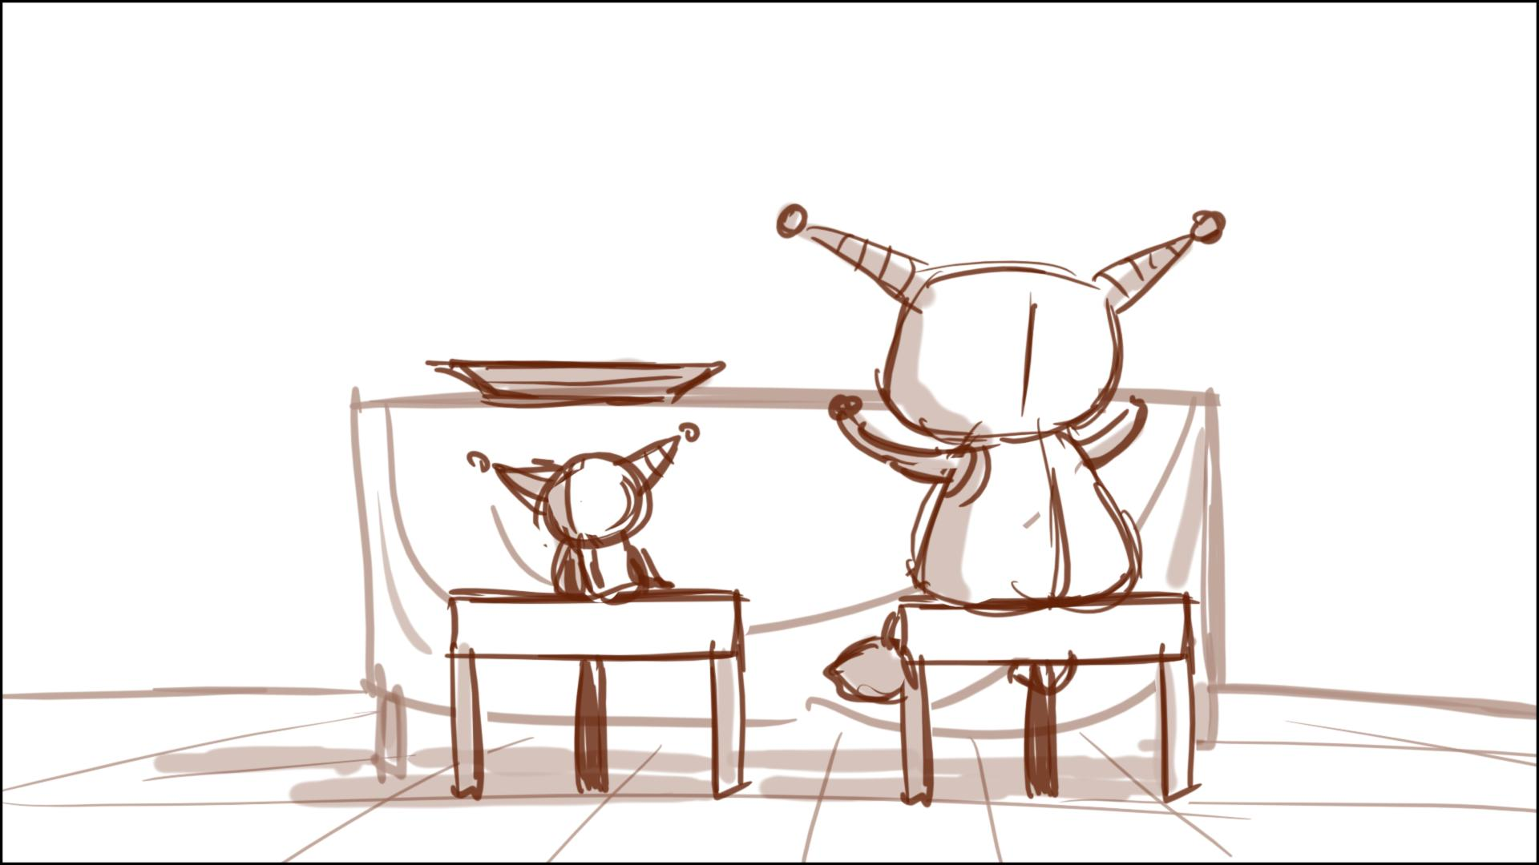

For Sascha - could Estelle say: "hey Henry, isn't that seat a little low for you?"

6- Stay wide for the whole shot. EDIT. Can we please change Enormo-mom's line to "Just Estelle's baby chair..."...

8- Henry has to look like he's very far down so he really couldn't possibly reach the table. Estelle should be sitting too. EDIT: Can we trim "baby chair?" from Henry's protesting dialogue? Estelle should be sitting as she happily takes a pop probably in a profile kind of shot so we can how much lower H is.

9- Or whatever number it works out to be...Let's invent an action where Henry flies up from his seat, takes one of the big pops and tries to hover ready to eat it...but the heavy pop causes him to fall, drop the pop and bounce down to his seat again. This is all much more in profile shots than in down angles. Probably Henry's next line about loving the pops would happen as the end of this action, in the same shot.

9-02 - it would probably be best to stage Estelle's dialogue here from Henry's POV or past him so show Estelle much higher than he is.

10 Henry’s dialogue here should be staged in a longer shot, probably on his level, it's about his thought process and he's talking to us. This moment feels overwrought, a little out of our style, so please underplay the posing a little bit.

Once Henry is grabbing a pop let’s make sure he eats it like a popcicle, not tossing them into his mouth like candy...it has a stick. Let’s have him take a lick, then say "Hugglisious!" Then he sucks the pop off it's stick, smiles happily for a beat...Estelle says "don't eat them too fast!" Henry's eyes pop open like "oh oh!" then the turns to us for the Brain Freeze" gag.

12- Please create a funnier, to camera expression for the "brain freeze" gag. Then let's not have Henry take another pop..instead Estelle proposes the game. She would not loom over Henry as drawn, she's not that big. Maybe we should keep her sitting for the question?

13- So perhaps we can come up with some business for this moment? I'd say maybe Henry starts climbing down, ending up sliding down the leg of the chair, and finishing this rant while standing on the ground...Maybe in the FG we see Estelle onto the ground too. Again H should feel pretty small by the time he asks: what is Enormo-ball again?

Check Estelle’s size…?

30- Maybe we should extend this scene to include Henry's dial up to where the Enormodad speaks. We don't need to see him pick up the dog's ball.

33- When Henry says “I think I’m gonna go home, Estelle – “ she should be in shot. Let’s do this as a steady pull wide so by this point in shot Estelle is also there, both big giants too, and Henry looking very small.

38 it’d be good to have a proper skating scene here, could be similar to what’s there but with panning - Summer going around Cobby, then making a figure eight as she goes around Henry, then she falls.

40 – can Cobby quickly pull out his sketchbook, and draw in there, saying “interesting”, Norton?

42 – 44 – We need to come up with more interesting shots for this quick montage…Could do something with split screen? Summer on one side, rummaging through art supplies, which come flying at camera. On the other side, Henry, rummaging through a kitchen drawer or a box in the kitchen – spoons of different styles coming up to camera. CUT to split screen sliced horizontally – Henry runs one way with a bunch of the stuff Cobby needs, Summer runs the other way…Cut to a three way split screen with Cobby in the middle pumping, as H and S run up to camera…the Cobby split screen widens to include the other two arriving by Cobby as he pumps.

Vitaly’s sketches for Norton’s 42-44 montage idea – below:

Split screen, Summer flies to her make up box (could be anything), Henry – pulls the drawer in the kitchen.

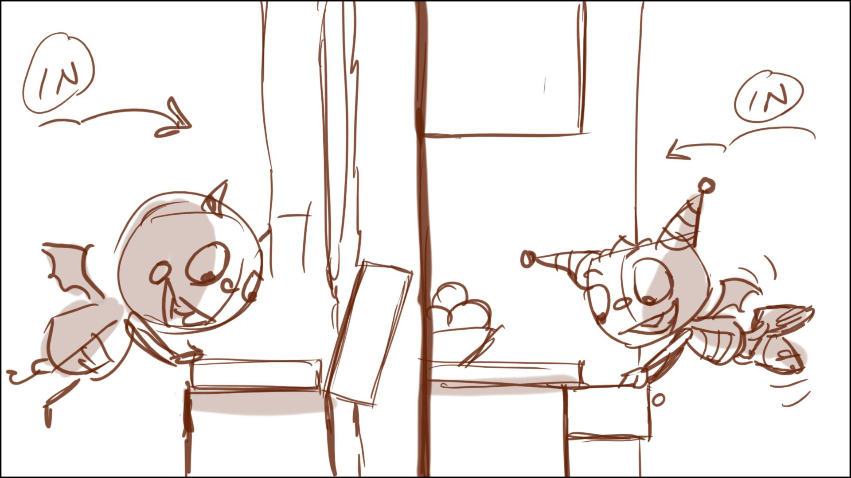

Camera rotates to see their backs, stuff flies toward camera – below:

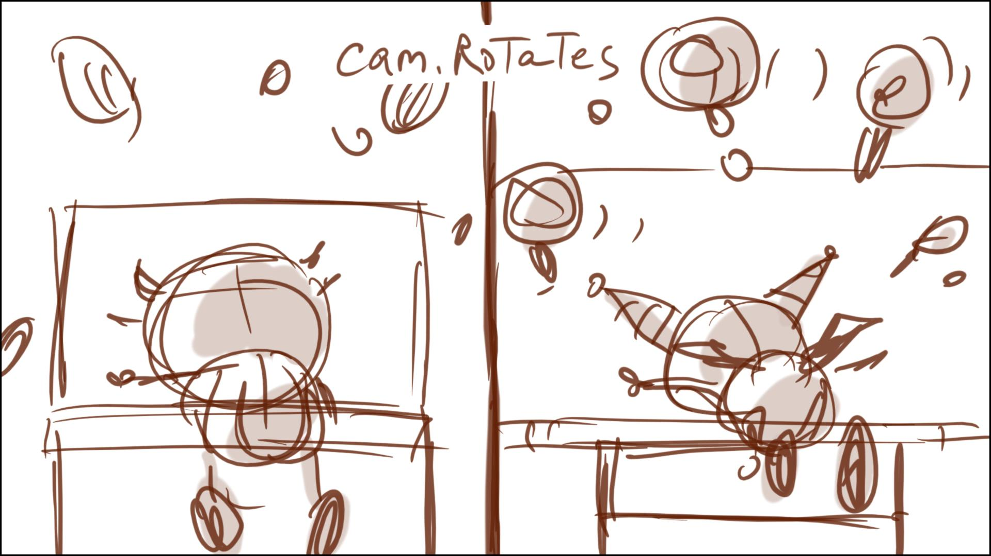

Split screen – stuff slides in (on the floor), spoons and brushes, pencils from Summer – below:

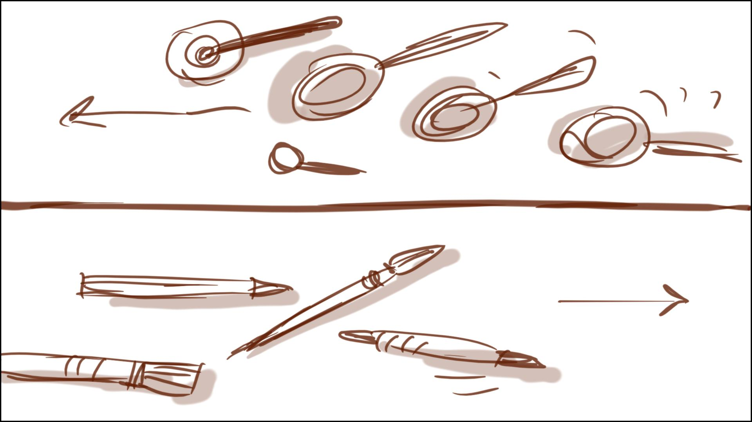

Kids bring a roll of rubber from the house – below:

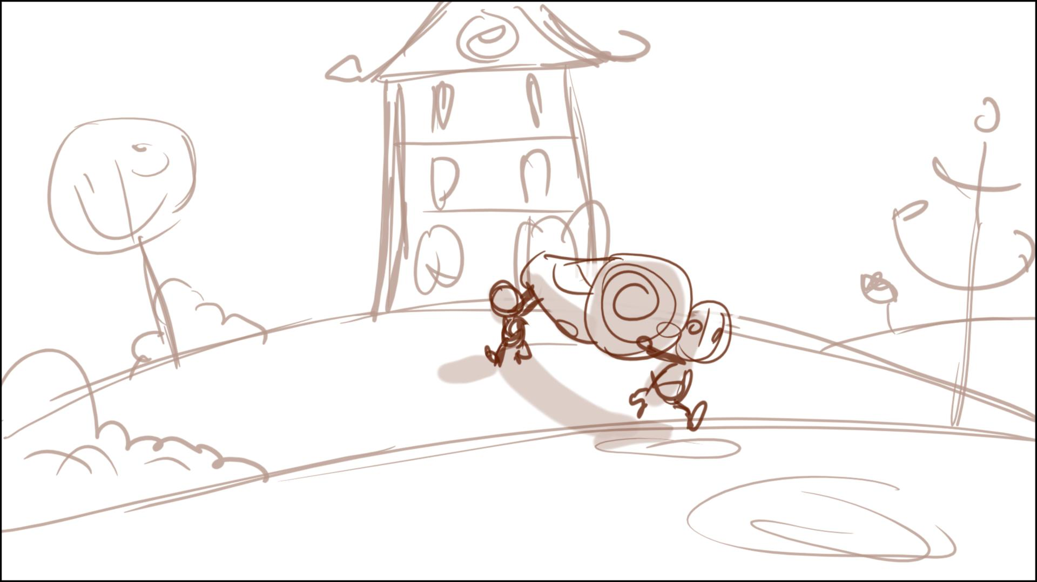

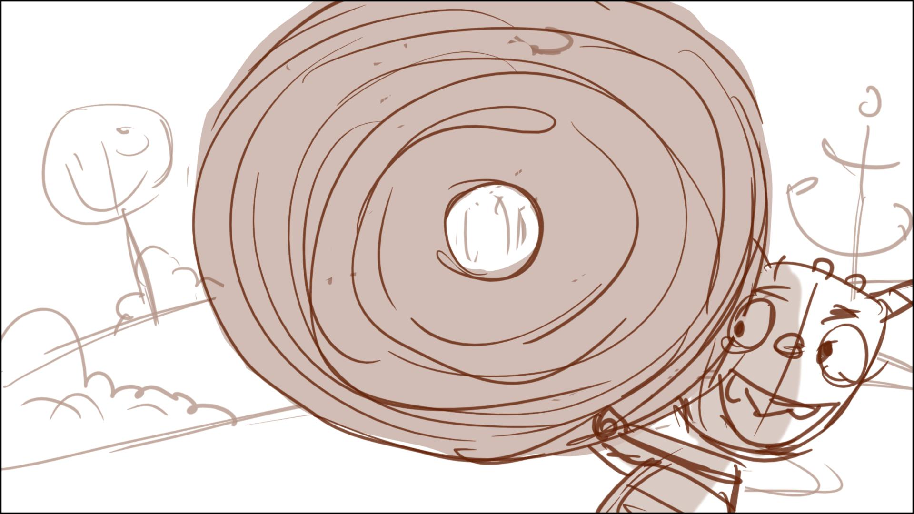

Camera can move through the roll – below:

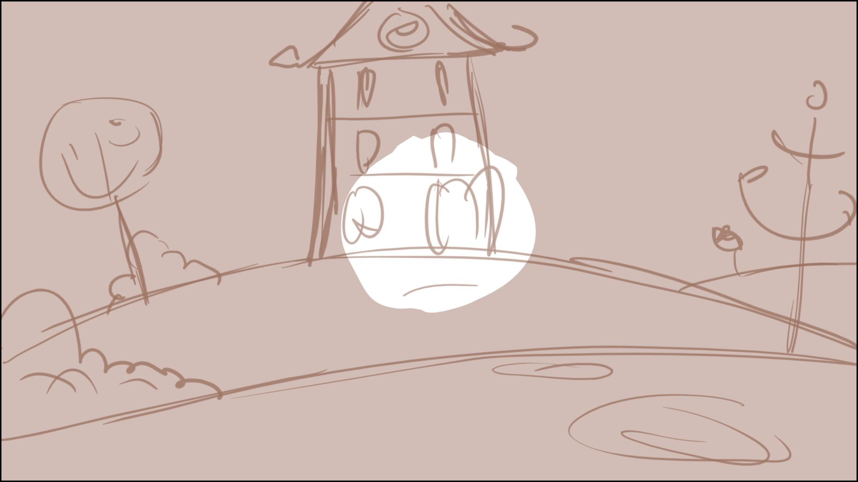

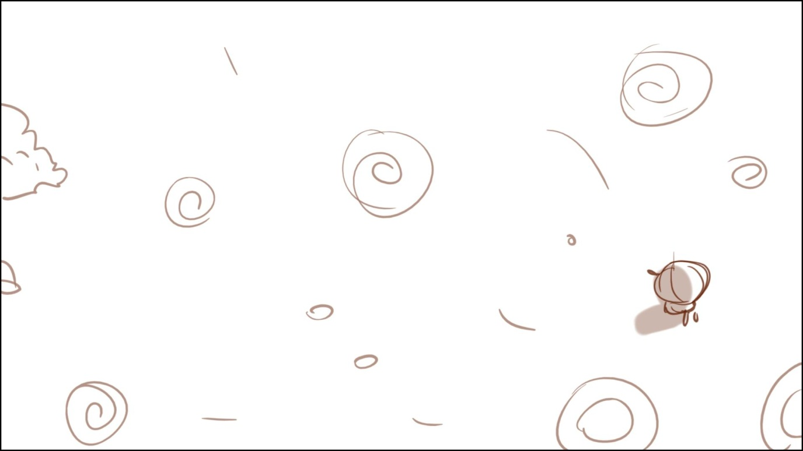

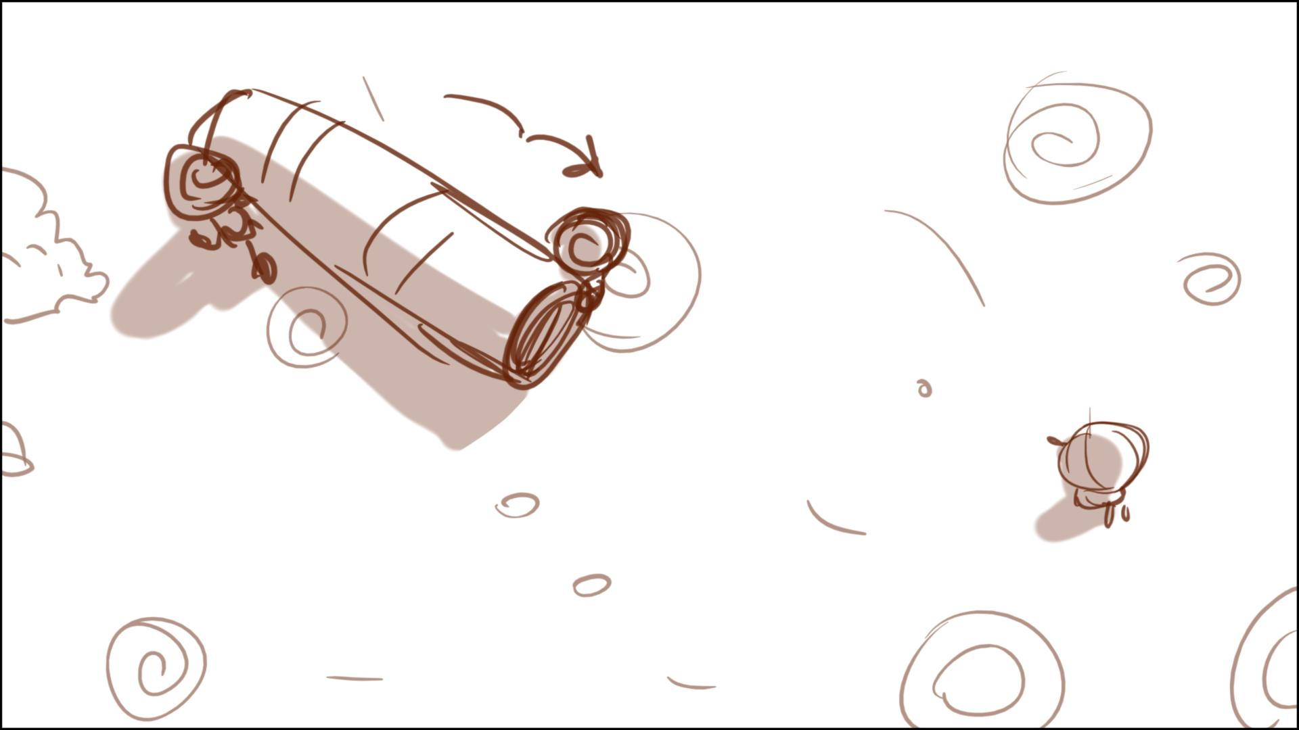

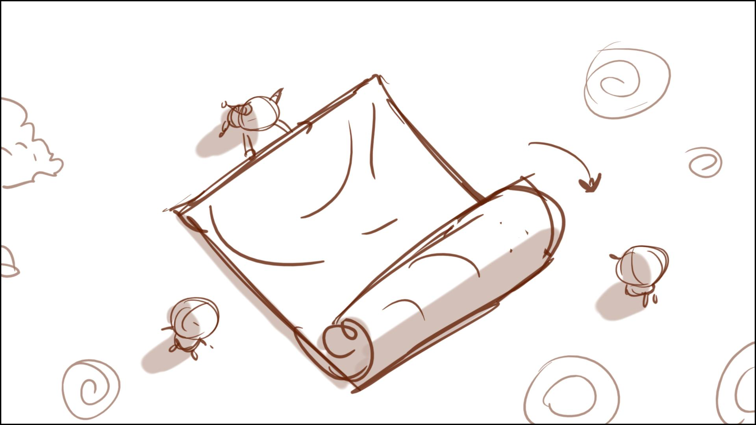

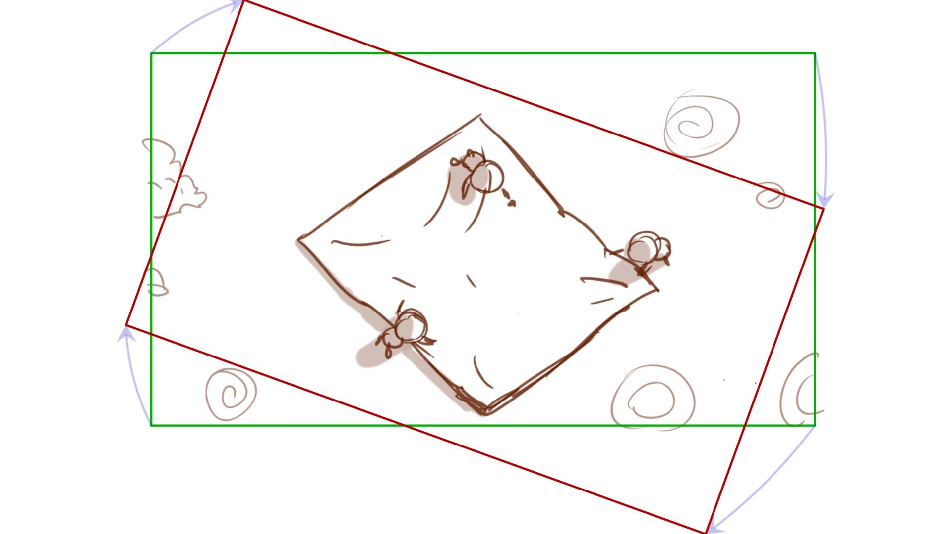

Kitchen roll cutter cuts the rubber

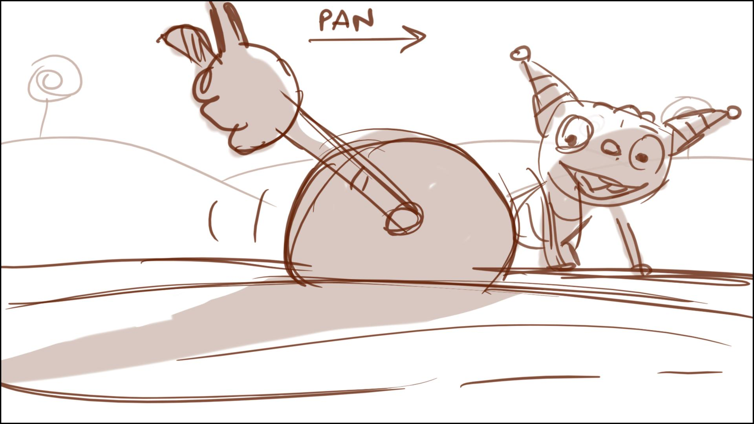

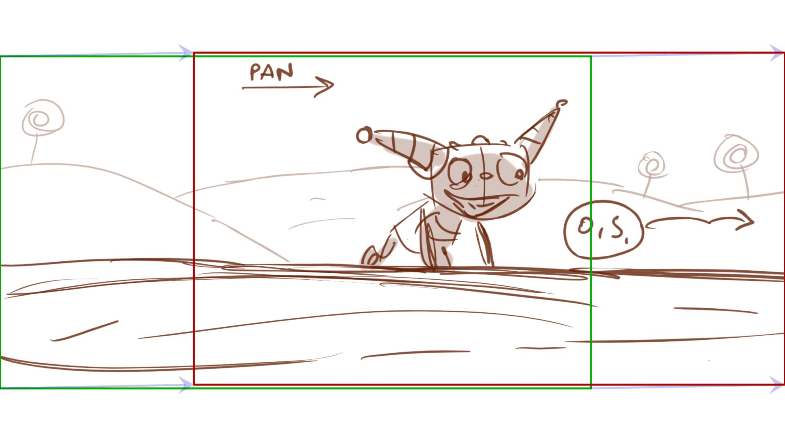

Down shot on Henry or Cobby, cutting the material.

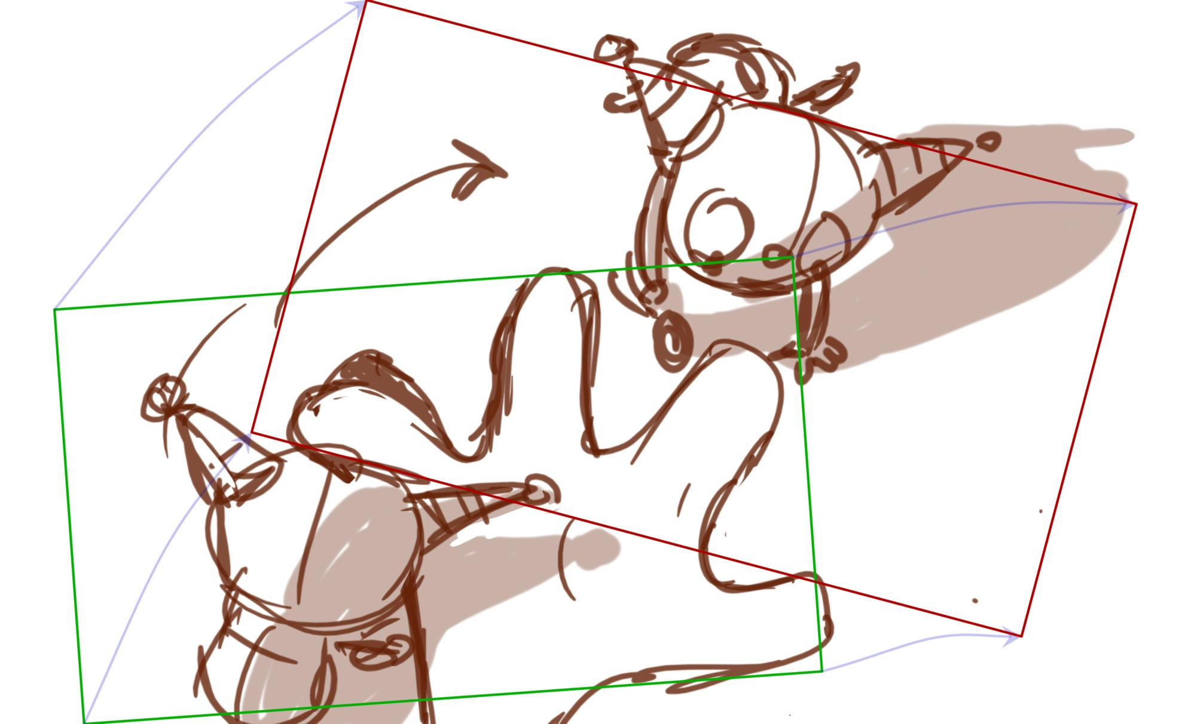

Henry (or Cobby) lift the cut out hand up (make it appear like a harder material for easier 3D animating)

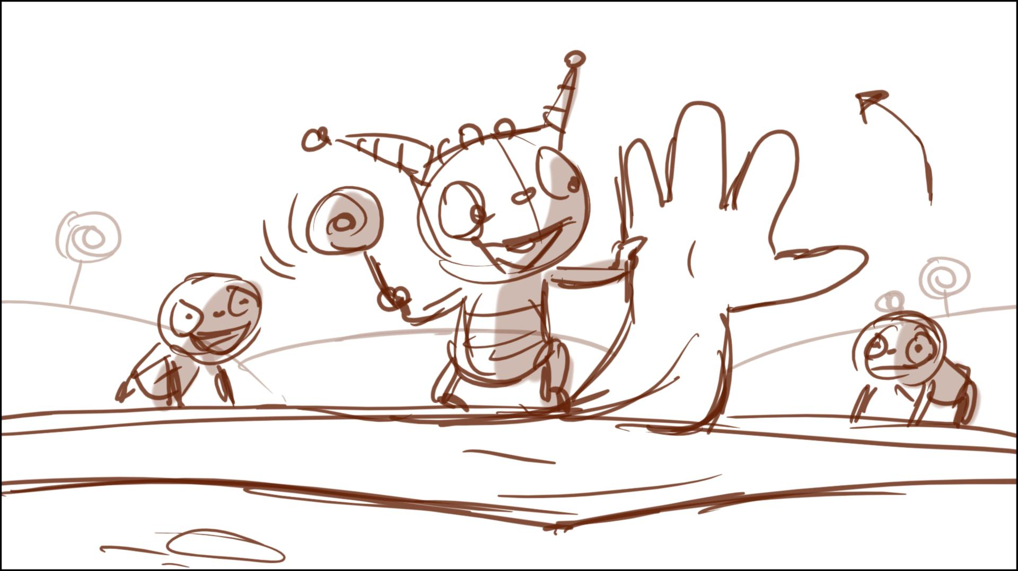

The kids pull the scraps away…

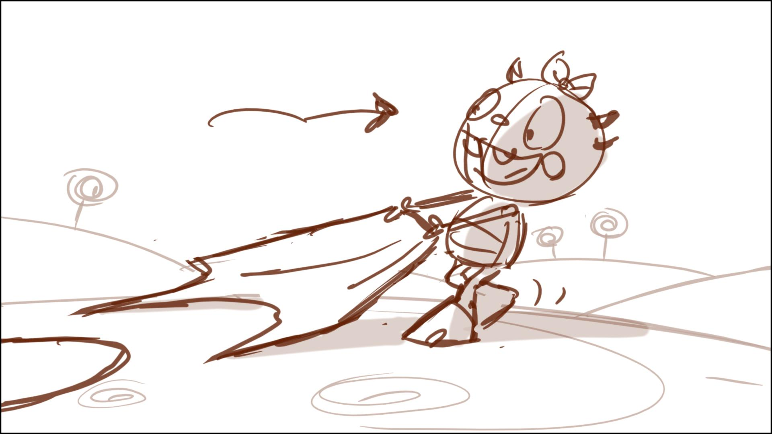

The kids pull the scraps away…(cont). Please make this shot to be his foot (not face, or only small part of the face) – the first time we should see his full face happens in a scene with the pump

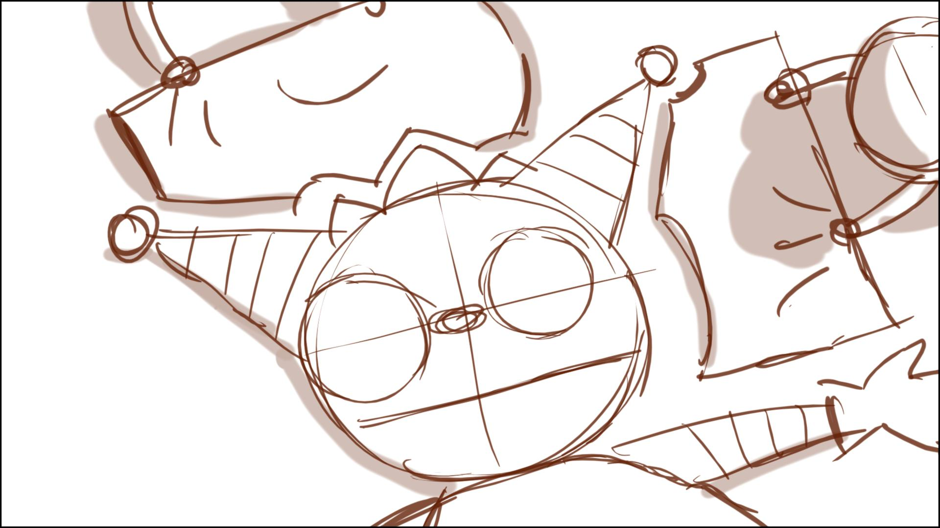

Summer dips the brush in paint…

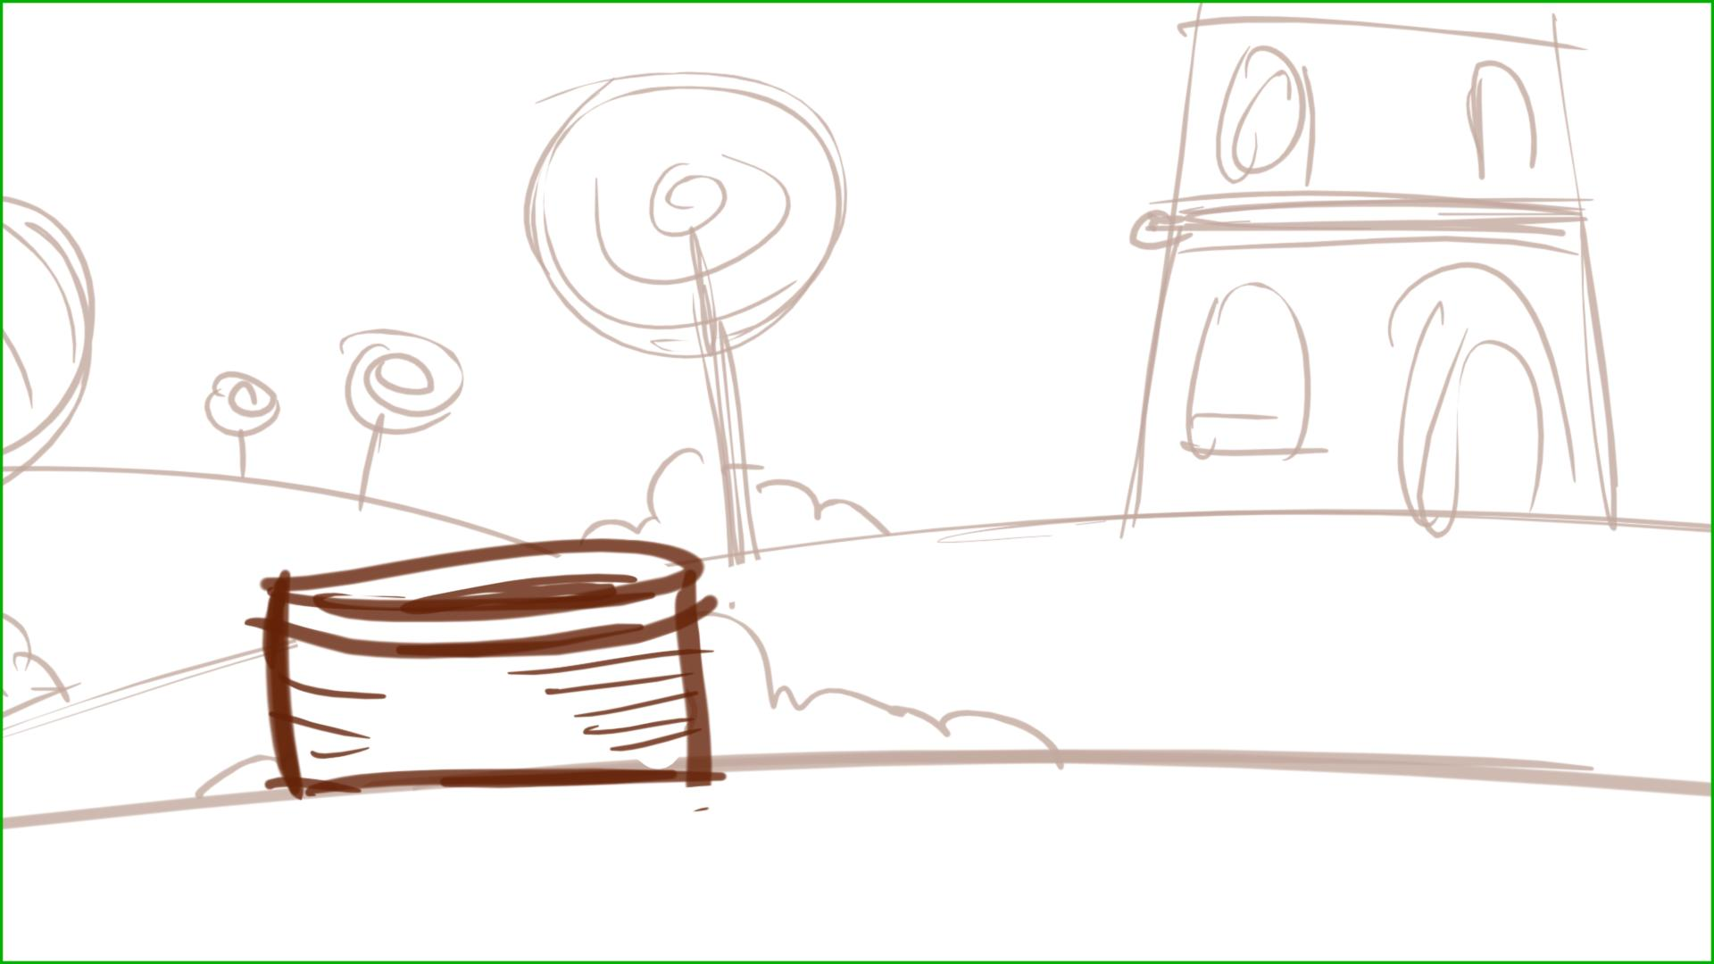

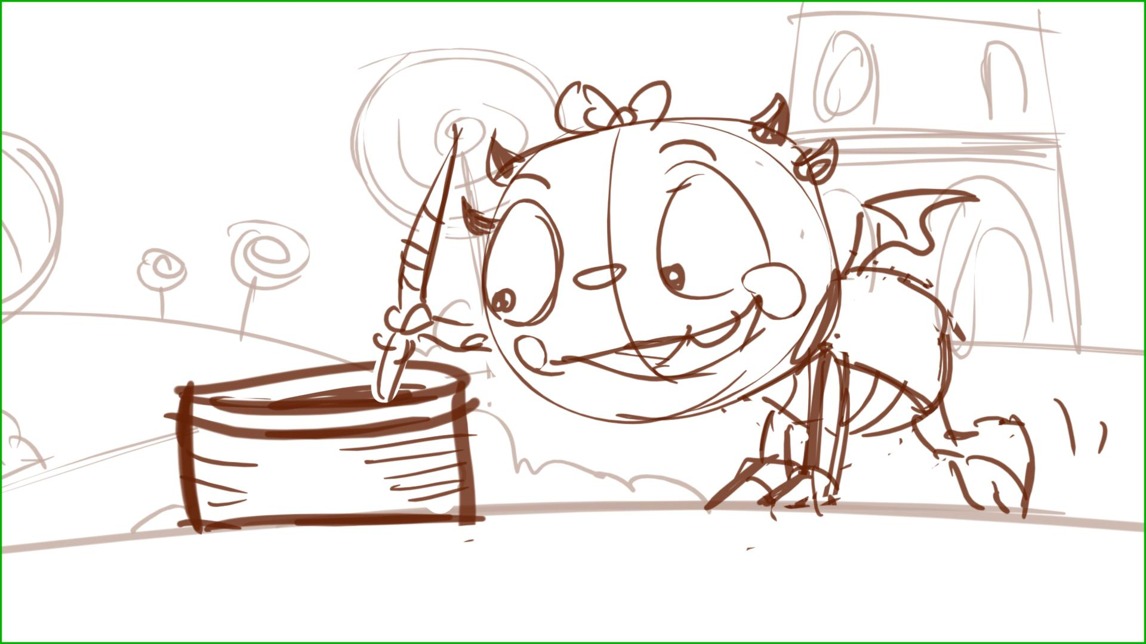

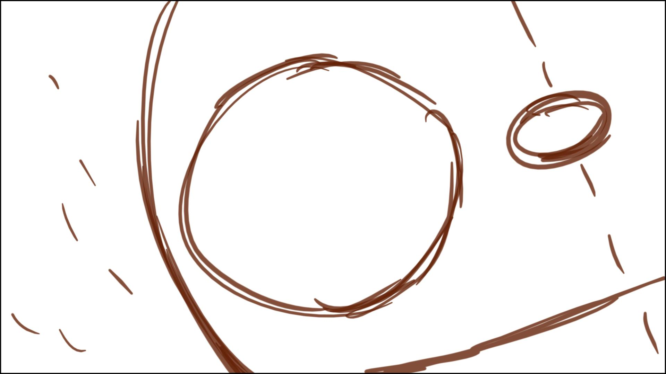

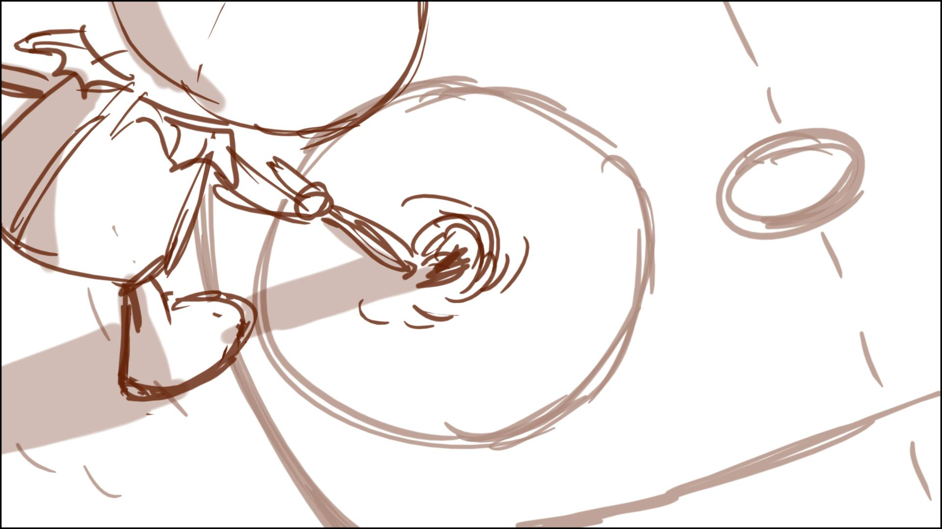

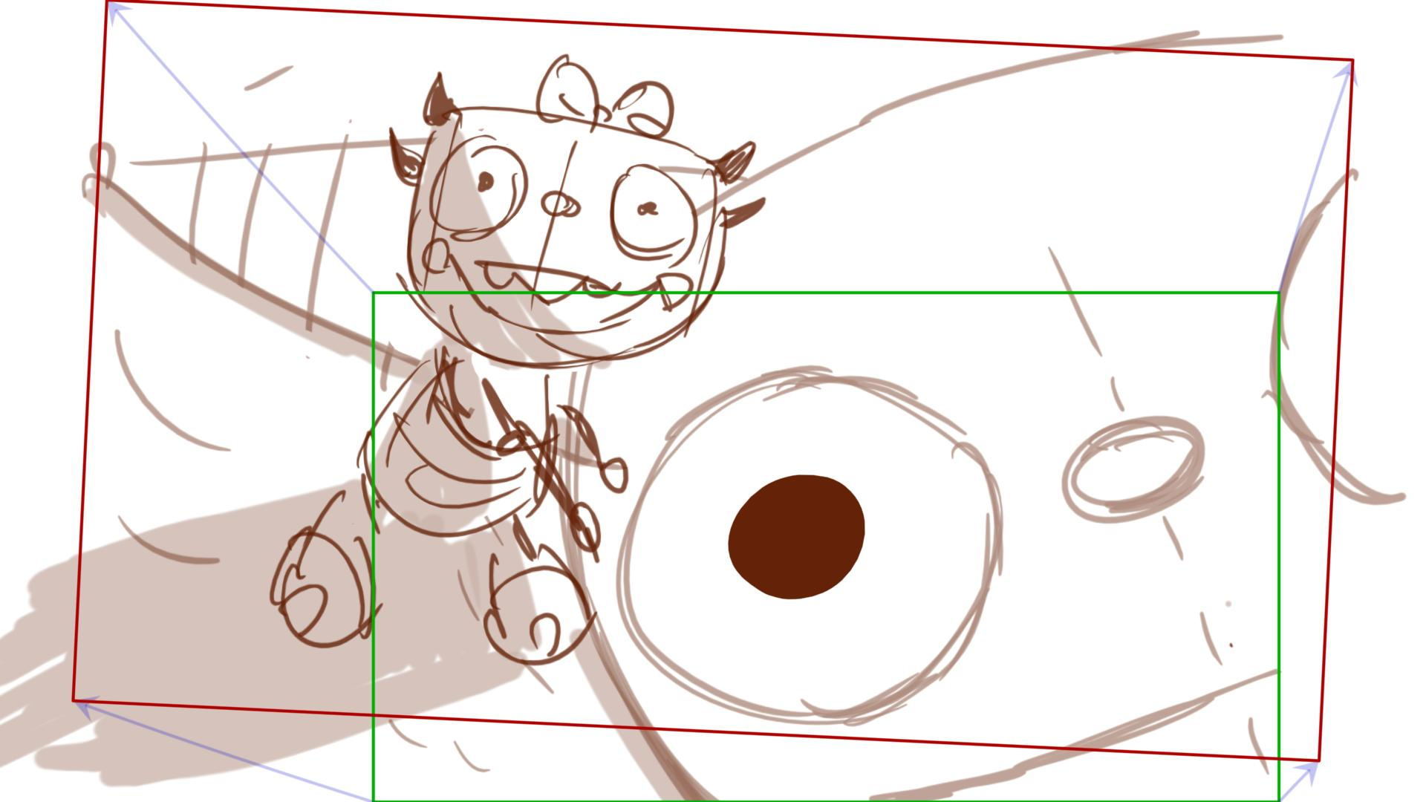

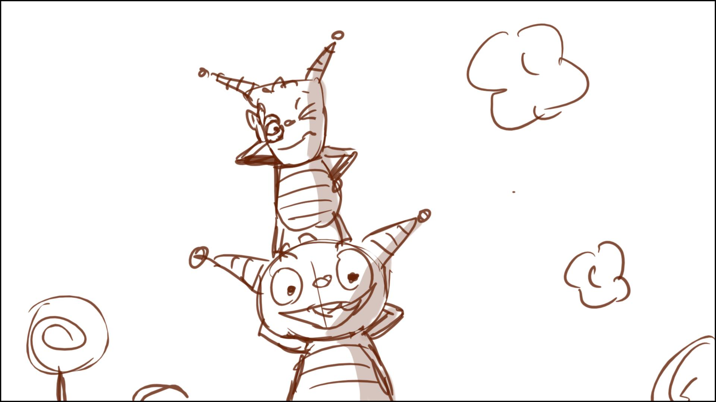

We start from a closer view of the pump, pan to right to see the kids ins. - below

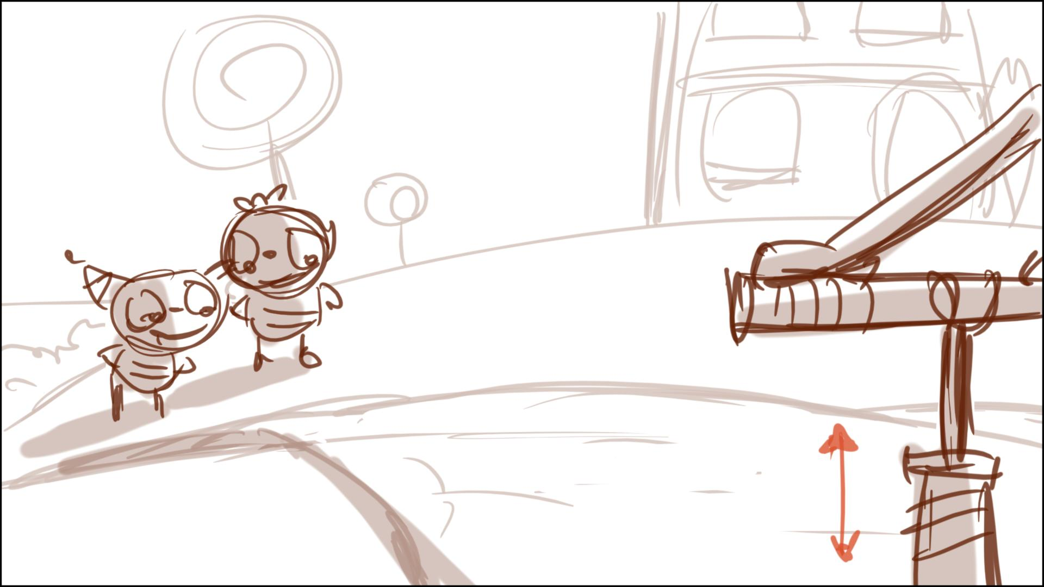

… and finally the EHenry’s head pop up….

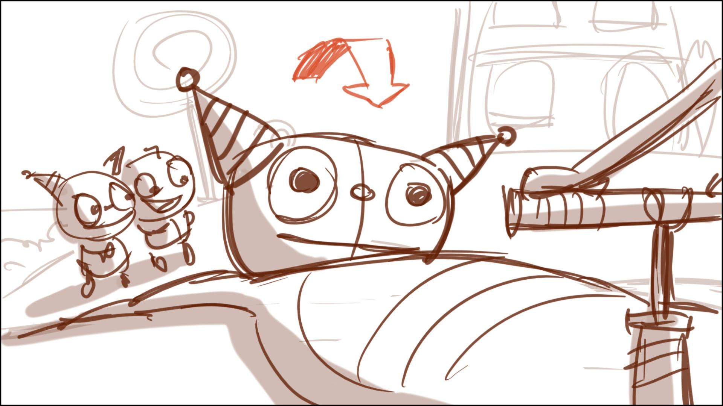

46 01 – Let’s have Henry deliver this whole speech as he climbs up the side of the enormo Henry…avoid pinching the material…use cuts to speed this up – but include aside to camera “ok maybe it is!”, perhaps as Henry reaches the shoulder of the balloon-figure. (Don’t want him to fly up!) Can the balloon-Henry be still sitting (in L shape) when Henry climbs up, Norton? It will make easier for him without flying, and visually more interesting – horizontal pan on legs, then more vertical, but shor.

52 – Estelle walks a circle around H, looking at him ap/down as she says: “You’ve grown….”

EDIT – 55 01 and 55 02 should be the same scene with a pull back!

Around 67 – add a quick visual gag: Henry brings muffin to his mouth, the Balloon does the same – Henry can’ reach the muffin – below:

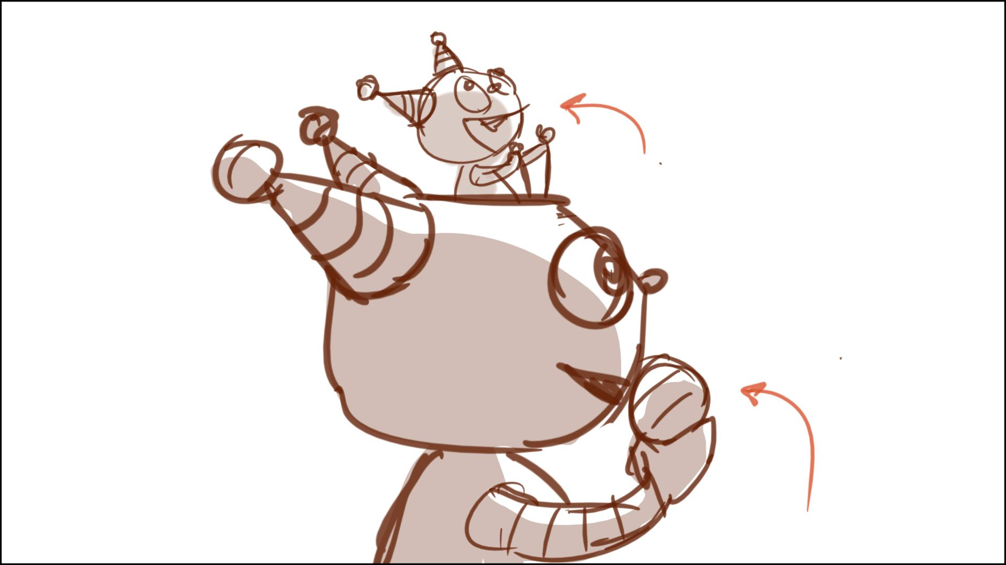

…so in order to get the muffin, Henry has to bring his arm up to his forehead – below. He holds the ropes all the time

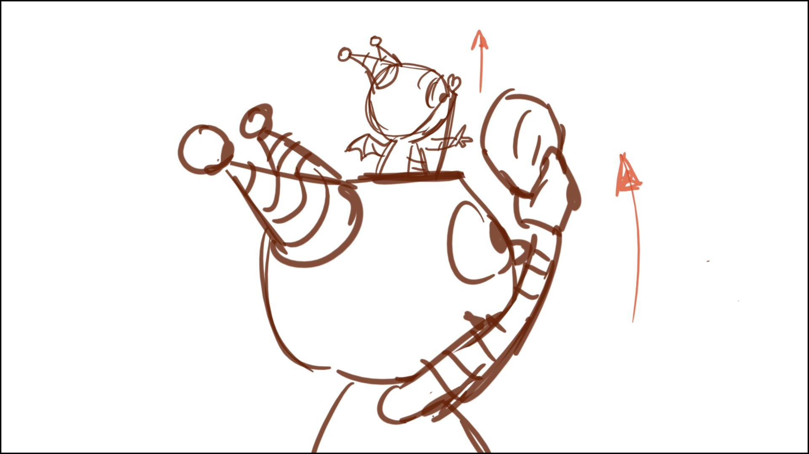

Then we can go to 67-68 gag – muffin slips up (as is)

69 – this should be wide, so we can see Henry’s suit. The Dad could be looking at the face on the suit at first, then notices the real Henry after “sorta!” Please draw the food item to look like a muffin. The muffin wouldn’t get crushed, instead the real Henry should reach out take a bite of the muffin without using his hands.

71 – Henry would not be holding the muffin with this hand, he needs to be holding the ropes.

84 – EDIT – WIPE to this. Let’s not pan down from the structure on top. Instead let’s start wide with drift out. Please put the panels from 84 01 into this framing, thanks.

89 – we need to see the top of the balloon’s head

97 through 100 – Reboard so this is clear. Kid is in the road. Henry coming up behind.

At the last second Henry manages to JUMP – so he goes right over Milo. Close on Milo: “Henry?”

101 through 116 – to be re-drawn.

101 – Redraw without an intersection. Higgins should be riding along, not eating a sandwich - sees Henry and says: “Slow down, now, Henry – “ Double take. “Henry?!!” Cut to real Henry – HELP!! Cut to Higgins: “Don’t worry, young fella – I’m comin’!”

104 –105 Please try to stage this using a more rounded hill. No road, he’s on the grass.

106 – Please play this with an angle to show that Enormo H is way too big for Higgins to stop Henry.

109 – This would be re-drawn but Higgins is much to big, it’d be good to include Estelle?

113 – Let’s try to make this all clear. (How do you like THAT for a note?) Suggest we have Henry hit a lollipop tree not a branch – bend it, his arms and legs extending beyond – and then the tree snaps back and sends everyone flying.

119 – This shot should widen out to include Henry standing on the deflated suit in the FG for “I like you just the way you are!”

131 – This needs to be a shot of the Enormo dad trying to jam his finger into the tiny hole.

132 – Roller skates should be off. Check Estelle sizes.

138 – The hole should be much smaller. We should only see the bird’s face through it. Don’t want him to walk closer.

140 etc – New shots, Henry can put his hand into the hole. He carefully pulls his hand out, on his finger we see the bird sitting.

143 OUT – put dial on following scene.

143 02 – serious up angle past Henry to see Enormo-dad instead. Not clear what Henry saved the monster bird from…

144 - Let’s rethink ending song – Something that shows the sizes of the characters in a happy way and with a kind of group hug feeling. Maybe Enormo-dad picks Henry up in his hand, Mom picks up Estelle (sitting on her crooked arm?) They all enjoy H’s song then hug?