HUGGSGIVING DIRECTOR’S NOTES FOR FINAL ANIMATION 26.11.12
General notes (for Norton/Shane):
Quite many problems that should have been solved at blocking, I don’t know if I should point them out at this stage or let them go. Eye contact is mostly off. Camera is totally dead, and I gave up on some cam adjustments because it’s too many of them. Lip sync is too often off to some extent, I don’t know when to ask for a fix, and when to just ignore it. Frame count/scene numbering appear wrong sometimes – hard to refer
Notes by shots:
1A – Please adjust framing up by 20 - 25% when Henry pops up from behind the box. Please delay H’s appearance from behind the box by 7 frames. Make Henry flitter over the box, not standing in the air, adjust cam constantly to keep him in shot as he flitters/talks. Make H look to camera on “this is I“. Use ref. image below.
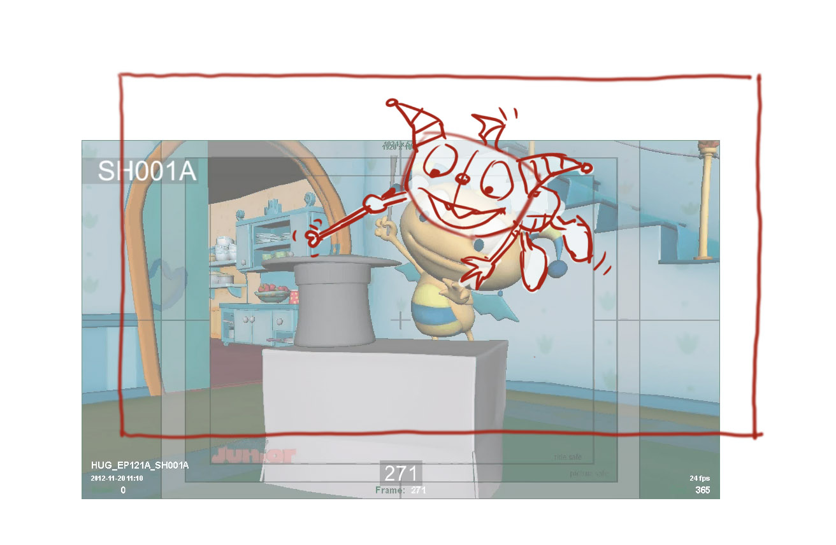
Starting from frame 190 keep H in vertical position, but keep him flitter, and higher in shot - Use ref. image below.

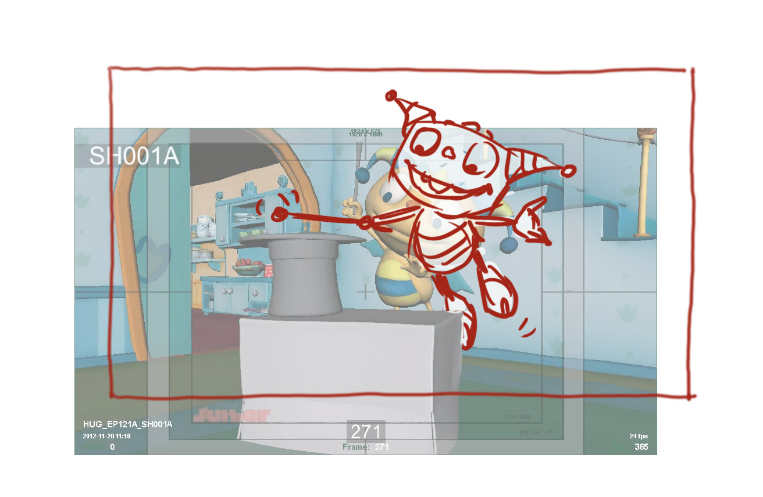
Pose between frames 274-297 doesn’t work. Keep H with his eyes opened, like at frame 272. Keep H flitter to the end of scene.
2 – Adjust start cam position screen right by 25%, and pan with action when Beckett pops out of the box - use ref. image below. Start scene without H, make him fly in shot from behind the box starting from frame 1 or 2.

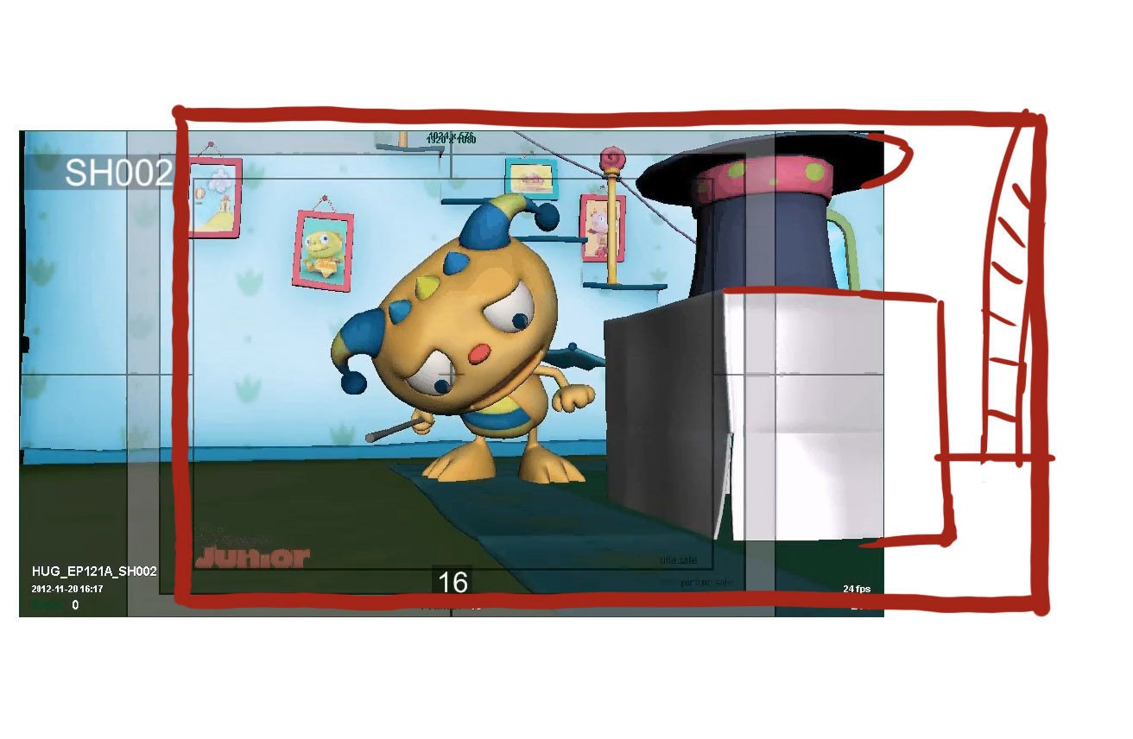
Starting from frame 28 and on position Henry and Becket in a more readable angle – a flat silhouette. Henry’s face is still turned ¾ to cam, but his eyes look at Beckett - use ref. image below
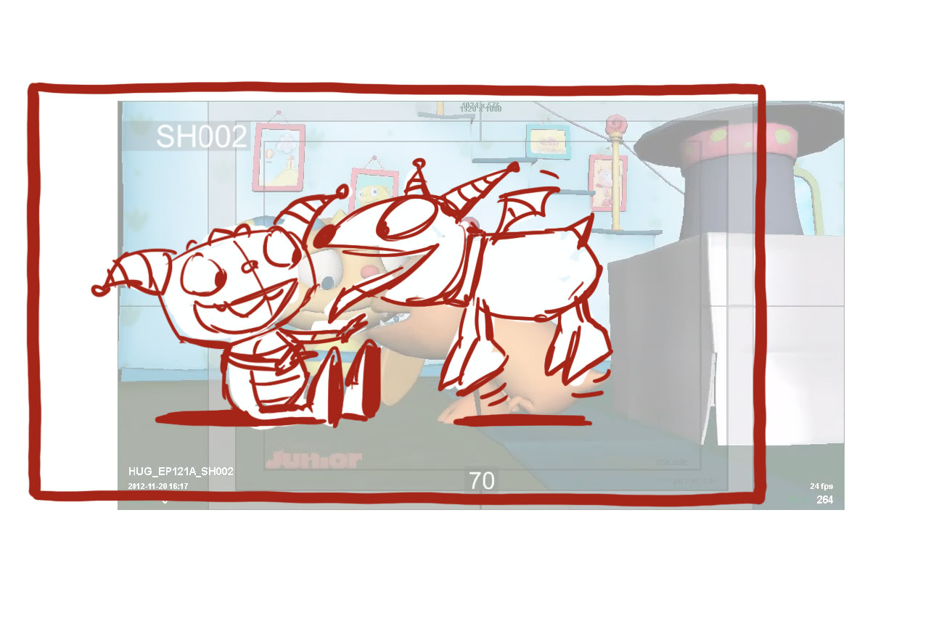
Daddo – Starting from frame 158 please make Daddo step on each step naturally, without jumping or leg twisting – refer to BBF walk samples. Momma – make her hands more like in the ref. image below – with the palms facing the floor
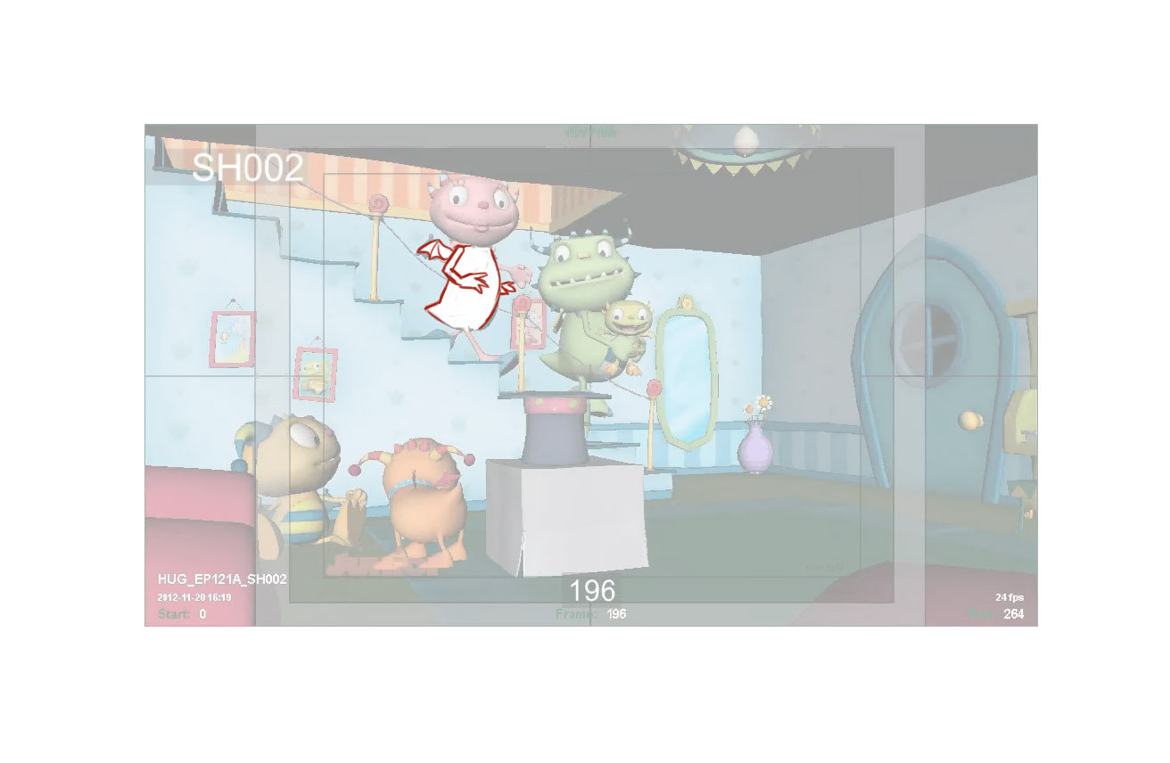
At frame 268 start pan with action screen right, and finish at frame 285 – use ref. image below.
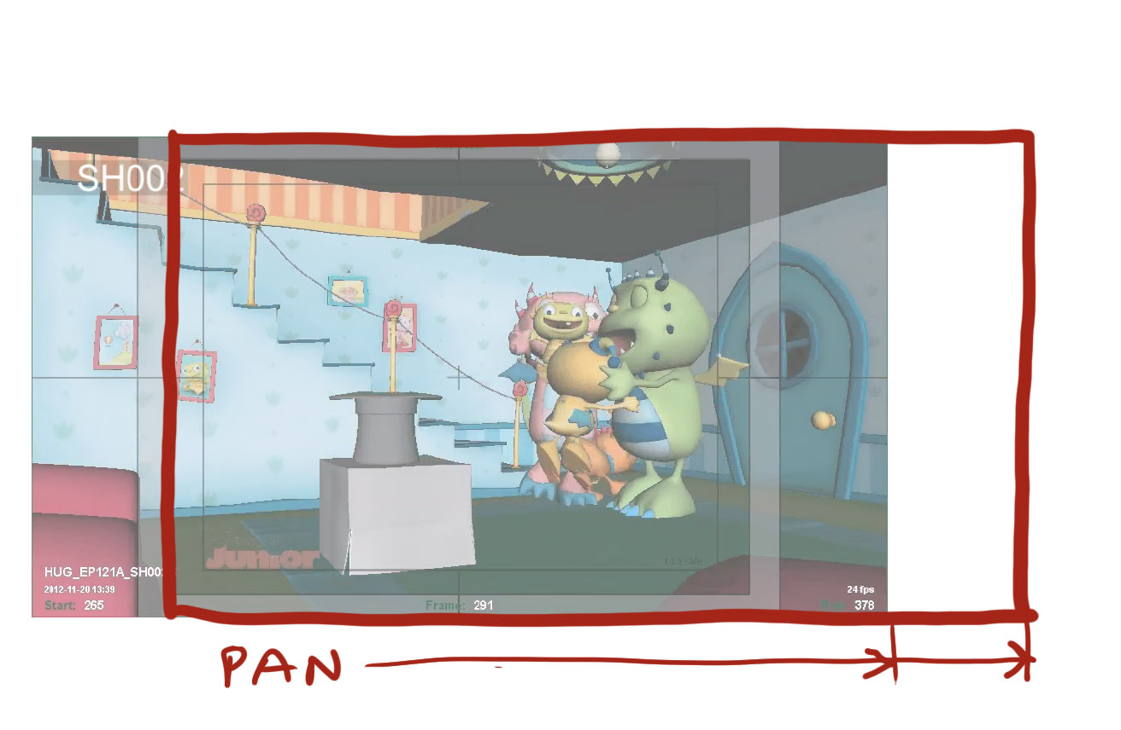
Frames 292 – 324 – make the hug more expressive, have all 3 characters hug tighter and closer like in ref. image below. Ivor’s head can be visible between Daddo and Momma. Make Beckett run OS by shot 314 (as is now) but don’t bring him back in shot (frame 317, and on), leave him OS.
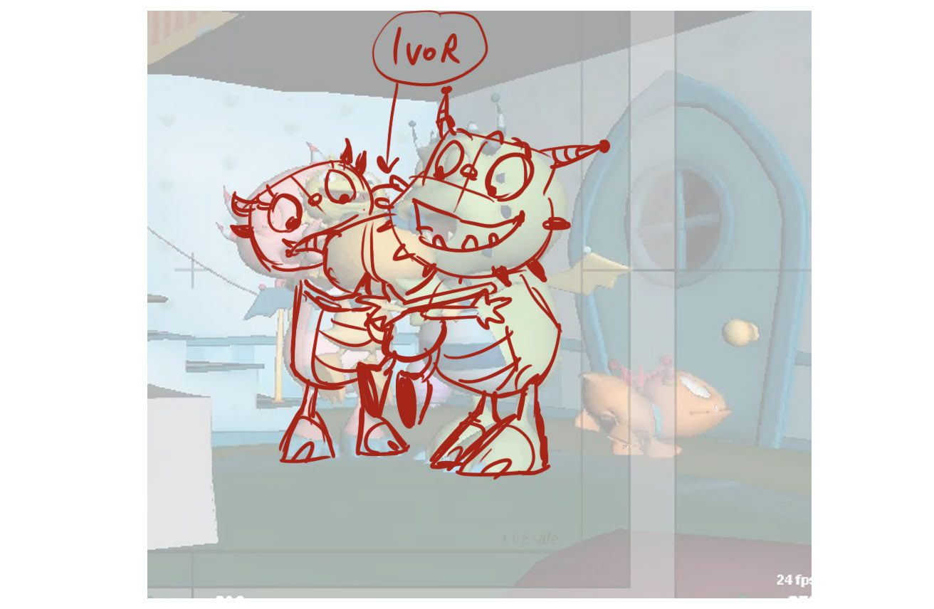
Start pan with action screen left at frame 340
3 – Start H’s start pose further away from cam, in a still (not walking position) – use ref. image below. H starts to walk to cam at frame 4.
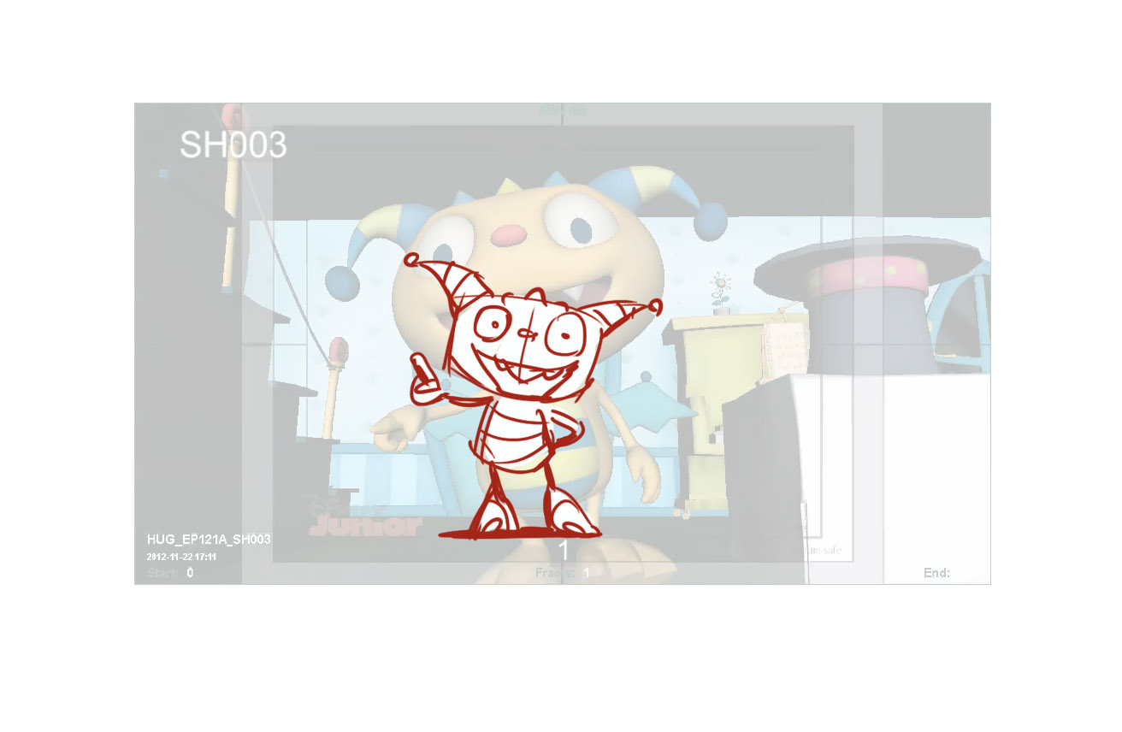
Make the truck out slower, to finish it at frame 110 ( not 83 as it is now). Make H look to cam – use ref. image below
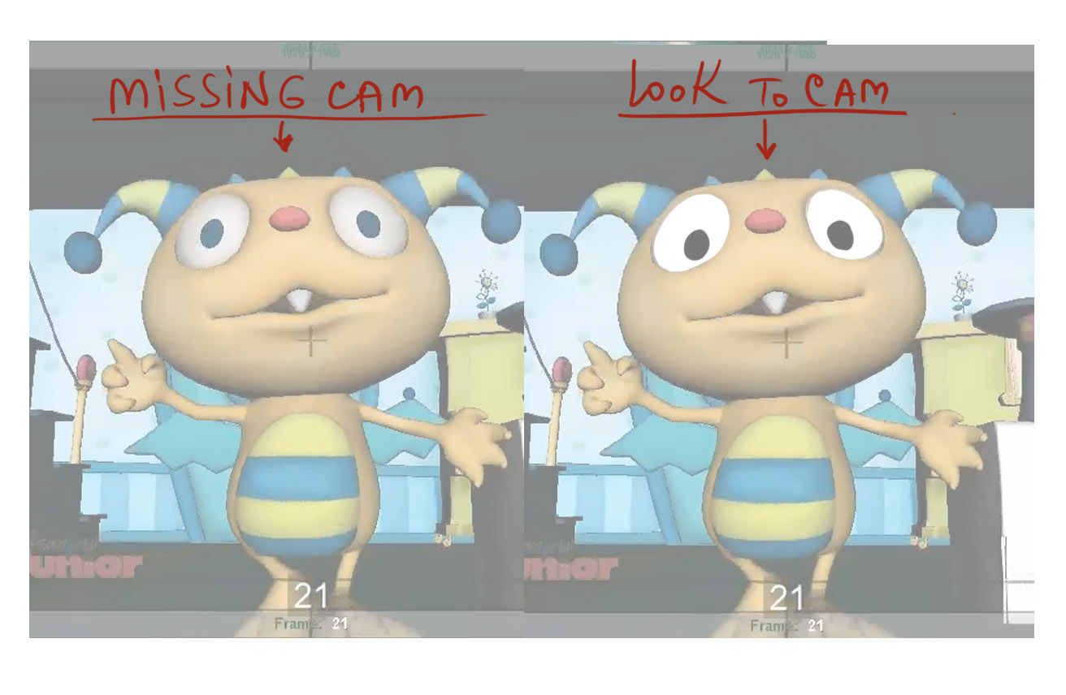
Henry’s poses for ‘Roarsome day’ and ‘ever!’ he seems a bit dull, please make it more expressive, use ref. image below.
Also Henry needs to anticipate to HU to his move in the next scene - make H turn his head to his right at frame 117
4 – Start H’s first pose like at frame 3, facing cam, keep him in this pose till frame 28, them make him quickly fly. Spread Daddo/Momma apart in their start pose to give more space to Henry. Make pan screen right happen sooner, with H’s action, not after it. Make Henry say “….family gets together” to cam.
Here Henry does a chomping eating sound, have him chomp down on a piece of whatever he takes from the bowl.
Also when Henry sucks the straw his up body and head should move tilt up back as he sucks to exaggerate the action, he seems a bit still here.
When Henry fly’s through the archway he looks robotic, please offset his limbs and add some overlapping action to loosen up his flying so it feels more fluid and less robotic.
6 – Move the box in FG screen left by 50%, but keep the hat on the same spot, so the box would not block Summer, and be still readable as magic box. Add 8 frames to a hold after H says “…day”
Here Henry is very rigid and stiff, please loosen his limbs and body up with overlapping action and offset.
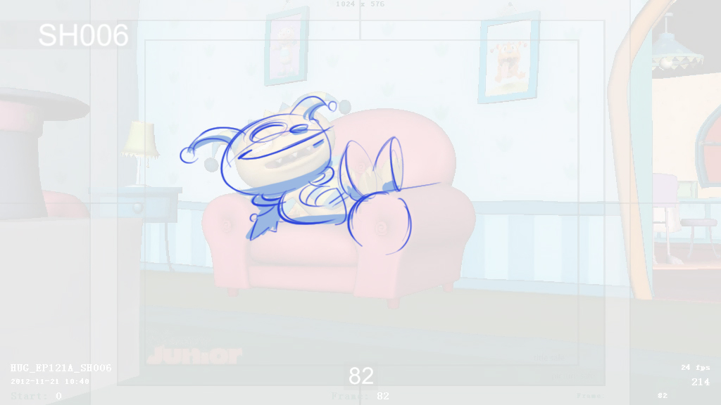
His relaxing pose looks odd, better have both hand behind his head to make it more obvious and cliché relaxing. Also bend his body so it moulds to the seat so he looks relaxed and not stiff.
7 - Move the box in FG screen left by 40%. Frames 97- 241 – keep H/S screen right by 35% for better composition. Frames 163 – 185 – make H look at Summer, not past her. Frames 136-228 – make Summer look at H, not past him. Adjust cam when Beckett comes in shot – use ref. image below
Ok so this animation needs allot of work, we need to see them anticipate hug then both anticipate together while hugging and hop around in a circle not spin around sliding around magically they need to hop around. Also the framing need to have Henry and Summer centred more when they do their hug spin.

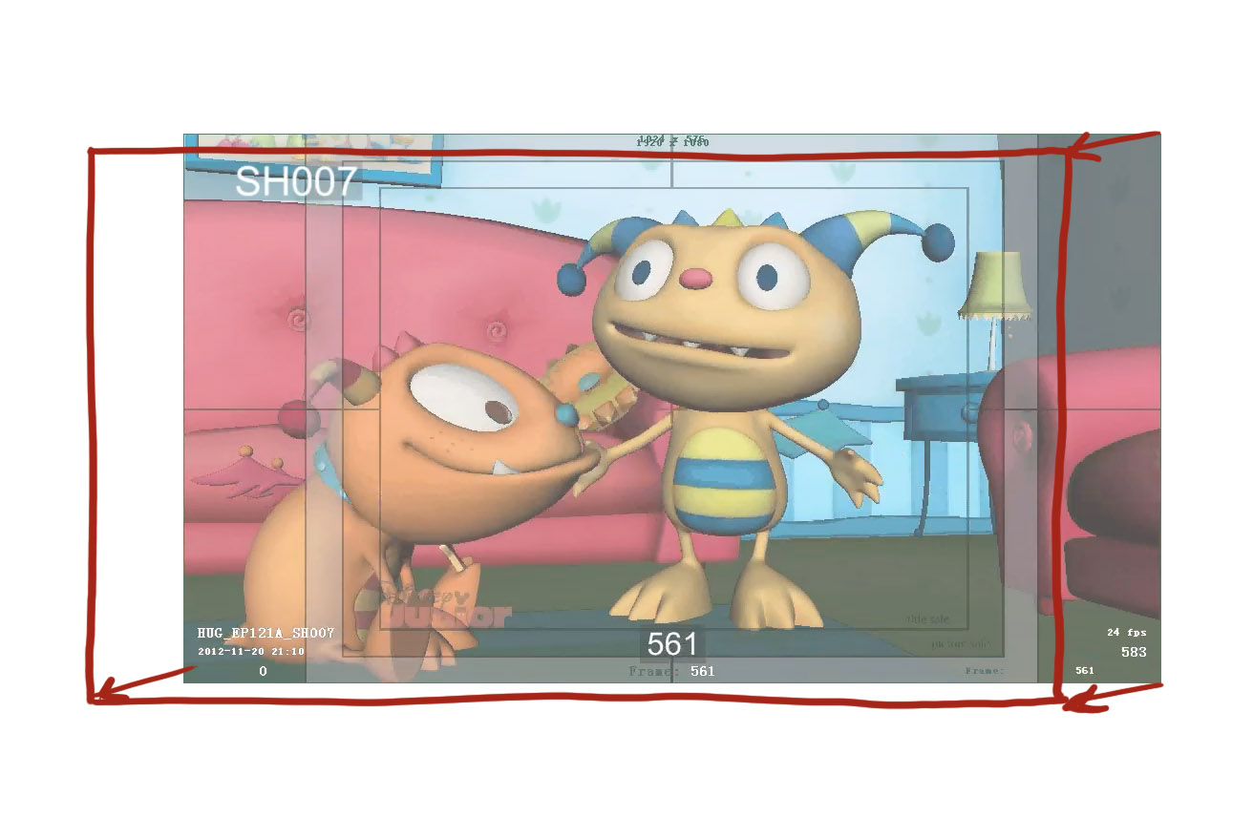
Summer says “can we wrap up on the hugging” still in the hug with Henry, and on “…hugging” she slightly pushes H away.
12 – adjust cam up by 15%
Hold his pose at frame 38 till the end, taking out the head shake, it’s a bit jarring.
13 – Have Robot in the center of frame in the start pose, then pan right with action when Cobby pops out from robot’s back. Frames 165 to about 196 – separate the actions: allow Cobby to turn the switch first, only then make Robot speak. Move Cobby more screen right (for this action) to have a clear view of the switch (it’s blocked now by robot’s palm)
Cobby’s motion is a bit jerky just before the robot walks forwards please smooth this out.
14 – Make Robot’s hands higher/readable (not blocked by the wings) – use ref. image below.
Would be better for Henry to look with his pupils at the Hugglebot for ‘Roarsome!’
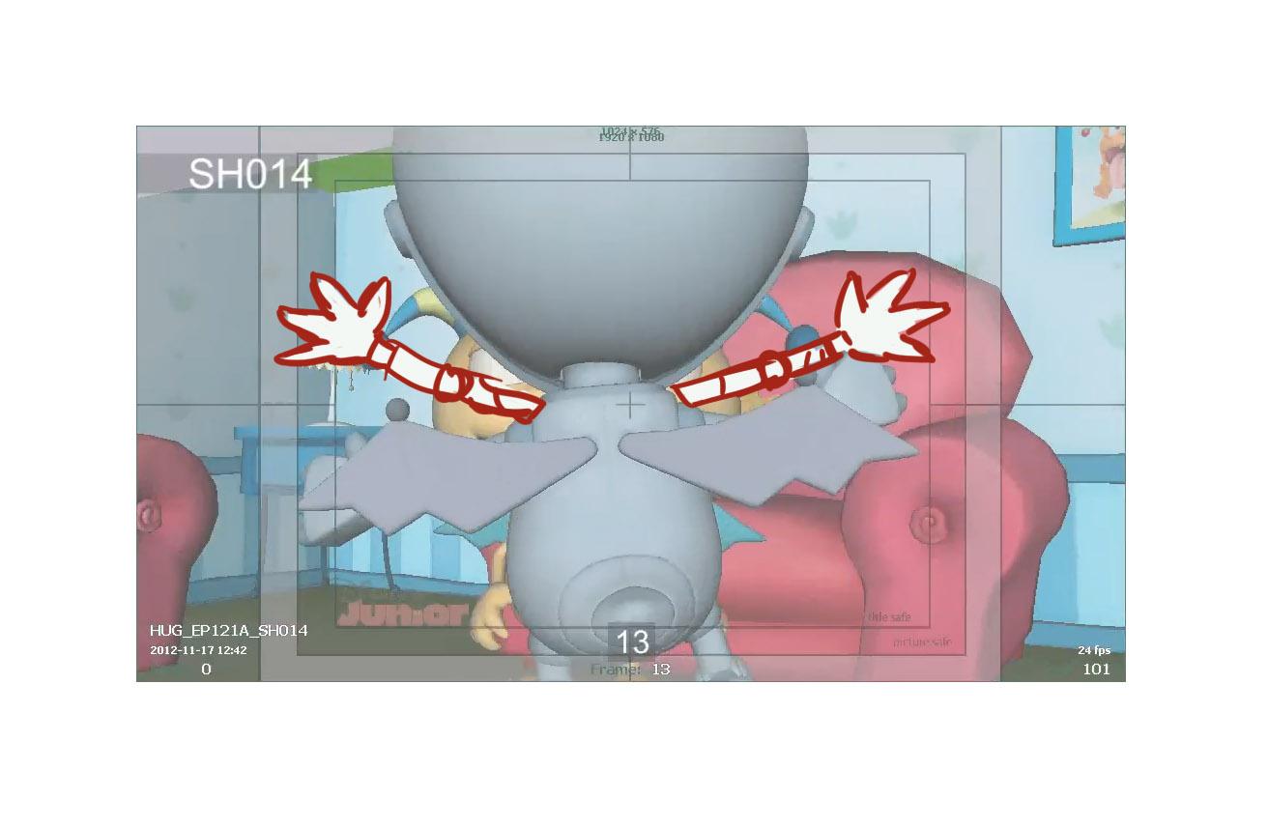
Frames 65 and on – Henry’s palms are sliding up and down on Robot’s back, please keep H’s palms firmly on Robot’s sides/back
15 – Frames 40 to about 55: keep Henry’s/Robot’s hands wide spread, like they just finished hugging. Then they lower their hands. Frames 121-135 – keep H’s right hand position more like in ref. image below. As Momma stops in the doorway, have her stop (and stand) screen right by 30-40%, so Henry would not block her hands when she gestures.
This is some nice acting from Henry, let’s say say it
15 (again? Scene needs a new number) – frames 16 – 67: please make Henry look at Momma, not at the wall.
15 (again? Scene needs a new number) – a close up on Momma – frames 201- 2012: keep Momma’s pupils on Henry.
15 (again? Scene needs a new number) – frames 127-133: make H’s hand more like in ref. image below
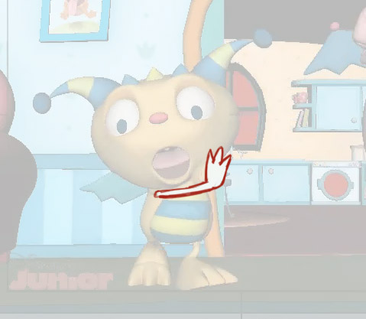
16 – delay Henry’s/Momma’s walking in frame by 30-40% (start scene without them in shot) to have a clear view on the guests, saying “Happy huggsgiving day”
Cobby’s move when opening the door has strange flapping feet, please animate him running across in some way but making sure his body mechanics work so his feet relate to his body motions and aren’t acting independently.
Let’s have Uncle Dexter anticipate before the end to HU into his motion in the next scene.
Mommas walk up jerky at the start smooth out this jerky motion.
Summers hands looks frozen in mid-air, loosen them up a bit.
Add some eye darts to all 3 characters at the door as they look at Momma, Summer, Henry inside.
17 – frames 167 – 205: please make good eye contact, make the adults look at Henry, use ref. image below.
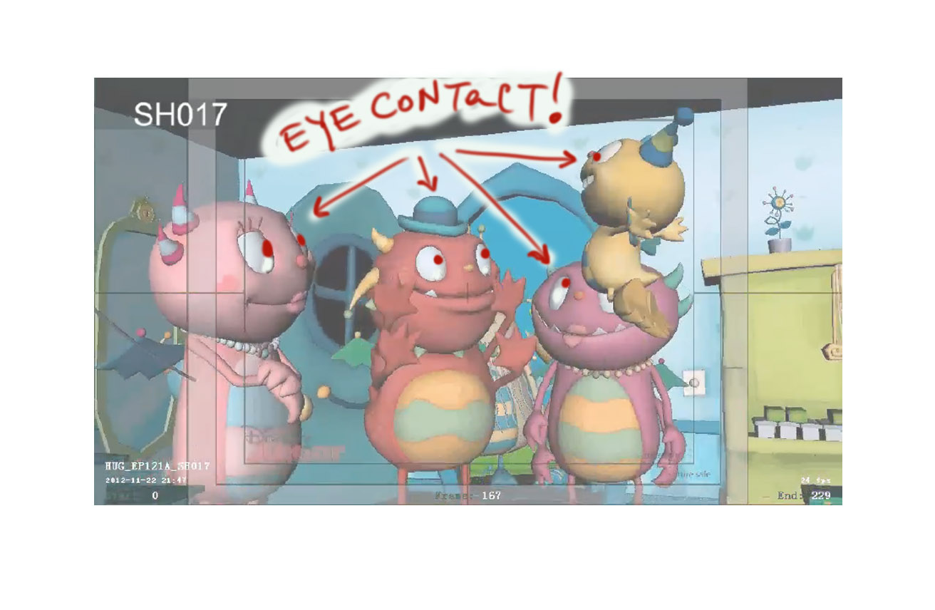
Please re-animate the “hi four”. Make Henry jump up with his arms/legs folded – see ref. image below.
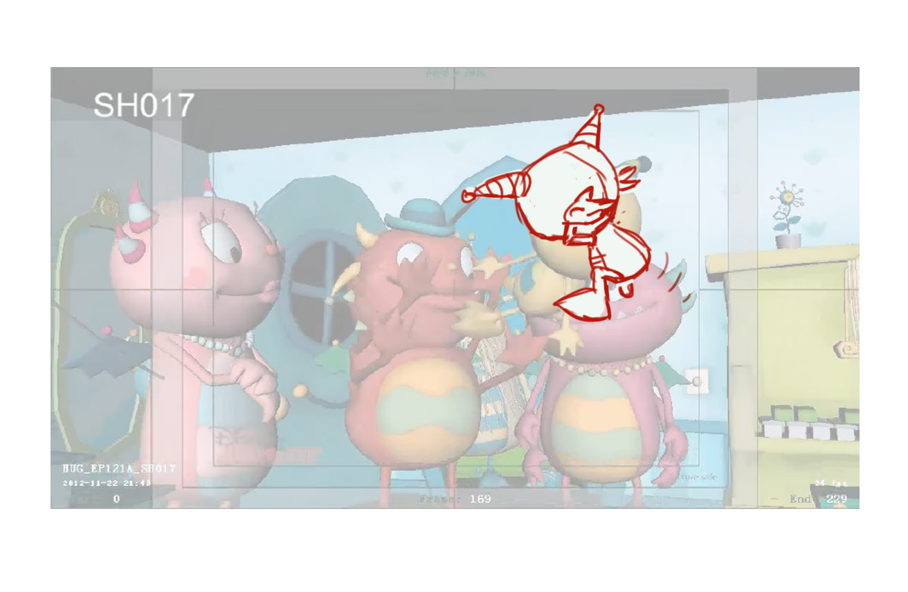
Then make Henry clap his palms only – see ref. image below
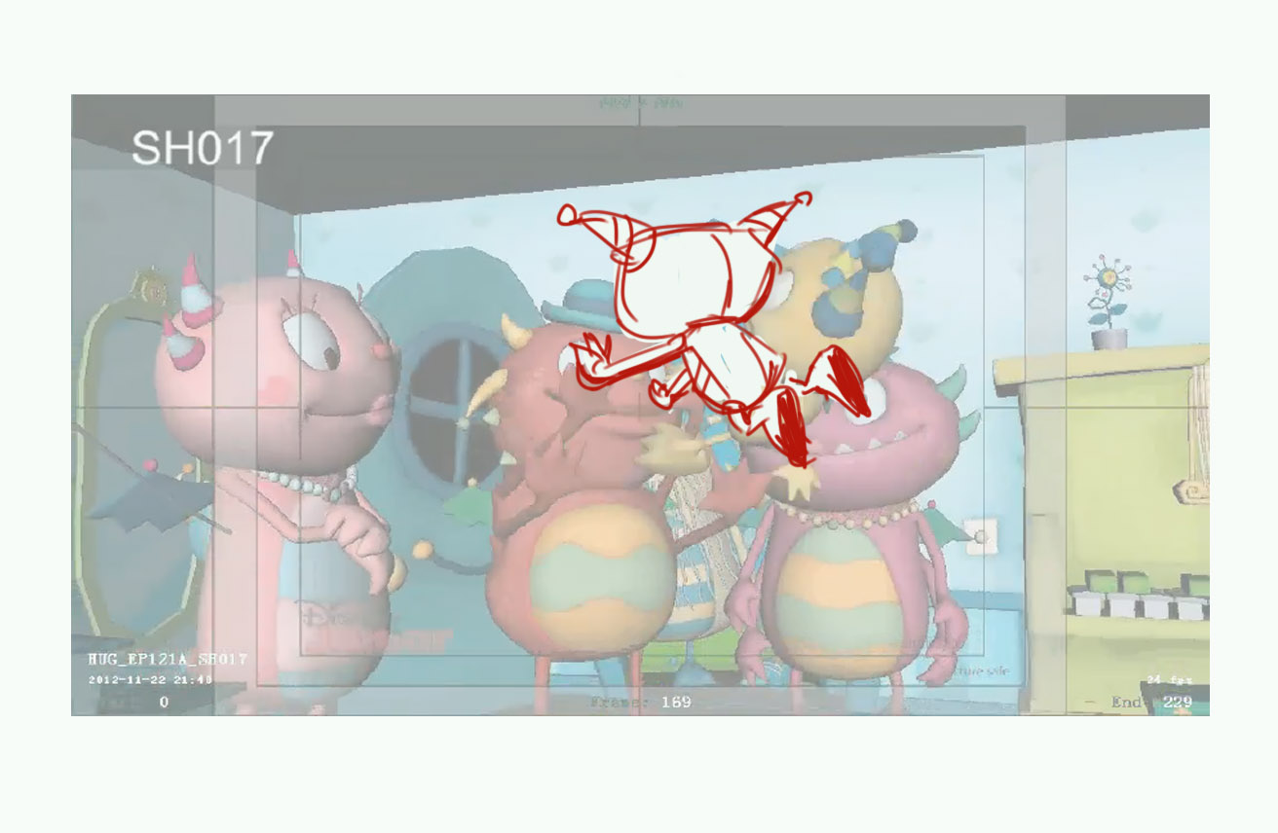
…then he bounces back a little – see ref. image below
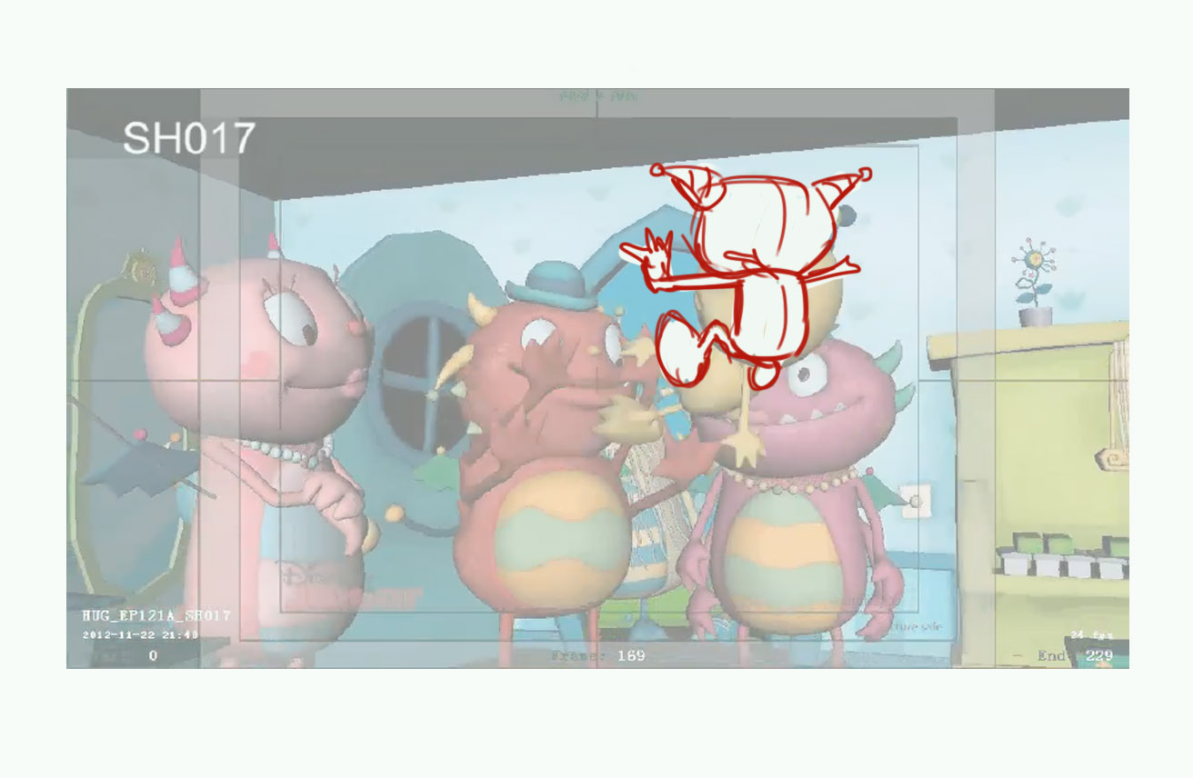
…then Henry claps his feet – see ref. image below
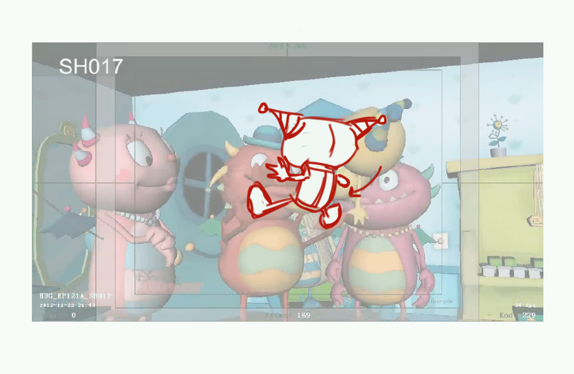
…then Henry bounces back up in the air again, and lands from this position – see ref. image below.
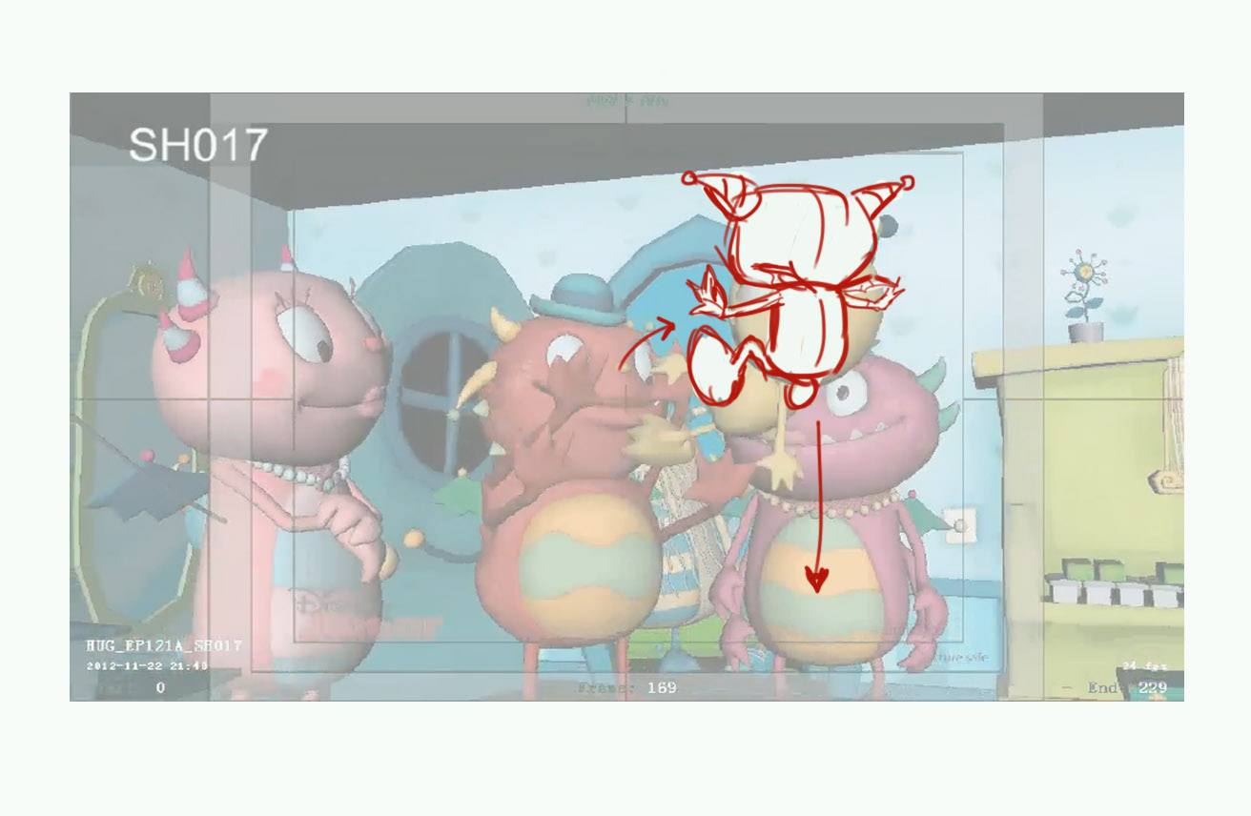
Frames 207-228: make Nanoh look at Henry here, not at far wall.
18 – make Cobby’s/Summers hugging poses more expressive, streach their hands out to the maximum. Re-position table (move it deeper in shot), so it stays off frame after camera swing.
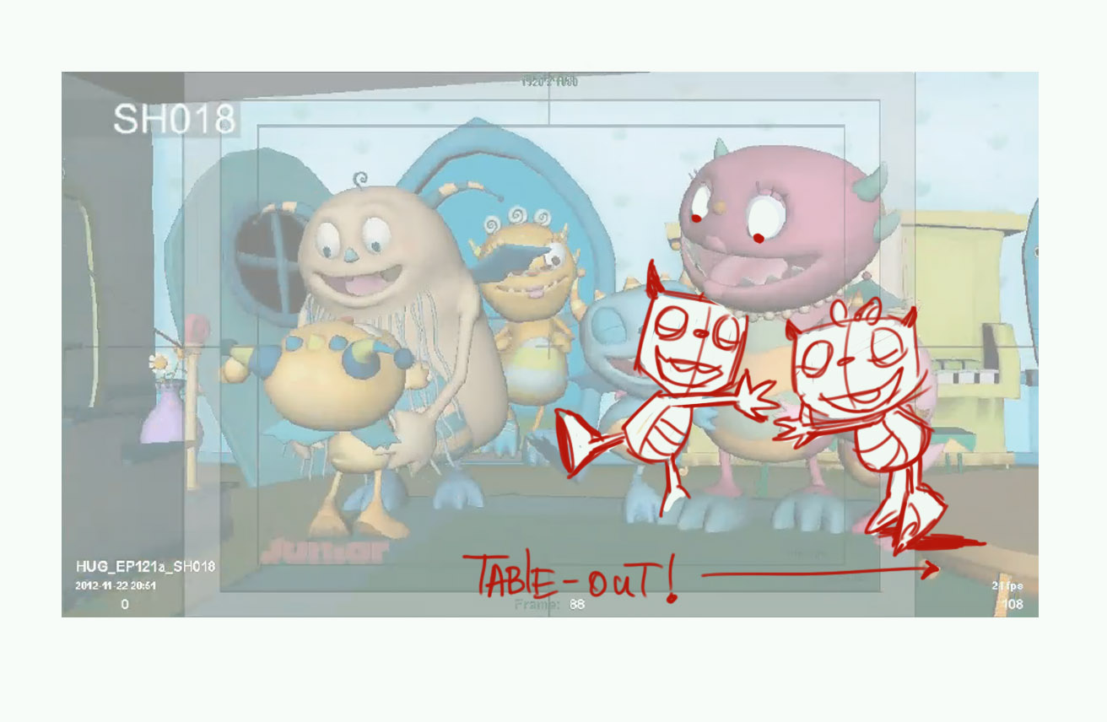
18A – frames 100 and on: please make Cobby walk away (screen right/to cam) with everybody else, leaving only Henry and Harry in shot
I think Harry needs to be more manic here, doing actions on each ‘surprise’, this is the first time we see him so we need to make him seem a bit hyper and excited. Let’s exaggerate these poses and snappy up the timing adding more poses to him.
Harry need to hug Henry tighter and closer.
19 – re-frame this scene: widen frame by 20%, adjust down by 10%. Re-position camera to a much lower angle (like from kids’ POV)
22 – This scene is not really working due to a bad cam angle. We don’t see them hug as FG chars block the view. Henry’s reaction/ running out is also not reading well for the same reason. Too late for re-staging, but maybe we can add the ending to the scene: Harry turns around after hugging Momma to see Henry gone
23 – frames 156-179: please add more rotating movements to Harry’s hands. Frames 334-358 – please add more rotating movements to Harry’s hands. Adjust camera screen right at frames 197-205 by 15%
23A – spread Henry and Harry apart a little as they stand and walk, so Henry would not block Harry
28 – keep Daddo at the same spot (where bananas are, frame 41). As cam swings adjust it screen right to give more space to Daddo. Extend scene to include “…my famous mashed…” in this scene, and cut to next scene when Daddo bends to pick up the huggletato bowl. Remove the huggletato bowl from the table in the beginning of the scene, move more food there instead. Use ref. image below
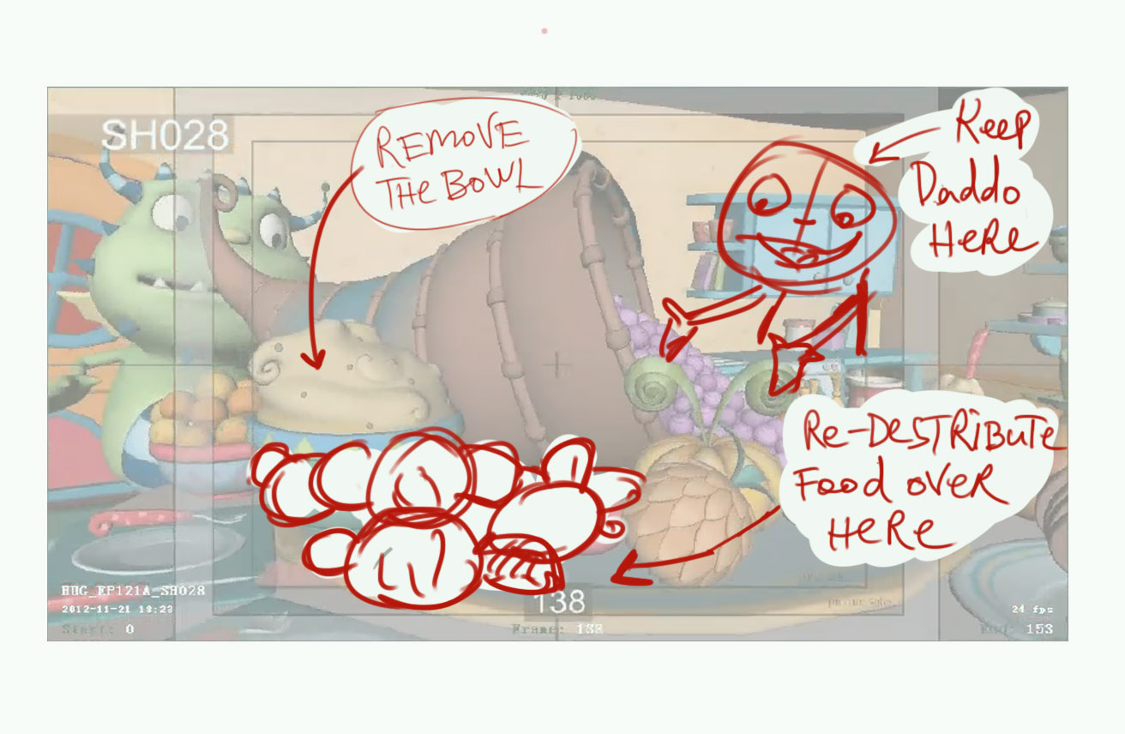
29 – start this scene from frame 29
30 – please make the monsters quickly walk to the table from around frame 40 to the end of scene
31B – dollish look on Harry’s face, please make him look at Henry, not at the wall
33 – frames 39-70: please make Cobby look at Henry, turn his head more if needed. Frames 86-105: keep Henry’s eyes on Harry, don’t make him look up.
39 – frames 149-175: separate the actions, have Henry put the plate on the table first, then have Harry rise his foot up. Have Henry look at Harry as Harry rises his foot. The BG chars (Summer/Cobby) must look down at their plates, smiling happily.
40 – have Henry stay still, looking at Harry, no head sways please
41 – make Harry stand on one hand for “…can you do this” (frames 9-21), use ref. image below
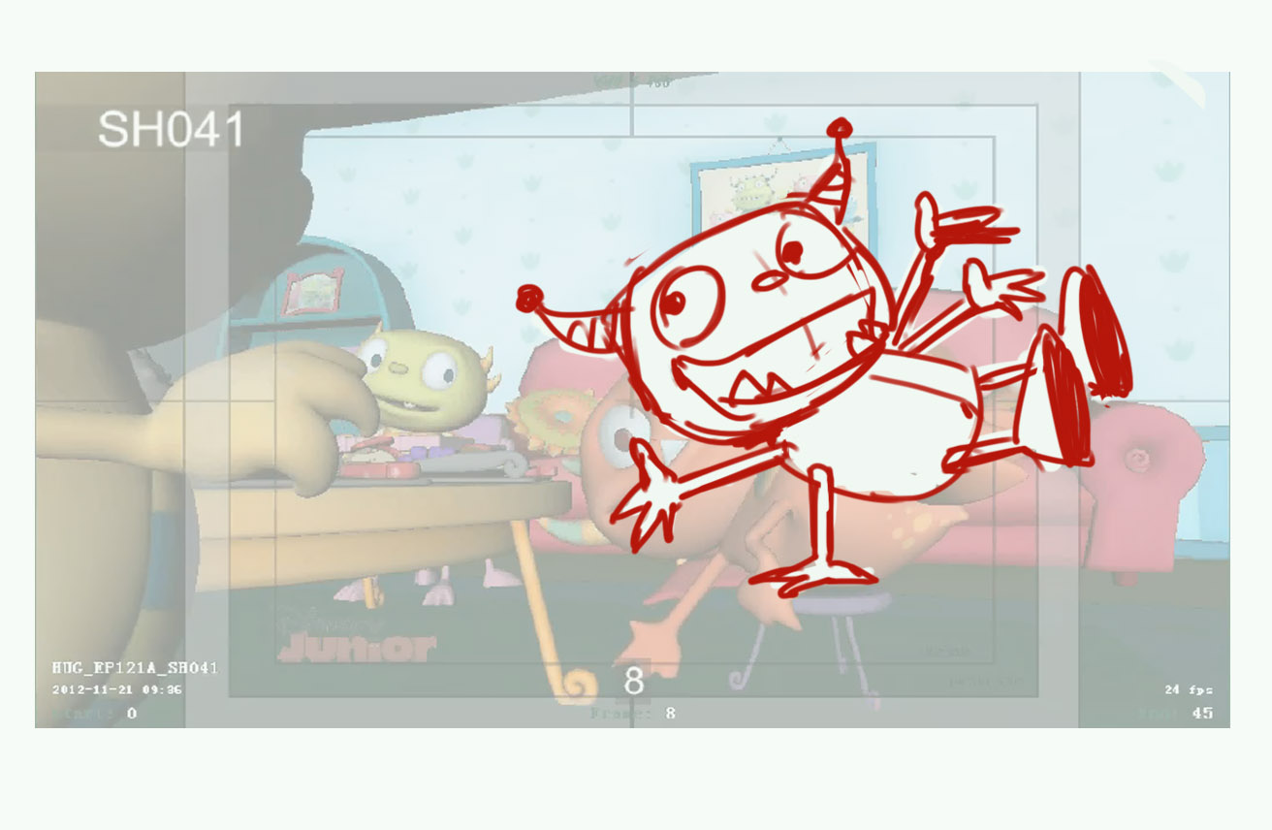
make Harry stand on one hand for the second “…can you do this” (frames 26-45), pan up if needed, use ref. image below
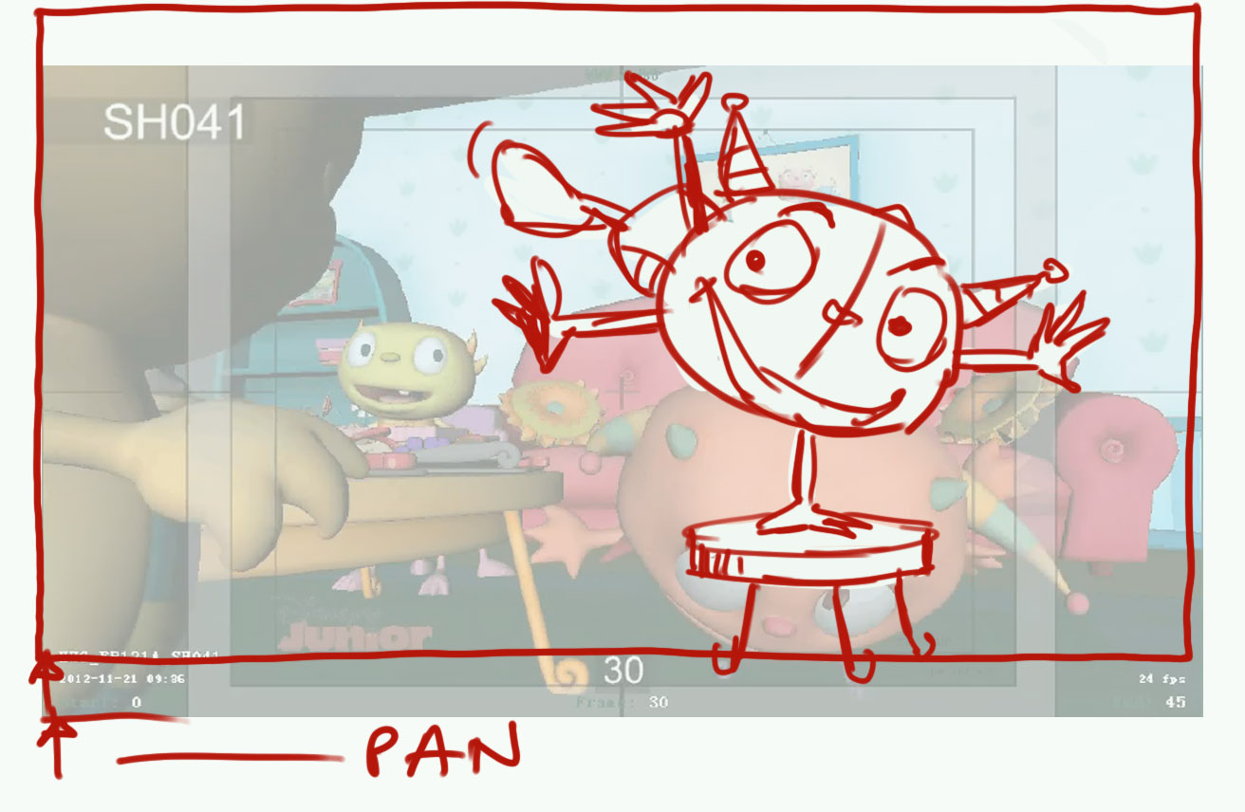
42 – Summer should not look at camera, make her chew her food with closed eyes, smiling
43 – move the bowl in FG screen left to unblock Summer’s plate – we need to see what is “so yummy”
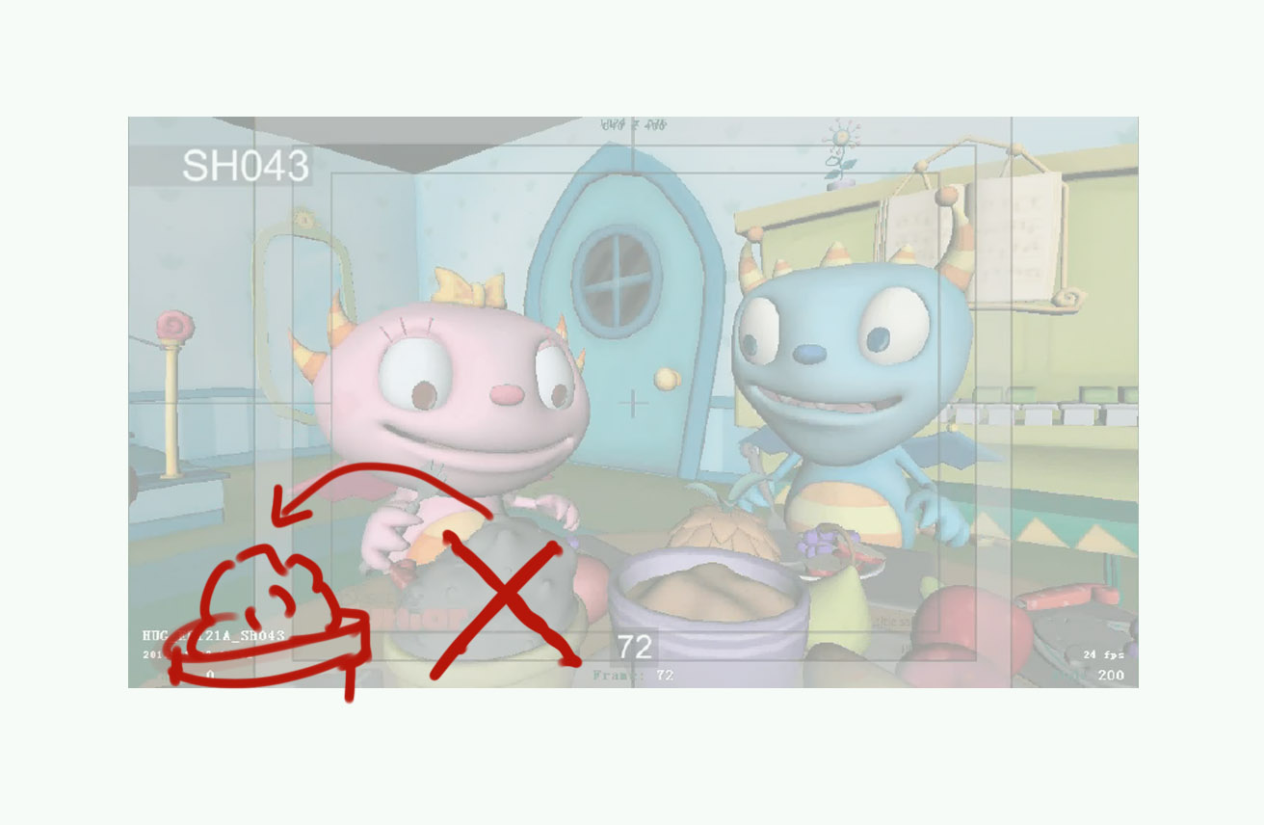
frame 98: jerky cam move in the opposite direction to the pan. Make Cobby point/lean as he says “please pass the pickleberries?”. Make Summer turn her head too – use ref. image below.
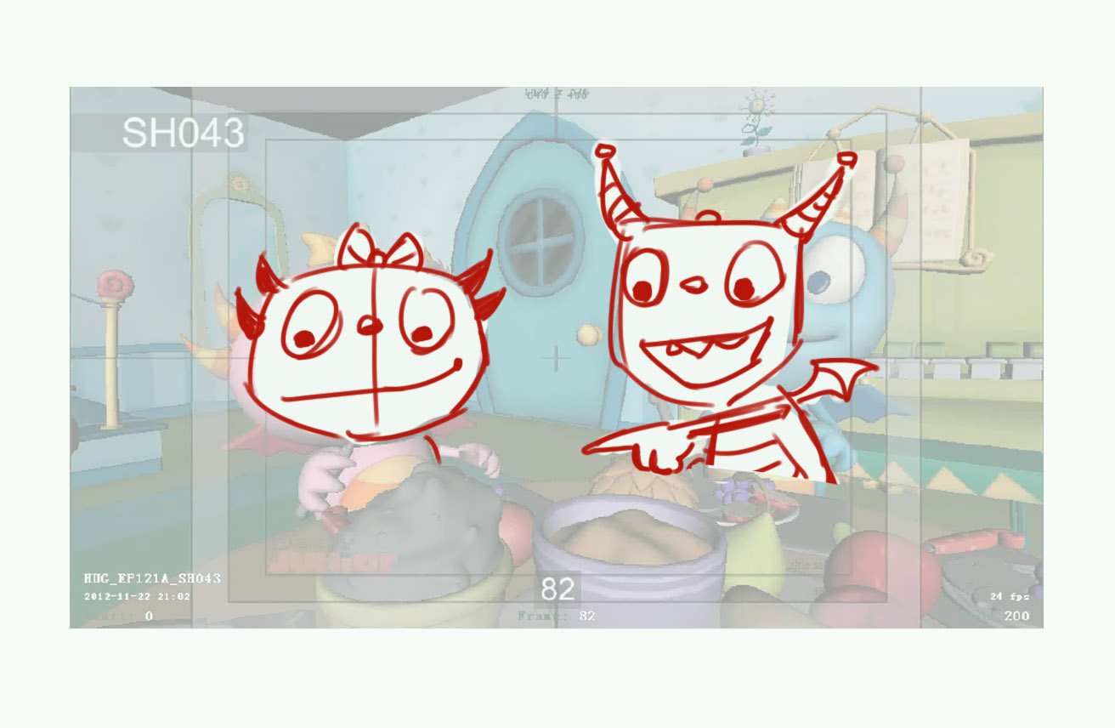
After pan – the food bowl must be on H’s left, not to block his face – use ref. image below.
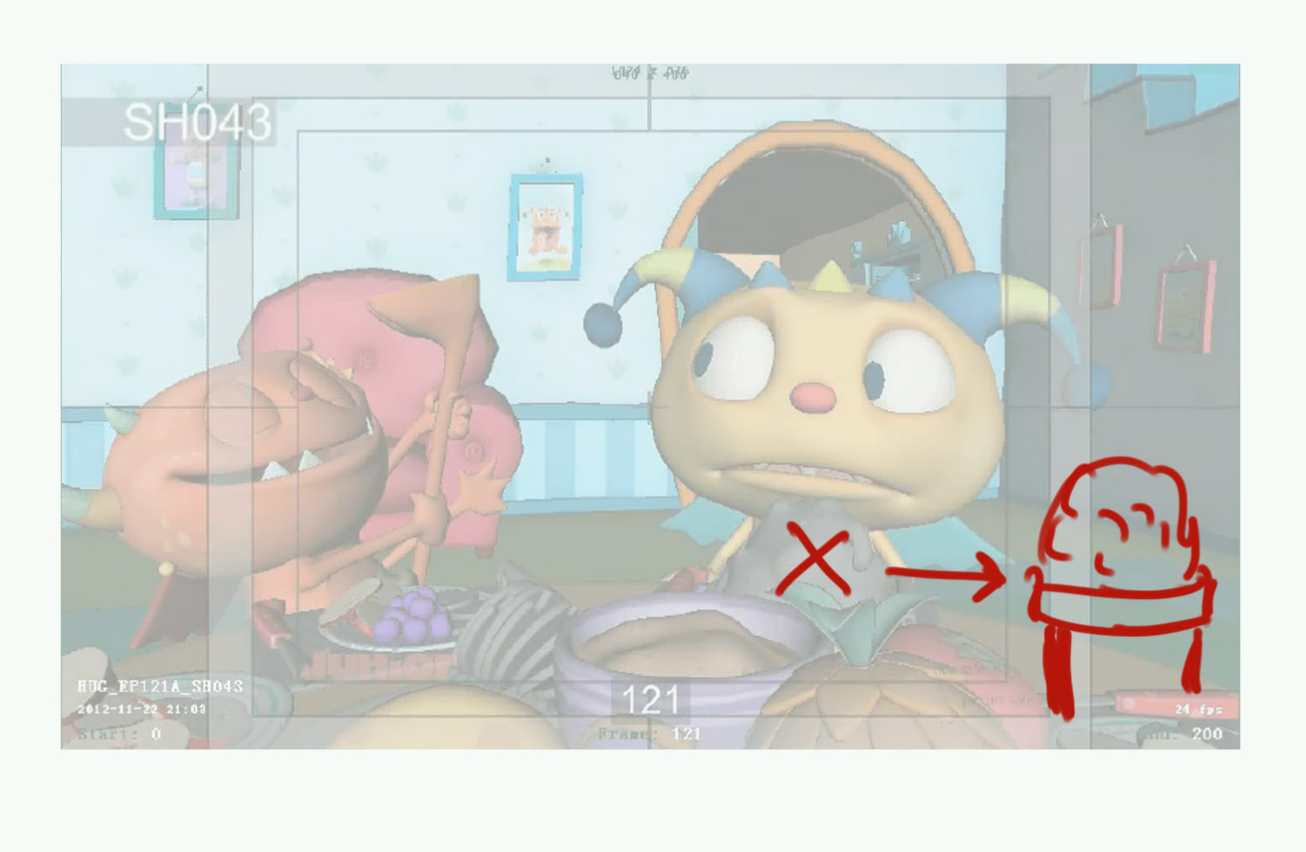
Make Harry more intrusive to motivate Henry for seat switching game, make him poke his foot into Henry’s face – see ref. image below
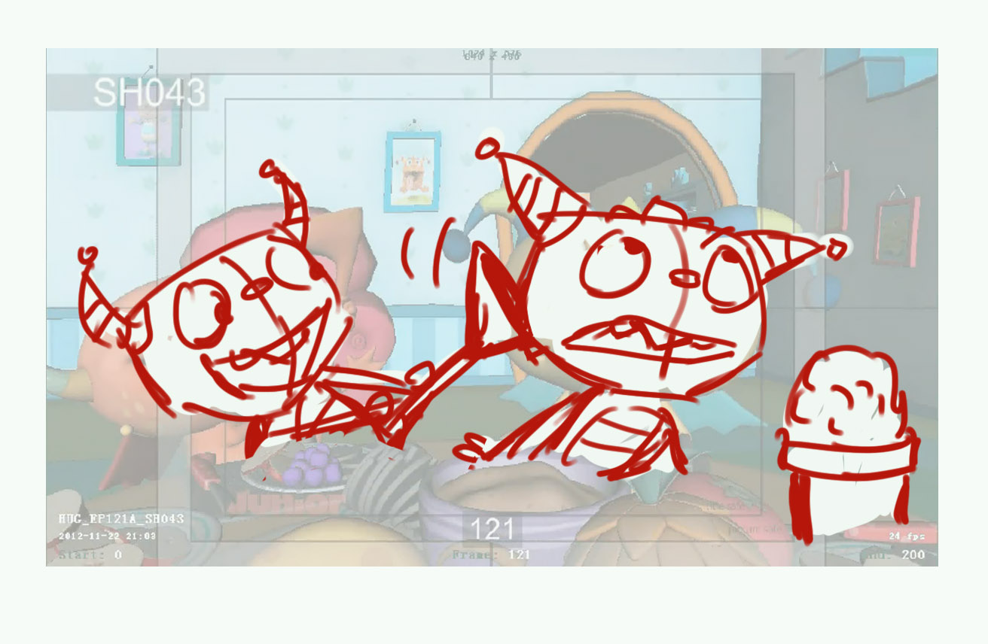
45 - Make Harry look at Henry through scene, not past him. Either reduce or remove Summer’s jerky head move at frames 19-25
After pan – the food bowl must be on H’s left, not to block his face – use ref. image below.
53 – move the FG pineapple down, into the table by 40%, so it will not block much H’s face. Keep H’s palms on the table, with elbows facing up a little, till about frame 44, then he pushes himself up. Frames 50-61: please re-animate Henry “switcheroo” – make him jump up (with pan) and yell “switcheroo” in the air, then he quickly runs OS (screen right) – see ref. image below

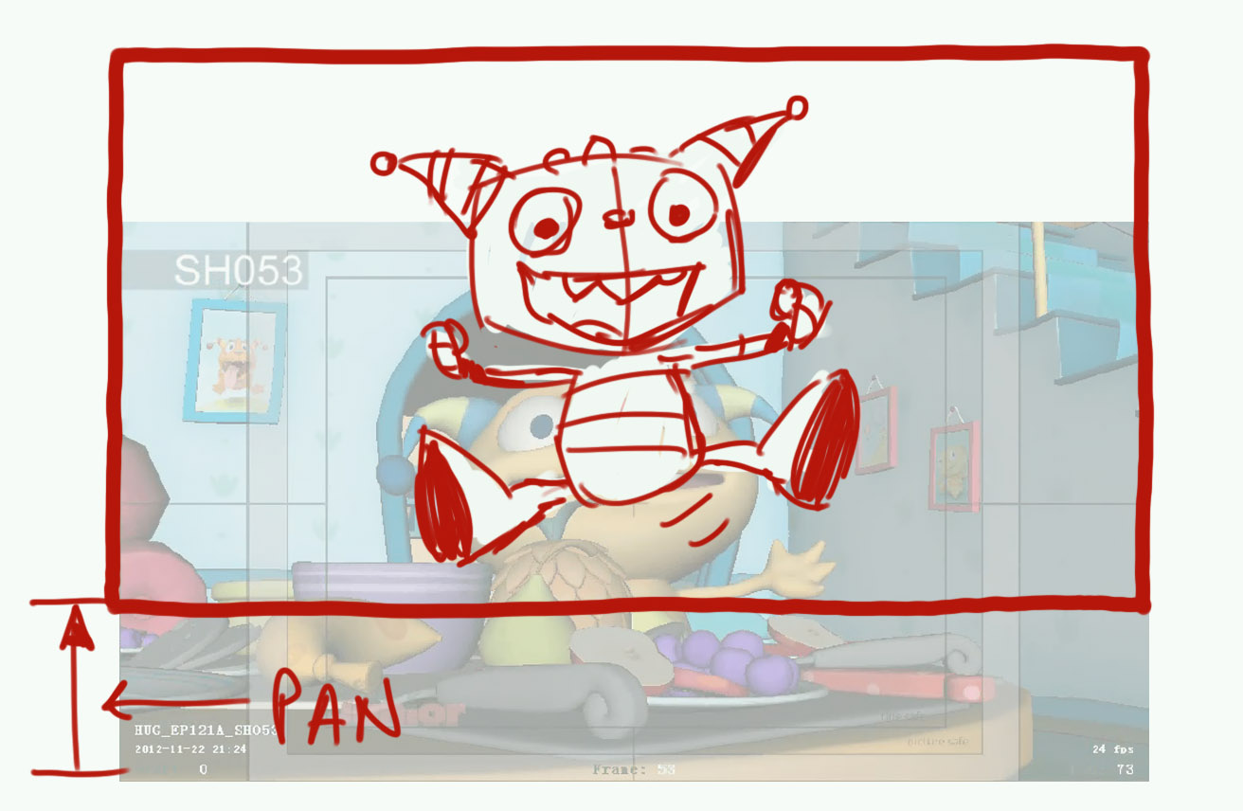
54 – add pan with action (frames 20-30) to have Robot in the center of frame by the end of scene
55 – no Summer in shot till frame 3 or 4 please, start scene without her in shot. Move the FG pineapple down, into the table by 40%, so it will not block much S’s face.
56 – no Cobby in shot till frame 2 please. Widen shot by 15%, adjust up by 10% to have his horns in full in shot.
57 – make H quickly look at the table (left/right) to evaluate his new seat (roughly frames 4-33) before he says his line “ did you see…” to cam. After pan – re-adjust the framing to a more balanced composition, use ref. image below
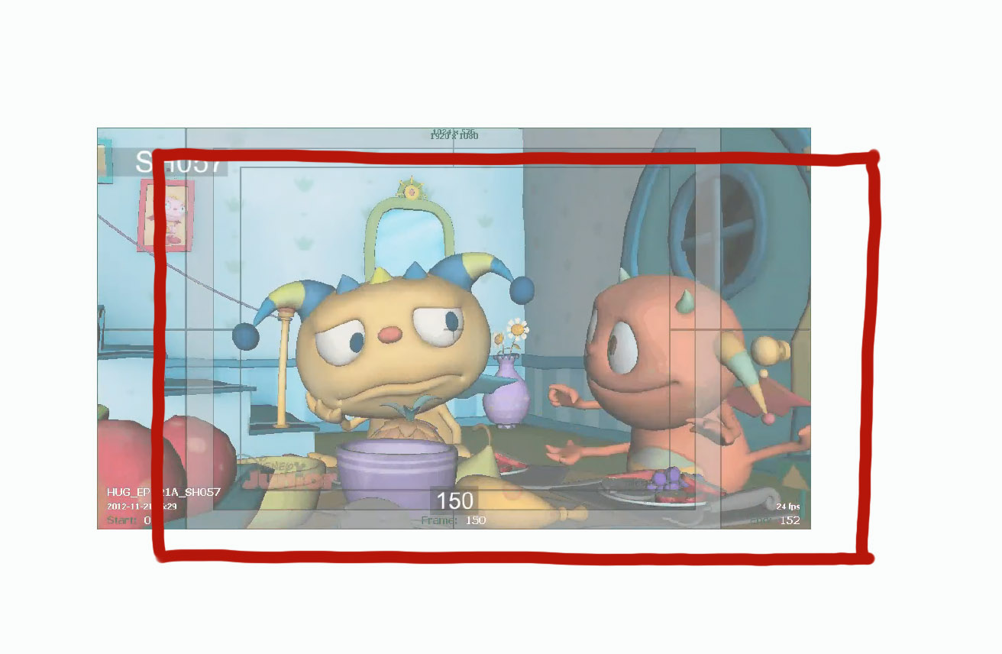
57 (again? Scene needs a new number) – re-frame screen right. Move Harry screen right a little. Make Harry do knocking moves with his left hand for his “knock-knock-knock” - use ref. image below.
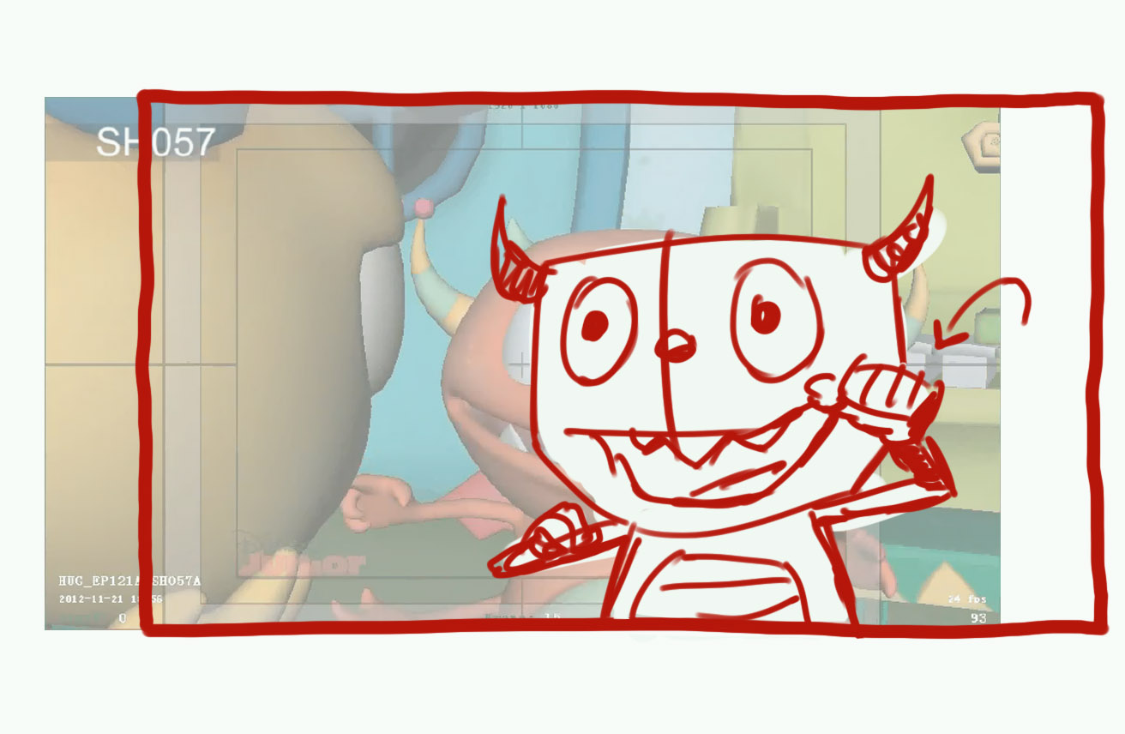
57 (again? Scene needs a new number) – sink pineapple into the table by 40%, it should not block H’s face. Re-frame for better composition: move frame screen right by 15%, down by 10%, widen by 10%. Adjust framing again when Momma comes to table to have Momma nicely in screen with her horns fully in shot – move frame up/widen by about 15-25%
58 – Bad SB wasn’t fixed timely: it looks like Summer/Cobby sit at a second table in the room. Scene needs re-staging to the following composition – Summer/Cobby and the rest sit across Harry at the same table (see ref. image below). Then they leave frame screen right.
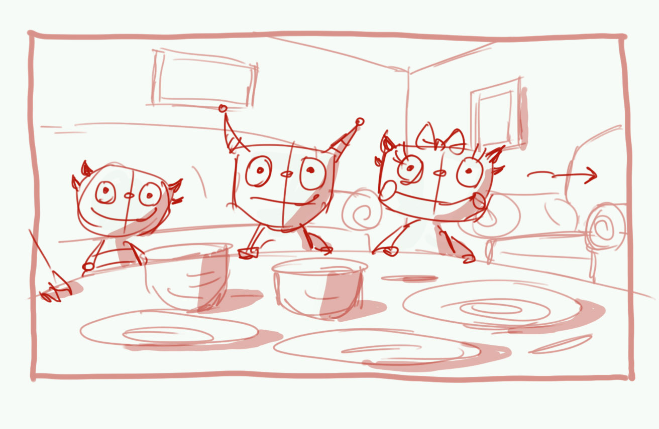
59 – it looks like Momma talks to cam, she can’t talk to cam. Lower her pupils so she would talk to Harry. Frames 197-204: it looks like Momma react to some sound – this is wrong, she is watching the kids running off the room. Lower her head, pupils, make her head move more to the kitchen door
60 – remove Grando from scene. Make Cobby run into kitchen, followed by Harry Make Momma’s run into kitchen 40% faster, end scene earlier, and add that time to the next scene, it needs it.
61 – delay Henry’s appearance by 10 frames. Make Henry look to his right (at kitchen doorway) for 8-10 frames before his “finally” line. Move the far left glass screen right, so it will not block H’s hand – see ref. image below
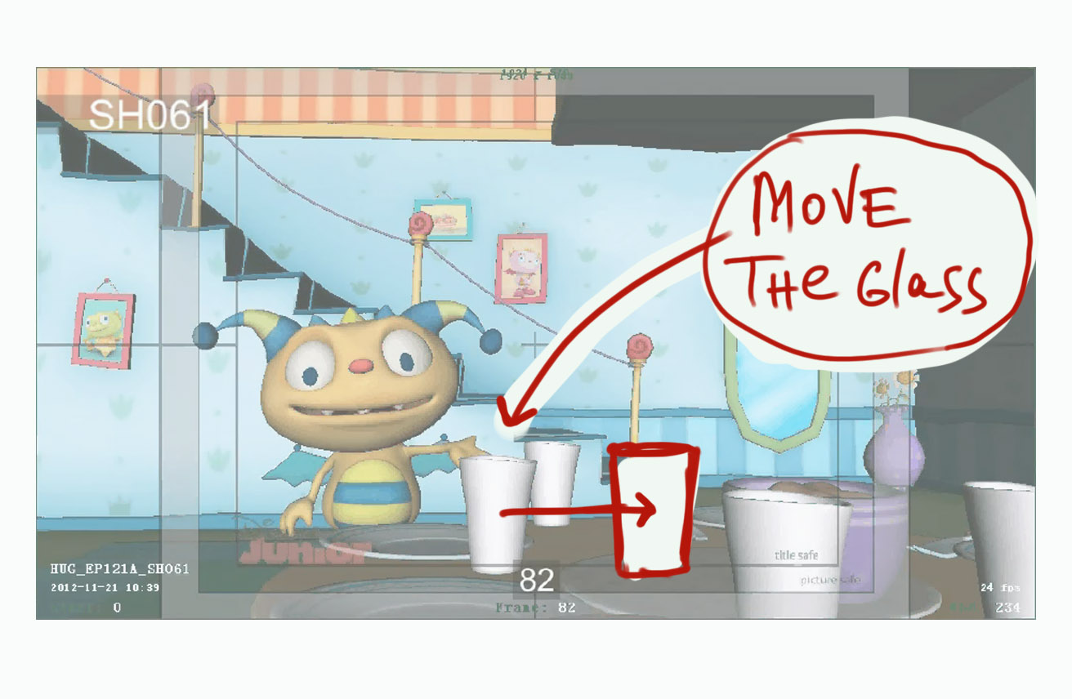
61B – re-position the chars, spread them apart so they would be blocked by the box, and by each other. Have them stay that way as they speak to each other – no gesturing limbs blocked by the box. Make H’s acting for “huggle-badaggle” more expressive – see ref. image below.
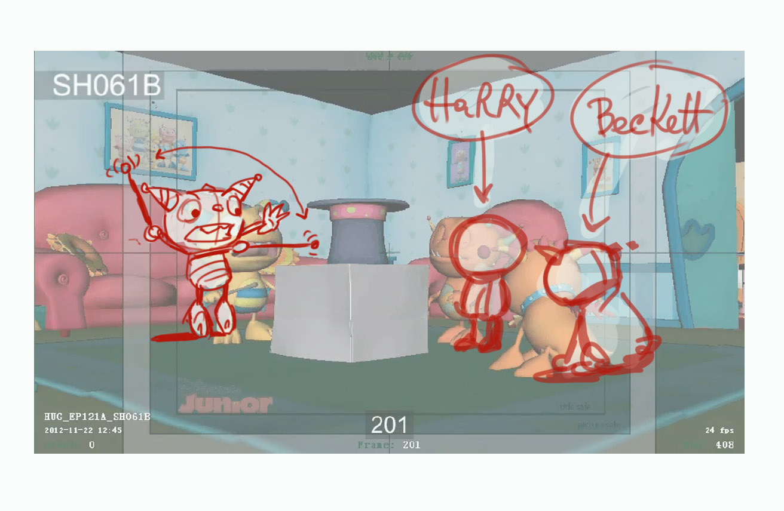
Remove jerky cam moves (pull out) at frames 408-0 and 91-0. Frames 5-10: make H look/concentrate at Beckett, without his eyes darting around, for “Beckett, come here”. Frames 21-101: make Henry look in the direction of ran away Harry/Beckett – more to his left. Frames 129-140: separate actions – Henry falls on the box, then the box fall in its turn, Beckett steps on the hat – only then hat moves, not vice versa. Around frame 159-170 – adjust framing screen right by 25-30% for a balanced composition, make Harry stop, and stand quite further away from Henry – see the next scene for geographical consistency. Frames 177-241 – make Henry look at Harry, not at the opposite wall.
65 – Frames 102-151: let’s organize Harry’s hands a little – make him point at himself when he refers to himself – use ref. image below
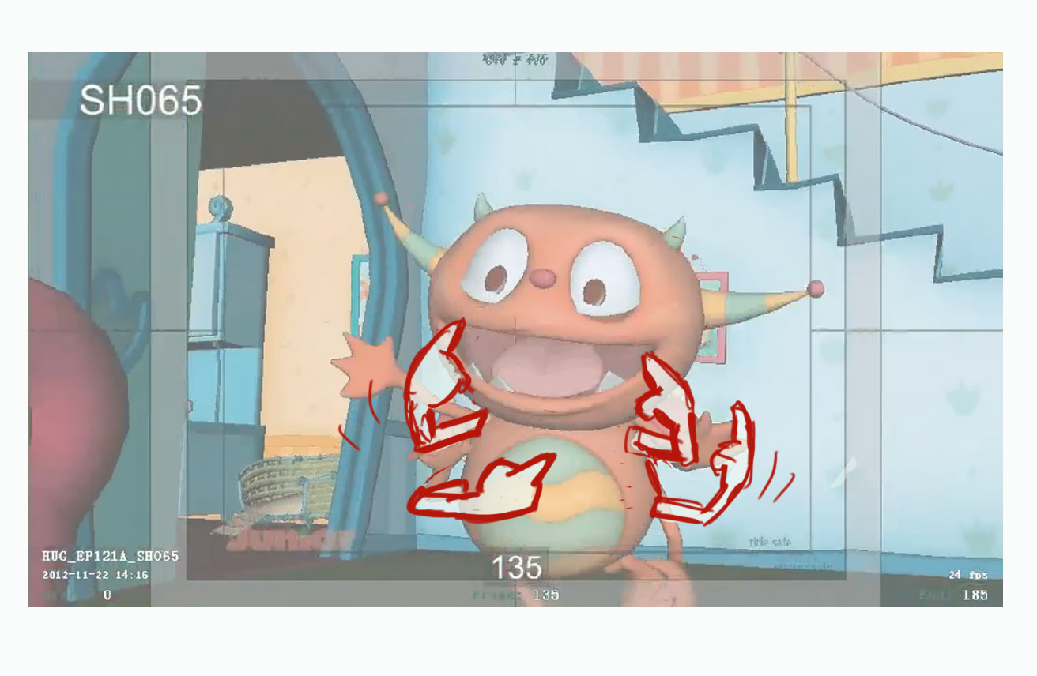
Frames 162-185: remove jerky head nodding, leaving just blinking
66 - Keep Harry with his hands spread to the end of scene
67 – Have the following pose for Henry for “… no more jokes/anything” – see ref. image below
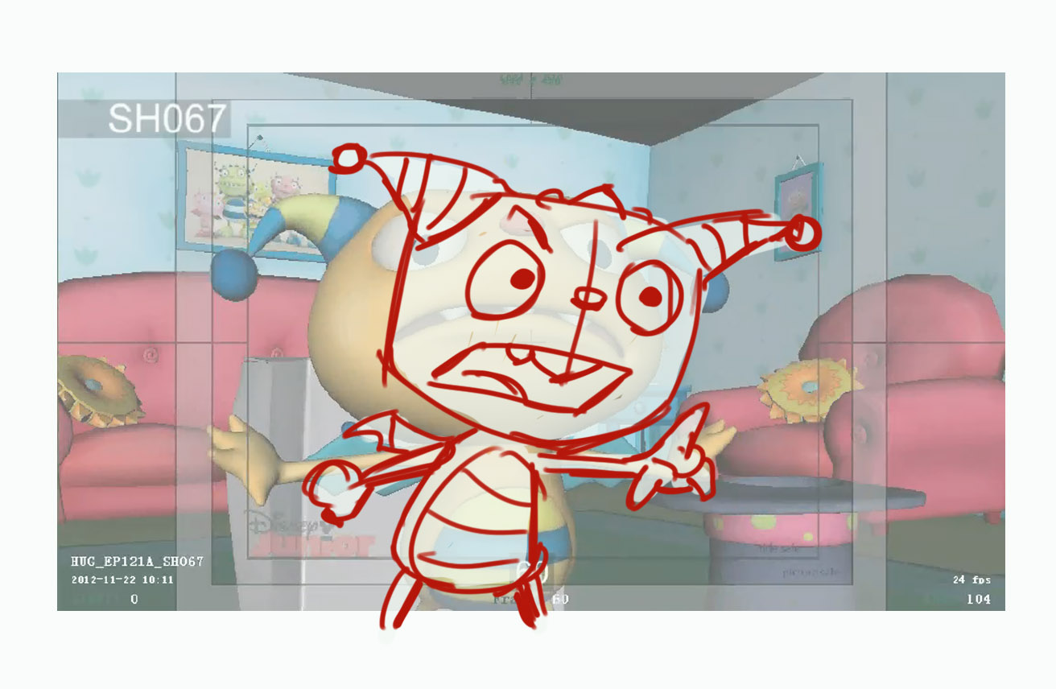
Have the following pose for Henry for “…just leave me…” (before “alone”) – see ref. image below
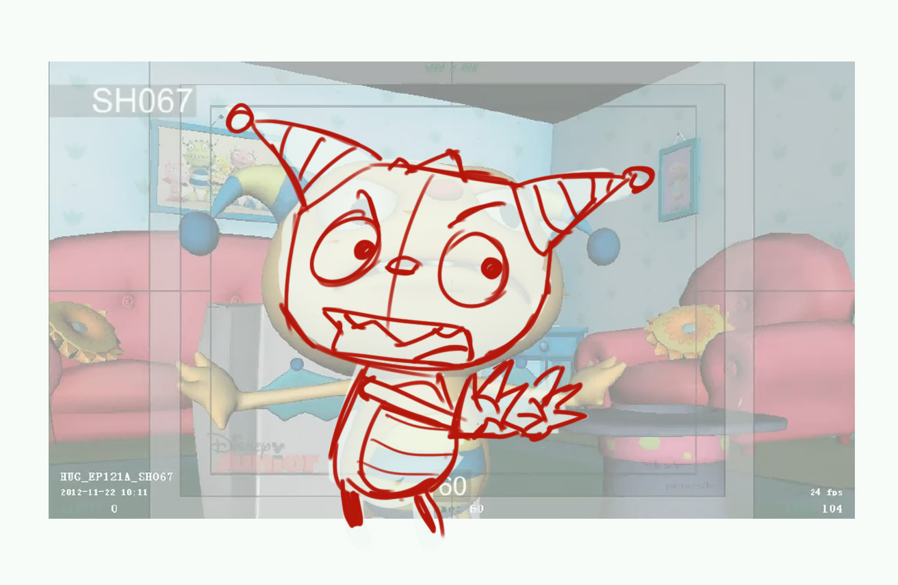
…then, on “alone” have Henry spread his hands wide apart – as is, see ref. image below
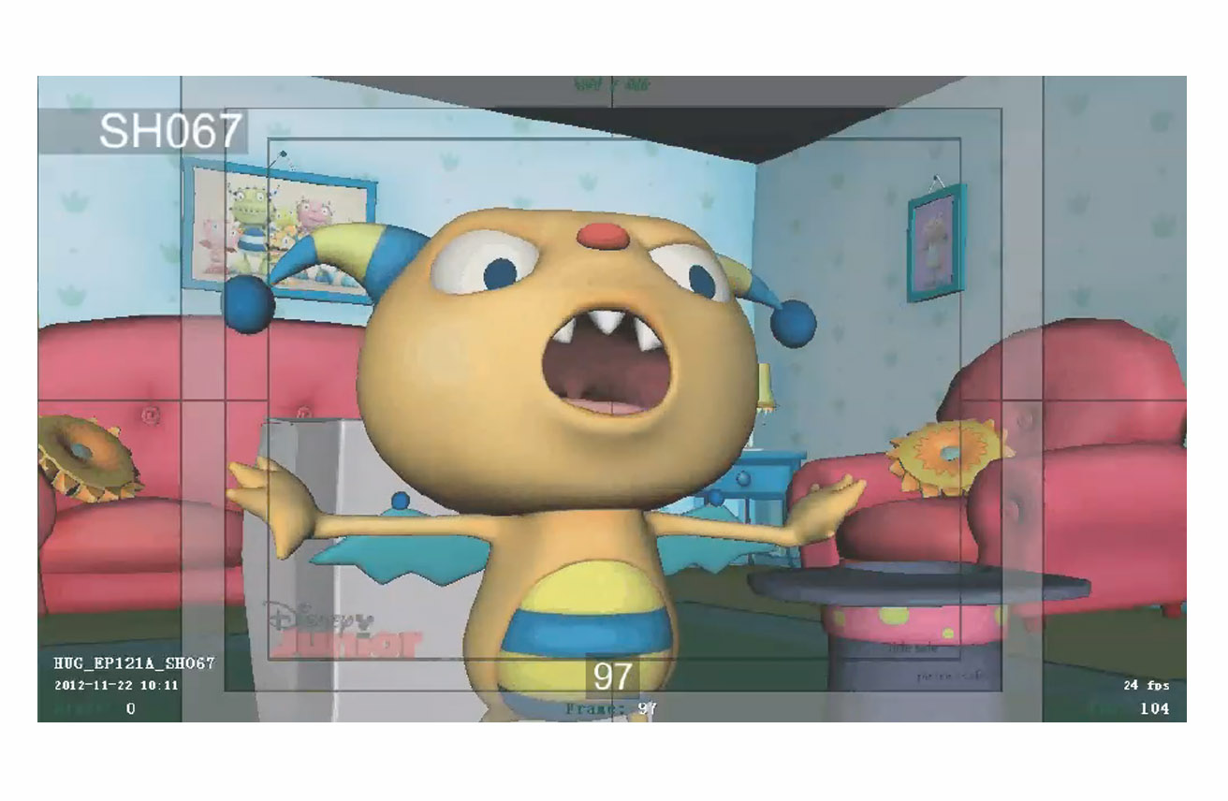
68 – Have Harry’s horns pointing up, hands spread for a hug, and have a smile on his face in the start pose – give this pose a hold of 16 frames, make Harry blink once. Keep Harry further away from cam to see his lower hands in shot. See ref. image below.
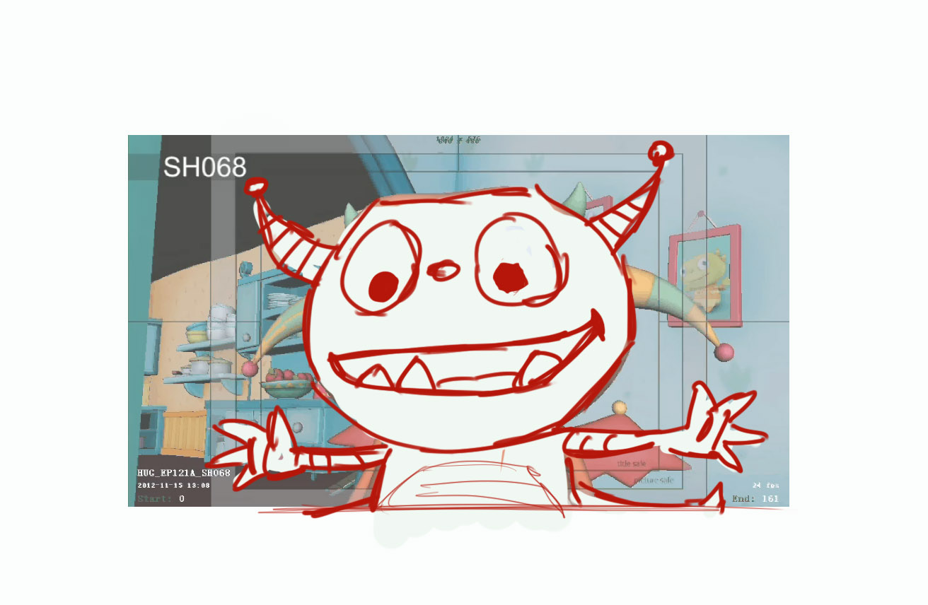
Frames 124-160: add cam movement with action – use ref. image below
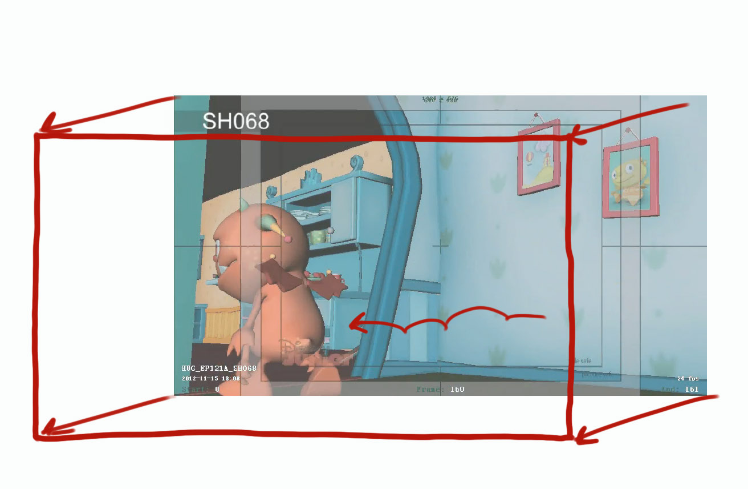
70 – Turn Robot’s head a little more to cam so we see it speak (frames 15-70)
Frames 220-517: position chars farther apart to have more space between them, re-frame shot more to screen left – use ref. image below
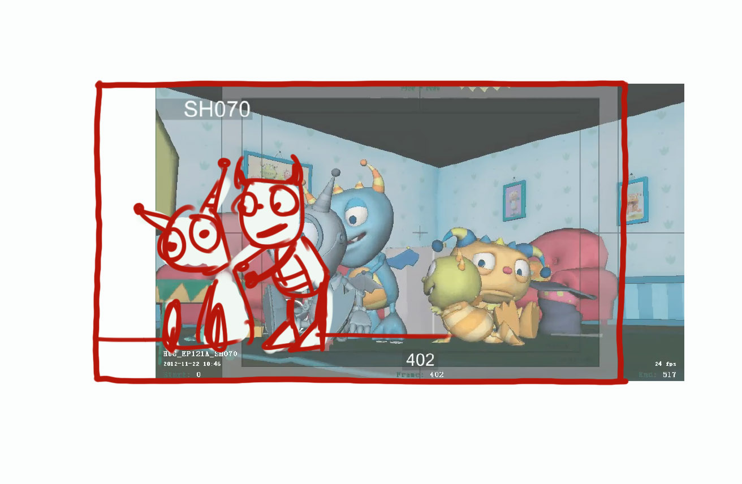
Frames 440-449: eliminate contact between the screwdriver and Ivor’s mouth, position Ivor more screen right.
71 – Frames 100-250: re-position Robot screen right/to cam to have a clear view of Ivor, re-frame shot up/right – use ref. image below
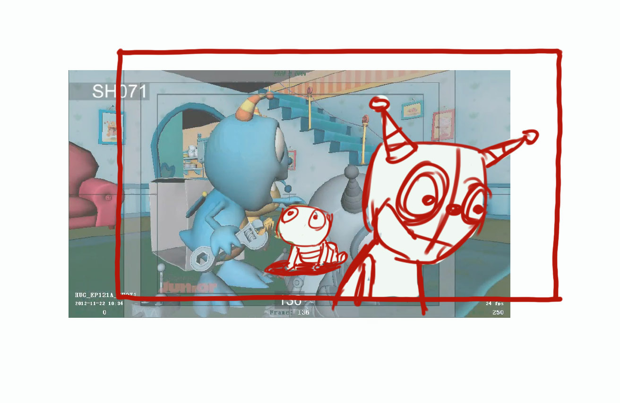
73 – Pivot the group Robot/Cobby/Ivor clockwise by about 30-40* to get a better view of Ivor, and have a better view of Cobby face.
77 – Move the hat screen left by 50% (more behind Henry). Frames 0-43: have Cobby work on the Robot. Frames 43-135: have Cobby react to Harry (as is but add a smile). Frames 135-206: have Cobby go back to work on the Robot. Starting from frame 36 start cam pan screen right, and finish by about frame 73. Keep Henry’s head turned more to Harry when Harry/Summer speak. Make Summer look at Harry when Harry speaks, and when she speaks to Harry, not past him. Use ref. image below.
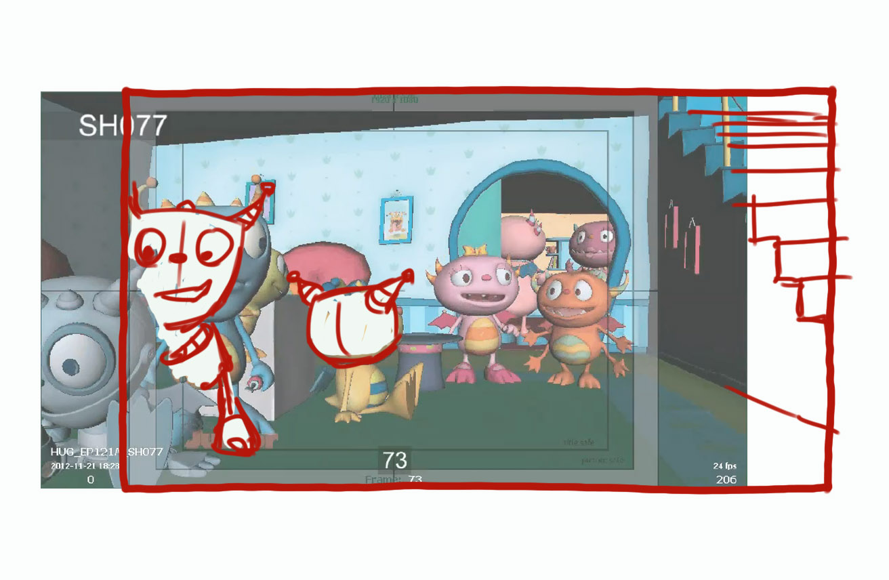
78 - Re-frame shot: adjust screen right by 15%, down by 20%, widen by 15%. Have Cobby work on the Robot between frames 1-47, then make him turn to Summer between frames 47-70, then back on Robot between frames 70-168, then he turns to Summer again from frame 168 to the end of scene.
79 – Frames 180 to about 324: Harry’s left lower arm is unnaturally stretched (holding Summer) – looks bad, not sure what to advise. Summer, trying to break free (about same frames) doesn’t look very convincing. Stop cam move (truck in) at frame 617, but adjust framing down, so it looked like in ref. image below
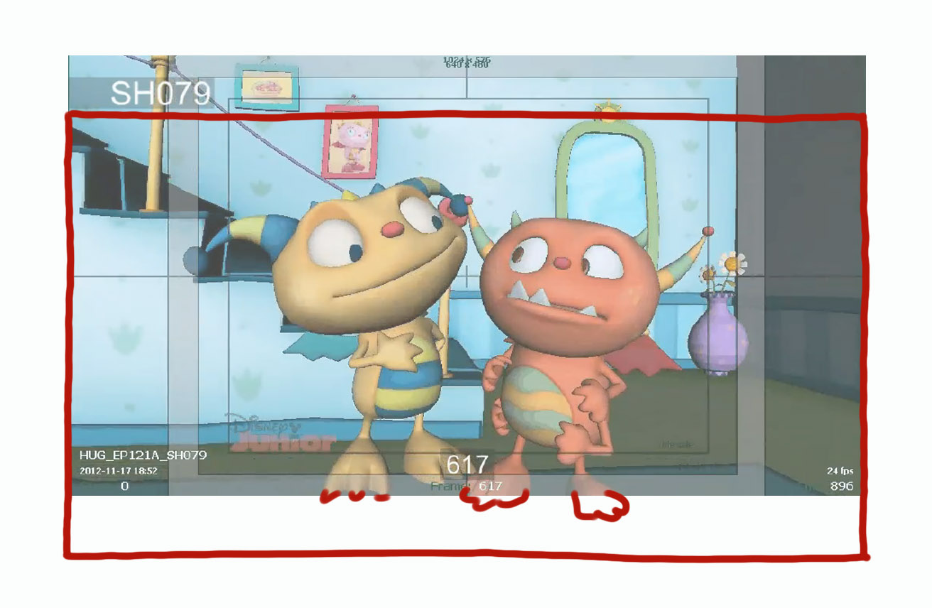
Frames 874-881: add pan screen right, to keep Henry in the center of shot after Harry is gone.
81 – remove Henry’s head sways (frames 8-25). Instead make him slowly moving from pose in frame 7 to pose in frame 21, like he is anticipating.
82 – Frames 10-23: it looks like Harry attempts to do two shallow antics, please make one DEEP antic, before Harry throws the hat upward. The hat can touch the floor in antic, that’s fine. Make the hat go up vertically (faster) off screen for about 8 frames (kids loop upward), then it falls down in screen. Re-frame the shot (screen right) so Henry/Harry are positioned nicely in shot without being blocked by FG elements. Change Harry’s pose for a handshake to a more natural, and easier to animate – use ref. image below.
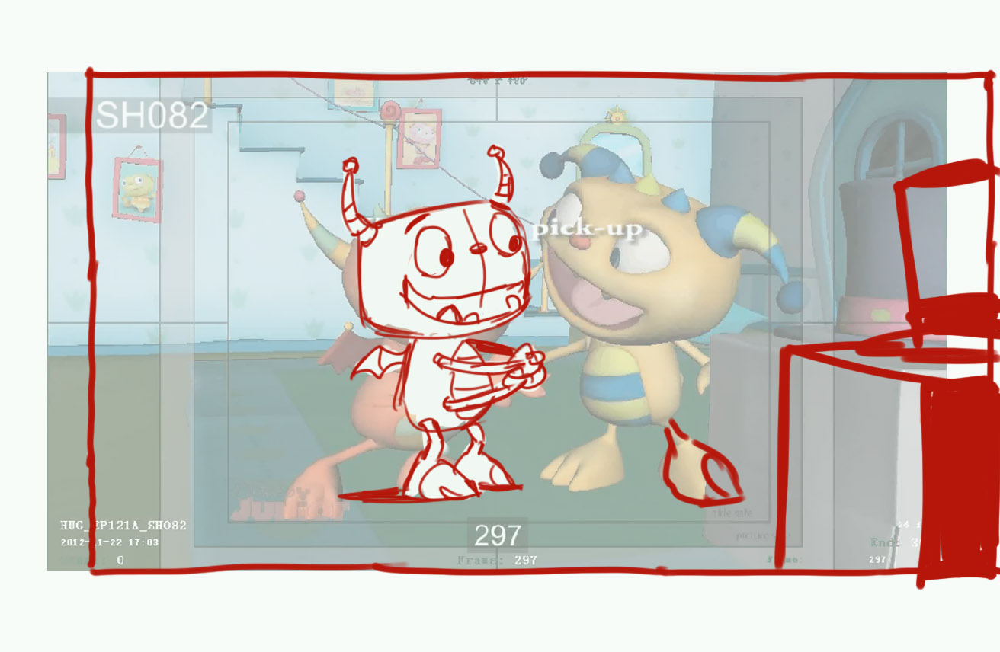
84 – Widen shot by 15%, adjust down, to have a nice framing without chars’ feet cut off. Have Momma look more to her right (at Henry), keep her mouth open in the first pose (frames 1-10). Don’t keep chars clamped, whatever position they take through the scene KEEP SOME DISTANCE BETWEEN THEM to have a nice readable silhouette – there is plenty of room in shot !
86 - Widen shot by 15%, adjust down, to have a nice framing without chars’ feet cut off. Make Momma smile when she listens to Henry
87 – stop truck in by frame 86, and keep this framing to frame 138 (the next cam move). Frames 153-216: make Momma look at Summer, not past her. Frames 238-244: make a clear readable emotional contact between Summer and Cobby, make Summer jump (sooner, on “…love my…” to hug Cobby – use ref. image below.
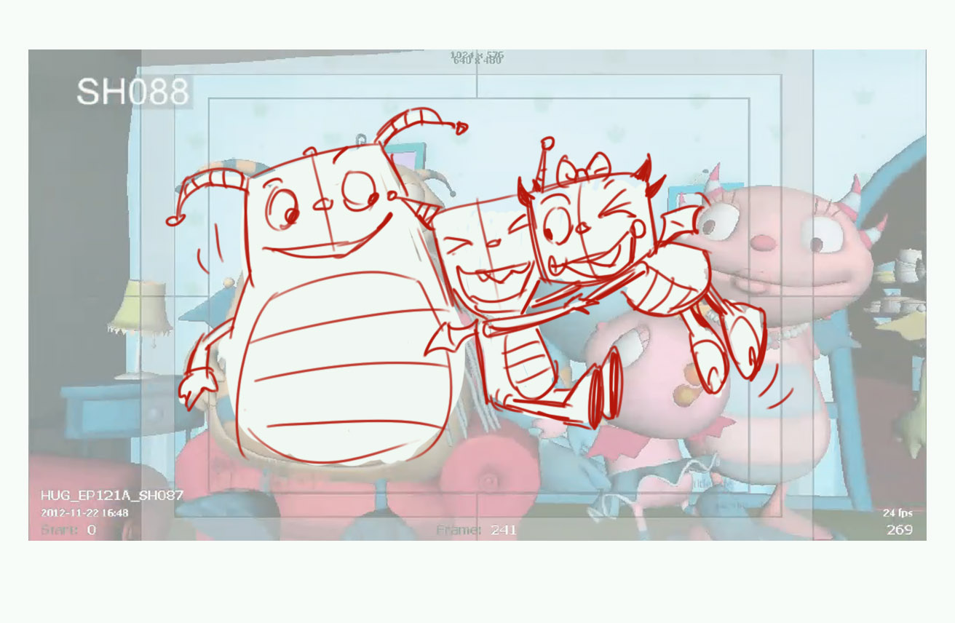
89 – widen frame by 15%, adjust down by 5%
90 – shouldn’t the adults make some rhythmic dance moves, Shane? Or this is too much to ask? The crowd is too static.
92 – make Daddo’s pupils move left and right, like he is looking at the crowd, he shouldn’t look to camera. The BG chars – make them look at Daddo, not to outer space.
93 – Frame 43 (truck out ending) – re-frame shot: make it 10% wider, adjust down by 15% to avoid chars’ feet being cut off. Why is Henry angry here, any reason?
95 – Make Harry look at Henry in frames 194-21, not at the wall.
96 – re-frame shot: move down by 15%, widen by 10%
98 – Where Summer/Cobby are standing here? In the air?
97 – make the hat move up, and then down in the air, as it spins, don’t keep it at the same spot, like it’s on axis
101 – no cam move in this scene, please, keep it wide all the way. Can we make the treat three times bigger? It doesn’t read well…
102 – again, where Summer/Cobby are standing here? On the chair? Shouldn’t we make the shot wider to see that?
103 - re-frame shot: move down by 15%, widen by 10%
104 – Re-frame shot: move framing screen left by 20%. Remove Summer’s head from FG. Delay Daddo’s entrance in shot by 7 frames. Make Beckett jump off the hat farther screen right, by 100% ( by the size of Beckett). Make Becket’s trajectory more arched as he jumps off, it looks too quick now. Make Becket’s head turn right (and look at Daddo) right after landing.
105 – Beckett’s licking looks a little wooden, can we make his tongue a little softer? It has a plastic feel…
106 – Open Henry’s eyes in frames 1-37, make him look at Daddo, and then at the rest of the guests. His performance is dull, sharper acting poses are needed, eye contact is poor. Harry is dead in this scene. He should be looking at Henry and Daddo, alternatively, smiling. Final hug is flabby, they need to lean inside the circle more.

