Carried Away DIRECTOR’S shipment NOTES

Questions for production are in green, for Norton – in yellow

Location:

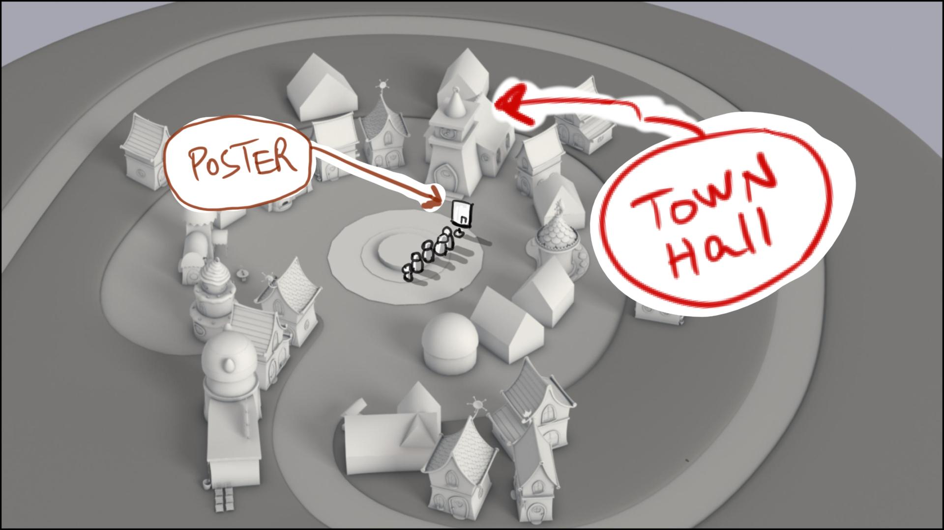

By shot numbers :

1 – start tighter, and pull out after H turns to cam – on “…check out this poster”. Place H to the side of the poster so he will not block the Mr. G’s photo – sketch below

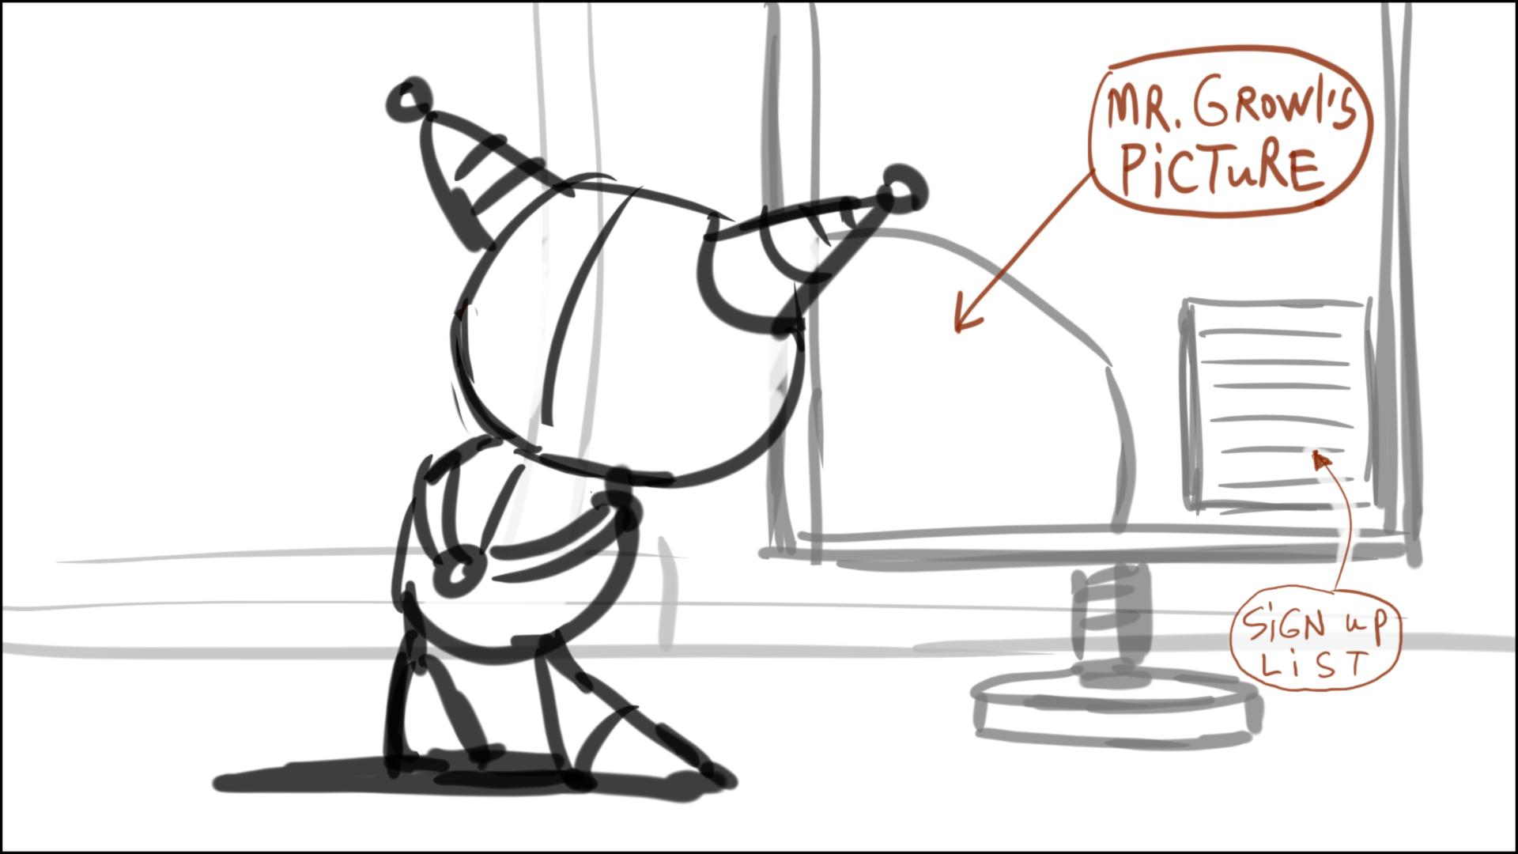

Have monsters come in shot (to sign up) on “…someone who has tons of talent”

4 – in first frame make H walk two steps to cam, and take his place in line. Keep frame wide enough to have H’s feet in shot in full. Make a better pose for Summer, like in sketch below

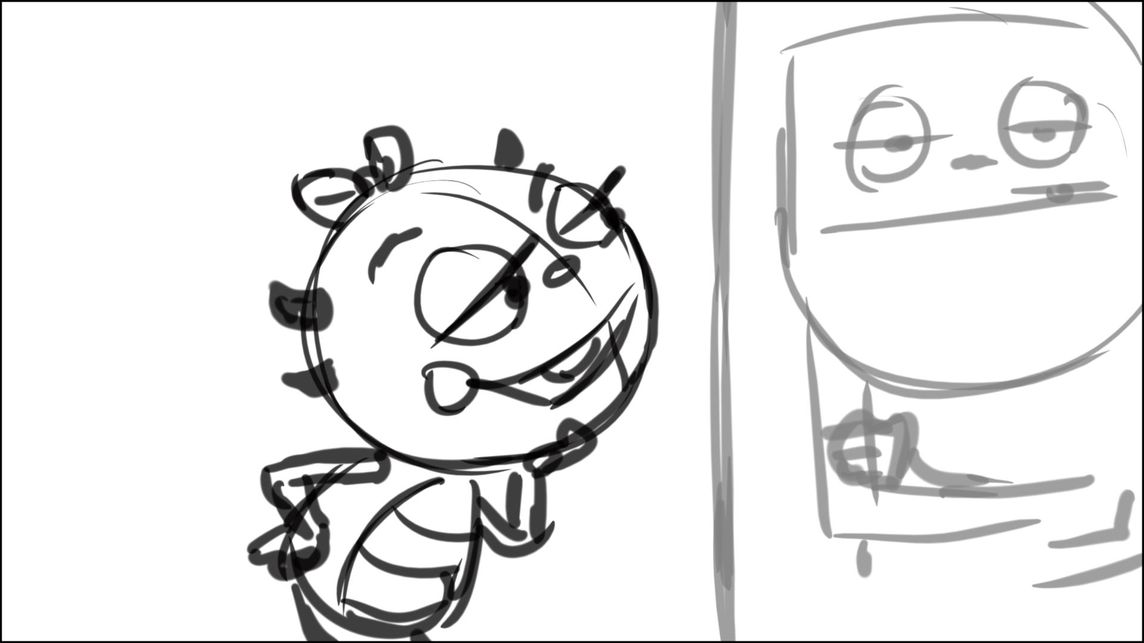

11 – extend this scene to the end of “ …you can’t even try out”, then cut to 12_01

12 – I suggest to cut out

12_01 – move line from sc. 12 into this scene. Widen frame by 20%

12_04 – start airship more to screen left so the bus/rope are behind the house, pan with airship screen right

24 – start sc. with the doors closed

26 – more dry “English teacher” pose here, no threatening, like in sketch below

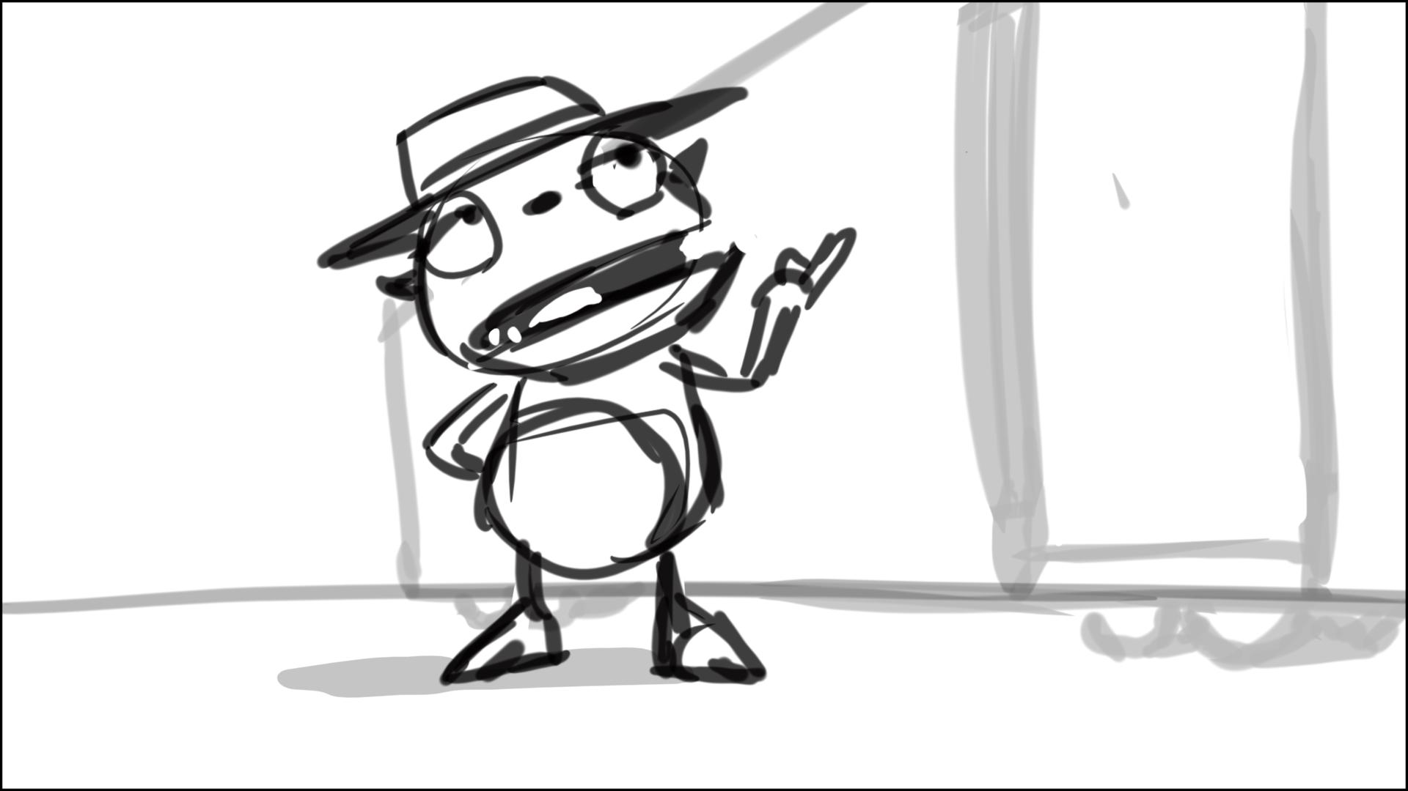

26_02 – widen frame by 15%. Mr.G. has nothing to do in BG – should we reverse the shot or change cam angle to have him out? Or he can slowly walk toward cam?

28 – extend scene to have “… and by sir he means” in this scene, then cut to 30

35 – Mr.G’s hands are folded in the start frame

36 – make H quickly go through 3 facial expressions like in sketch below, before he runs after Mr. G.

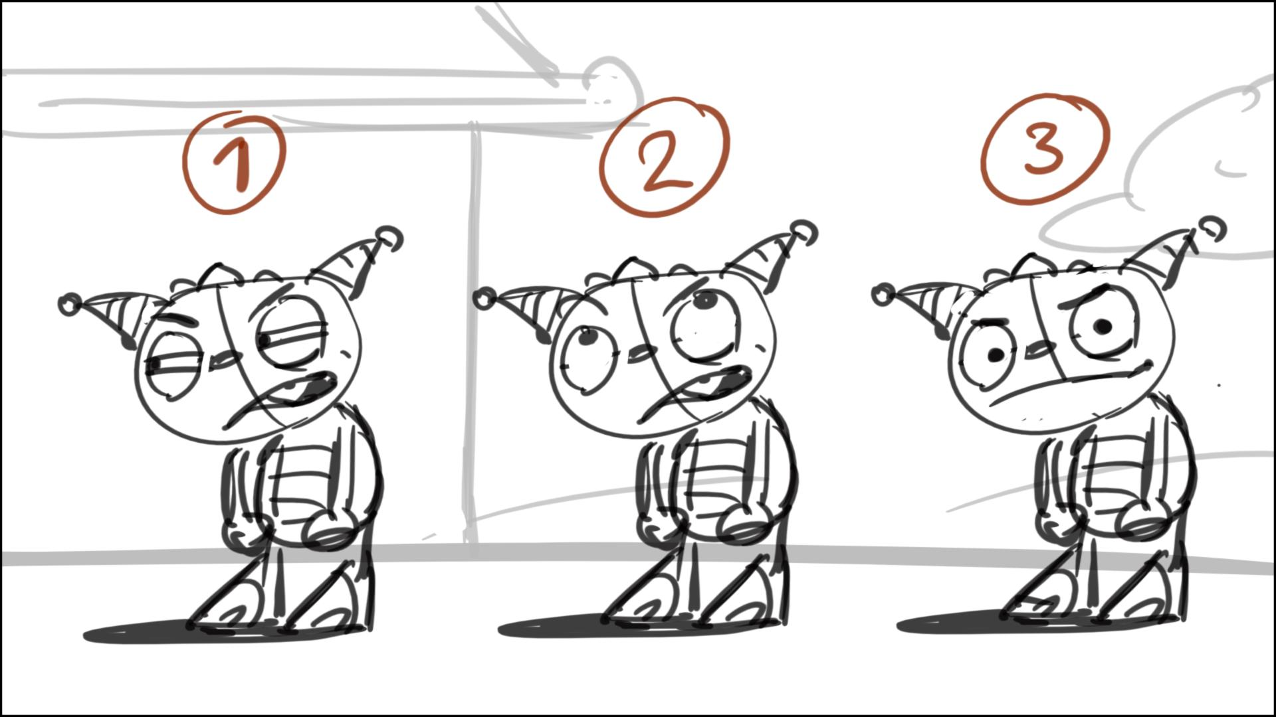

Make Mr.G exit frame by “…your mind”, and H alone in shot, like in sketch below

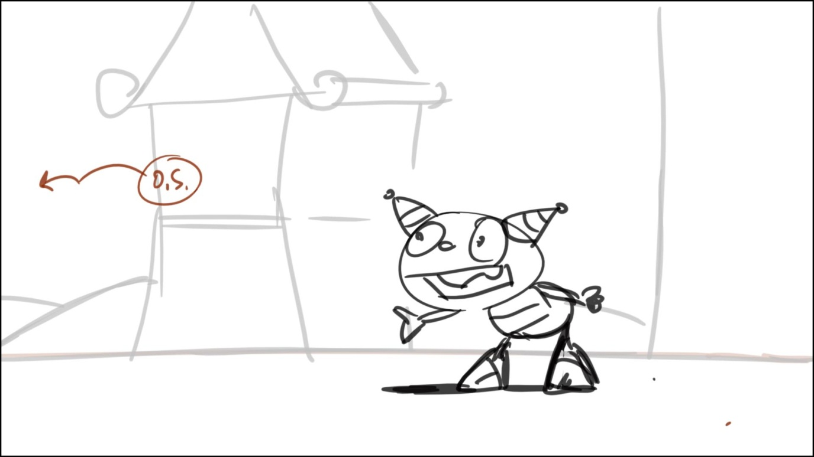

40 – no H in the first frame of scene, he comes in “… why don’t you come…”

45 – make Mr.G. look at one object here (Henry)

47 – Daddo is juggling pots and pans, his mouth is closed, he is thinking, listening to Henry

51 – make Momma stand right by the counter, like in sketch below

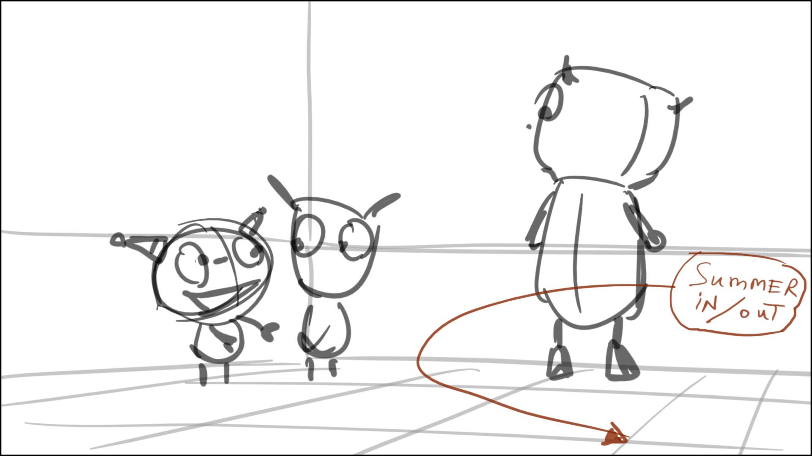

53 – no apron on Momma

59 – more frontal angle on Summer, without Cobby in shot

72 – C starts to crank after “…baloonulater”. He cranks first, then pushes the button to start the process, the balloon don’t pop out before the button push! Logically it must hook up with a later scene, when C tries to stop the machine by pushing the button – or it doesn’t make much difference, Norton?

73 – add a little touch here – H dodges a balloon while saying this line. Or add a balloon or two, flying behind H.

81 – make C keep hitting the button before and during his line, looking at the button/balloons, no need to touch crank – like in sketch below

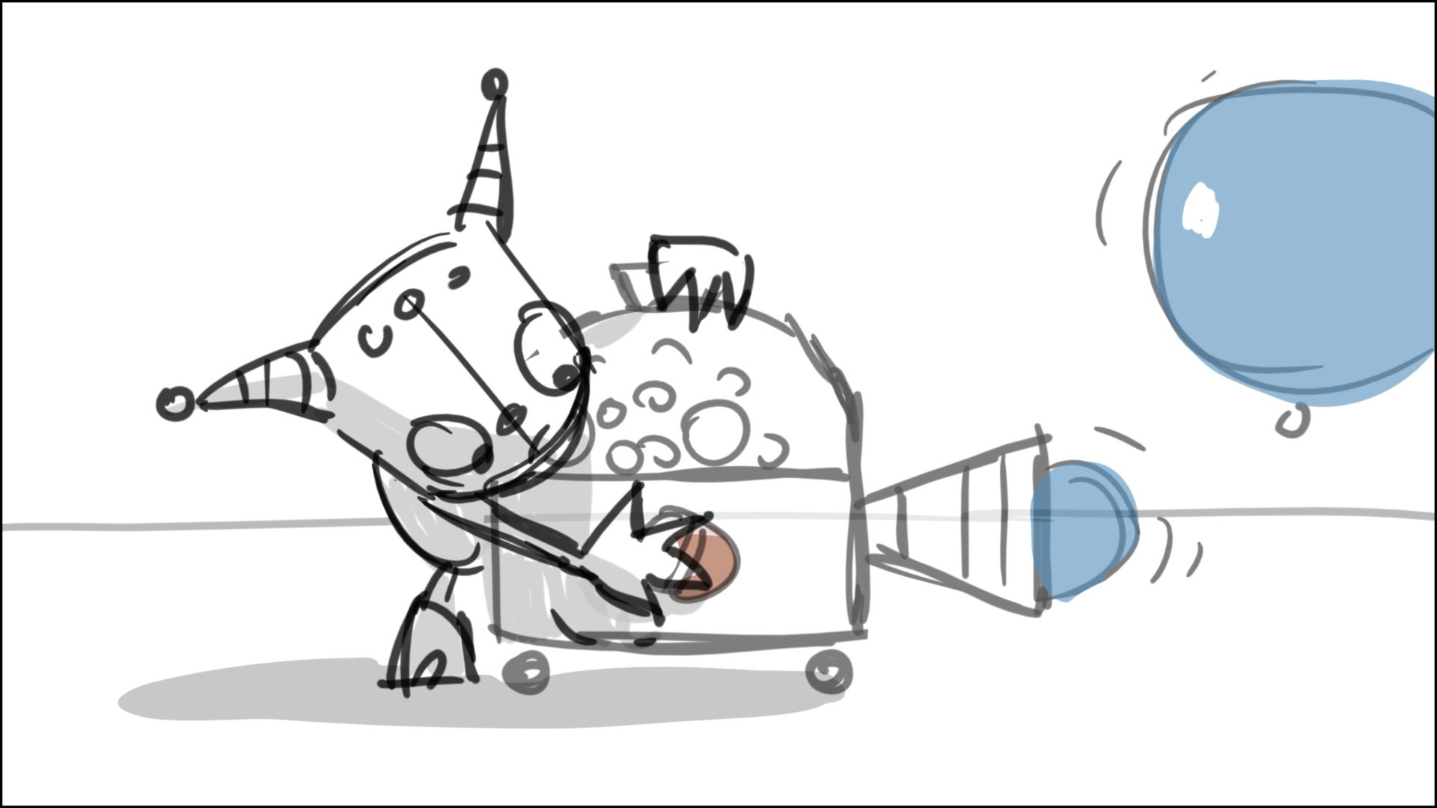

84 to 85 – strange cut. Let’s add a balloon, floating in front of Summer in 84 screen left to right, and cont. with this balloon in 85 exiting frame screen right. Also, add some balloons floating behind kids in 85, somewhat close to the top frame – for better continuity to 84

86 – Let’s make this scene wider: Coby says this line, raising his head from the jammed button, while continuing to hit on it with his hand – sketch below

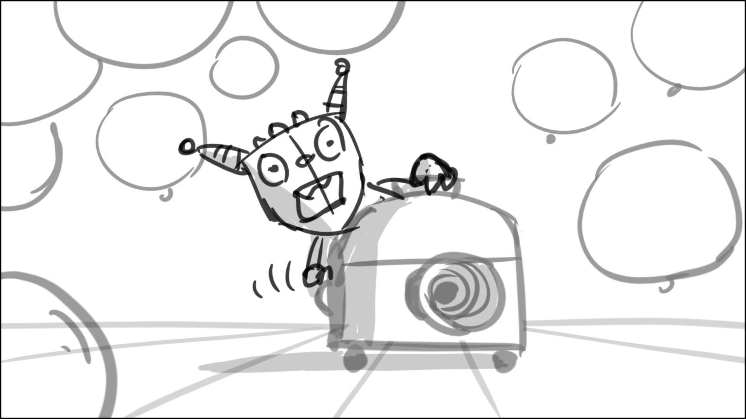

87 - continuity problem. Let’s change this scene a little: kids are not in shot, H runs in, and turns around for his line, balloons come in a little later – like in sketches below

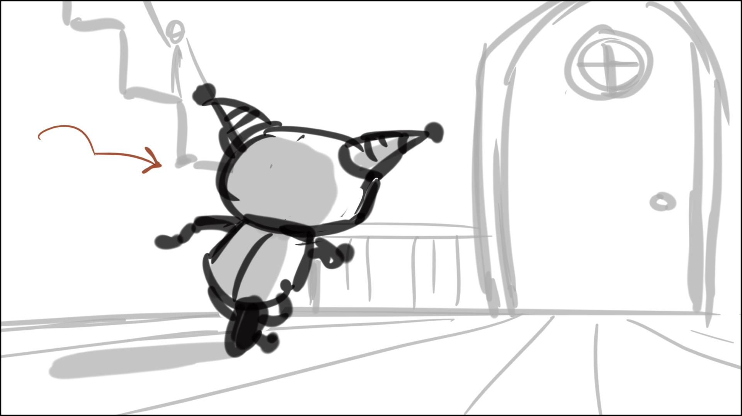

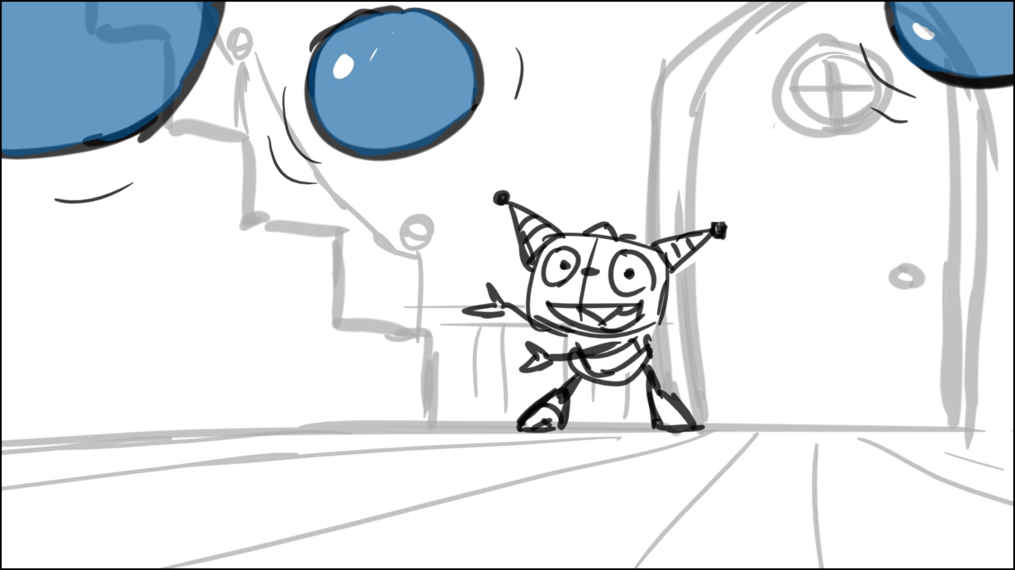

90 – no cranking, Cobby keeps hitting the button (let’s have two buttons on the two opposite sides of the machine – asset check?). Make H look at cam on “…feeling it is”, and screen right on “… places!”

94 – no H/C in the first frame, they enter shot from the stairs. They look concerned, not smiley.

94 – don’t make D step on the balloon in full, like this looks in the animatic, make him slide when his foot is about 30-40% into the balloon – sketches below. No pots on Daddo’s feet 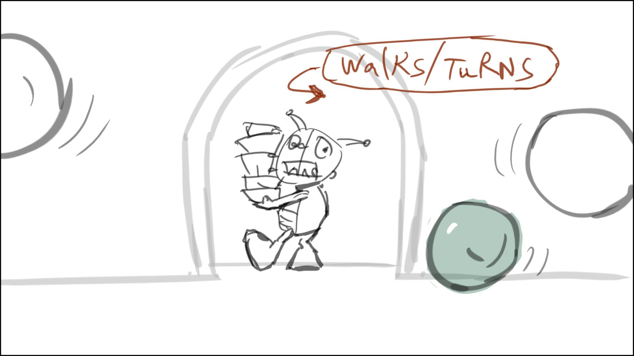

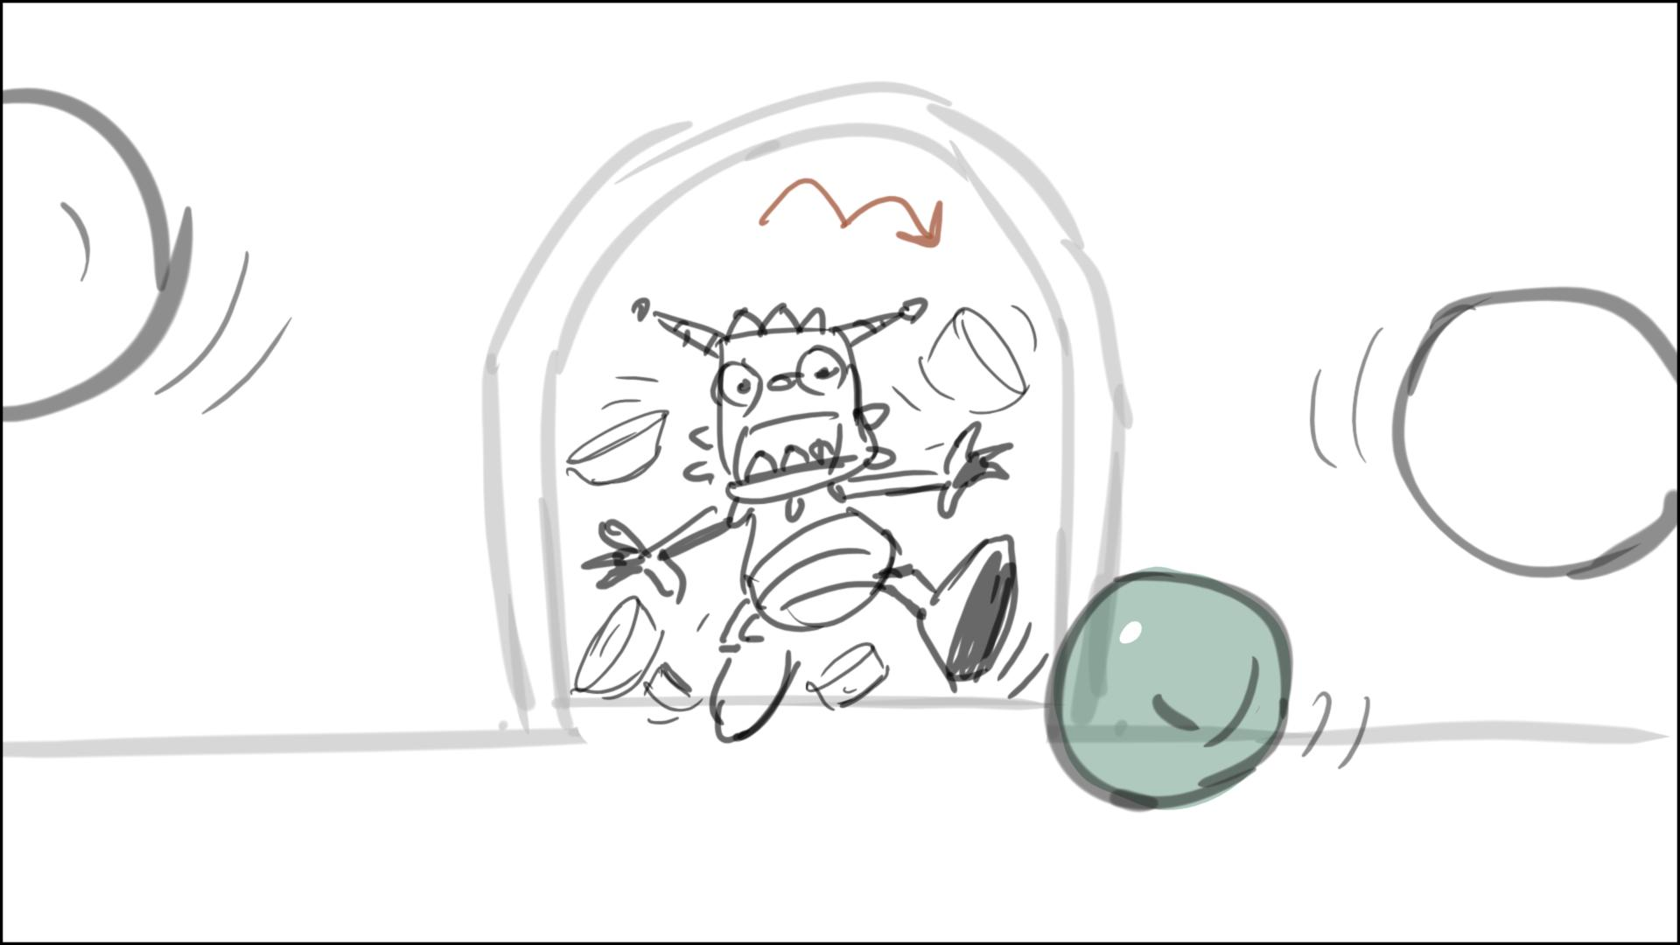

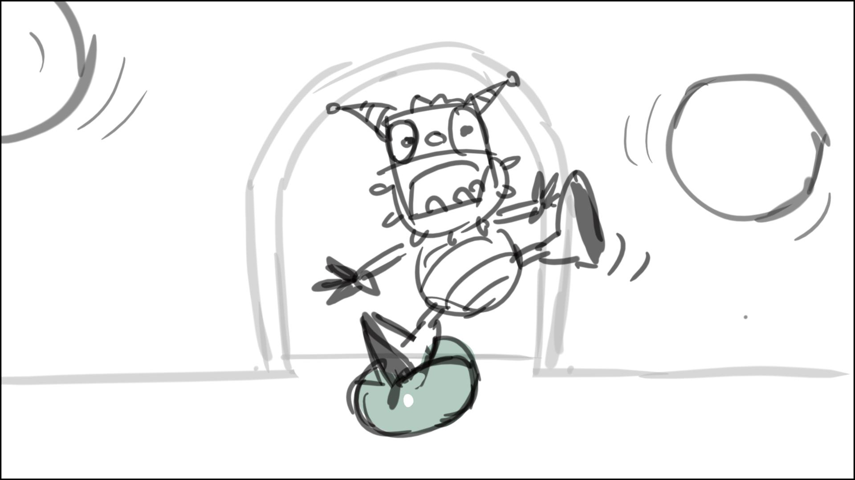

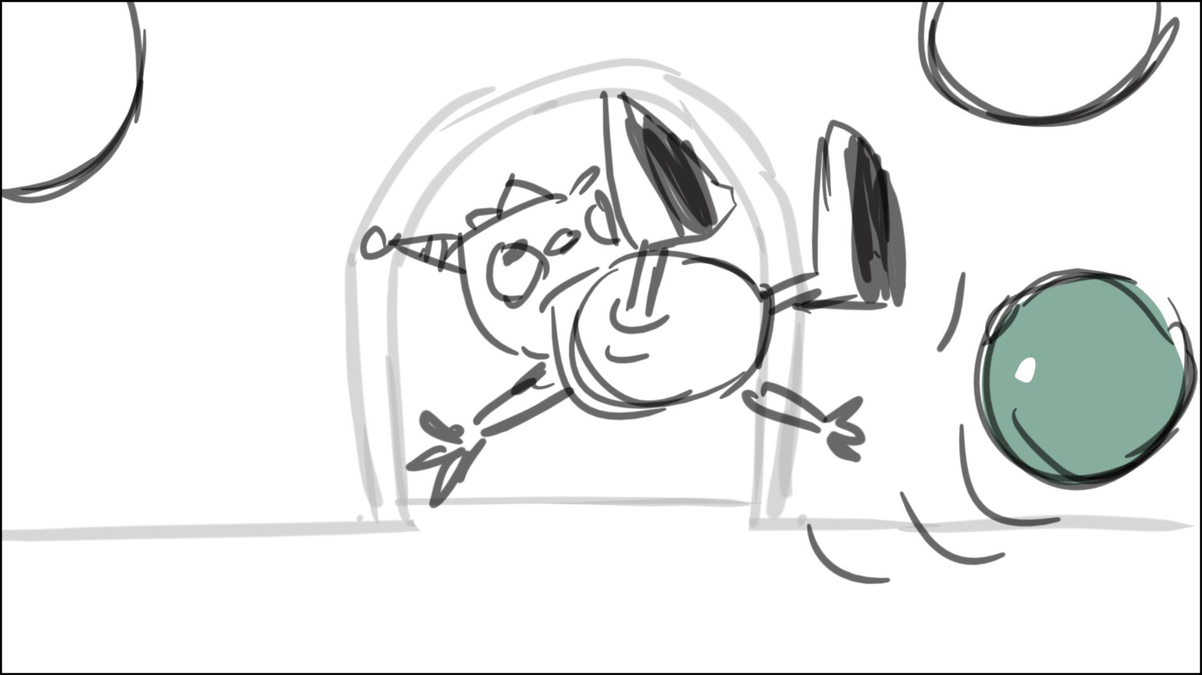

94 – cont. Let’s see S’s face for “…break a leg”, without Daddo blocking Summer – sketch below. The dishes/pots are on the floor around them. Only then Daddo runs off shot.

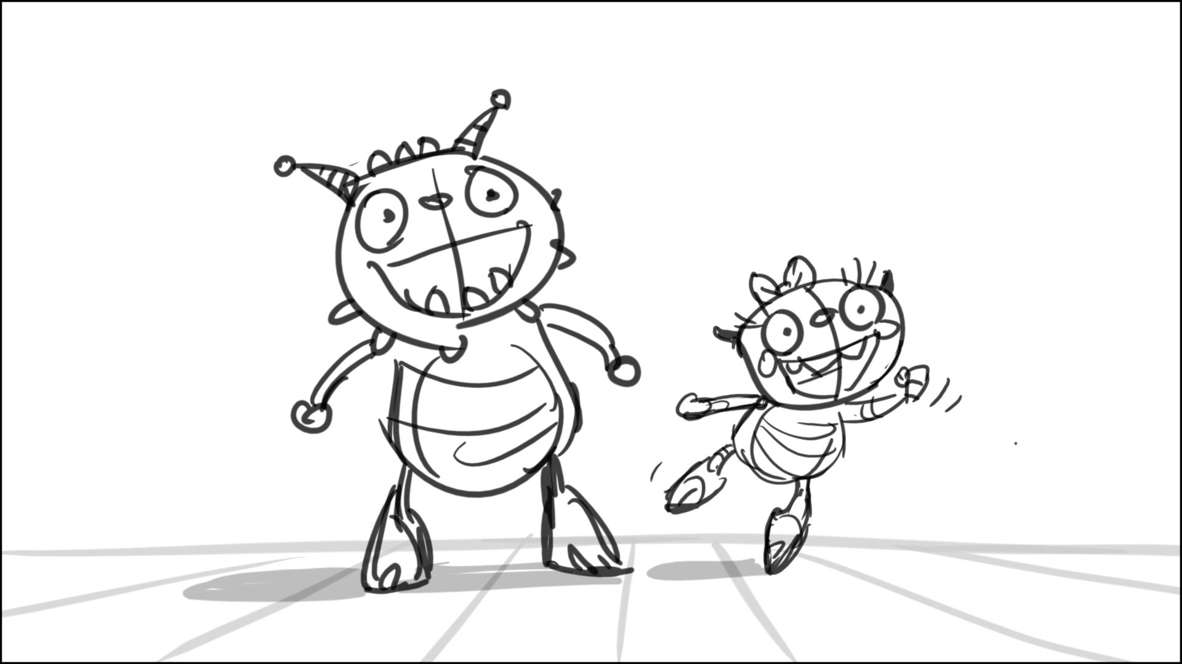

96 – No Summer in scene. Daddo steps into one of the pots here, and the pot remains on his left foot till sc. 128. Sketch of how the pot looks on D’s foot - below

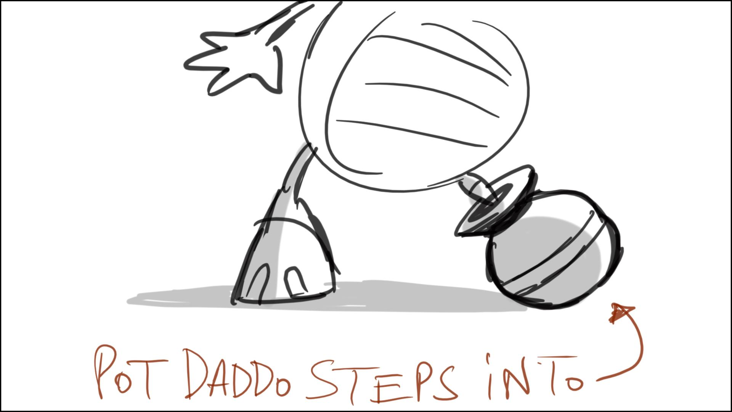

100 – Daddo in kneeling on the floor, picking up dishes/pots, pot is on his left foot

102 – I think there must be a scene right after 102 of Henry and family reacting to what just happened, while Mr. G remains oblivious – like sc. 106 – Norton?

106 – Daddo must be kneeling on the floor, picking up the dishes/pots, a few steps deeper in shot, pot is on his left foot

108 - pot is on his left foot

108­_01 – Daddo just stands up from the knees as we truck out, pot is on his left foot

111 – Norton, you should be able to do a better job on the notes for this scene, I don’t see it work very well, unless re-boarded a little

114 – no leaning out the window, H stays deeper inside

116 - Daddo wears a pot on his left foot

118 -119 – lets cut to 119 when Summer jumps (and lands in 119) to make it rather a hook up, cut looks a little jarring

120_01 – have only 1-2 balloons behind Mr. G. floating here

128 – Henry sing “me” here. Daddo picks up same stuff he held earlier – props check for continuity. This is the last scene where Daddo wears a pot on his left foot. I’m not sure we need to keep Momma/Cobby in kitchen in this scene – Norton?

138 to 139 – hook up on a motion as they form a circle

139_01 – change the front door of the house to the side, like in sketch below.

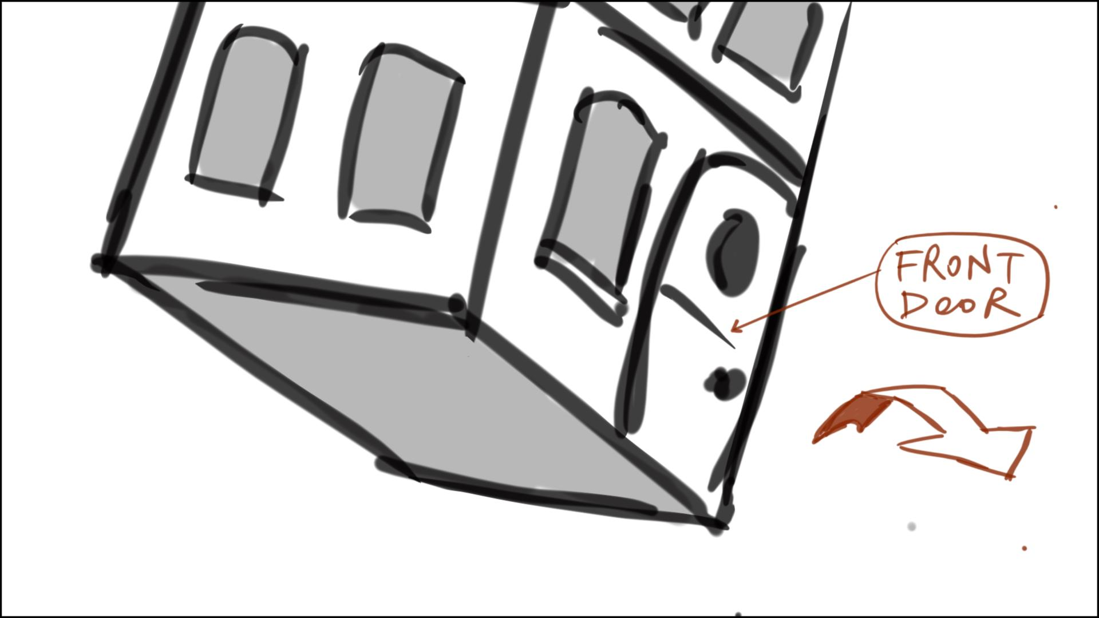

143­_02 - change the front door of the house to the side, like in sketch below.

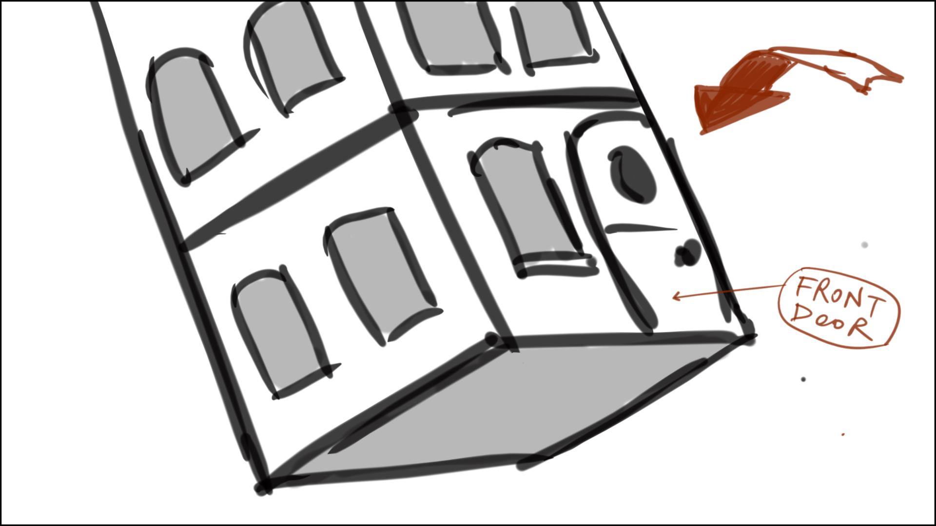

144 – make Daddo look at Mr. G. as he juggles the kids/Momma – they pretend that this is a performance, trying to hide the fact they’re flying. Make them all look at Mr.G in the last frame of scene like they just finished the performance

145 – Mr.G. looks puzzled here

181 - we need to start from the oven – sketch below

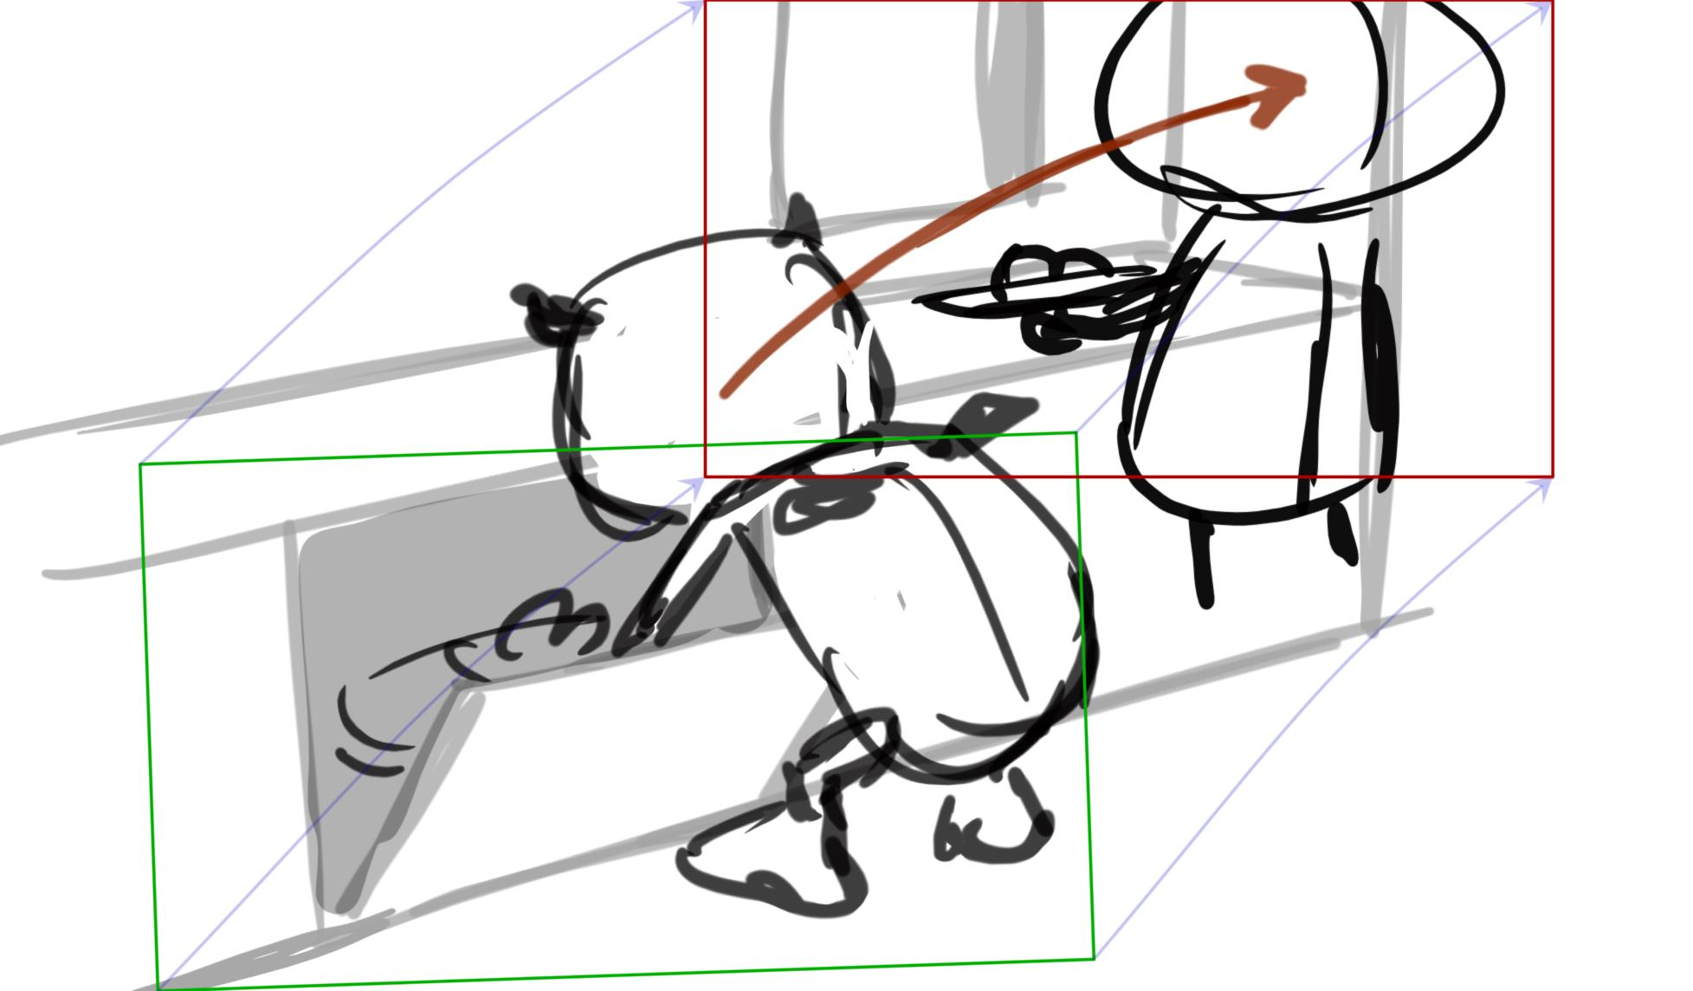

143­_01 – rotate the house to have the front door as in the sketch below



195 – start from empty frame, they quickly come in shot, and climb on top of each other

202 – Henry rolls in first, then Summer, Cobby, Momma, Daddo, who was in the room in part from frame one. We start pan only after Daddo is in in full, following him, and catching up with Momma as they roll into kitchen – pre-viz?

204 - Suggest to cut out, moving audio to 205

205 – make wider, like in sketch below. Mr. G. sees the rolling monsters. Then we zoom on him to see his thinking process - sketches below

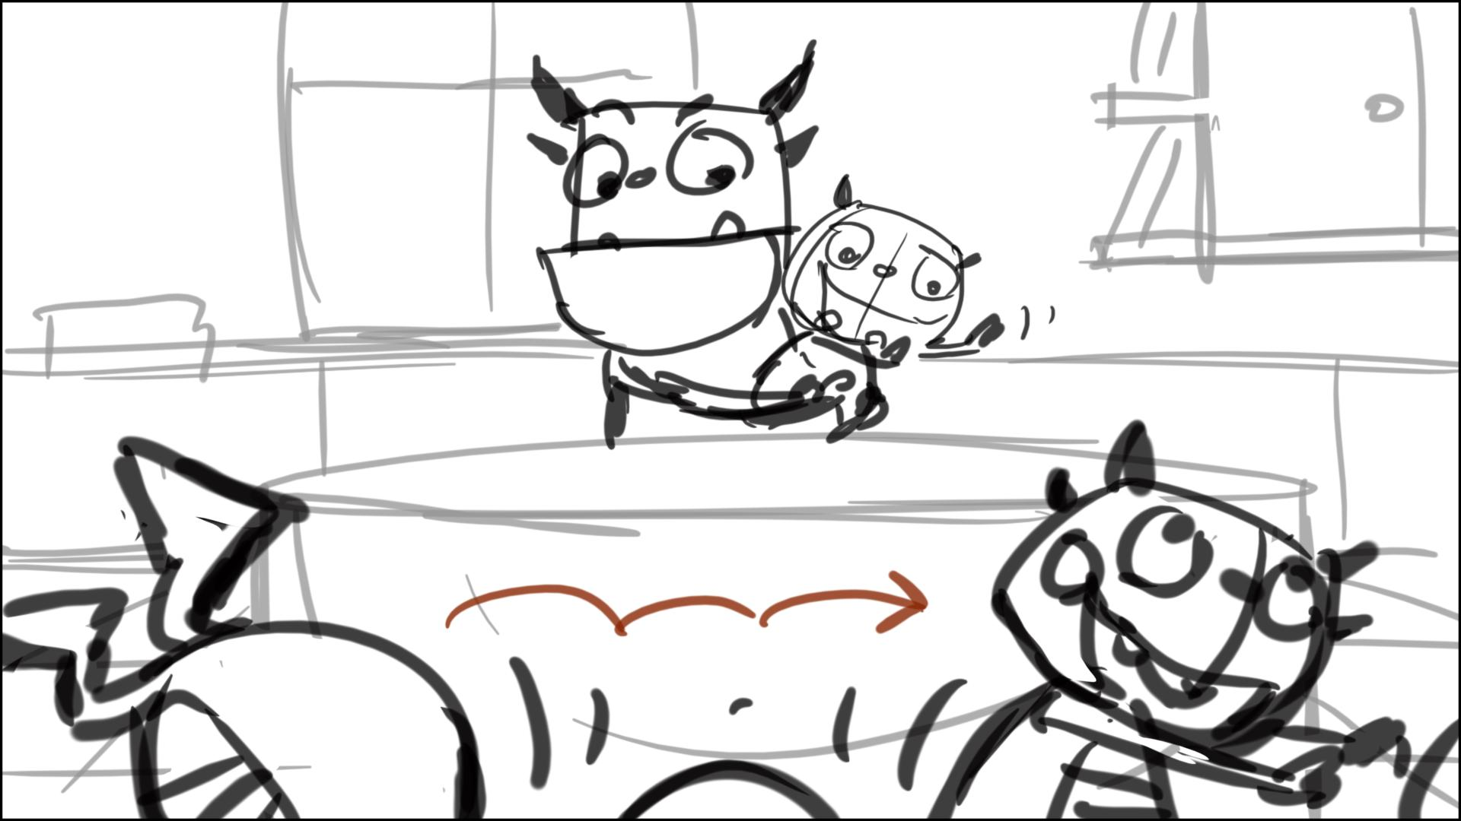

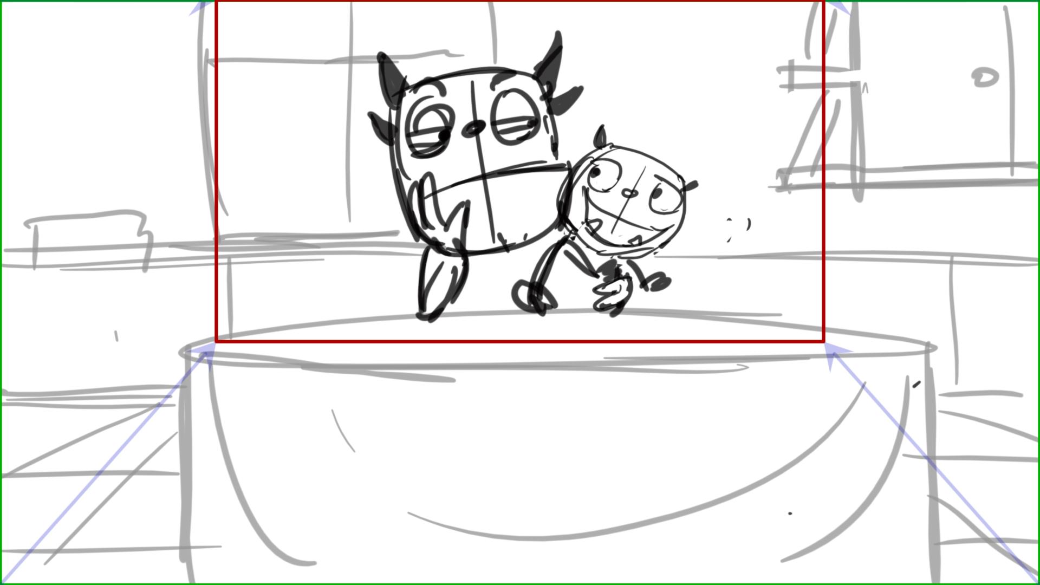

209 – Beckett walk out screen left in this scene

212 – Mr.G. is happy here, holding Ivor

216 – we need to see that this is the boys’ room. The balloons must be higher in shot, and we need to see the walls in part behind the boys - pre-viz?

218 – instead of this extreme angle let’s have a nice flatter panorama like in sketch below: the balloons are flying out the window one by one

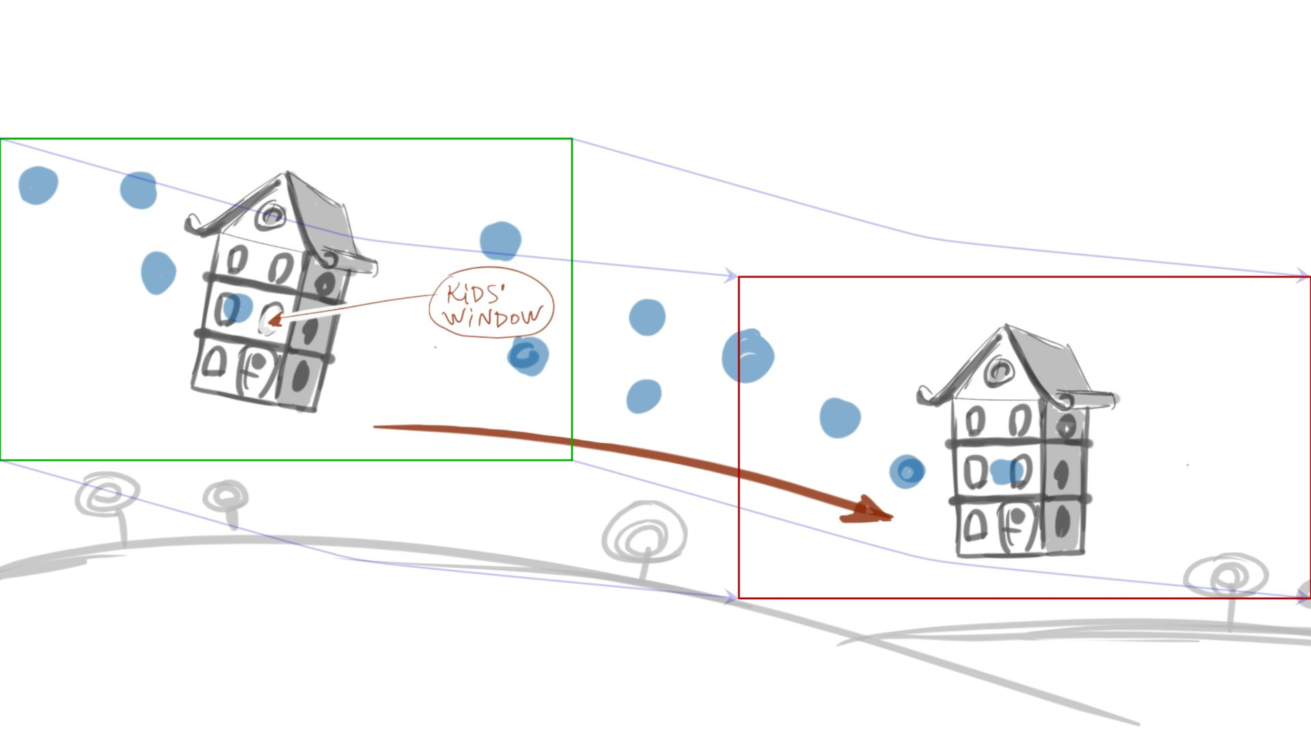

221 – Mr.G eats in not the most economic way (for 3D animation): will he use a fork, how will he hold Ivor, how does the pie look like - pre-viz?

225 – Mr. G. extends his hand to take Momma’s in the first frame of scene. Make a nicer pose for Momma for her “Oh….” – sketch below

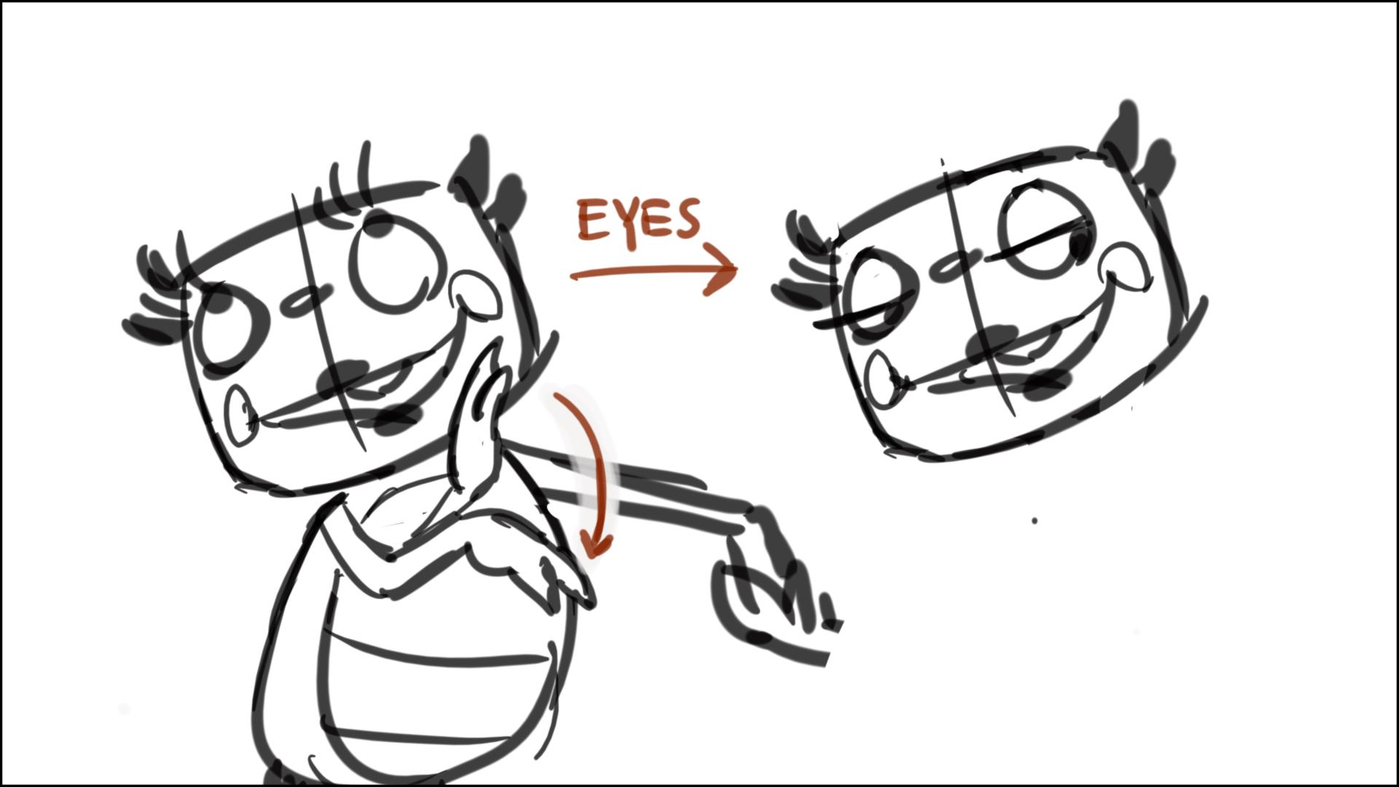

225 – 226 - can be easily combined into one scene

226 to 231 – Norton, scenes must have been cut here, continuity was lost a little. The ironing board appears from nowhere, and Momma hooks up (animates) to a flying Ivor. For hook up problem we can start from Momma, and pan to Daddo, and ironing board, hitting him in the heel, (sketch below) then Momma jumps in shot, but for ironing board we may need to add a quick scene early on - ironing board falls out of closet after house swings. I also suggest pre-viz for scenes 226 – 232 to see how high they can fly in the kitchen, and for cam moves

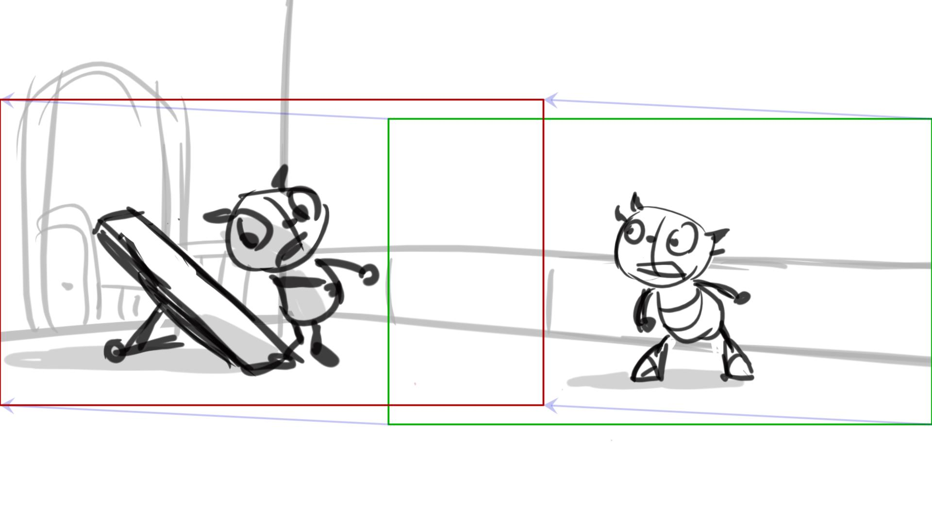

232 – Daddo/Ivor are out before cut

232­_01 – they look at Mr.G. in the end of scene, and then at each other, unsure of themselves – like in sketch below

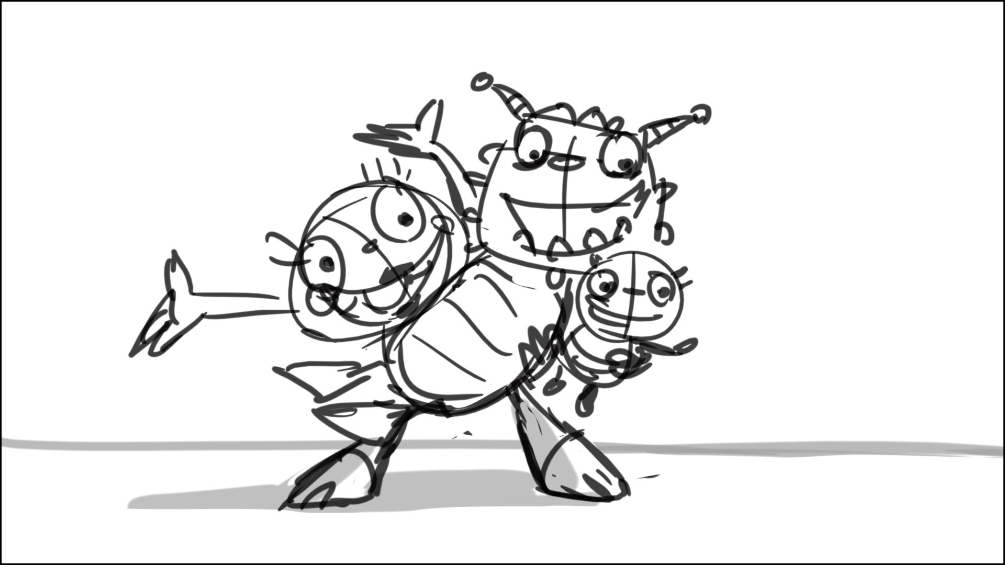

235, 237 – more definite poses here – they are not frightened, just sad, sketch below

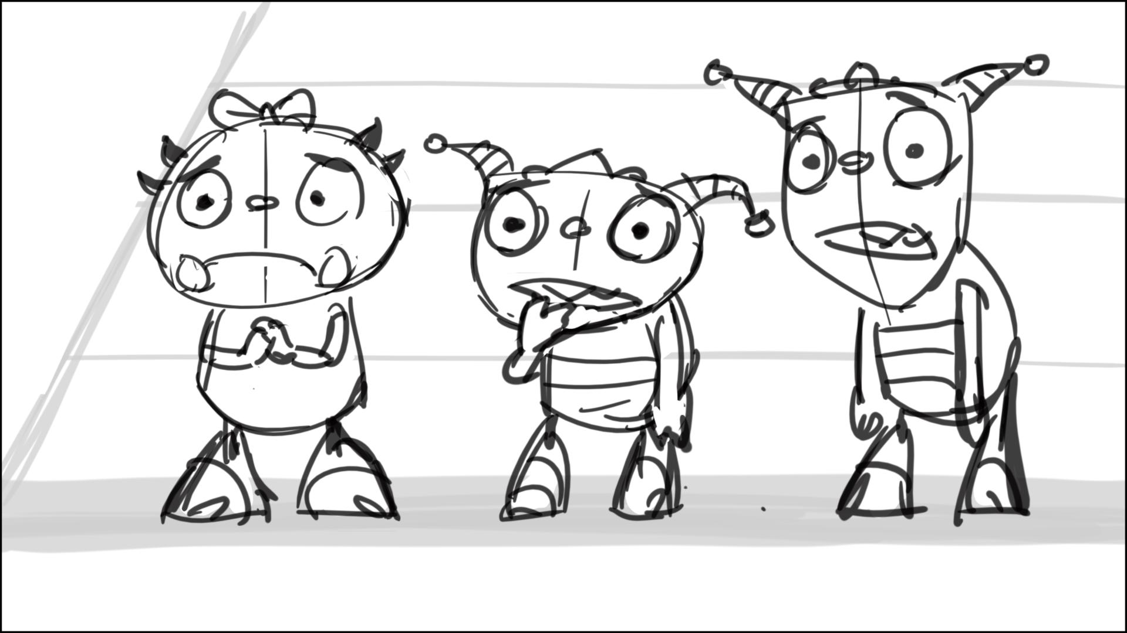

236 – add a nice touch, have Daddo hand Mr.G. his hat

239 – Henry looks rather forward, right behind cam, not to his left

242 – I suggest a quick scene of Daddo’s quick reaction, like in three sketches below, it will cut better to next scenes

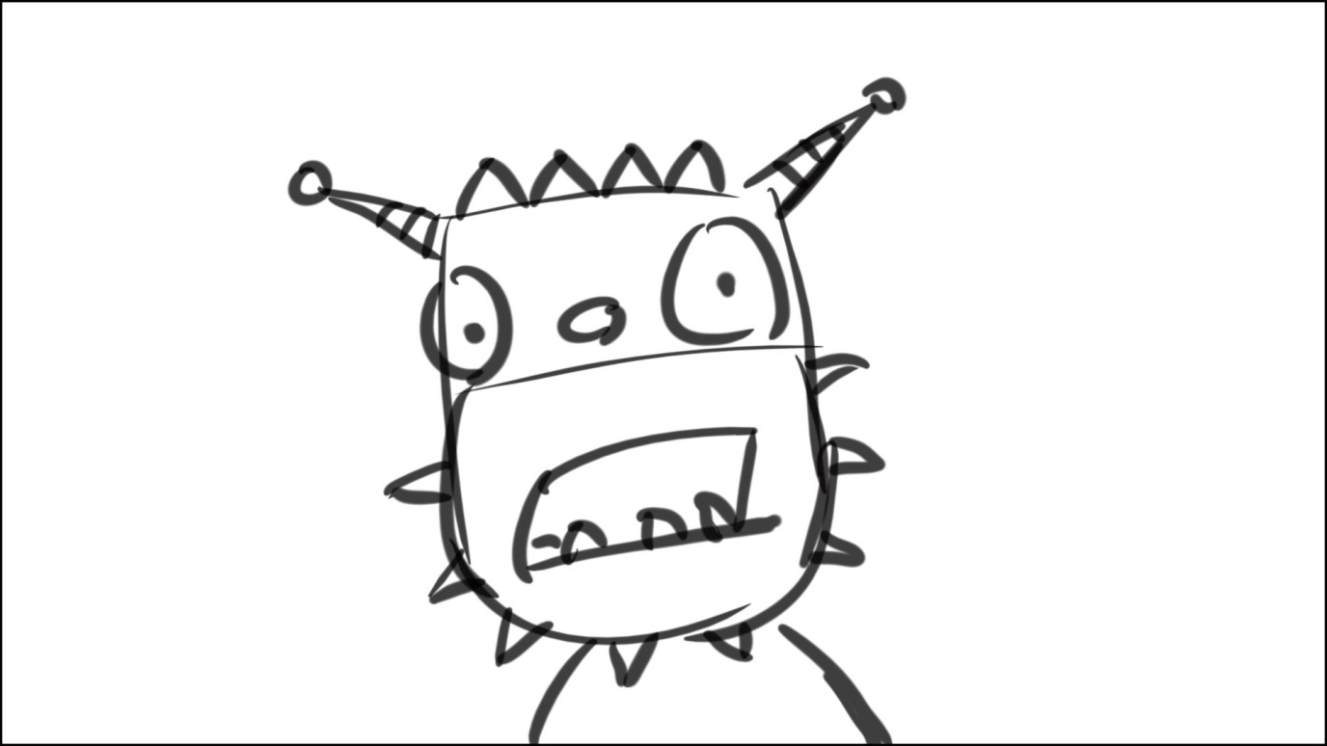

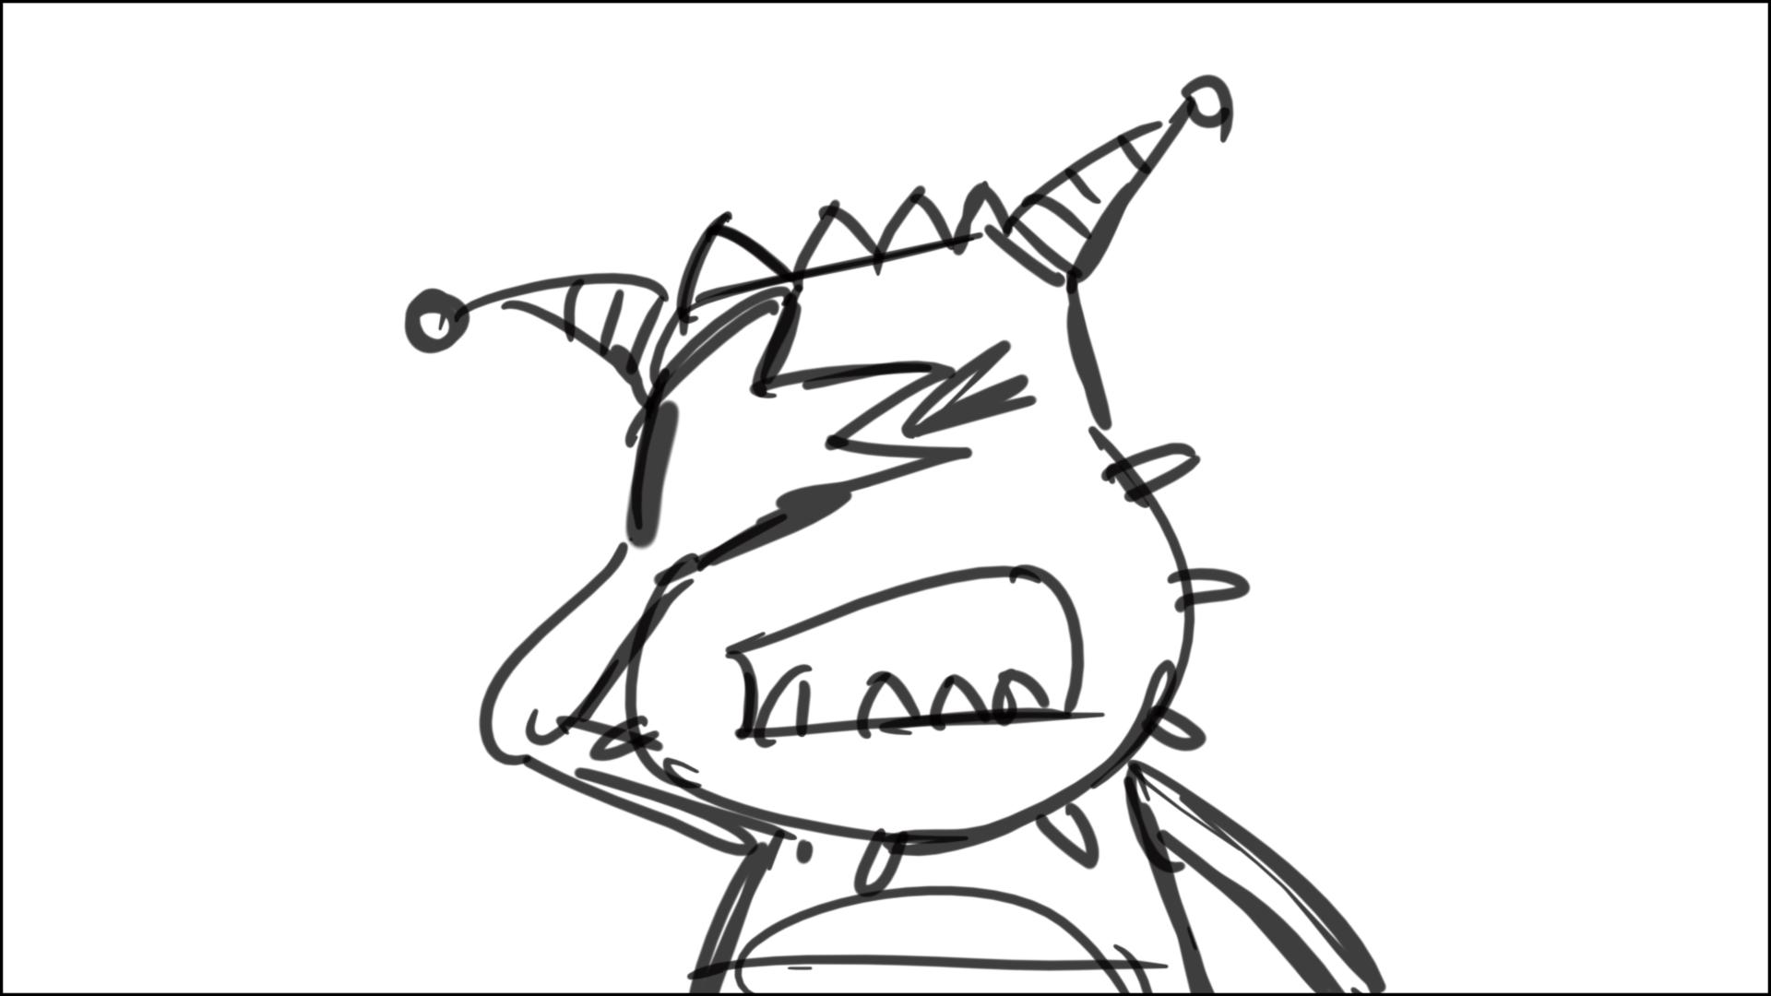

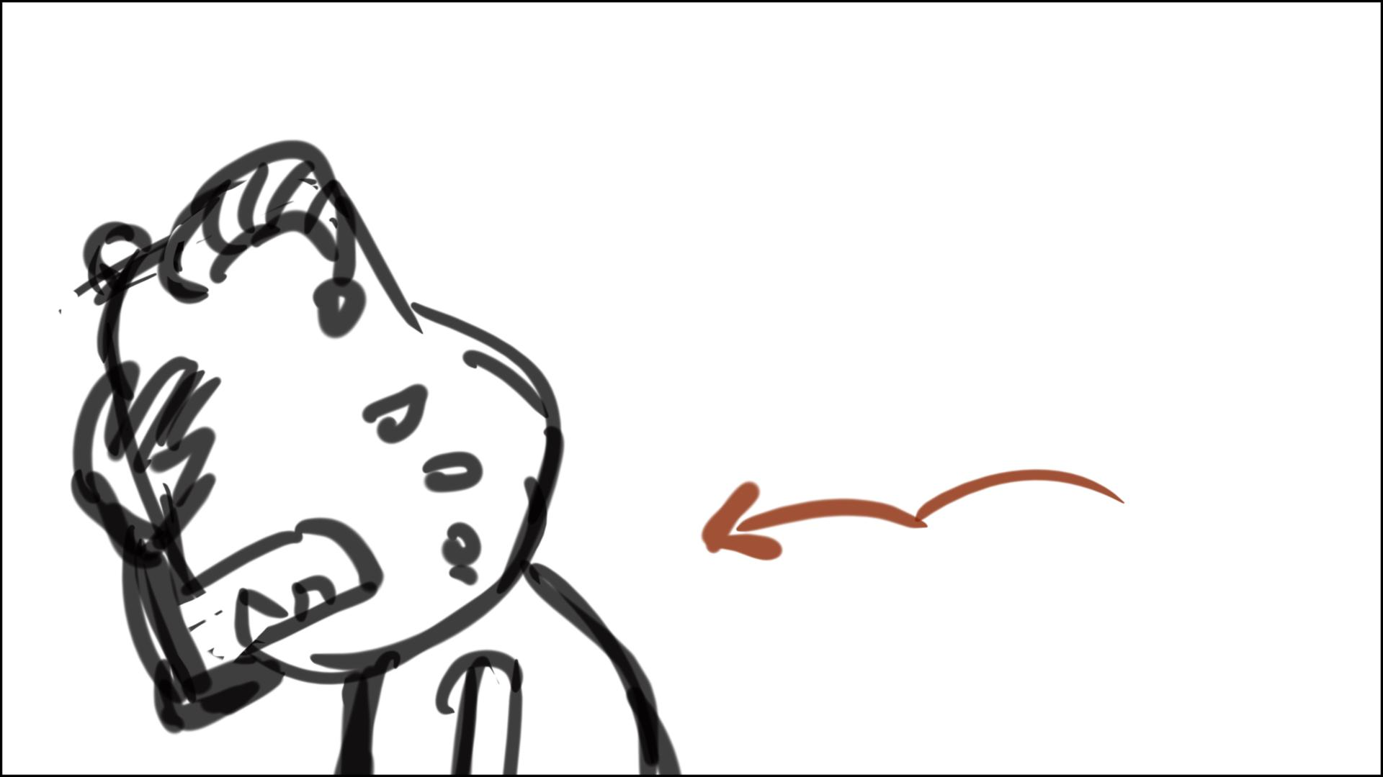

247 – start Daddo’s roar in this scene, and quickly hook up to 248, slow down truck out as D roars by 40-50%.

248 – have Daddo look up after a roar, and then close his eyes, as Henry talks to cam – sketch below

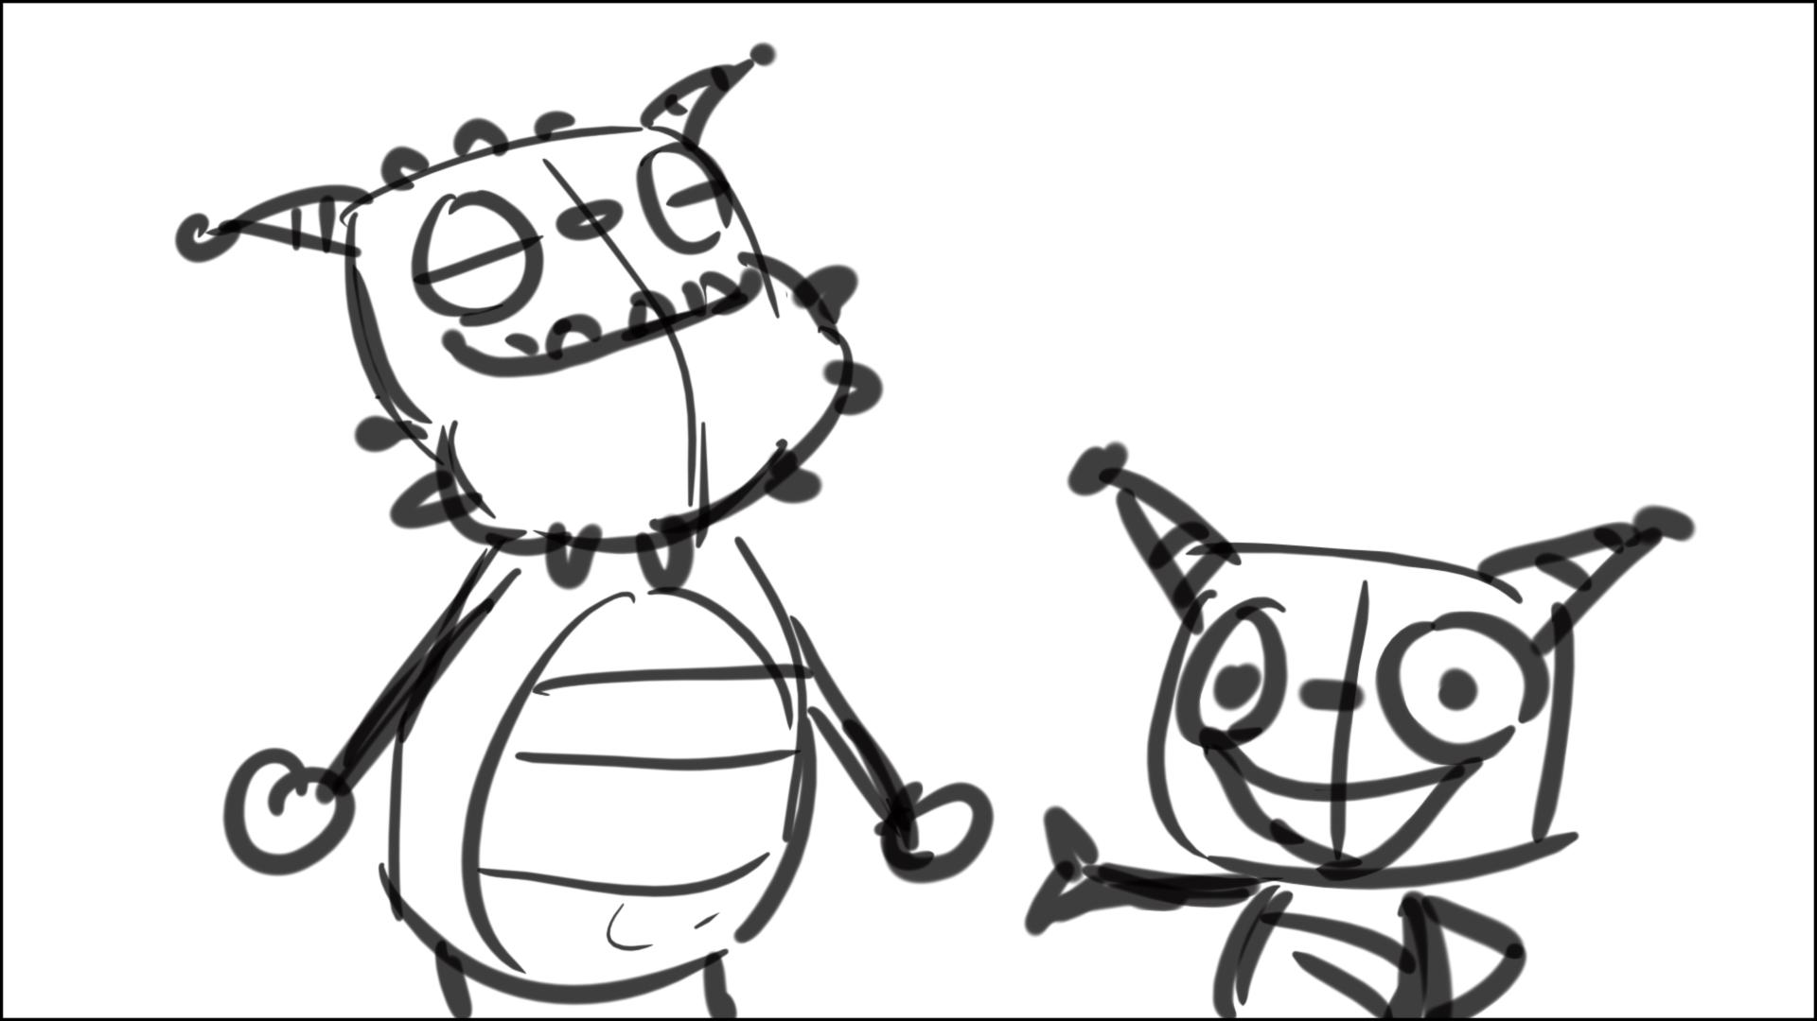

254 – 261 – problematic cutting, may need more attention at blocking

263 – Daddo says “Thank you Mr.G…..” to Mr. G., and only then turns to his left, following Mr.G., who is walking to stage