DIRECTOR’S NOTES (for clean up) for Monster kid on the block

Notes by page numbers

55 – 65 – we need to keep the sack on the ground, open (no need to animate it) like in sketch below. Henry just drops it, and picks it up later.

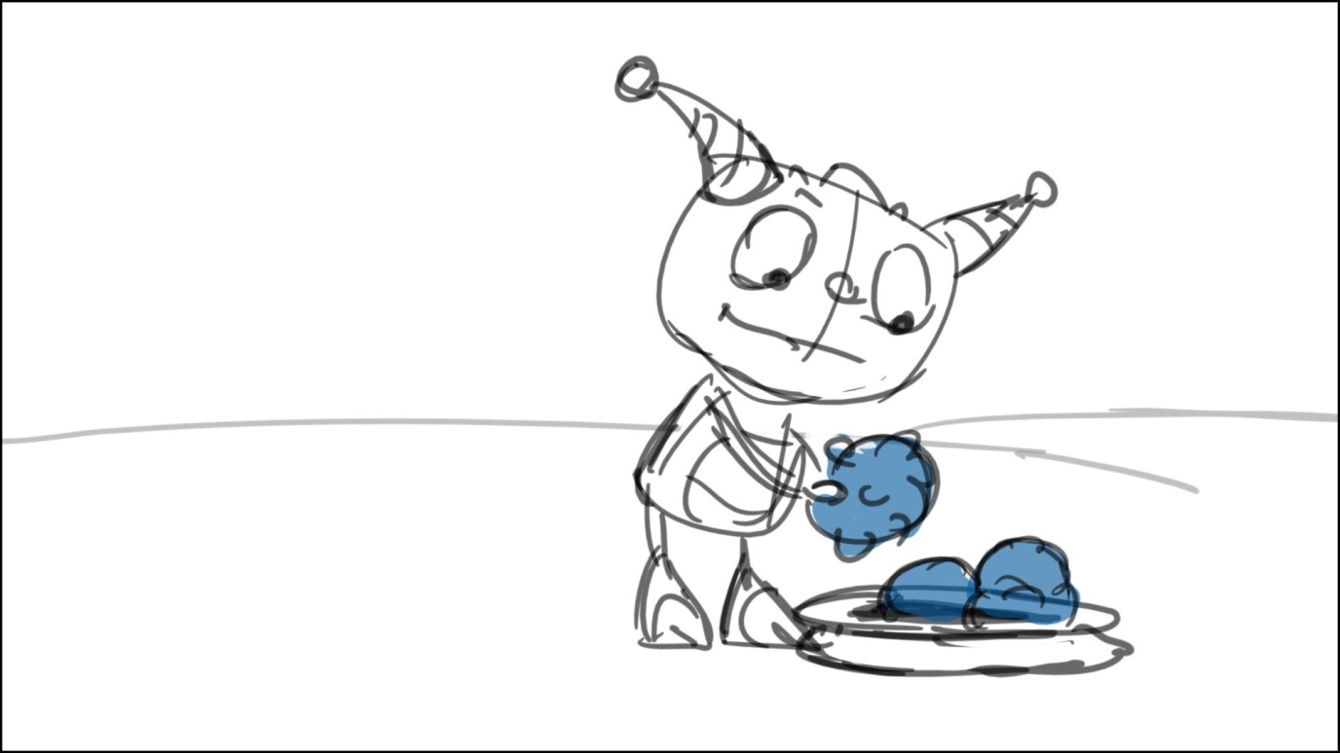

Old notes to be deleted:

4-5 – make it a little wider to have both wheels in frame

1-16 – please make clear (in clean ups) what exact part of town square the bikers pass in each shot: do they ride out of the square at some point, and in what shot, etc.?

10 – 11 - better to split the action: start from Higgins/his line, then cont. with Henry as he says his line, keep their faces to cam – sketches below

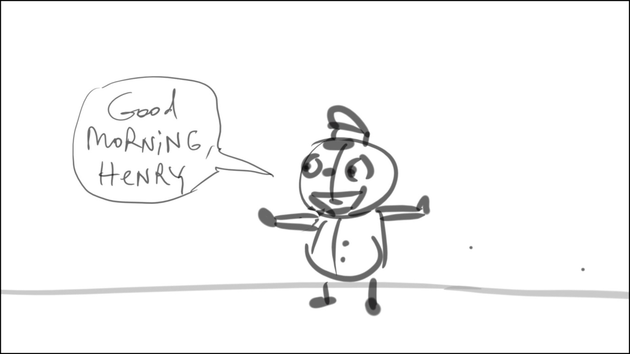

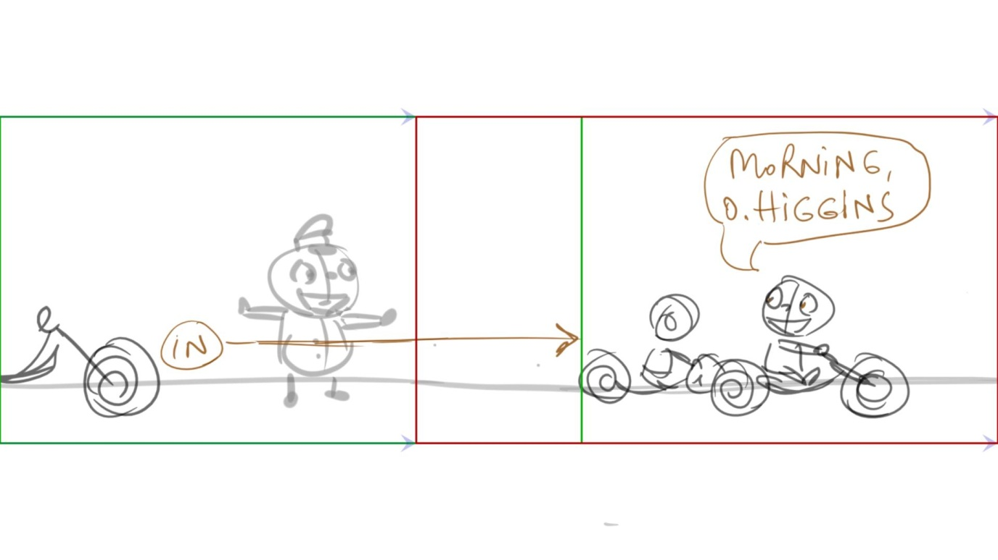

14 – cut to the people without bikers in shot, almost from H’s POV – sketch below

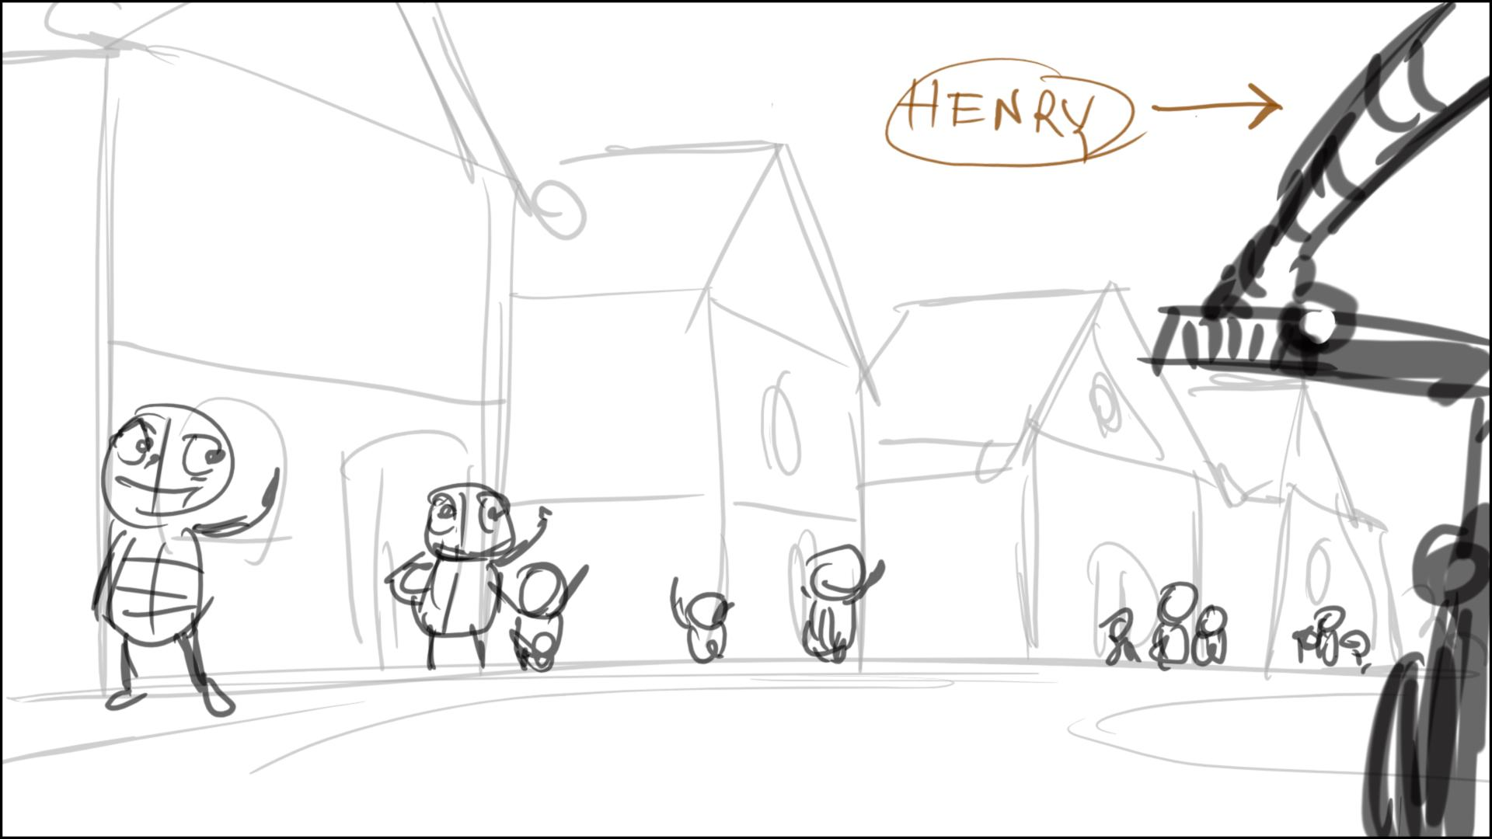

15 – make H wave to the people in the start pose (w/left hand)

20 - start earlier w/pan, and add Summer in shot – sketch below

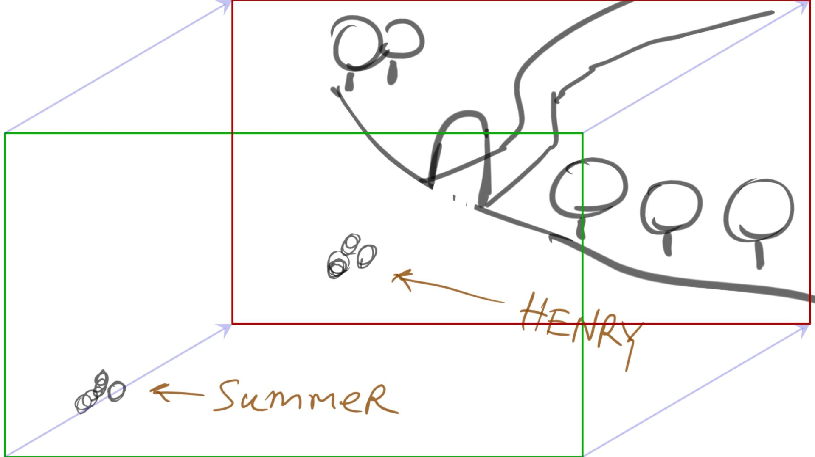

29 - 30 – somewhat jumpy cut. Lets have S jump all the way to H from 29, spin/dance around him on line 10, and splitting at the end of line 10, matching panel 36

25 – we need to add Ha-oh’s bike in shot behind her, at least in part

54 – much more expressive poses for the laugh

68 - Double check Estelle’s size, she is much bigger

75 – 76 – we use quick cam zooms on H in cases like this – when he talks to cam, let’s combine 75 and 76 with a zoom in on H

83 – Double check Estelle’s size, she is much bigger. This shot will look a little different now – like in sketch below

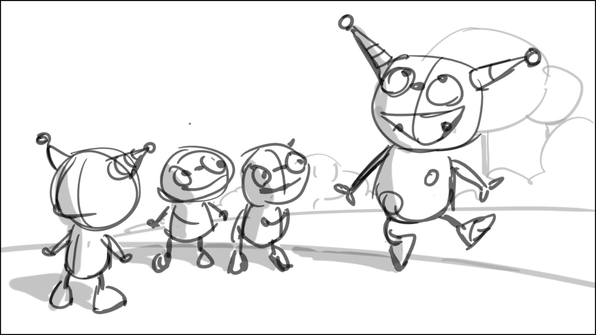

91 – let’s make a quick long cam zoom on the house from H’s POV here (through park’s gates, etc.) – like in three sketches below

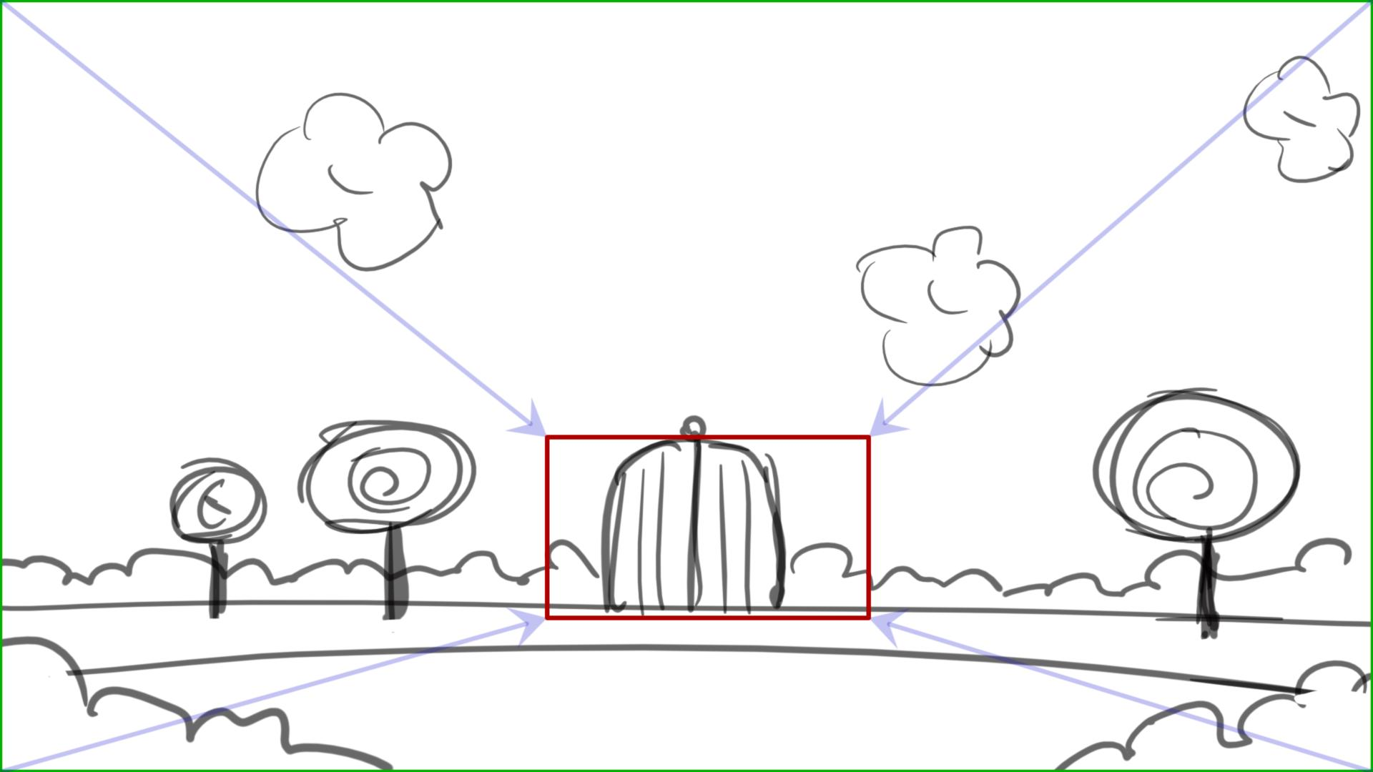

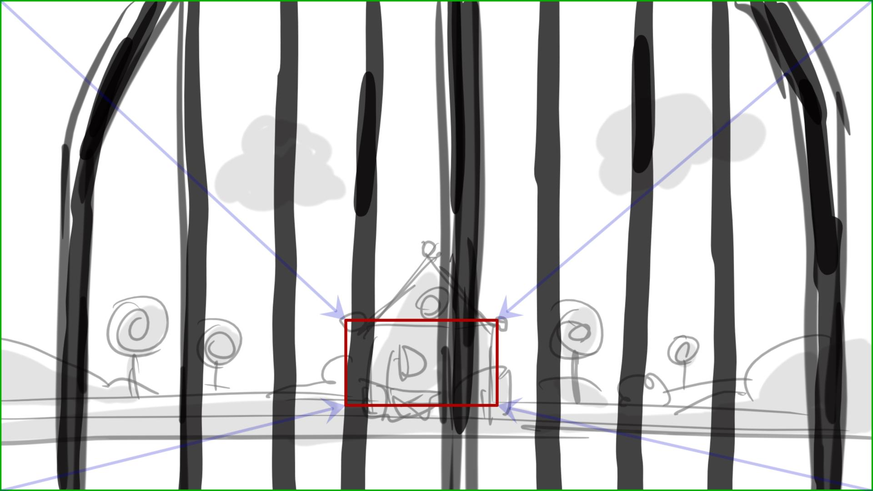

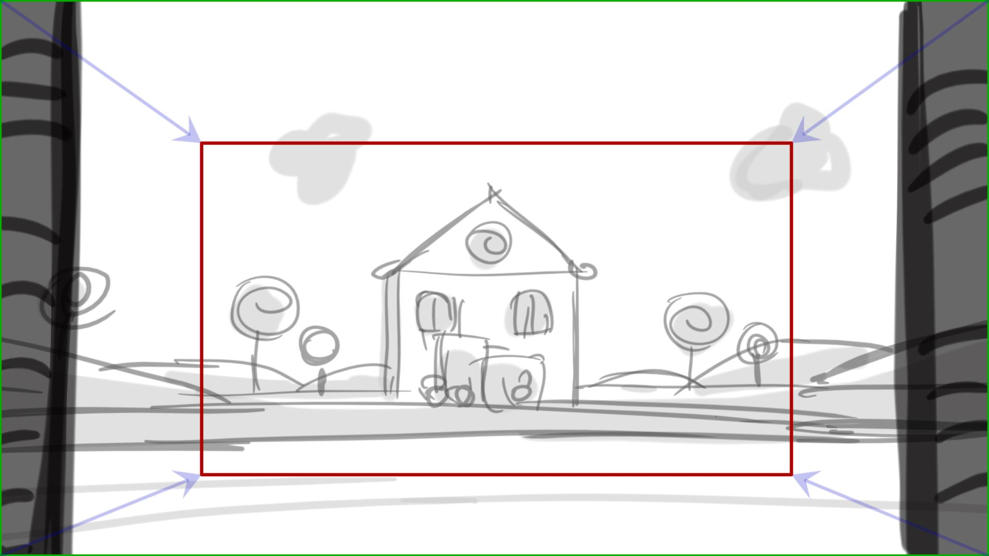

92 – close on Henry here – like in a sketch below. Megan, do we have designs of cloud monster’s house/ moving boxes/cart at this point?

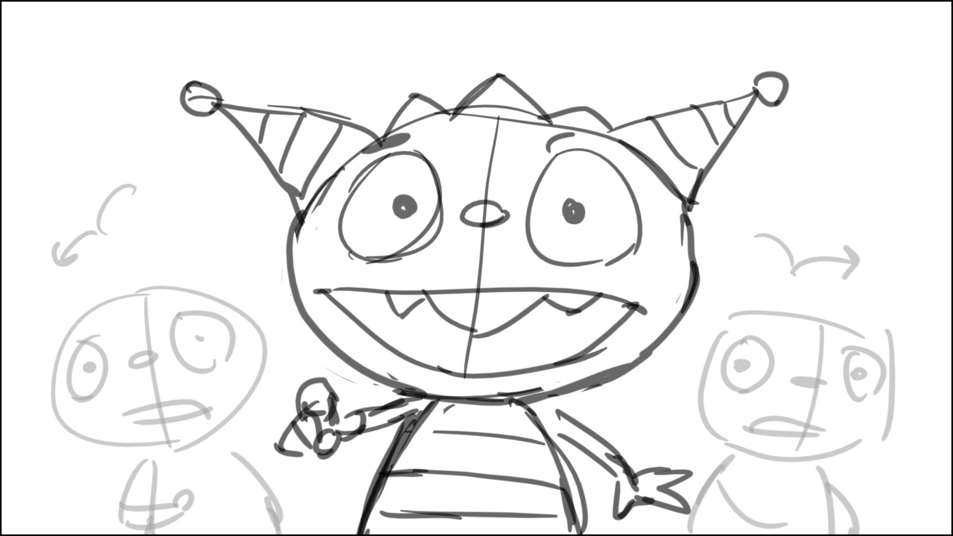  
93 – a quick cut back to house – pan from cart to moving boxes, then cut back to Henry, but wider, like in 93

97 – position H so he would point toward the house – like in sketch below

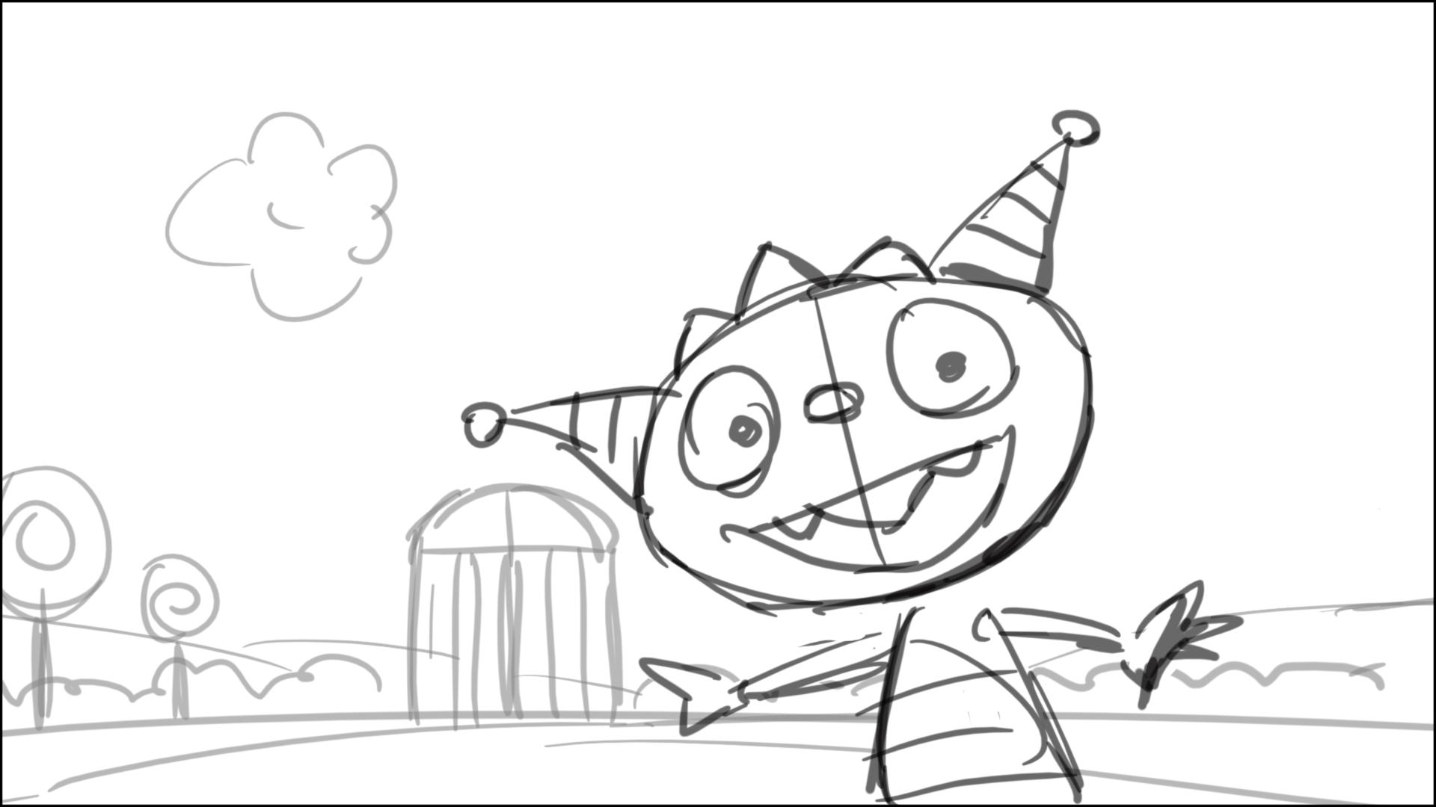

99 – lower cam angle, adjust Estelle’s size. The correct size/composition is in sketch below

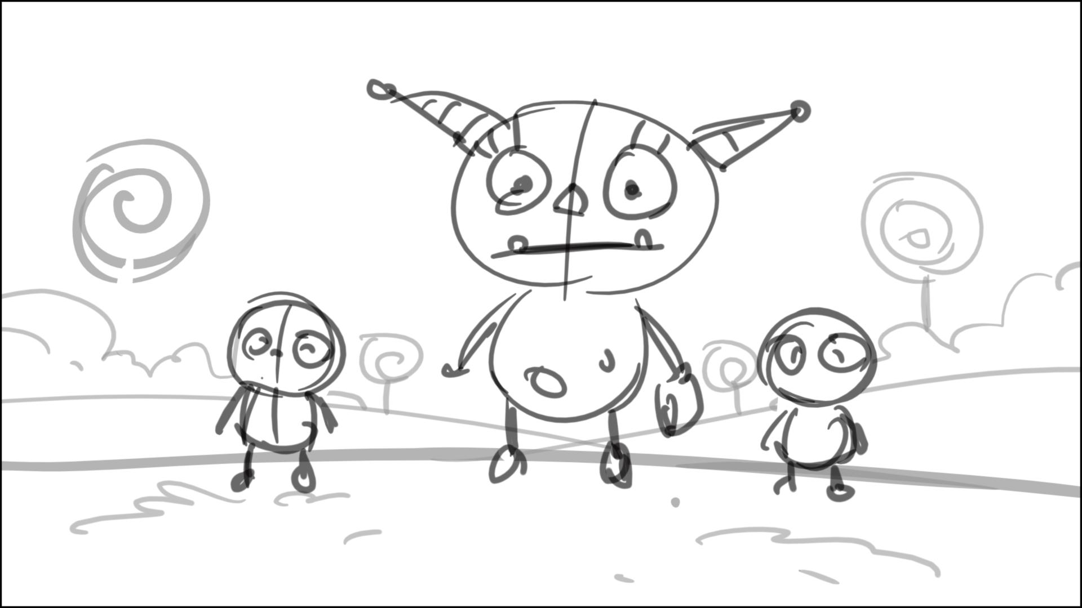

102 – no cam move is needed here, just cut to the house

103 – make the clouds readable, raising upwards with cam move

105 – H looks almost to cam here, just missing it – like in sketch below



110 – too many interaction with the bag in the ep. – we don‘t need to animate it in that many scenes. Please have the bag open, with the balls sticking out enough for easy grabbing without touching the bag – like in sketch below

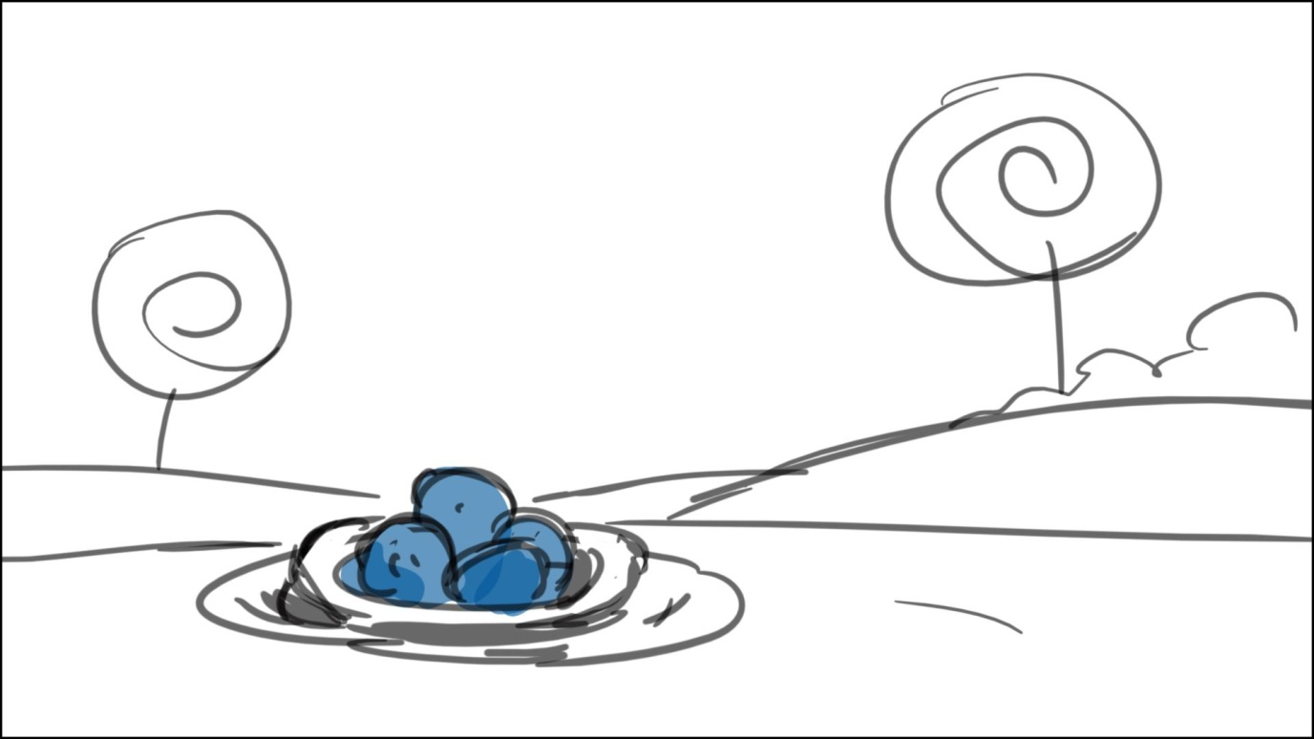

111 – They don’t use their hands in Hball game – look ref. movie file (Hball game). They use their bodies only It looks wrong now!

114 – if the house is across the park, shouldn’t we see the park behind Henry here?

116 – let’s make it a little more interesting – like in sketches below

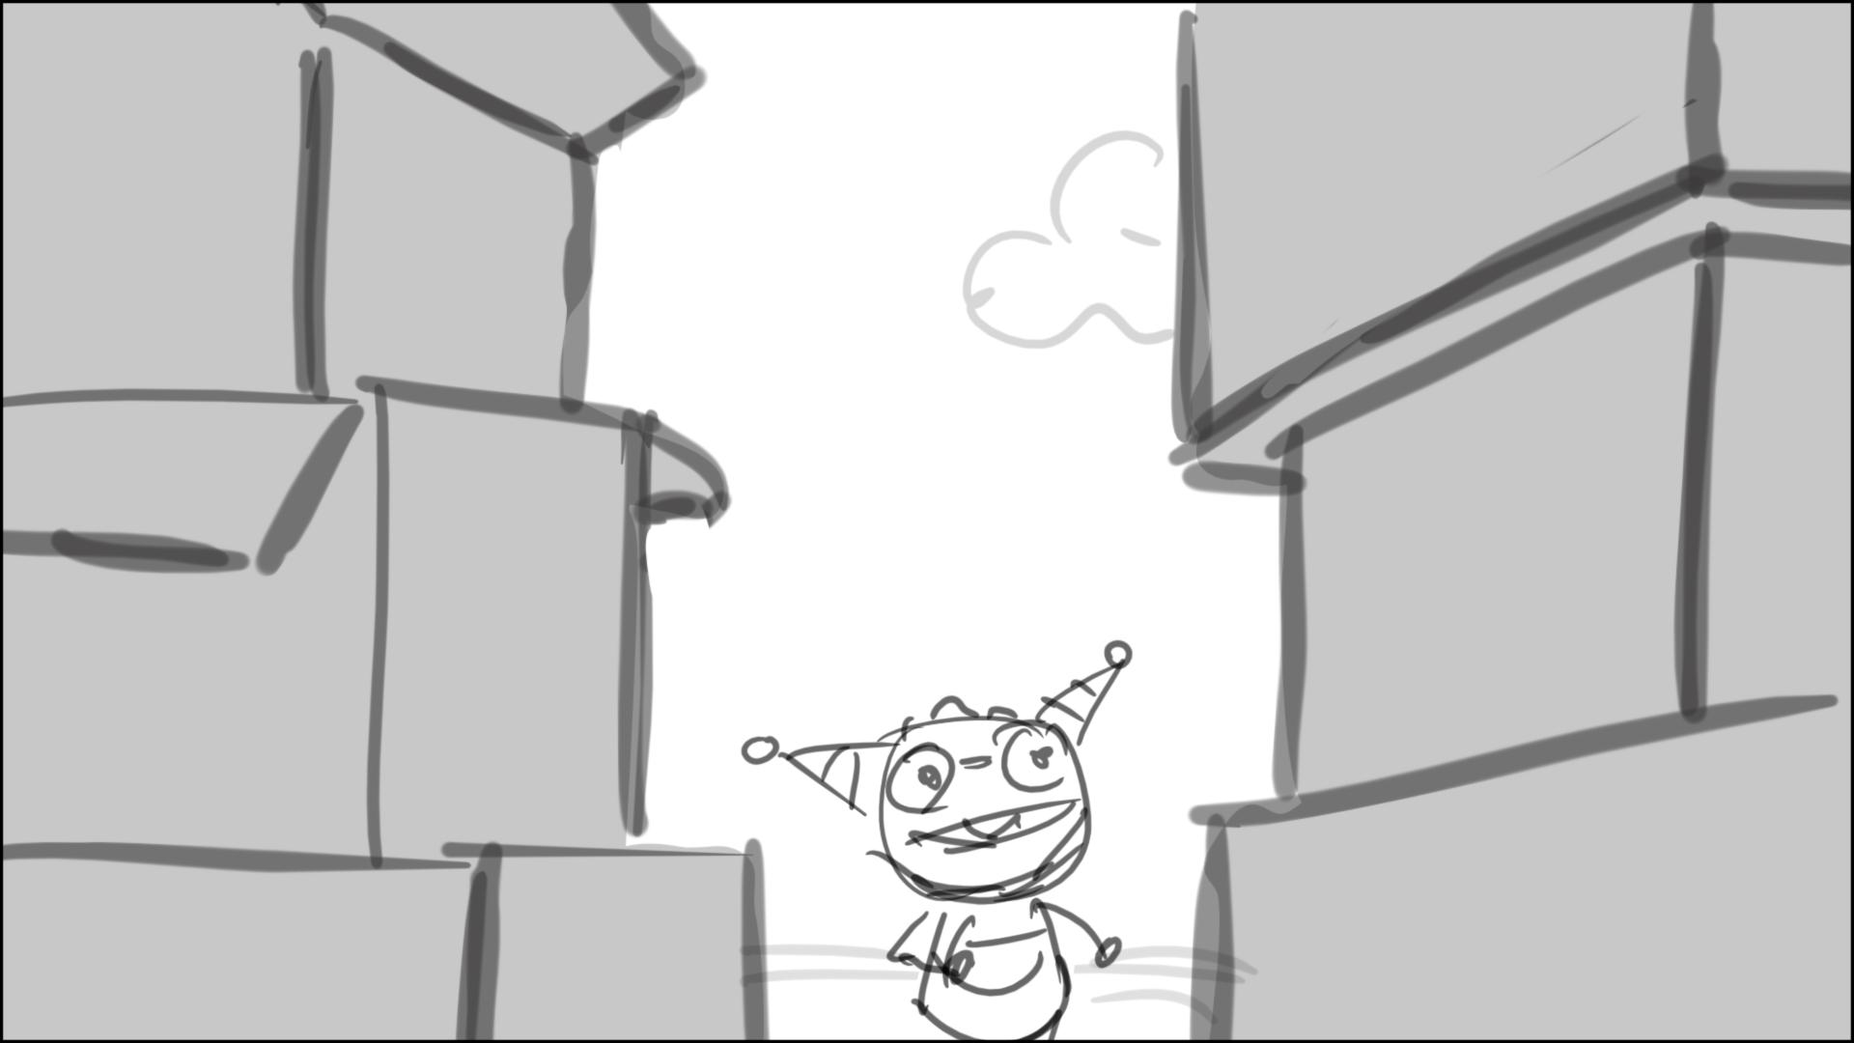

Cloud monster flies of screen here…

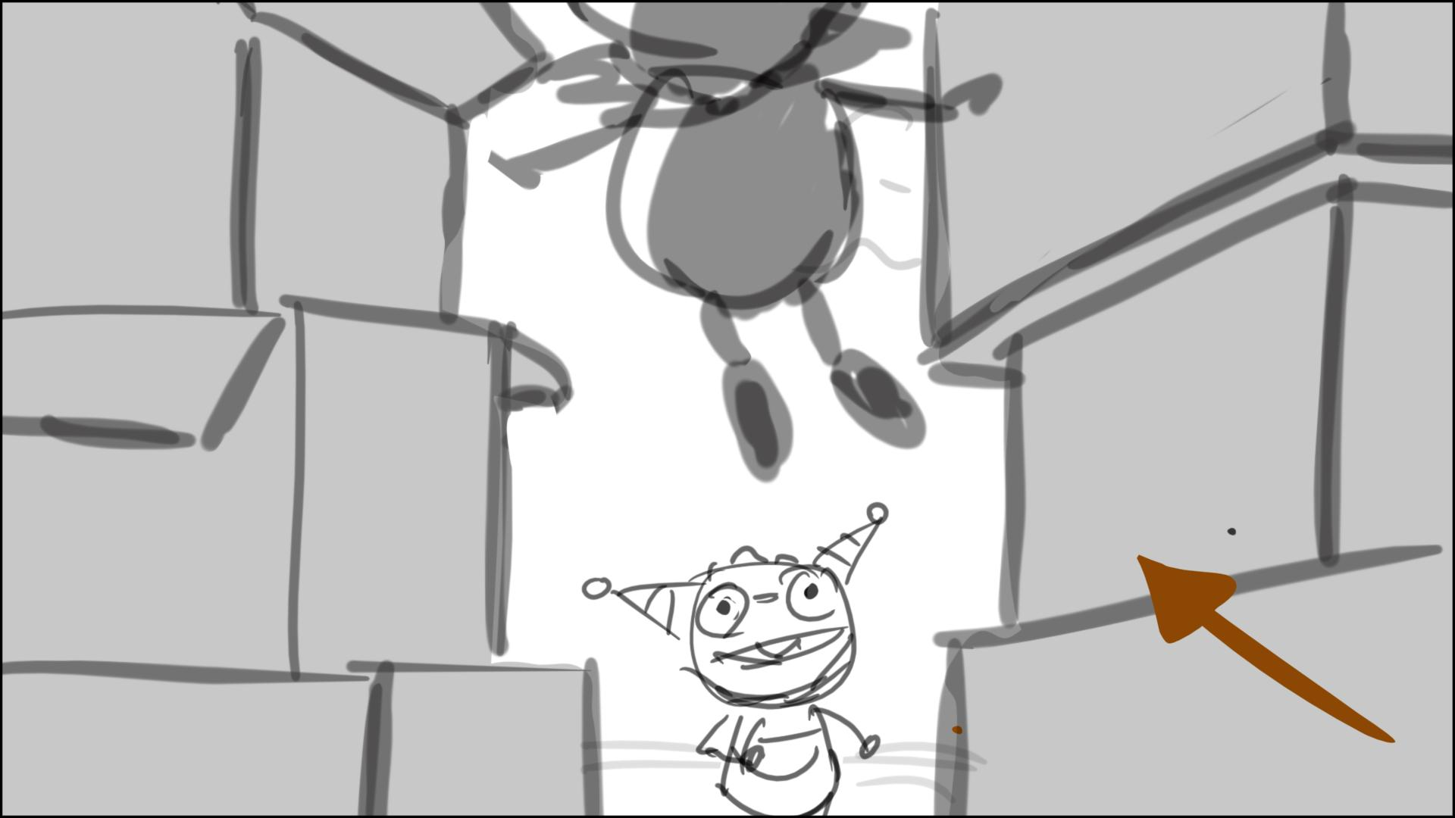

Then we cut to H’s POV – Roddy with box on his head – below

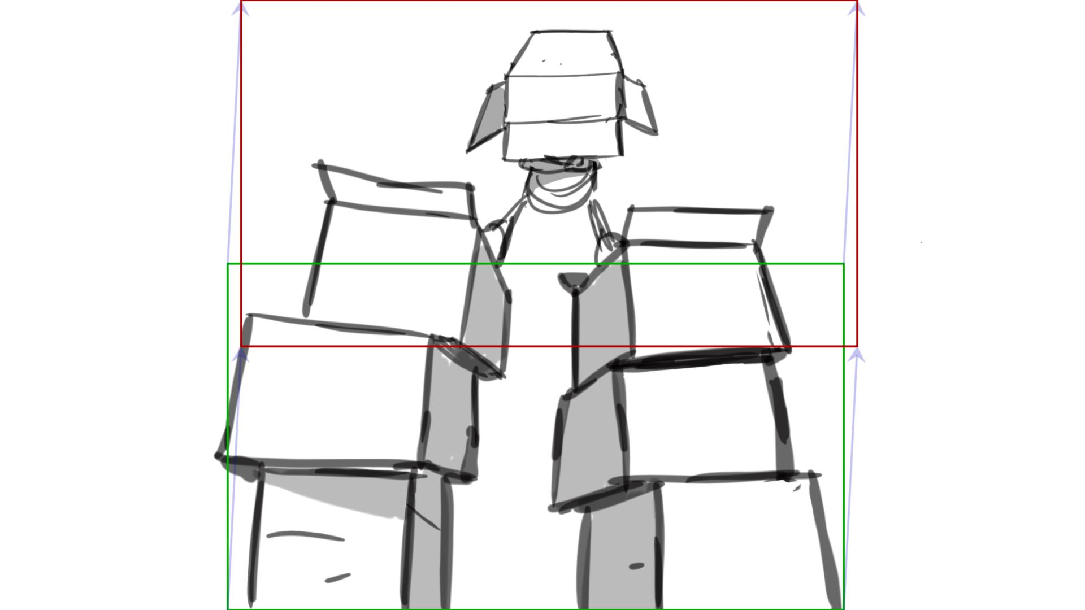

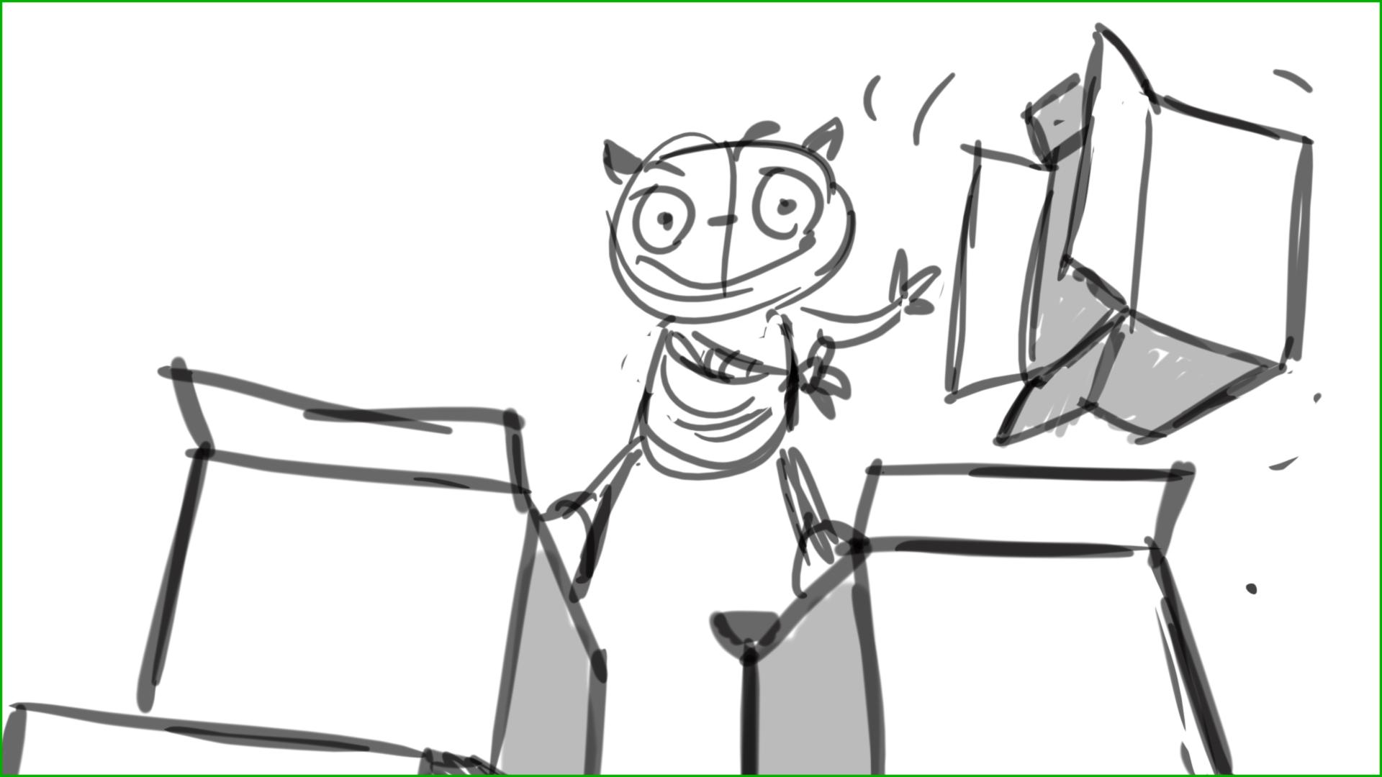

Ruddy remains on top till line 43, (keep cutting between them using tilted angles) then he flies down for a tail/hand shake

124 – we need to see more of the cloud - that makes Roddy special. We need to see cloud float above H, who is astonished by it. Only then he turns to R with his 45 line

130-133 – let’s cut to H earlier, when he is still shaking off the cloud

134 – H should point behind him, we should see the gate of the park

135 - we need to see R spotting the playground. Make R jump to see the playground like in sketches below

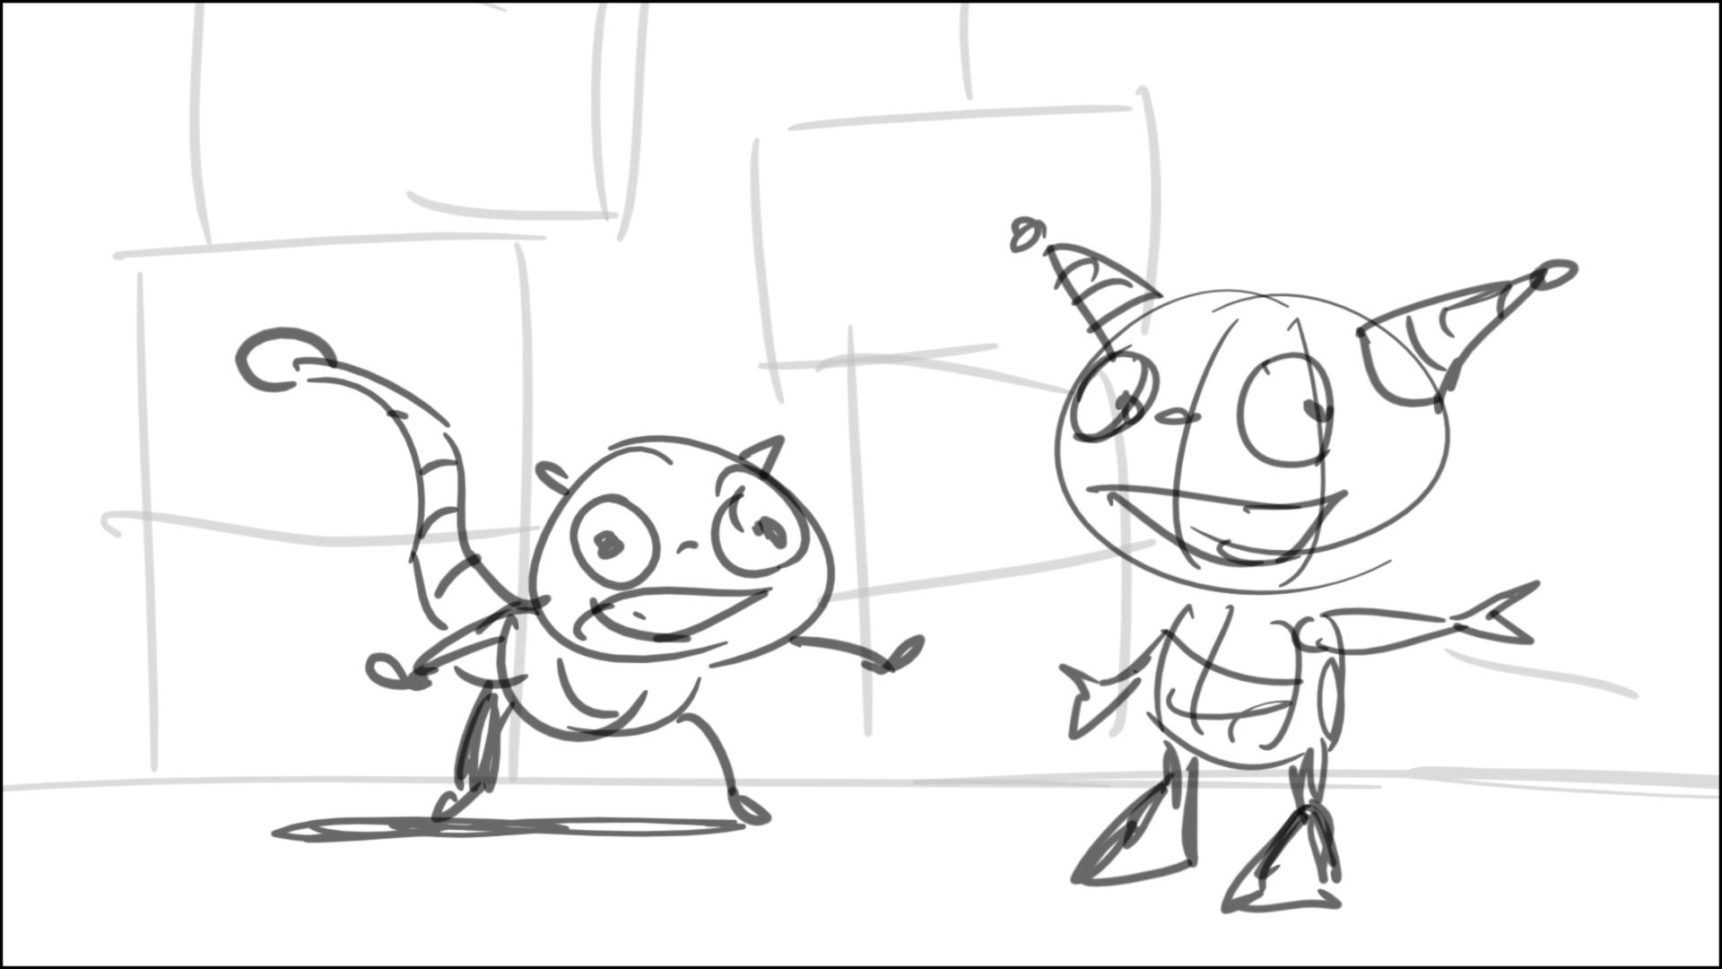

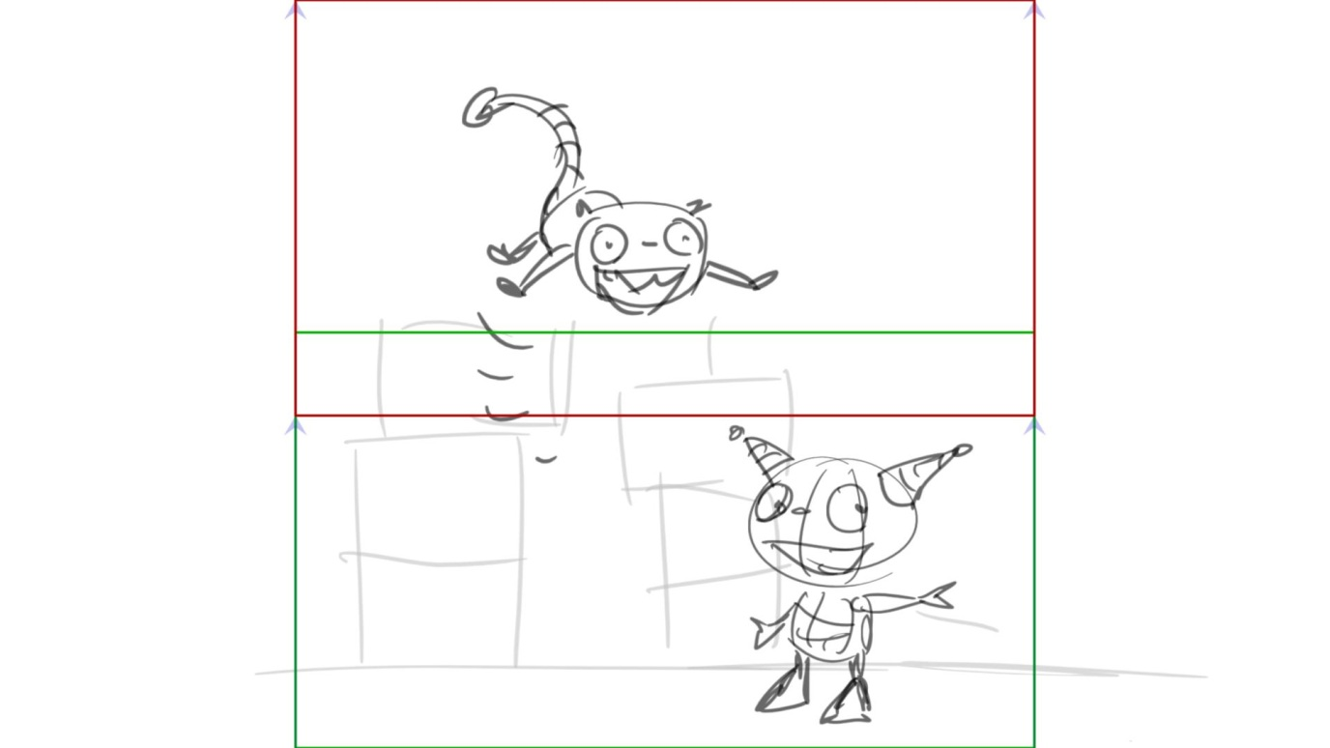

We cat to R’s over the shoulder shot to the playground – below

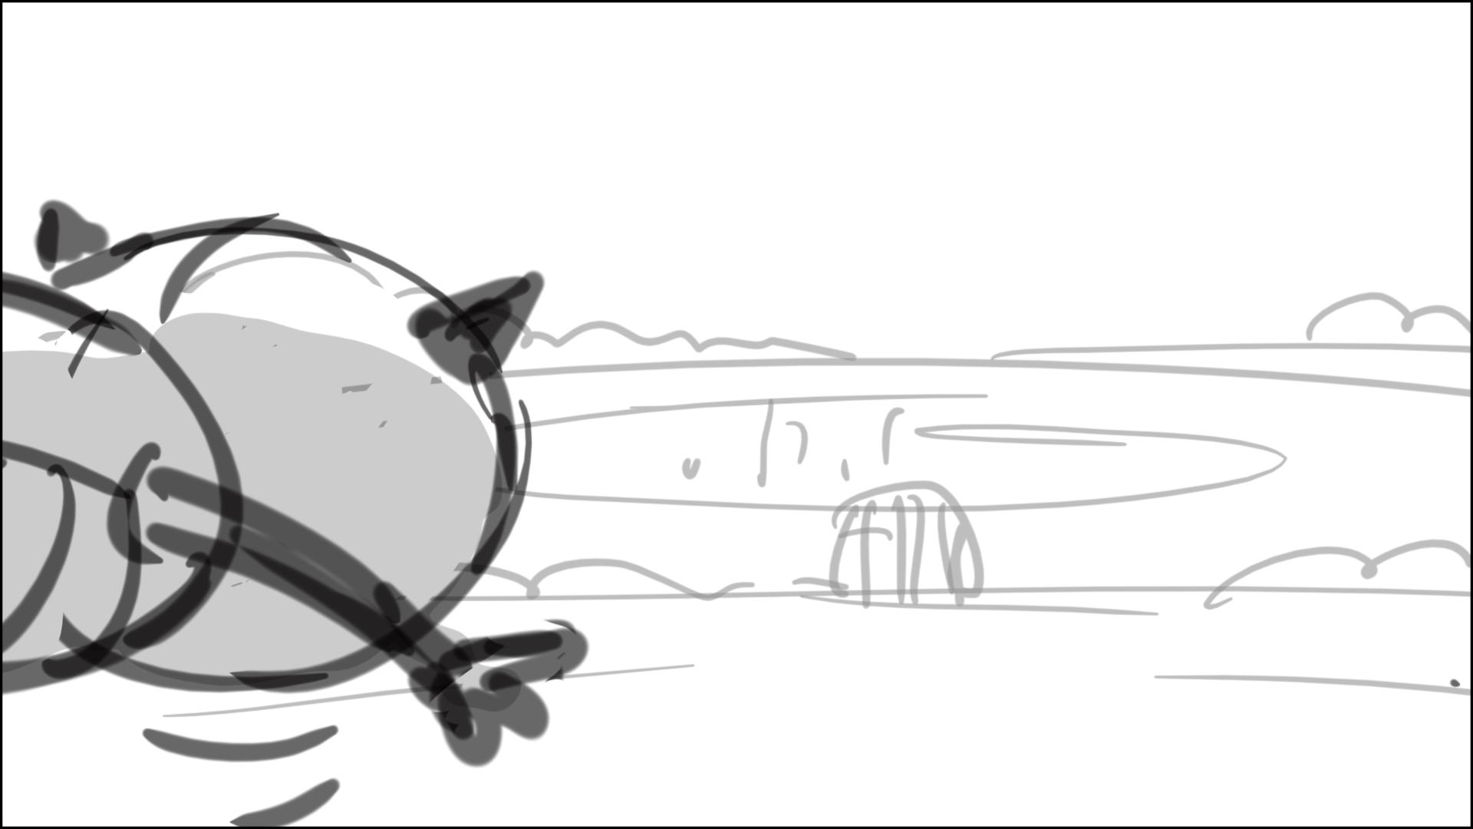

136 – we need to see Roddy running to the park, away from cam – sketch below

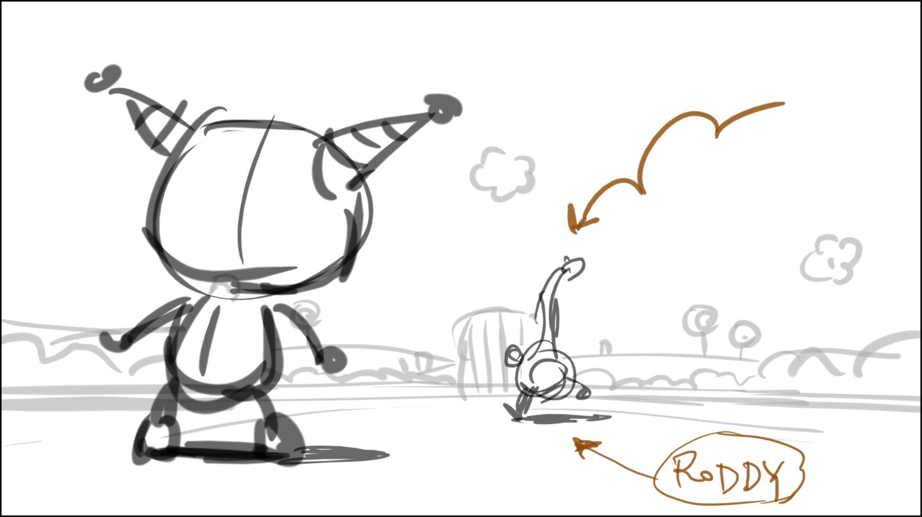

137 – H says it to cam, and then runs after Roddy in this very shot – below

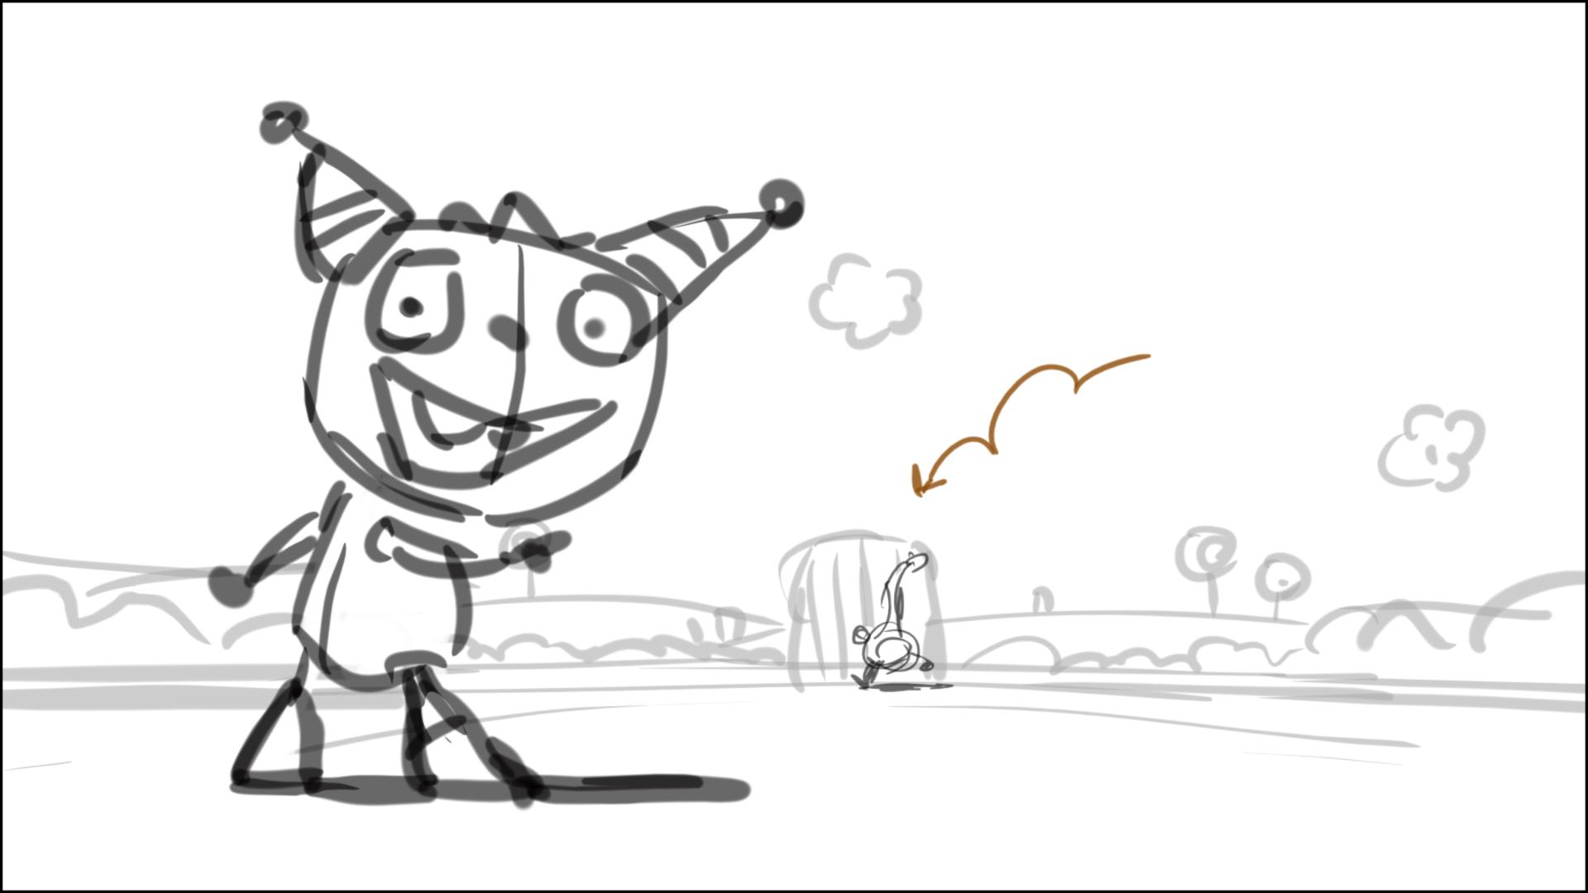

139a – we need to see R running here (to Denzel)

142-143 – doesn’t work. We need to see R’s tail grabbing the m-g-round, and spin it with one stroke – sketches below.

We need to have a closer look on the stopping/grabbing – below (match the m-g-round design)

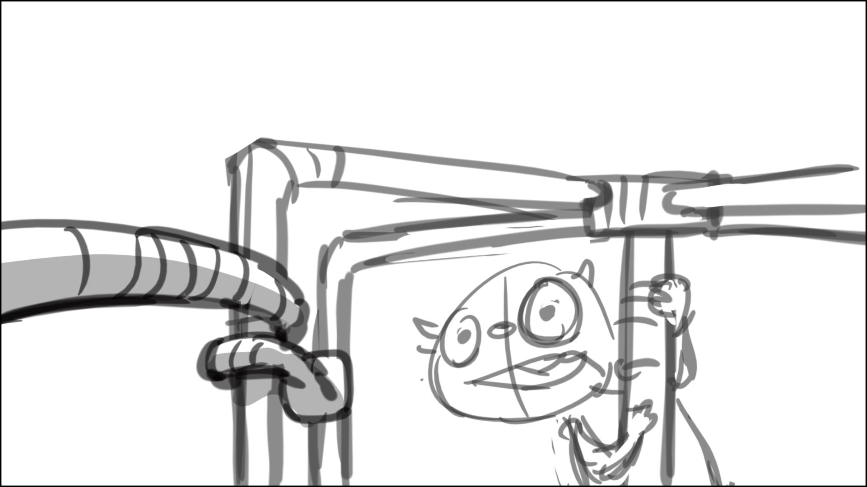

And then for spinning – below

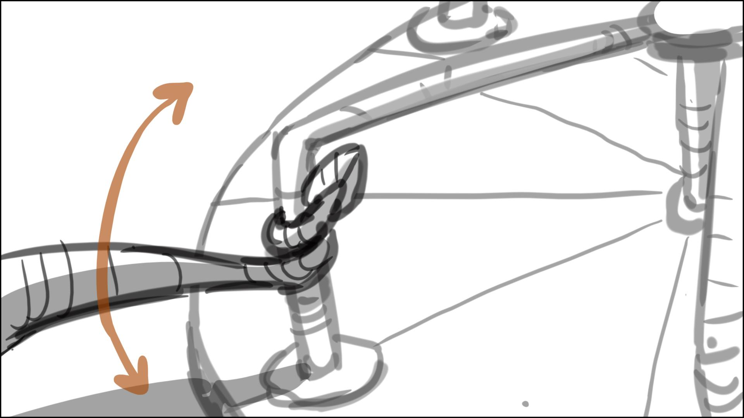

And then we need to see down shot for Denzel spinning/R laughing - below

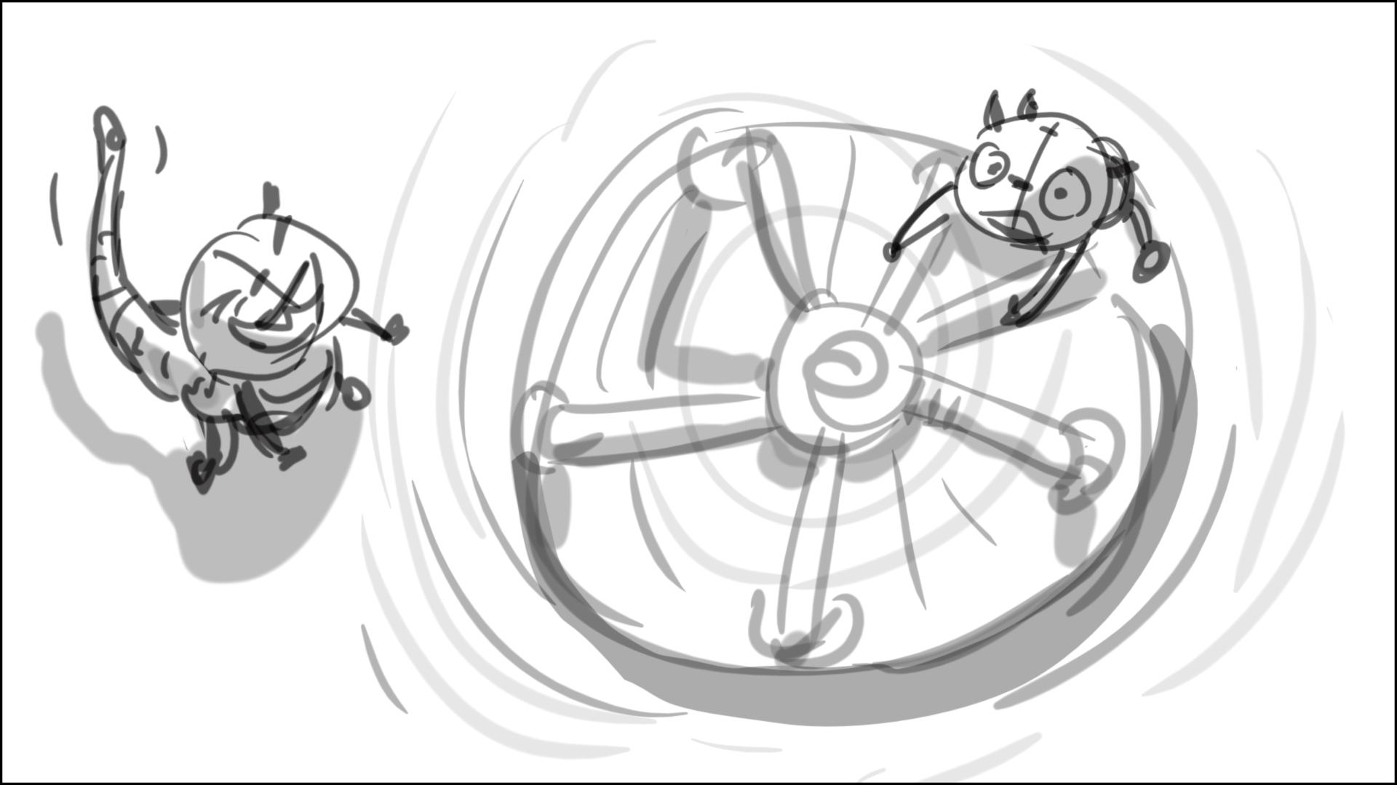

146 – D should fly at a sharper angle

151 – add pan w/a to follow Max before he goes o.s

155 – same here: add pan w/a

159 – have H fly up a little to catch Ava in the air, and then land with her

161 – pan to Denzel from H/A, we don’t need to keep them in one shot, make the action between Denzel and Roddy clear: Roddy is running around dizzy Denzel – like in a sketch below. Denzel can plop on his butt later

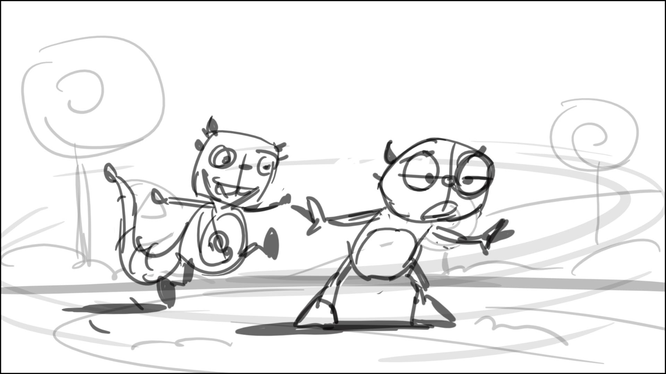

165 – H leaves frame here

166 – and enters frame here

167 – let’s make the cloud form under H, and raise him up a little, spinning 360\*. Then cloud quickly dissipates, and H plops on his butt - like in sketch below

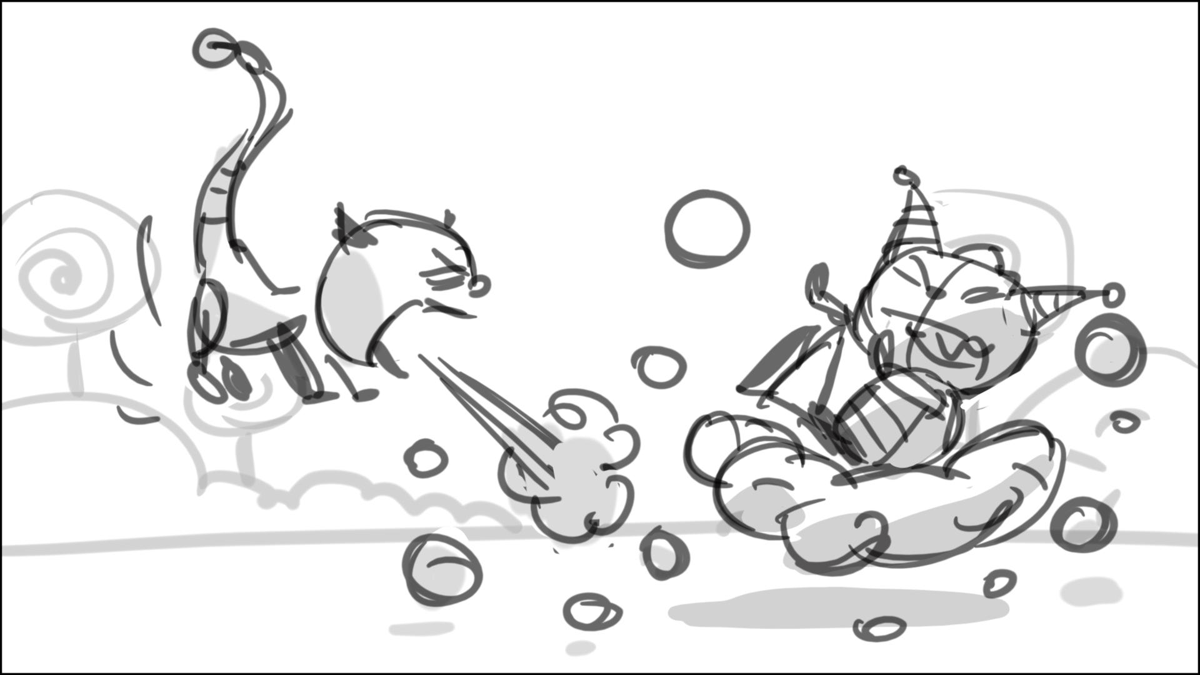

169 – H says is sitting on the ground, looking at the dissipating cloud – sketch below

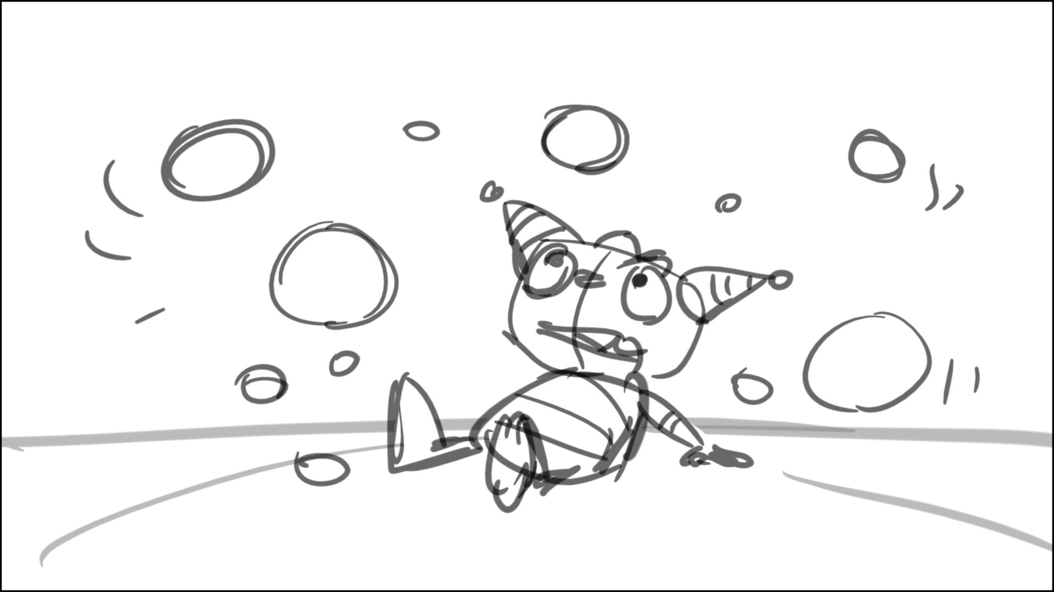

171 – Estelle’s size is wrong

176 – make H say his 72 line in this scene: pan up, and have H turn to cam

206 – move swings screen left, so Summer walk in a clear silhouette in relation to the rest in shot

209 – make cloud rise above H’s head, and pour a quick rain on H here

212 – Henry says his 89 line (to cam and the boys) as he walks, picking up the balls, then drops them in the bag (bag is not animating here) – sketch below

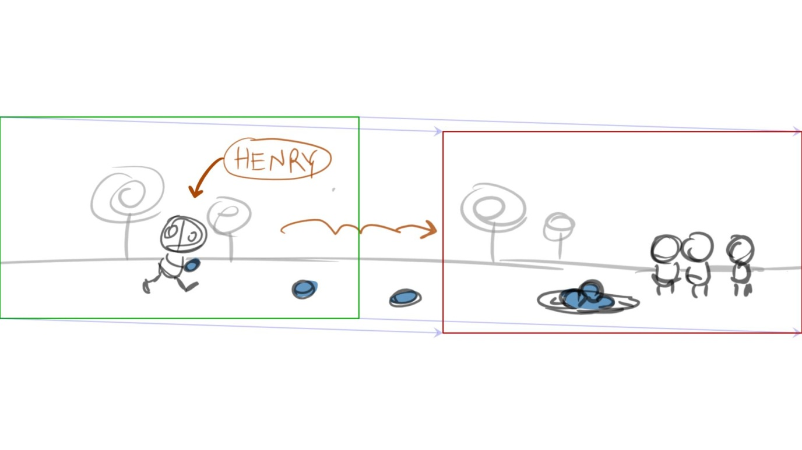

216 – no bag grabbing/ animating on “it’s time to just walk away”, Henry just drops the last ball into the bag, and just stands next to it, till Roddy comes ins.

218,219 – no bag grabbing/ animating, Roddy drops his tail into the bag, and all the balls fly up, landing/sticking around it – sketch below. Pan with R a little, then cut back to kids as in 220, but lower cam angle please

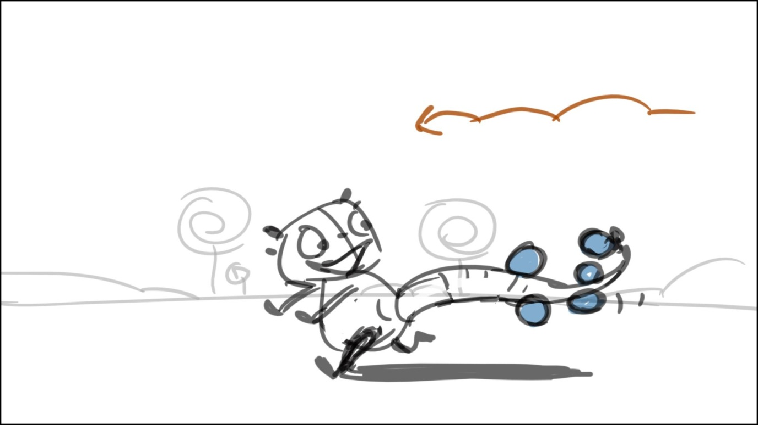

221 – quick zoom in on H here as he speaks to cam

223 – adjust the tail with balls (no bag)

225 to 226 – strange cut, lets combine these two scenes with cam move. Keep it wider when R jumps over table. Show watermelon clearly flying up in the sky, after R jumps off the table – sketch below

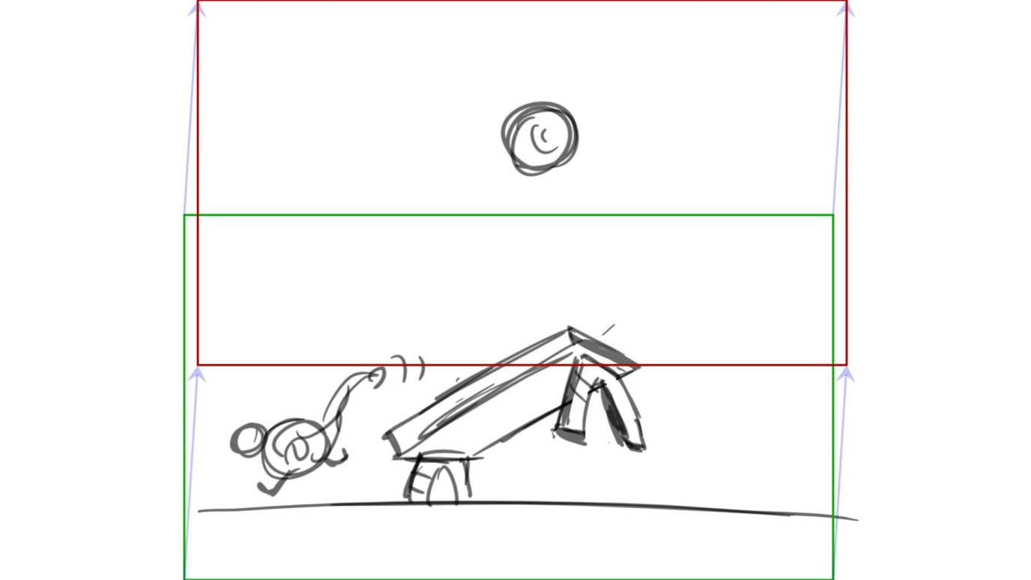

240 - adjust the tail with balls (no bag)

242 – make R jump on the skateboard, make a circle around the boys, and then roll away, widen shot

251 – make R sway left/right on skateboard, make H sway too – will be funny

251 – insert a scene of Roaartonio/Harold carrying food - to see the type of food they have in order to understand the food mix later

254 – no hands, no bag, R drops his balls by just flipping his tale

255 – make sure it’s Roartonio’s café in BG here

258 – have a shot of them turn to Henry’s scream (look out !) before they step on balls

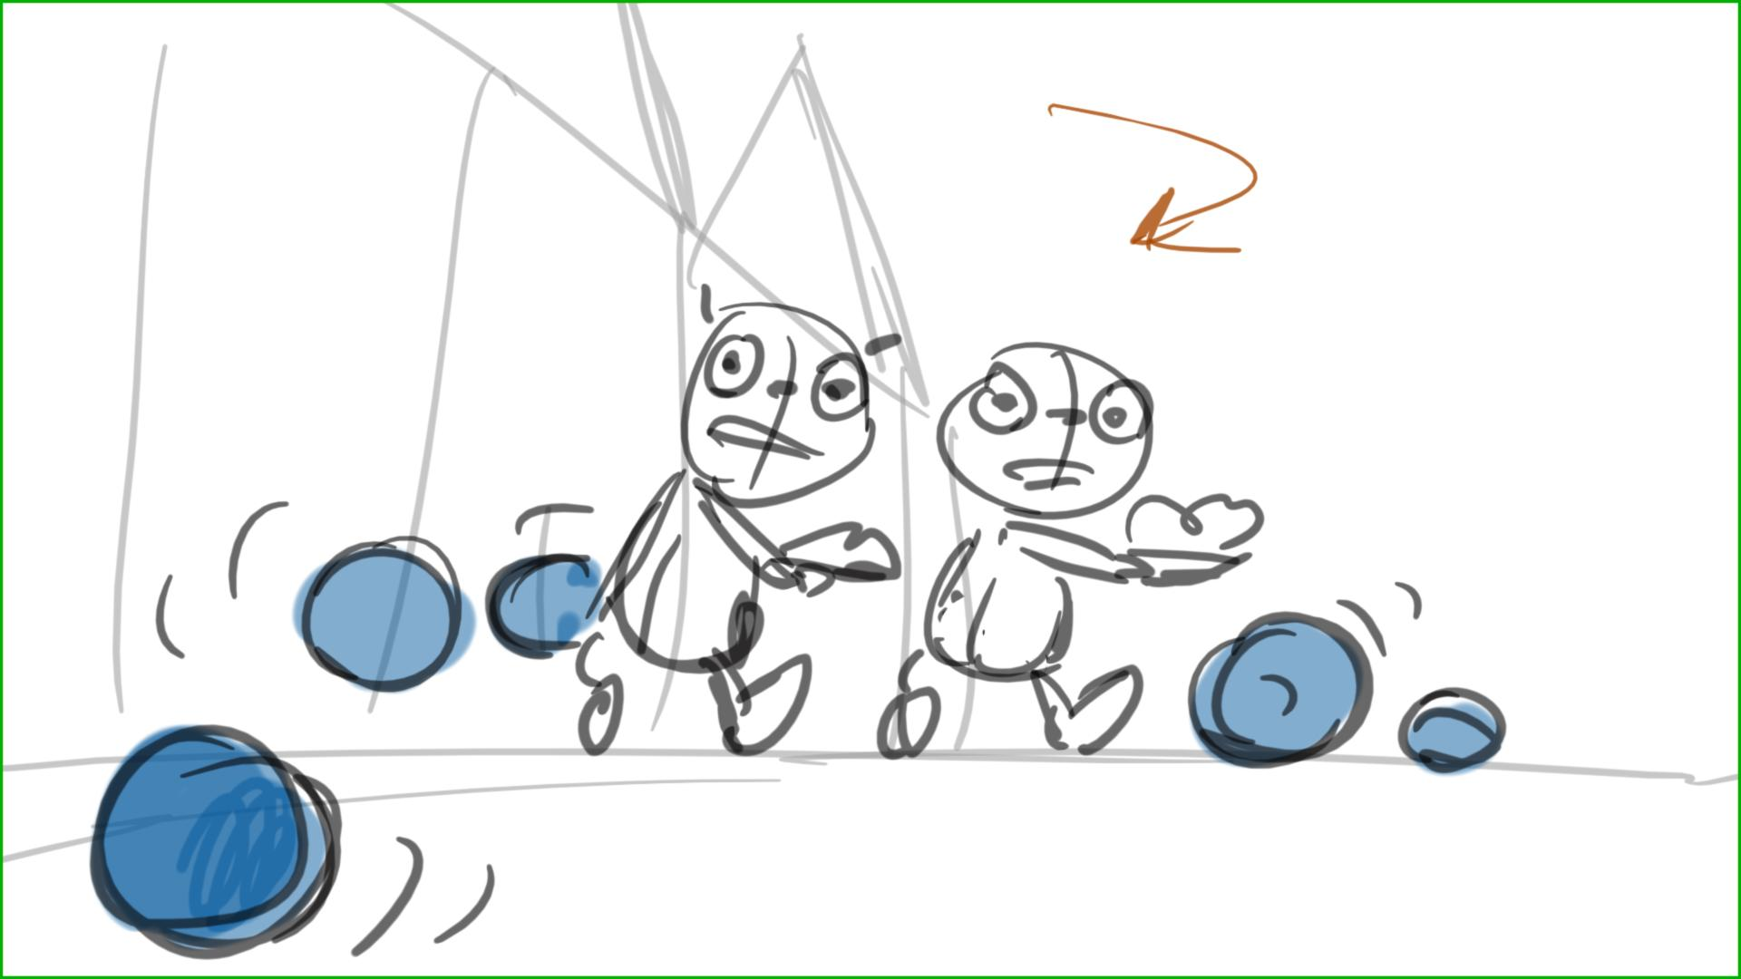

268 – we need more visual shot here to see the food change – like in sketch below. Make Hballs roll around the plate, and Roaartonio/Harold crawl up to the plate

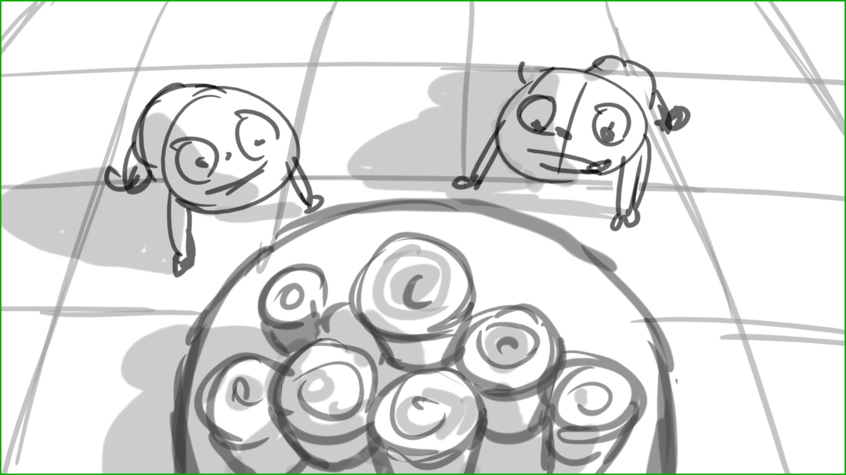

274 – H should stand next to the food tray here, then bite, then walk o.s.

278 – make it wider, have Roddy roll around Higgins 2-3 times, spinning him, then leaving shot. Higgins cont. spinning

283 – make bikers think for a second, and then ride around spinning Higgins. Make a wider angled down shot to make it work

284 – insert a scene here of Roddy tossing his balls/mesh sack into the air

295 – 311 – make sure you follow the ref. material in clean ups – for a clear geography of the area. Like the wall in 307 – we need to know what wall that is

320 (and all related scenes) – the kids stand by the slide, Roddy is preventing them from climbing up with his tale, then he gets on the top. Setup – below

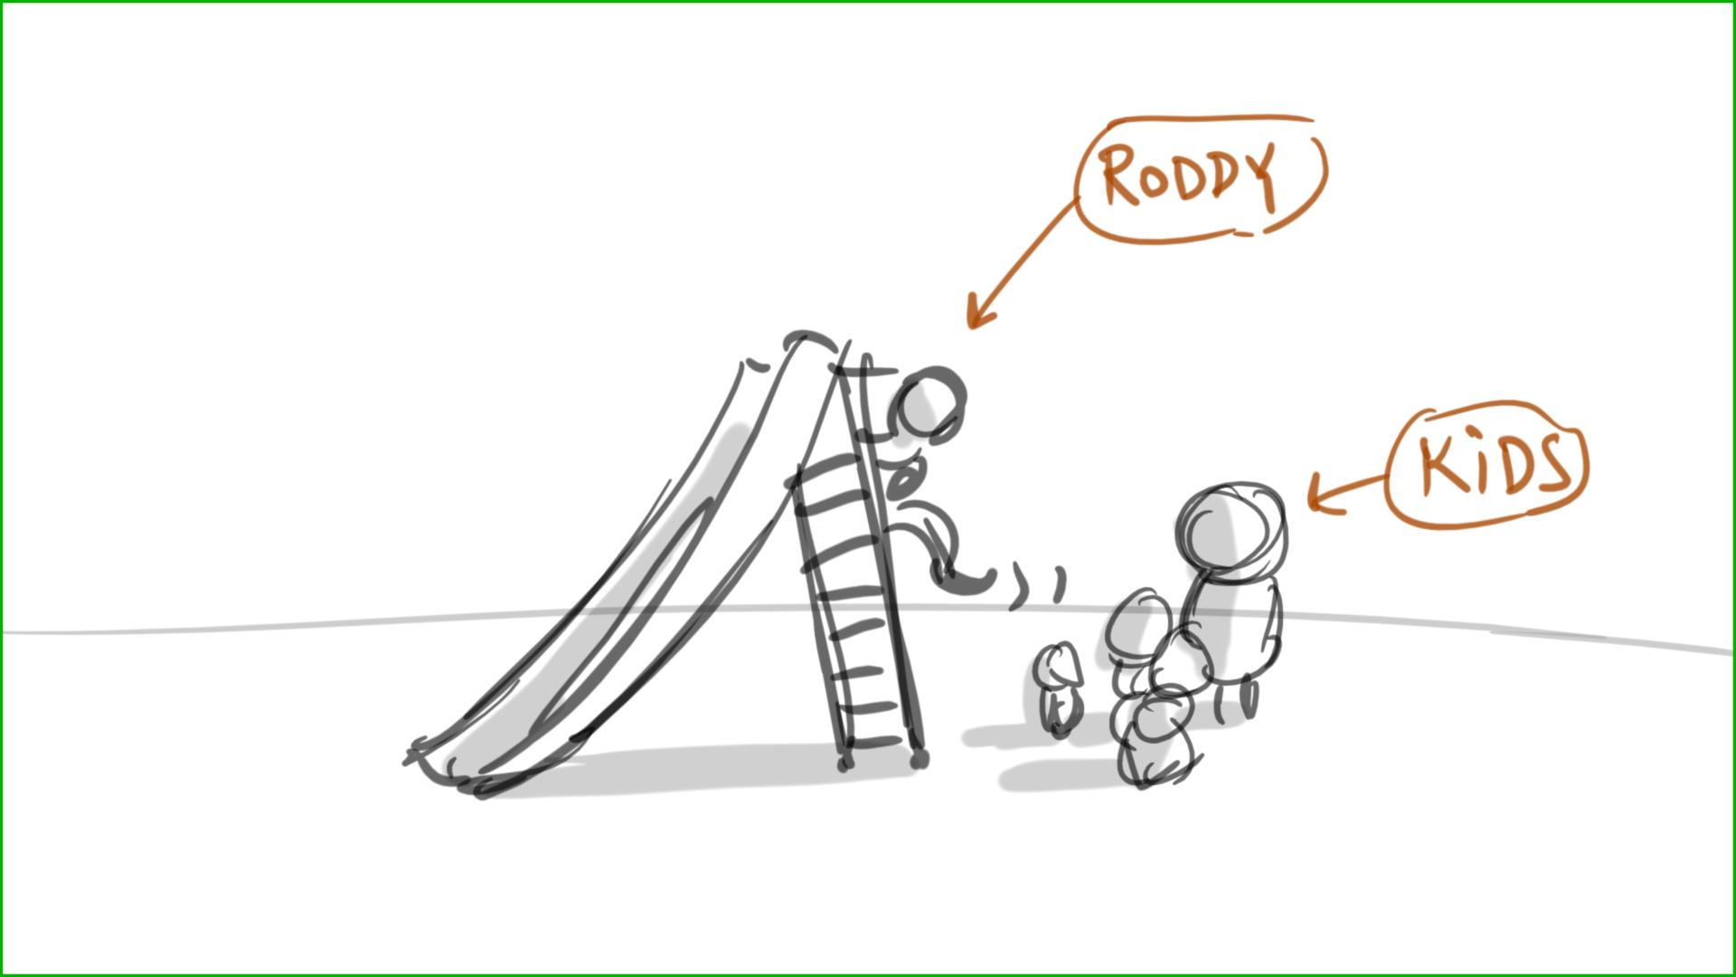

320 – 331 - Then H/kids talk facing each other like in setup below

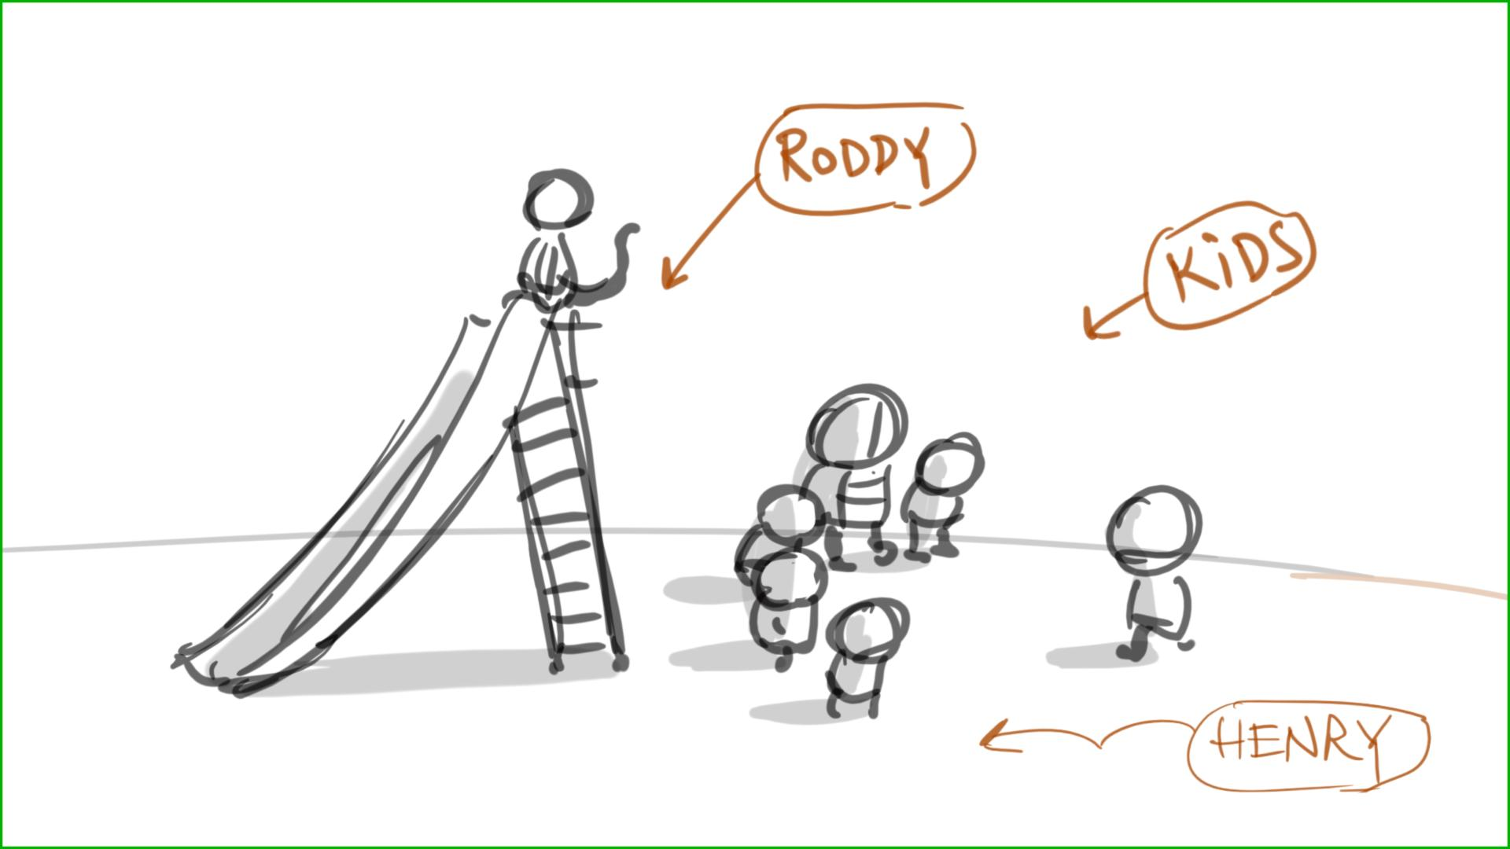

332 – till around 347 – they relocate to the front of the slide. Roddy remains on the top of slide – setup below

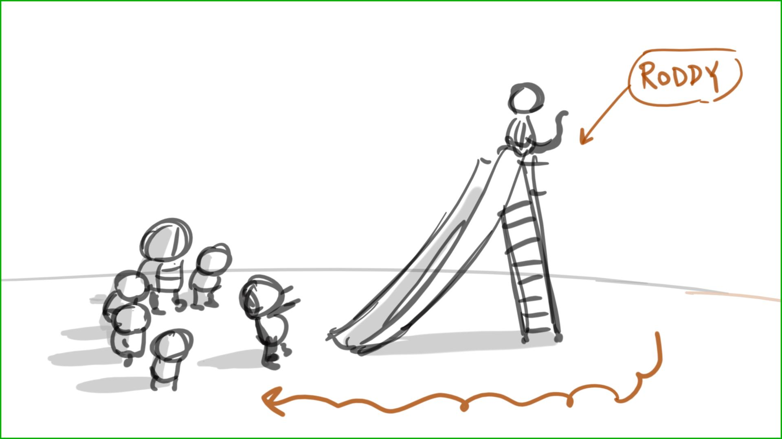

334 – Roddy doesn’t slide down, he makes all his shticks standing on top of the slide. Use angled up/down shots -- like in sketches below

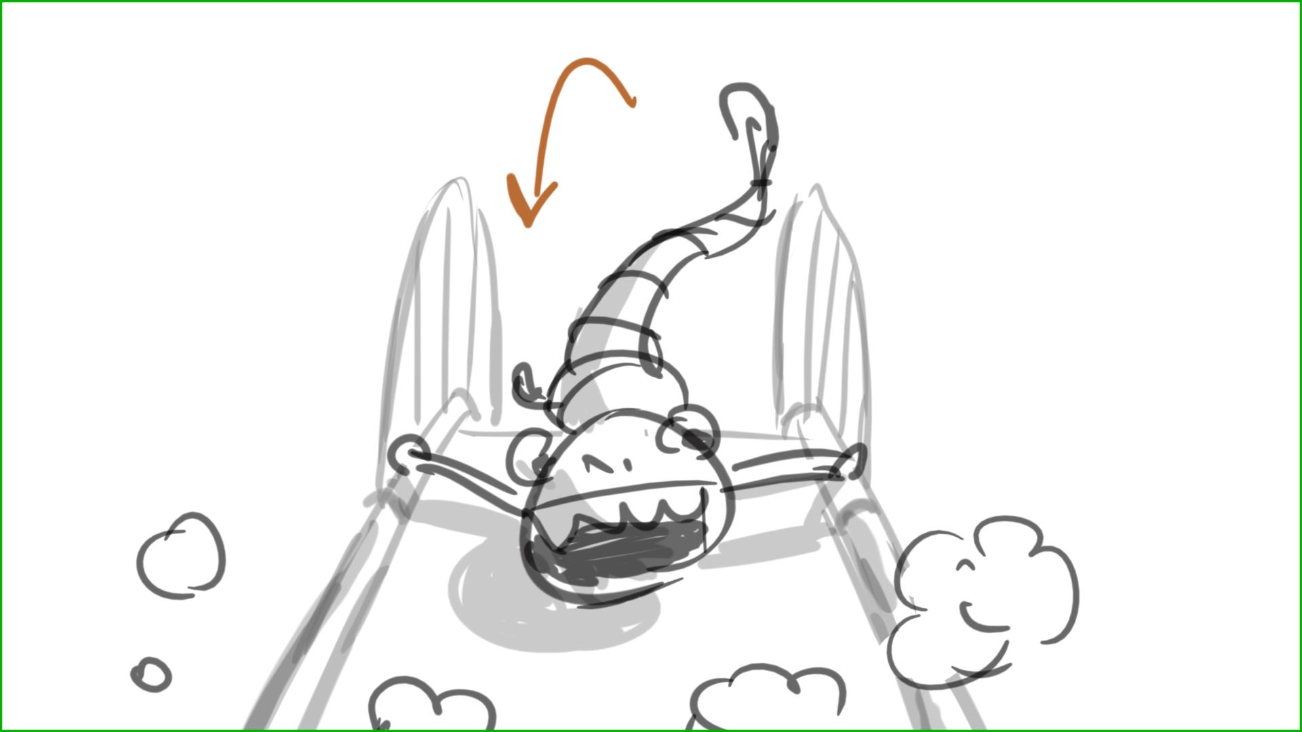

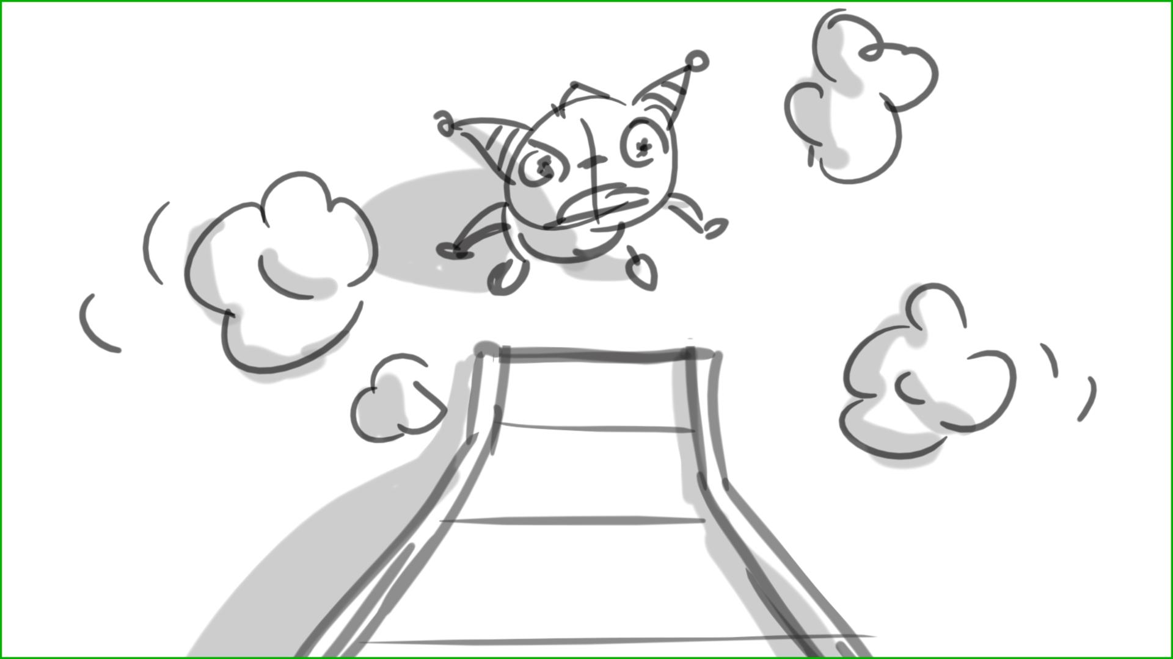

348 – 354 – Roddy is on top of slide, he slowly comes down in 354 – like in sketch below

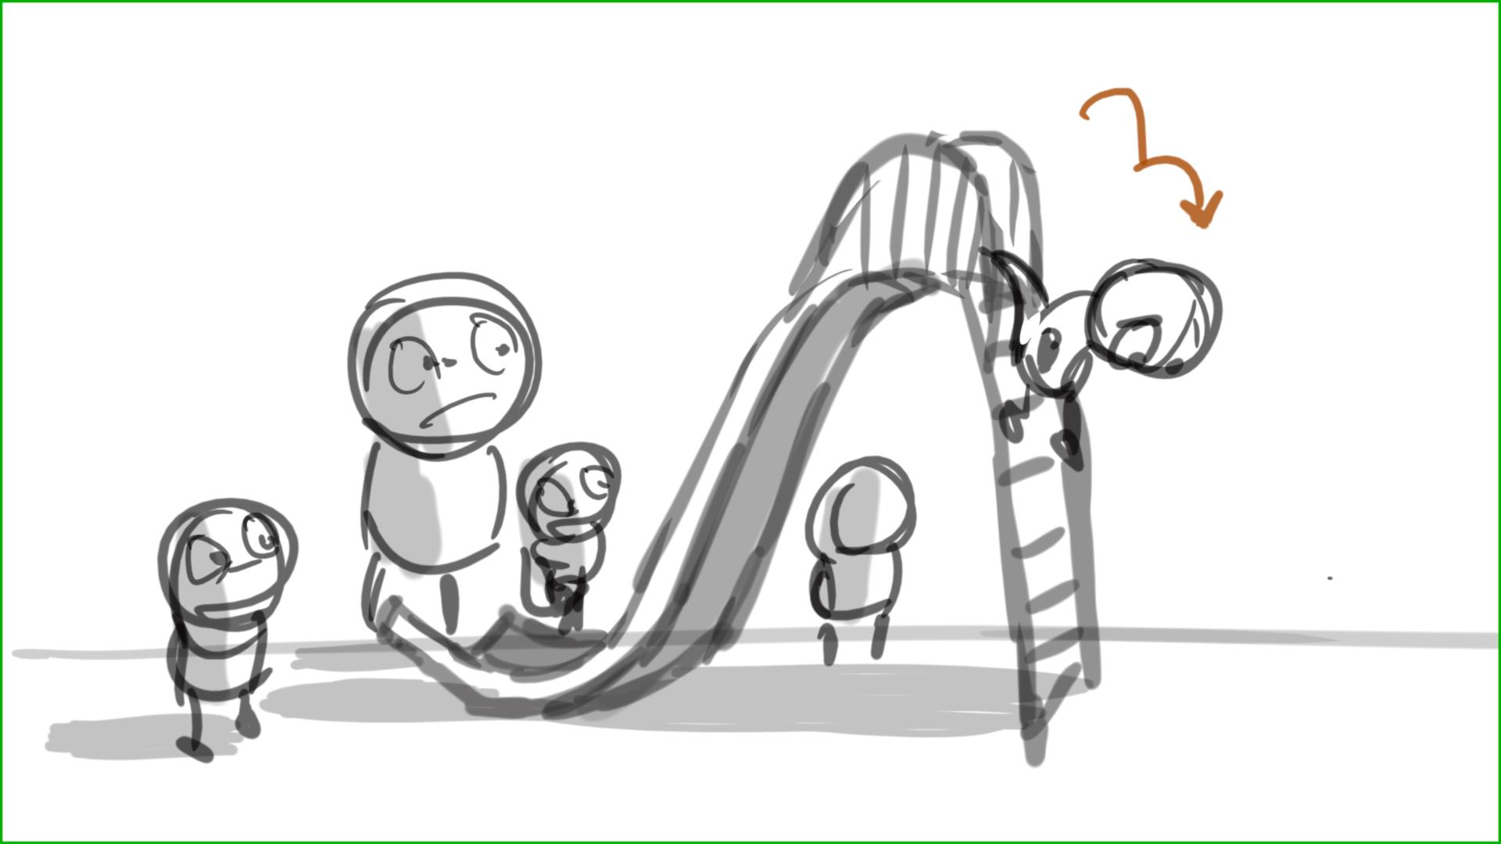

354 – should look like in sketch below

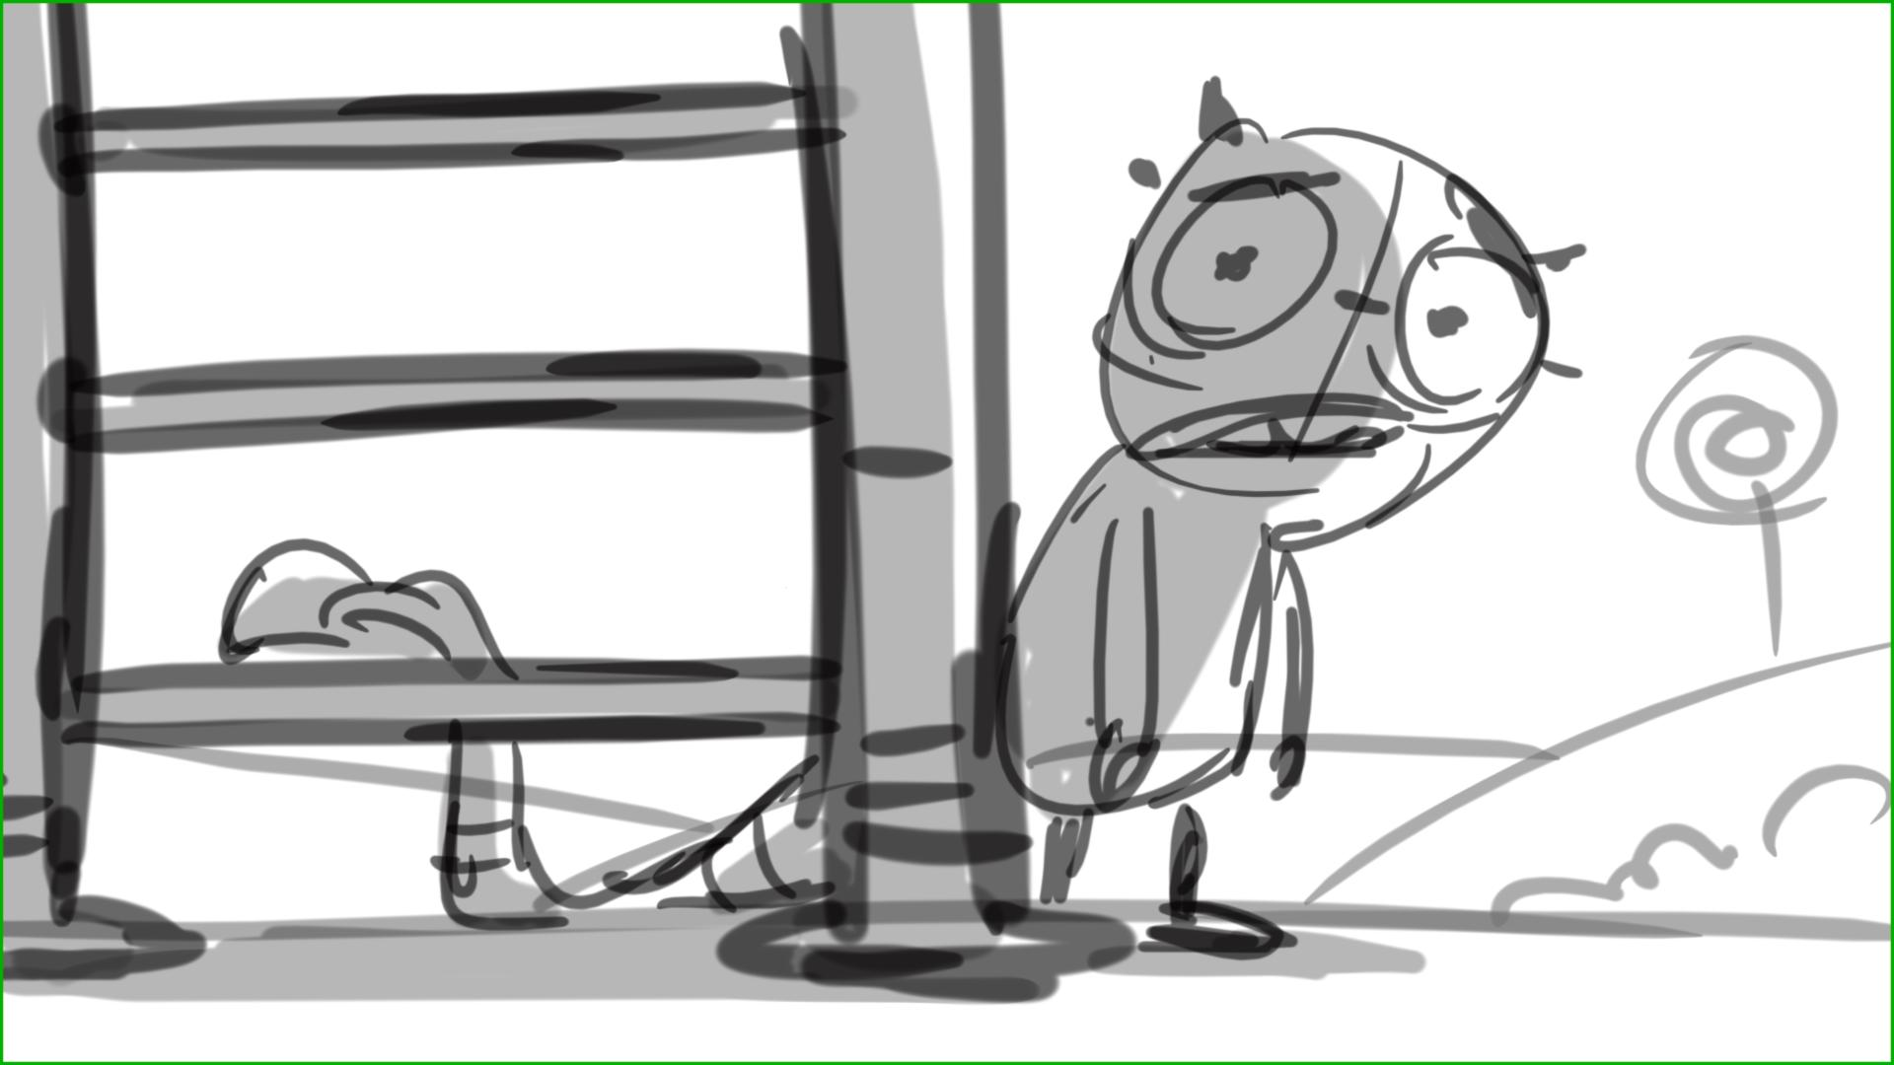

355 – Henry says it (…it worked), turning to cam, pointing to a freed slide – like in sketch below

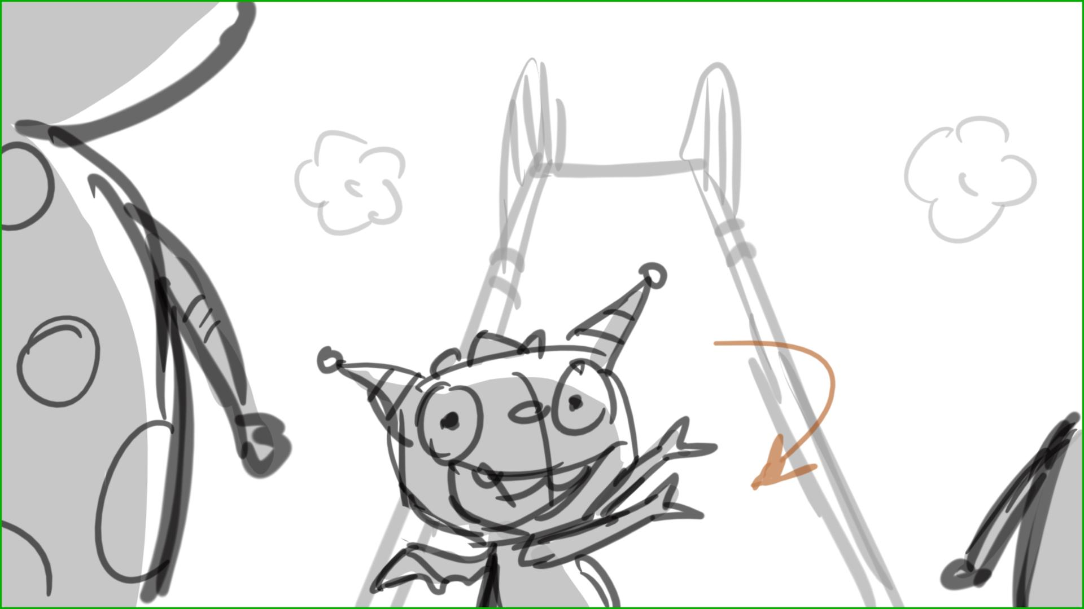

356 – 358 – they run from the front of the slide to the back

360 – more frontal shot(s) please – like below. Have them fly o.s.

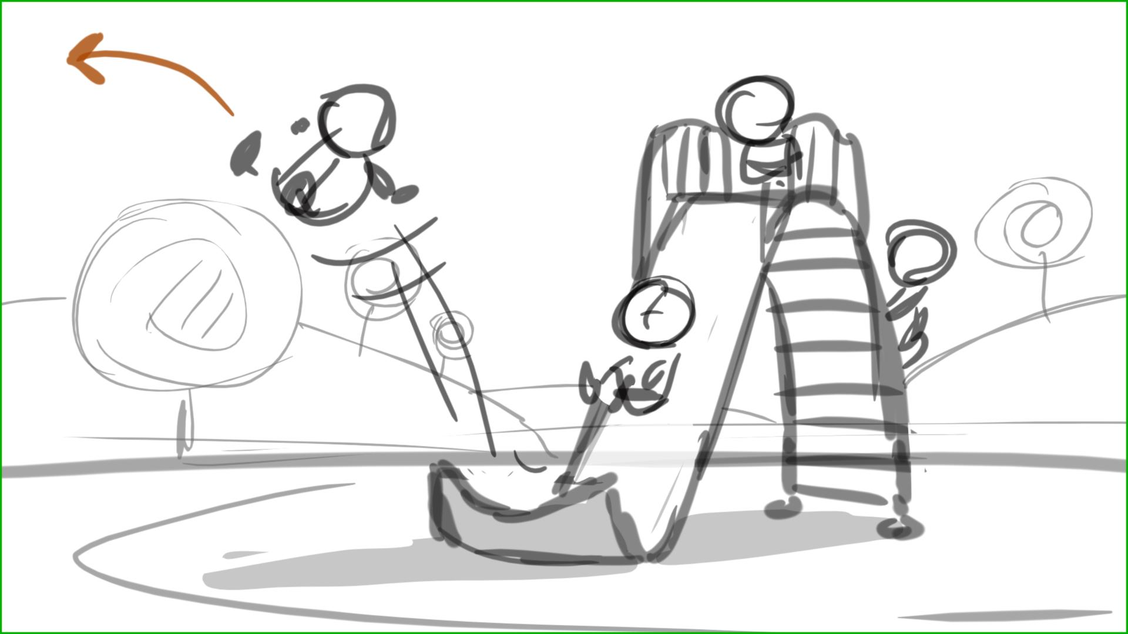

362 - 363 – have Roddy seen in BG as H lifts Milo up. Then H turns around and sees Roddy, then we cut to over the shoulder shot from H’s POV. Use this angle for lines 147,148 when H talks to cam

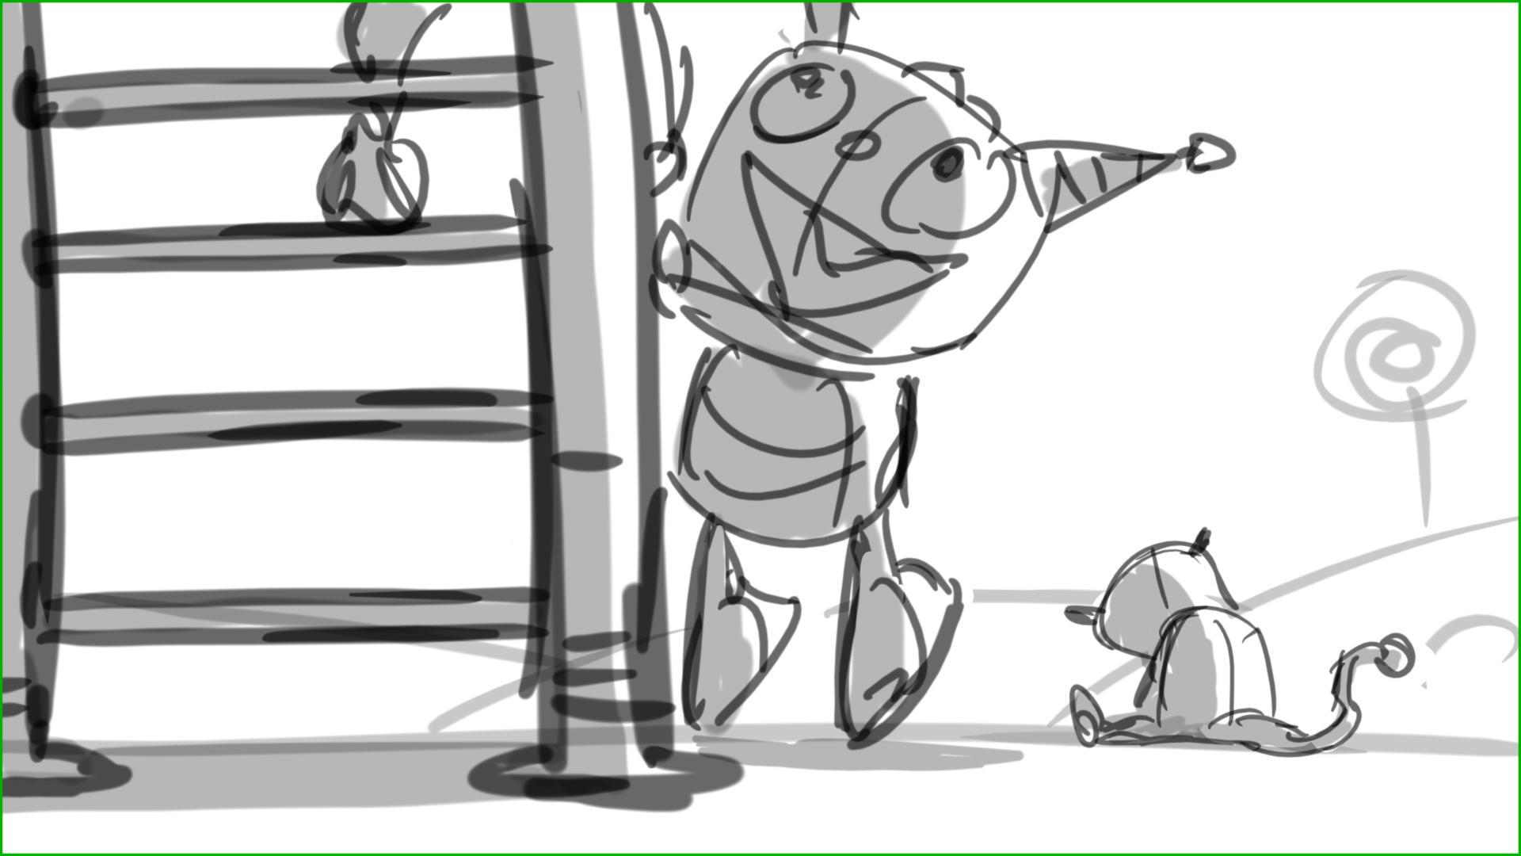

365 – 370 – we should see Robby’s sad face, and happy sliding kids in BG, as Henry approaches Robby. H can carry balls in his hands (having picked them up on his way to R) , but no bag please – sketch below

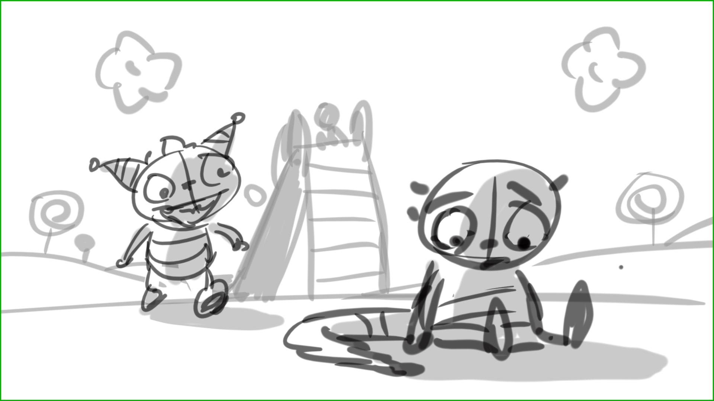

371 – 375 – restructure to nave cuts between them – angled shots please. H stands, R sits (means he’s lower). Please no bag in these scenes, just balls

383 – 384 – jump cut, please fix

386 – 388 – we need to stay on R in shot ( no H), then hook up to 389 as Roddy floats around H

390 – have R in BG, floating, H turns to cam to say his 164 line, while R is floating behind him

390 – 391 - jump cut, please fix

395 – where are they playing Hball ? They can play in the area next to playground, map - below

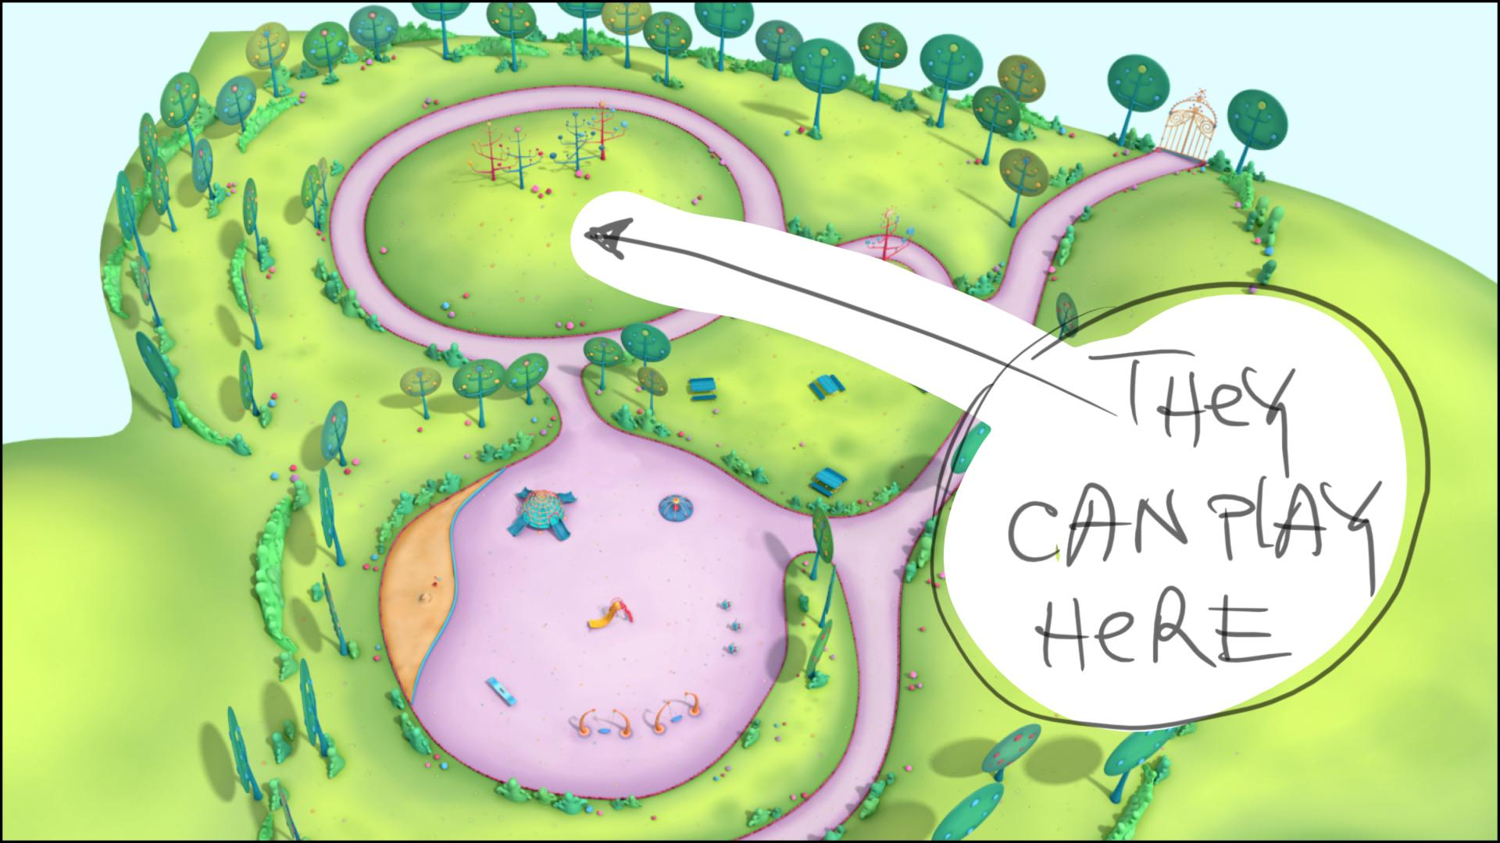

396 – 401 – no bag please

399 – 401 – have only Henry and Roddy in shot here, lower cam angle.

404 – have Milo stand inside circling Roddy around him. Then H joins in, make them play Hball, riding on clouds. Lower cam angle

408 – down shot on Milo here

409 – Robby is on cloud here in the first frame, then he jumps off it .

414 – 415 - jump cut, please fix

418 – 440 – they don’t use their hands in Hball game – look ref. movie file (Hball game). They use their bodies only